Assignment No. 6 – GREP Commands (Simplified)
Date: 17-09-2024

1. create file emp.txt with following content,
Sachin tendulkar was a great batsman
Arjun is a Medical representative
Aparna
agrawal
Veeru
sengupta lives at Kolkata
Gopinath
Dasgupta
Dasgupta
Anil Aggarwal
Sengupta
Agrawal
hetank
pulella Gopichand
P V Sandhu Sandhu
sachin
Agarwal
aparna
Atul
sandhu
Mayank
atul suvagiya
mayank patel
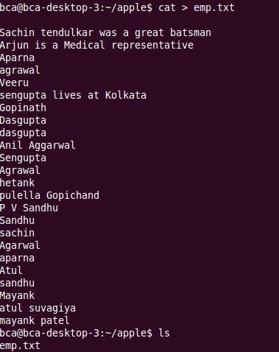

2. Find employee Veeru from emp.txt \
3. find pattern P V Sandhu from emp.txt
4. copy file emp.txt and create new file newemp.txt with copied content.
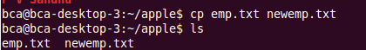
5. find Atul from file emp.txt and newemp.txt
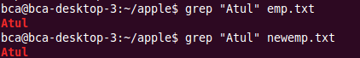
6. find Agrawal or agrawal from file.
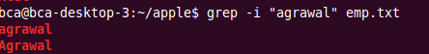
7. display all the lines from emp.txt except those containing Agrawal.
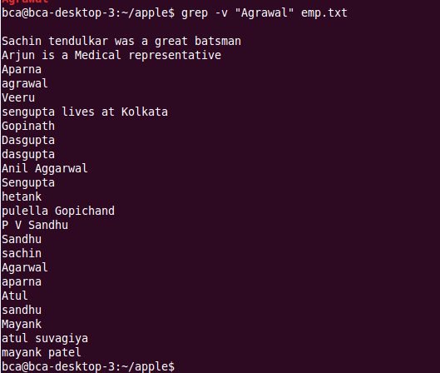
8. display the line numbers containing pattern agrawal. 17-09-2024 Page 2 of 2
9. count total number of lines containing pattern Sandhu or sandhu.
10. display name of text files containing pattern aparna
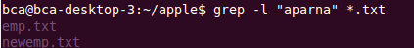
11. find agrawal or Agrawal from emp.txt using character class.

12. find multiple pattern sengupta and dasgupta from emp.txt.
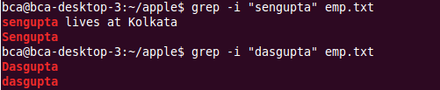
13. display lines that starts with character A.
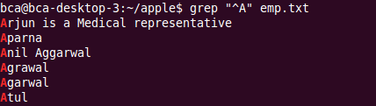
14. display line which end with character k.
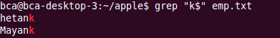
15. create file pattern.txt containing Sandhu Hetank Using file pattern.txt, search the words included in emp.txt.
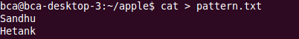
16. print line/s which only contains sachin word.
