Assignment no. 8
- Write a shell script to perform arithmetic operations using two operands. Take values from user.
- #!/bin/sh

- a=10
- b=20

- val=`expr $a + $b`
- echo "a + b : $val"

- val=`expr $a - $b`
- echo "a - b : $val"

- val=`expr $a \* $b`
- echo "a * b : $val"

- val=`expr $b / $a`
- echo "b / a : $val"

- val=`expr $b % $a`
- echo "b % a : $val"

- if [ $a == $b ]
- then
- echo "a is equal to b"
- fi

- if [ $a != $b ]
- then
- echo "a is not equal to b"
- fi
output:
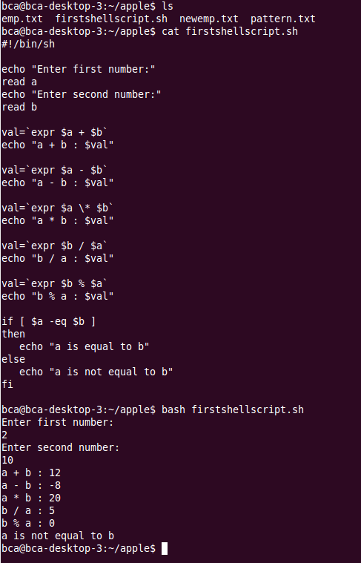

2. Write a shell script to demonstrate the use of relational operators.
#!/bin/sh

a=10
b=20

if [ $a -eq $b ]
then
echo "$a -eq $b : a is equal to b"
else
echo "$a -eq $b: a is not equal to b"
fi

if [ $a -ne $b ]
then
echo "$a -ne $b: a is not equal to b"
else
echo "$a -ne $b : a is equal to b"
fi

if [ $a -gt $b ]
then
echo "$a -gt $b: a is greater than b"
else
echo "$a -gt $b: a is not greater than b"
fi

if [ $a -lt $b ]
then
echo "$a -lt $b: a is less than b"
else
echo "$a -lt $b: a is not less than b"
fi

if [ $a -ge $b ]
then
echo "$a -ge $b: a is greater or equal to b"
else
echo "$a -ge $b: a is not greater or equal to b"
fi

if [ $a -le $b ]
then
echo "$a -le $b: a is less or equal to b"
else
echo "$a -le $b: a is not less or equal to b"
fi
output:
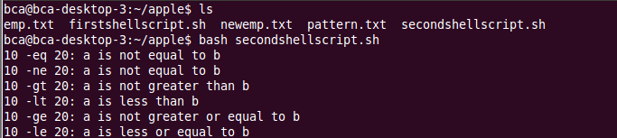
3. Write a shell script to illustrate the use of Boolean operators.
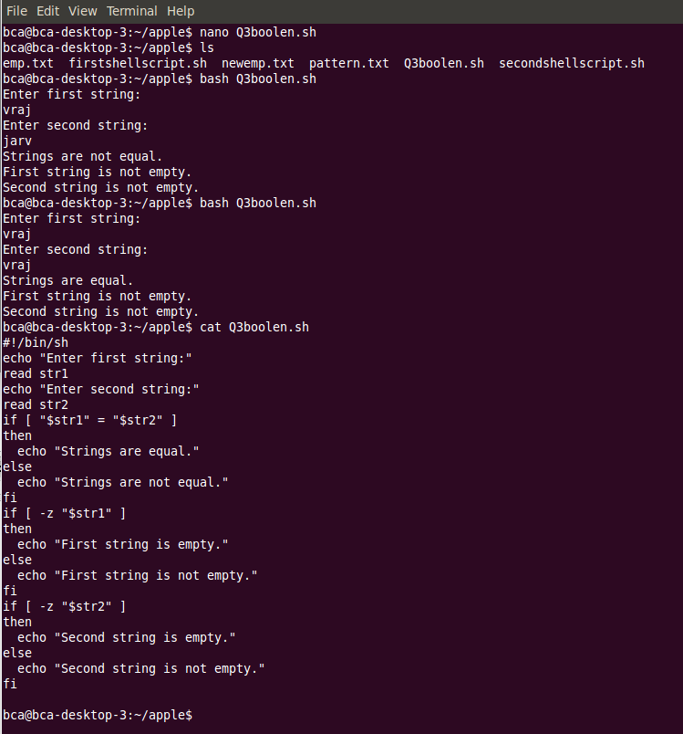
4. Take two string values from user and check
a) Two values are equal or not
b) String operand size is zero or not
c) String size is zero or not.
o/p:
5. Take any one file and write a script to perform following file test operations on that file.
a) Whether the given file has read permission or not
b) Whether the given file has write permission or not
c) Whether the given file has execute permission or not
d) Whether the given file is file or directory.
o/p: 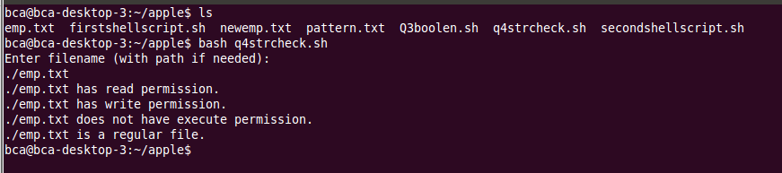
6. write a script using case statement,
Take choice from user for execution of date, cal, who and grep command
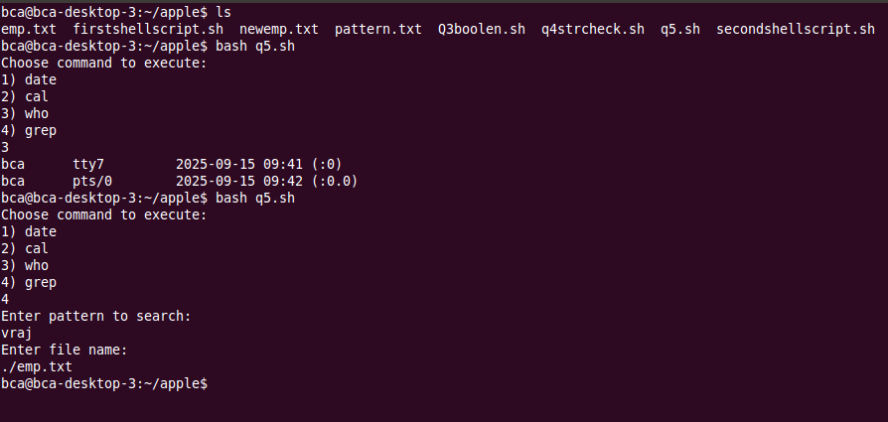
7. Write a shell script to print the sequence 1 to 49 using while loop.
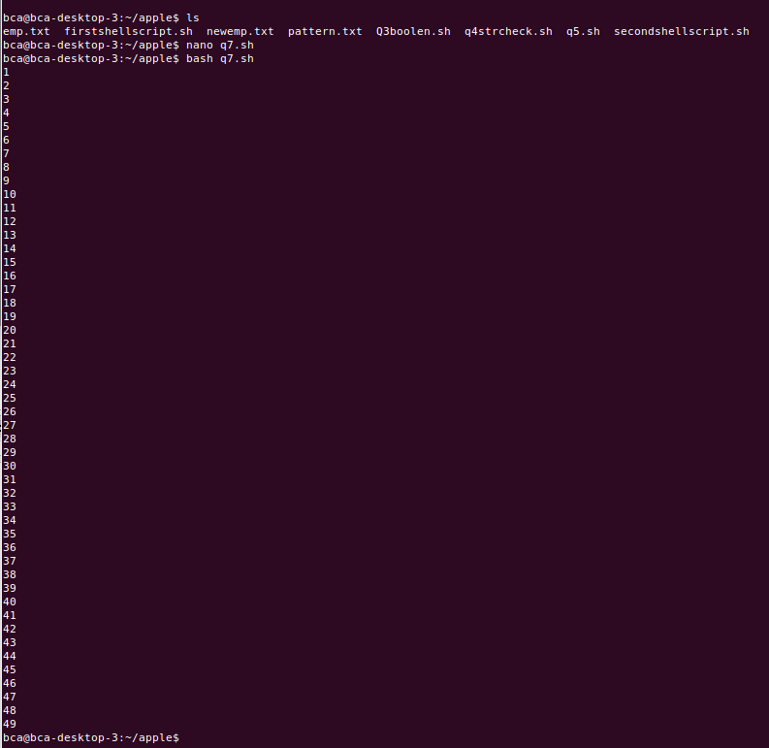
8. Write a shell script to print the sequence 20 to 1 using until loop.
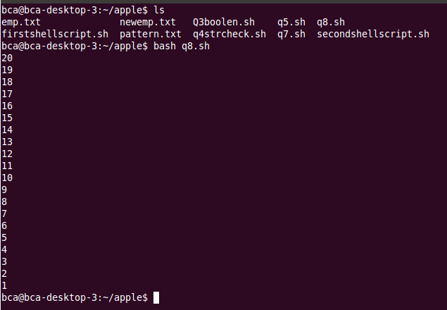
9. Write a shell script to print the sequence 1 to 19 using for loop.
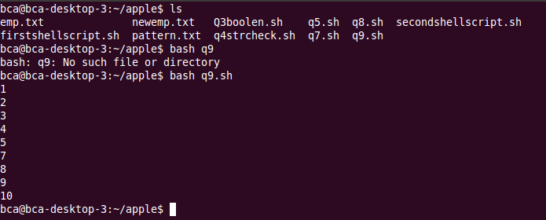
10. Write a shell script to print the following sequence,
1
2
3
4
5
7
8
9
10
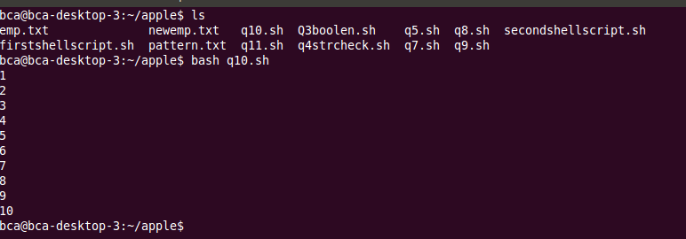

11. Write a script that check count is equal to 25, it breaks out of the loop immediately. If count is a multiple of 5, it skips the rest of the commands and starts the next iteration. If neither condition is met, it echoes the current value of count. Initial value of Count =1
