Question 1.

Question 2.
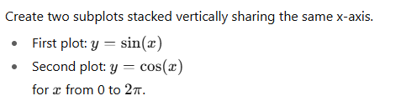

Question 3.

Question 4.
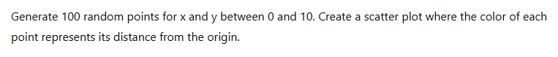

Question 5.
