Data visualization helps you understand complex datasets. The Matplotlib library in Python is a key tool for creating plots, and basic plotting. Whether you’re a student or professional, you’ll learn core concepts like line plots, histograms, bar charts, and scatter plots. It provides clear steps to build your first visualizations, making it easy to grasp Matplotlib’s essentials.
- What is Matplotlib?
- Installation of Matplotlib
- Types of Plots in Matplotlib
  - Line Plots
  - Histogram
  - Bar Plot
  - Scatter Plot
  - Pie Chart
  - Box Plot
  - Area Chart
- What is Matplotlib in Python?
Matplotlib is a popular plotting library in Python used for creating high-quality visualizations and graphs. It offers various tools to generate diverse plots, facilitating data analysis, exploration, and presentation. Matplotlib is flexible, supporting multiple plot types and customization options, making it valuable for scientific research, data analysis, and visual communication. It can create different types of visualization reports like line plots, scatter plots, histograms, bar charts, pie charts, box plots, and many more different plots. This library also supports 3-dimensional plotting.

Installation of Matplotlib
check how to set up the Matplotlib in Google Colab. Colab Notebooks are similar to Jupyter Notebooks except for running on the cloud. It is also connected to our Google Drive, making it much easier to access our Colab notebooks anytime, anywhere, and on any system. You can install Matplotlib by using the PIP command.
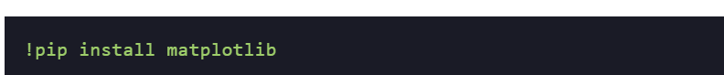
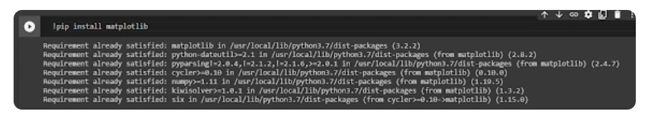

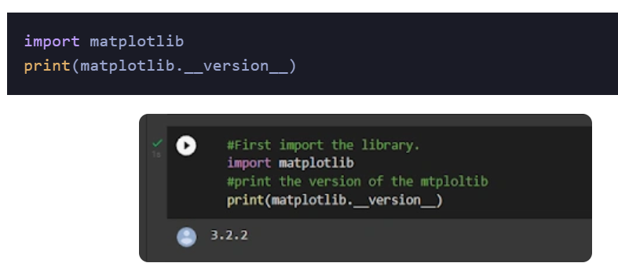

Types of Plots in Matplotlib
Now that you know what Matplotlib function is and how you can install it in your system, let’s discuss different kinds of plots that you can draw to analyze your data or present your findings.

Sub Plots
Subplots() is a Matplotlib function that displays multiple plots in one figure. It takes various arguments such as many rows, columns, or sharex, sharey axis.
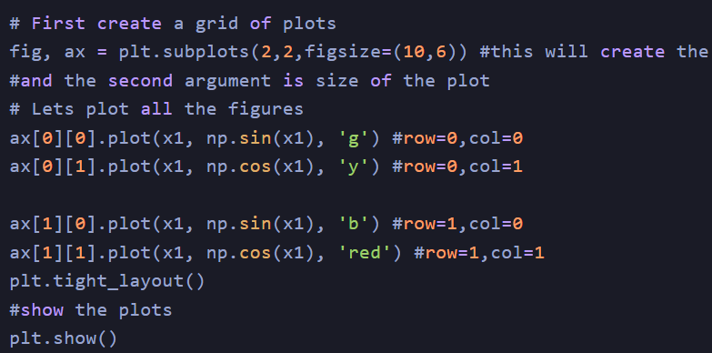
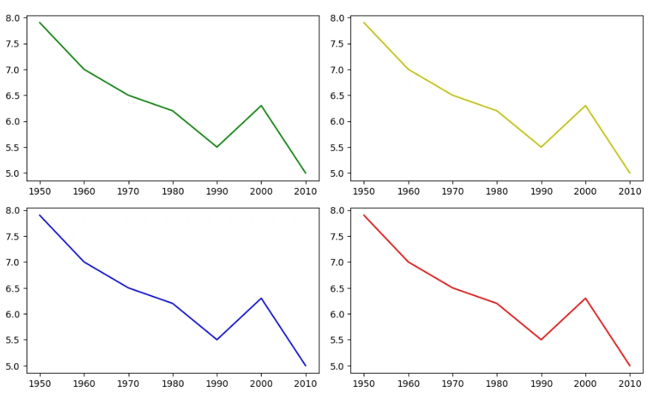

different categories of plots that Matplotlib provides.
- Line plot
- Histogram
- Bar Chart
- Scatter plot
- Pie charts
- Boxplot
- Most of the time, we have to work with Pyplot as an interface for Matplotlib. So, we import Pyplot like this:
- importmatplotlib.pyplot
- To make things easier, we can import it like this:
- import matplotlib. pyplot as plt

Line Plots
A line plot shows the relationship between the x and y-axis.
The plot() function in the Matplotlib library’s Pyplot module creates a 2D hexagonal plot of x and y coordinates. plot() will take various arguments like plot(x, y, scalex, scaley, data, **kwargs).
x, y are the horizontal and vertical axis coordinates where x values are optional, and its default value is range(len(y)).
scalex, scaley parameters are used to autoscale the x-axis or y-axis, and its default value is actual.
**kwargs specify the property like line label, linewidth, marker, color, etc
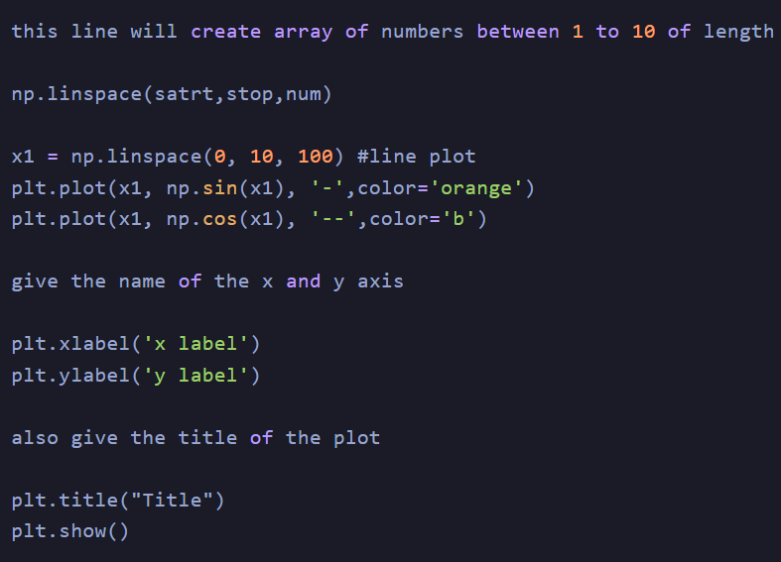

Histogram
The most common graph for displaying frequency distributions is a histogram. To create a histogram, the first step is to create a bin of ranges, then distribute the whole range of values into a series of intervals and count the value that will fall in the given interval. We can use plt.Hist () function plots the histograms, taking various arguments like data, bins, color, etc.
x: x-coordinate or sequence of the array
bins: integer value for the number of bins wanted in the graph
range: the lower and upper range of bins
density: optional parameter that contains boolean values
histtype: optional parameter used to create different types of histograms like:-bar bar stacked, step, step filled, and the default is a bar
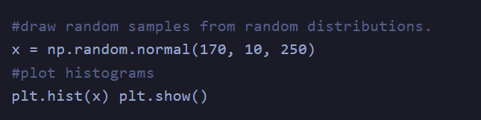
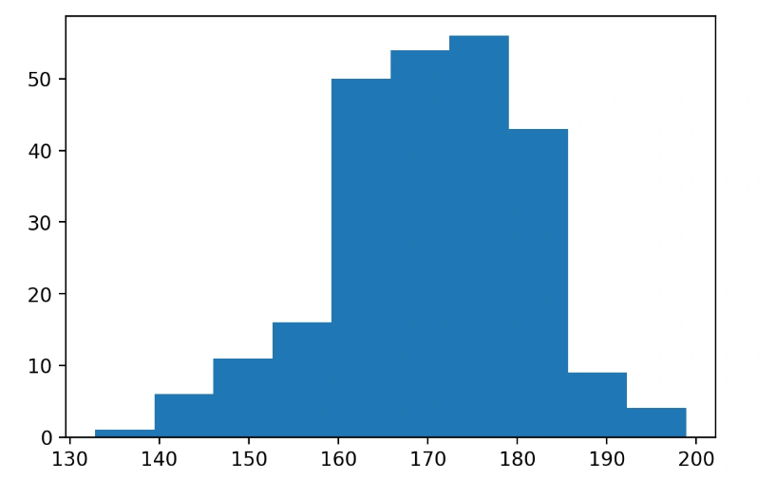

Bar Plot
Mainly, the barplot shows the relationship between the numeric and categoric values. In a bar chart, we have one axis representing a particular category of the columns and another axis representing the values or counts of the specific category. Barchartscan be plotted both vertically and horizontally using the following line of code:
plt.bar(x,height,width,bottom,align)
x: representing the coordinates of the x-axis
height: the height of the bars
width: width of the bars. Its default value is 0.8
bottom: It’s optional. It is a y-coordinate of the bar. Its default value is None
align: center, edge its default value is center
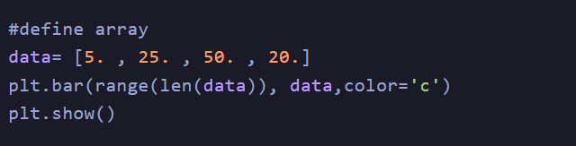
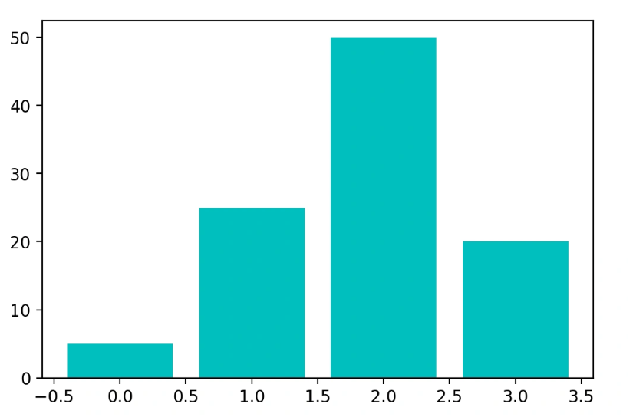

Scatter Plot
Scatter plots show the relationships between variables by using dots to represent the connection between two numeric variables.
The scatter() method in the Matplotlib library is used for plotting.
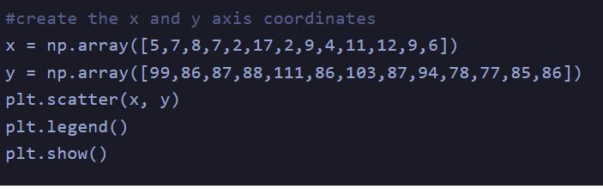
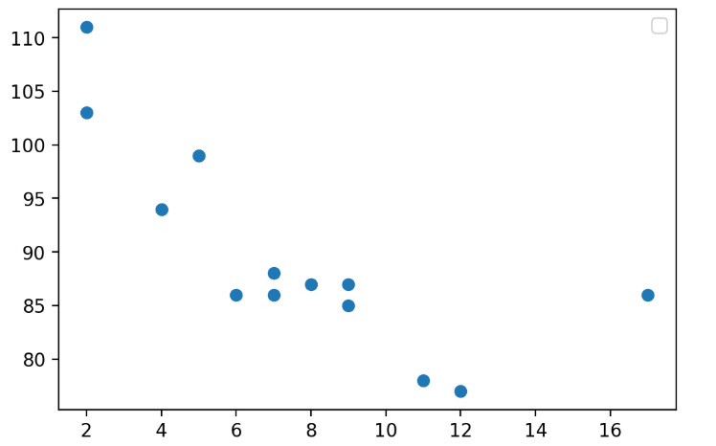

Pie Chart
A pie chart (or circular chart ) is used to show the percentage of the whole. Hence, it is used to compare the individual categories with the whole. Pie() will take the different parameters such as:
x: Sequence of an array
labels: List of strings which will be the name of each slice in the pie chart
Autopct: It is used to label the wedges with numeric values. The labels will be placed inside the wedges. Its format is %1.2f%
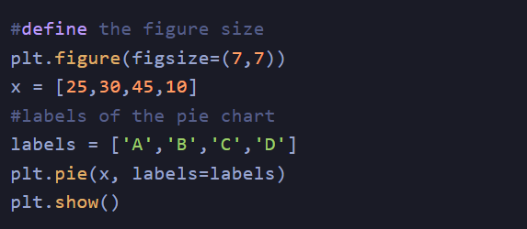
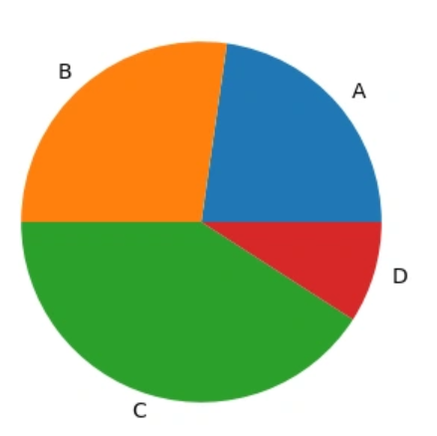

Box Plot
A Box plot in Python Matplotlibshowcases the dataset’s summary, encompassing all numeric values. It highlights the minimum, first quartile, median, third quartile, and maximum. The median lies between the first and third quartiles. On the x-axis, you’ll find the data values, while the y-coordinates represent the frequency distribution.
Parameters used in box plots are as follows:
data: NumPy array
vert: It will take boolean values, i.e., true or false, for the vertical and horizontal plot. The default is True
width: This will take an array and sets of the width of boxes. Optional parameters
Patch_artist: It is used to fill the boxes with color, and its default value is false
labels: Array of strings which is used to set the labels of the dataset
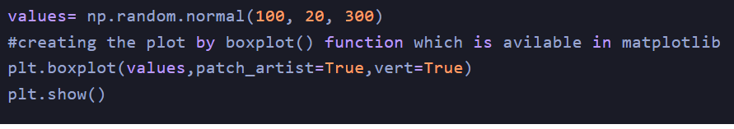
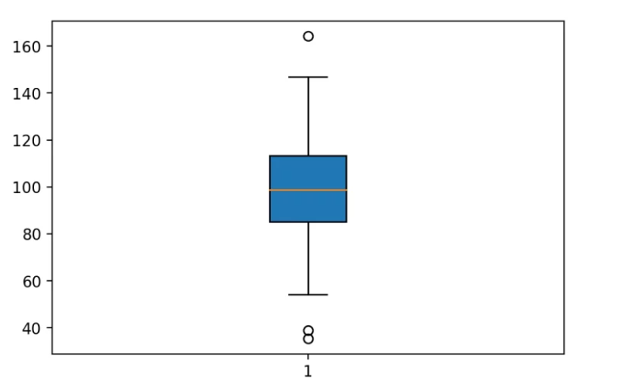

Area Chart
An area chart or plot visualizes quantitative data graphically based on the line plot. fill_between() function is used to plot the area chart.
Parameter:
x,y represent the x and y coordinates of the plot. This will take an array of length n.
Interpolate is a boolean value and is optional. If true, interpolate between the two lines to find the precise point of intersection.
**kwargs: alpha, color, face color, edge color, linewidth.
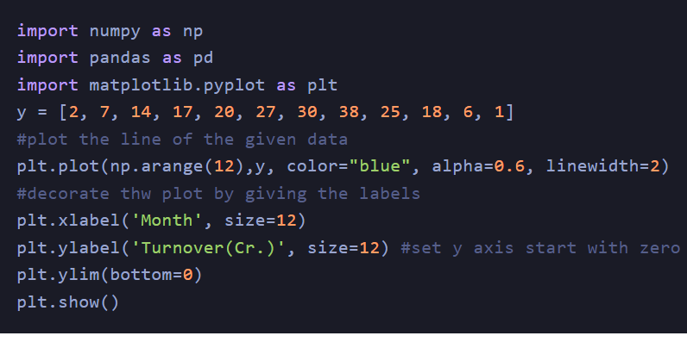
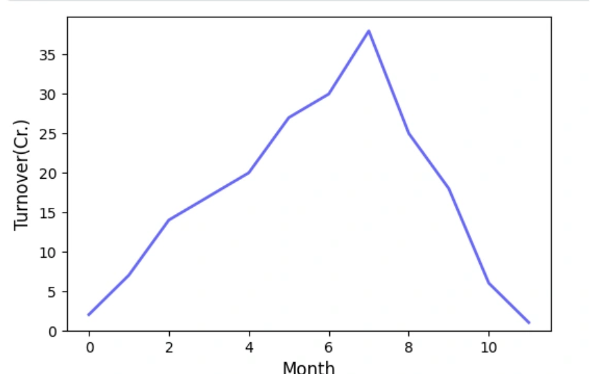

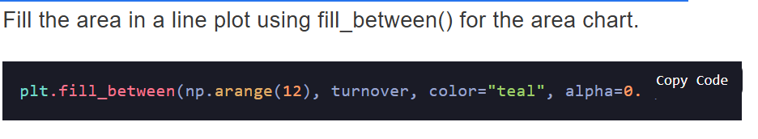
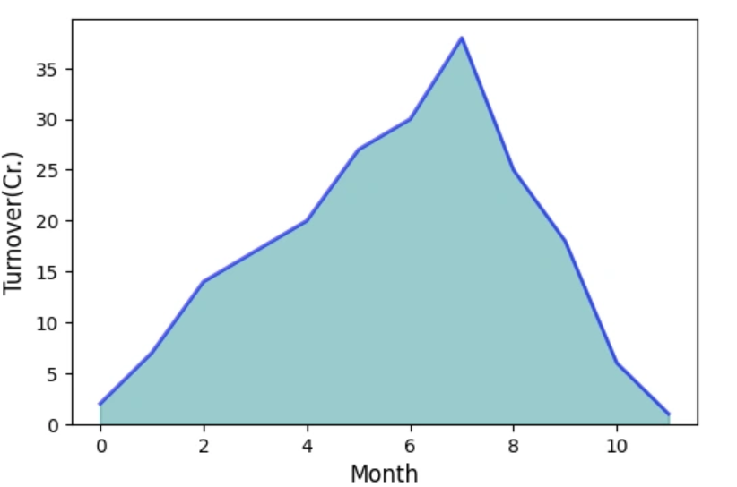

3-D Graphs
Now that you have seen some simple graphs, it’s time to check some complex ones, i.e., 3-D graphs. Initially, Matplotlibwas built for 2-dimensional graphs, but later, 3-D graphs were added. Let’s check how you can plot a 3-D graph in Matplotlib.
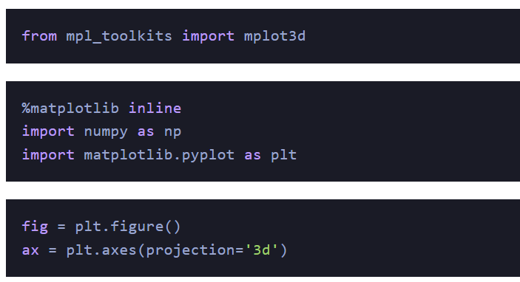
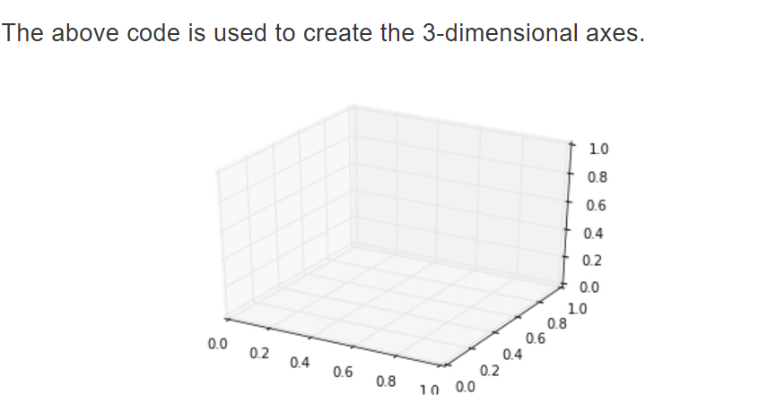
Each plot that we have seen in 2-D plotting through Matplotlibcan also be drawn as 3-D graphs. For instance, let’s check a line plot in a 3-D plane.
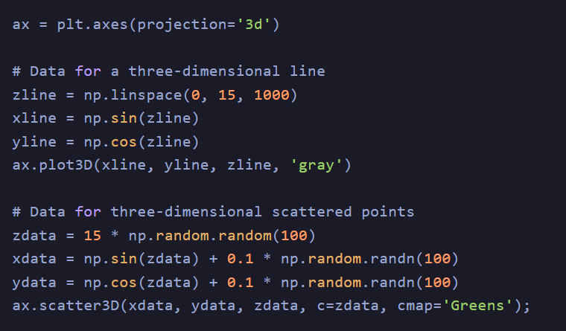
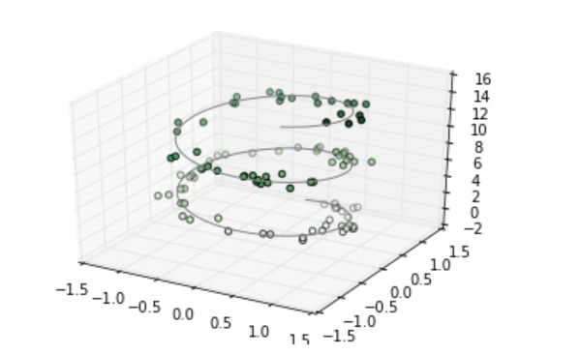
all other types of graphs can be drawn in the same way. One particular graph that Matplotlib 3-D provides is the Contour Plot. You can draw a contour plot using the following link:
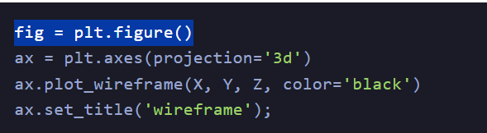
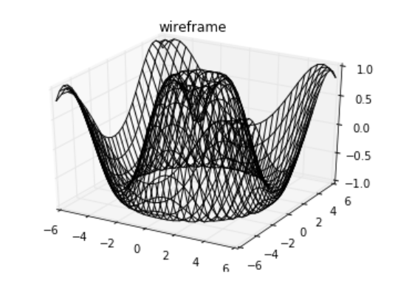

Introduction to pyplot
matplotlib.pyplot is a collection of functions that make matplotlib work like MATLAB. Each pyplot function makes some change to a figure: e.g., creates a figure, creates a plotting area in a figure, plots some lines in a plotting area, decorates the plot with labels, etc.
In matplotlib.pyplot various states are preserved across function calls, so that it keeps track of things like the current figure and plotting area, and the plotting functions are directed to the current Axes (please note that we use uppercase Axes to refer to the Axes concept, which is a central part of a figure and not only the plural of axis).
Generating visualizations with pyplot is very quick:
importmatplotlib.pyplot as plt

plt.plot([1,2,3,4])
plt.ylabel('some numbers')
plt.show()
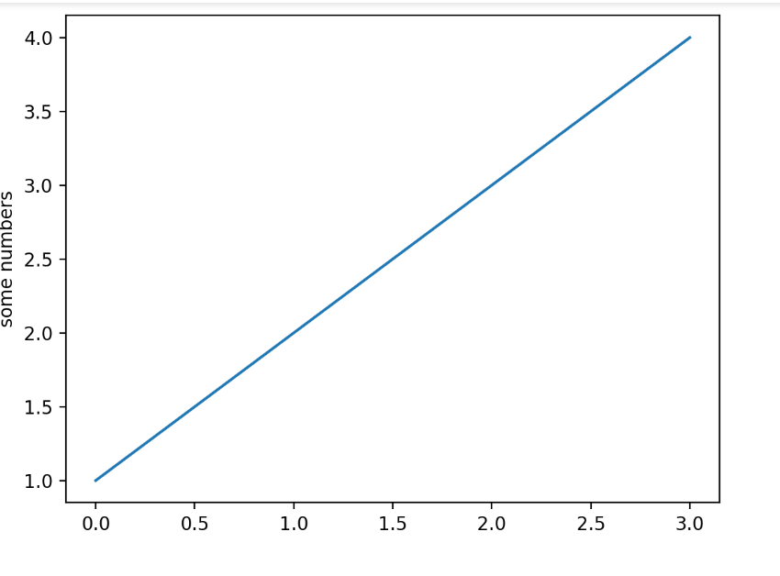
You may be wondering why the x-axis ranges from 0-3 and the y-axis from 1-4. If you provide a single list or array to plot, matplotlib assumes it is a sequence of y values, and automatically generates the x values for you. Since python ranges start with 0, the default x vector has the same length as y but starts with 0; therefore, the x data are [0, 1, 2, 3].
plot is a versatile function, and will take an arbitrary number of arguments. For example, to plot x versus y, you can write:
plt.plot([1,2,3,4],[1,4,9,16])
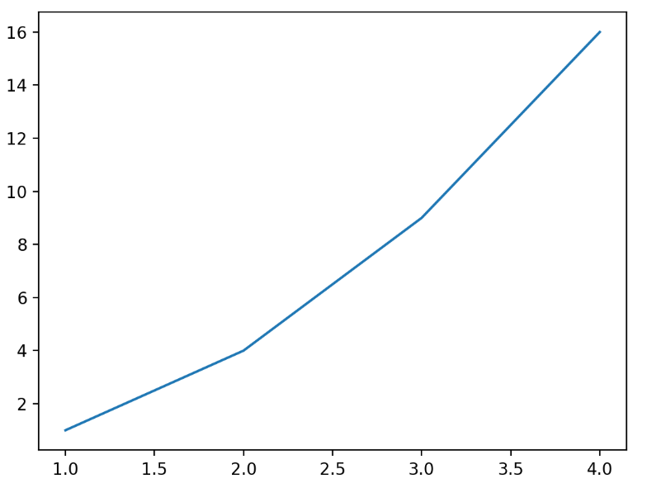

Formatting the style of your plot
For every x, y pair of arguments, there is an optional third argument which is the format string that indicates the color and line type of the plot. The letters and symbols of the format string are from MATLAB, and you concatenate a color string with a line style string. The default format string is 'b-', which is a solid blue line. For example, to plot the above with red circles, you would issue
plt.plot([1,2,3,4],[1,4,9,16],'ro')
plt.axis((0,6,0,20))
plt.show()
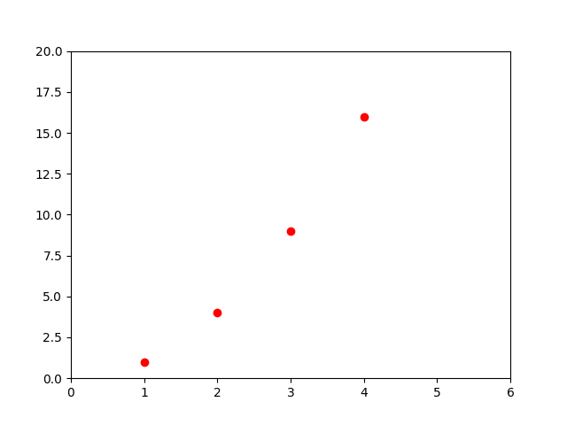
See the plot documentation for a complete list of line styles and format strings. The axis function in the example above takes a list of [xmin, xmax, ymin, ymax] and specifies the viewport of the Axes.
If matplotlib were limited to working with lists, it would be fairly useless for numeric processing. Generally, you will use numpy arrays. In fact, all sequences are converted to numpy arrays internally. The example below illustrates plotting several lines with different format styles in one function call using arrays.

The line fig, ax = plt.subplots() is a common way to create a figure and a set of axes in Matplotlib, a popular Python library for data visualization. Here's a breakdown of what it does:

Explanation
- plt.subplots(): This function creates a figure (fig) and a grid of subplots (ax). By default, it creates a single subplot.
- fig: Represents the entire figure or canvas where the plots will be drawn.
- ax: Represents the axes (plural of axis) object, which is where the actual plotting happens.

