1. Import numpy as np and see the version
Q. Import numpy as np and print the version number.
import numpy as np
print(np.__version__)
#> 1.13.3

2. How to create a 1D array?
Q. Create a 1D array of numbers from 0 to 9
Desired output:
#> array([0, 1, 2, 3, 4, 5, 6, 7, 8, 9])

arr = np.arange(10)
arr
#> array([0, 1, 2, 3, 4, 5, 6, 7, 8, 9])

3. How to create a boolean array?
Q. Create a 3×3 numpy array of all True’s
np.full((3, 3), True, dtype=bool)
#> array([[ True, True, True],
#> [ True, True, True],
#> [ True, True, True]], dtype=bool)

# Alternate method:
np.ones((3,3), dtype=bool)

4. How to extract items that satisfy a given condition from 1D array?
Q. Extract all odd numbers from arr
Input:
arr = np.array([0, 1, 2, 3, 4, 5, 6, 7, 8, 9])
Desired output:
#> array([1, 3, 5, 7, 9])

# Input
arr = np.array([0, 1, 2, 3, 4, 5, 6, 7, 8, 9])
# Solution
arr[arr % 2 == 1]
#> array([1, 3, 5, 7, 9])

5. How to replace items that satisfy a condition with another value in numpy array?
Q. Replace all odd numbers in arr with -1
Input:
arr = np.array([0, 1, 2, 3, 4, 5, 6, 7, 8, 9])
Desired Output:
#> array([ 0, -1, 2, -1, 4, -1, 6, -1, 8, -1])

arr[arr % 2 == 1] = -1
arr
#> array([ 0, -1, 2, -1, 4, -1, 6, -1, 8, -1])

6. How to replace items that satisfy a condition without affecting the original array?
Q. Replace all odd numbers in arr with -1 without changing arr
Input:
arr = np.array([0, 1, 2, 3, 4, 5, 6, 7, 8, 9])

Desired Output:
out
#> array([ 0, -1, 2, -1, 4, -1, 6, -1, 8, -1])
arr
#> array([0, 1, 2, 3, 4, 5, 6, 7, 8, 9])

Solution
import numpy as np
arr = np.arange(10)
out = np.where(arr % 2 == 1, -1, arr)
print(out)

print(arr)

7. How to reshape an array?
Q. Convert a 1D array to a 2D array with 2 rows
Input:
np.arange(10)
#> array([ 0, 1, 2, 3, 4, 5, 6, 7, 8, 9])
Desired Output:
#> array([[0, 1, 2, 3, 4],
#> [5, 6, 7, 8, 9]])

arr = np.arange(10)
arr.reshape(2, -1) # Setting to -1 automatically decides the number of cols
#> array([[0, 1, 2, 3, 4],
#> [5, 6, 7, 8, 9]])

How to extract all numbers between a given range from a numpy array?
Q. Get all items between 5 and 10 from a.
Input:
a = np.array([2, 6, 1, 9, 10, 3, 27])
Desired Output:
(array([6, 9, 10]),)

a = np.arange(15)
# Method 1
index = np.where((a >= 5) & (a <= 10))
a[index]
# Method 2:
index = np.where(np.logical_and(a>=5, a<=10))
a[index]
#> (array([6, 9, 10]),)
# Method 3: (thanks loganzk!)
a[(a >= 5) & (a <= 10)]

16. How to swap two columns in a 2d numpy array?
Q. Swap columns 1 and 2 in the array arr.
arr = np.arange(9).reshape(3,3)
arr

Show Solution
# Input
arr = np.arange(9).reshape(3,3)
arr
# Solution
arr[:, [1,0,2]]
#> array([[1, 0, 2],
#> [4, 3, 5],
#> [7, 6, 8]])

17. How to swap two rows in a 2d numpy array?
Q. Swap rows 1 and 2 in the array arr:
arr = np.arange(9).reshape(3,3)
arr

# Input
arr = np.arange(9).reshape(3,3)
# Solution
arr[[1,0,2], :]
#> array([[3, 4, 5],
#> [0, 1, 2],
#> [6, 7, 8]])

How to print only 3 decimal places in python numpy array?
Q. Print or show only 3 decimal places of the numpy array rand_arr.
rand_arr = np.random.random((5,3))

# Input
rand_arr = np.random.random((5,3))
# Create the random array
rand_arr = np.random.random([5,3])
# Limit to 3 decimal places
np.set_printoptions(precision=3)
rand_arr[:4]
#> array([[ 0.443, 0.109, 0.97 ],
#> [ 0.388, 0.447, 0.191],
#> [ 0.891, 0.474, 0.212],
#> [ 0.609, 0.518, 0.403]])

How to get the common items between two python numpy arrays?
Q. Get the common items between a and b
Input:
a = np.array([1,2,3,2,3,4,3,4,5,6])
b = np.array([7,2,10,2,7,4,9,4,9,8])
Desired Output:
array([2, 4])

a = np.array([1,2,3,2,3,4,3,4,5,6])
b = np.array([7,2,10,2,7,4,9,4,9,8])
c=np.intersect1d(a,b)
#> array([2, 4])

How to remove from one array those items that exist in another?
Q. From array a remove all items present in array b
Input:
a = np.array([1,2,3,4,5])
b = np.array([5,6,7,8,9])
Desired Output:
array([1,2,3,4])

a = np.array([1,2,3,4,5])
b = np.array([5,6,7,8,9])
# From 'a' remove all of 'b'
c=np.setdiff1d(a,b)
#> array([1, 2, 3, 4])

How to get the positions where elements of two arrays match?
Q. Get the positions where elements of a and b match
Input:
a = np.array([1,2,3,2,3,4,3,4,5,6])
b = np.array([7,2,10,2,7,4,9,4,9,8])
Desired Output:
#> (array([1, 3, 5, 7]),)

a = np.array([1,2,3,2,3,4,3,4,5,6])
b = np.array([7,2,10,2,7,4,9,4,9,8])
np.where(a == b)
#> (array([1, 3, 5, 7]),)

How to extract all numbers between a given range from a numpy array?
Q. Get all items between 5 and 10 from a.
Input:
a = np.array([2, 6, 1, 9, 10, 3, 27])
Desired Output:
(array([6, 9, 10]),)

a = np.arange(15)
# Method 1
index = np.where((a >= 5) & (a <= 10))
a[index]
# Method 2:
index = np.where(np.logical_and(a>=5, a<=10))
a[index]
#> (array([6, 9, 10]),)
# Method 3: (thanks loganzk!)
a[(a >= 5) & (a <= 10)]

Q.Find the Sum of All Values in a NumPy Array
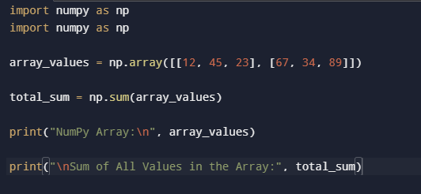

Q.Create a NumPy Array of Floating-Point Numbers Between 0 and 1 with Shape (2, 3, 4).
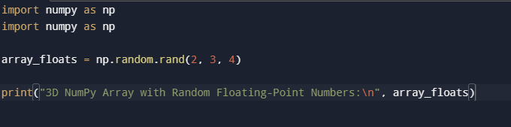

Q. Find the Maximum Value in a NumPy Array

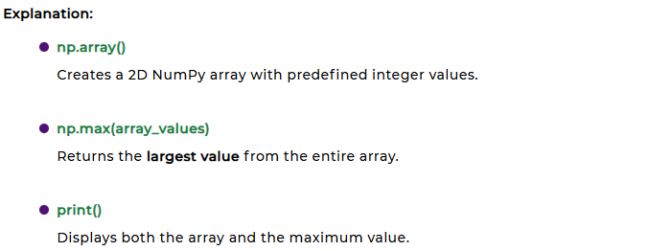
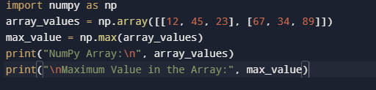

Q. Find the Minimum Value in a NumPy Array

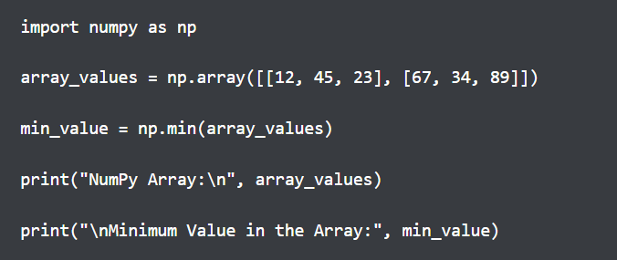

Q. Find the Median Value of a NumPy Array

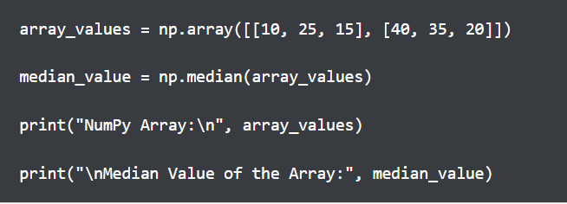

Q. Compute the Dot Product of Two NumPy Arrays

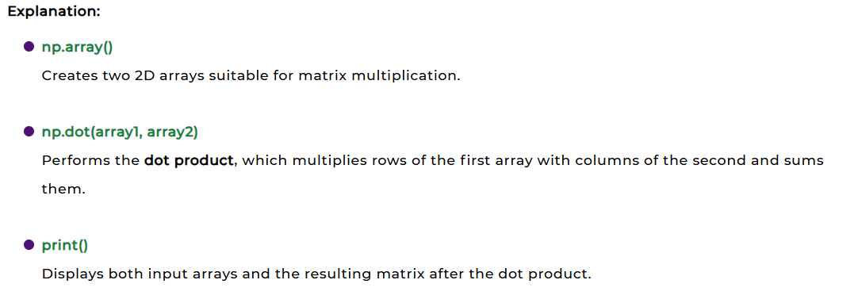
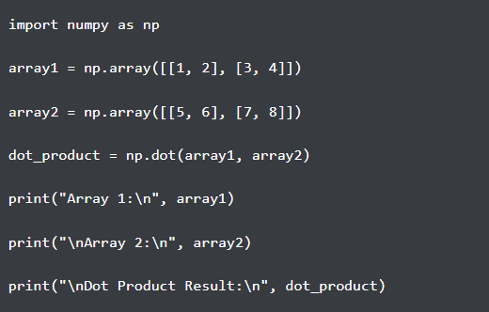

Q. Compute the Cross Product of Two NumPy Arrays

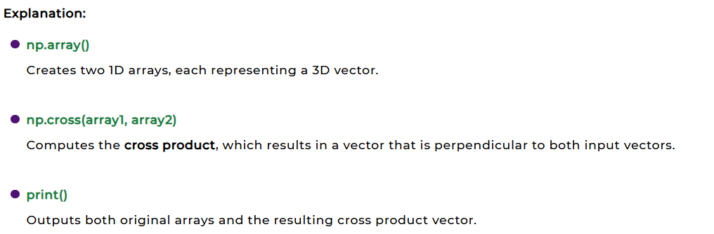
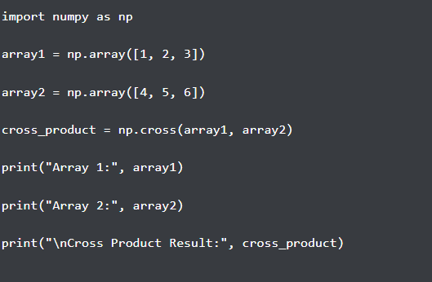

Q. Compute the Inverse of a NumPy Array
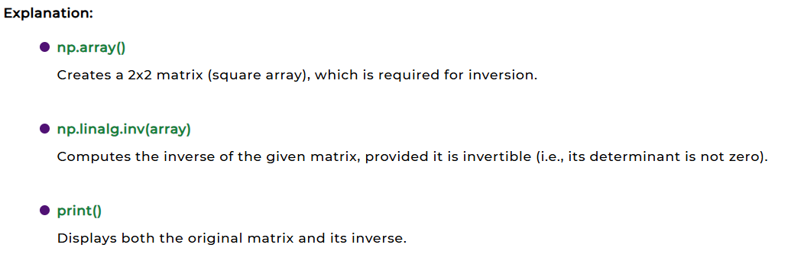
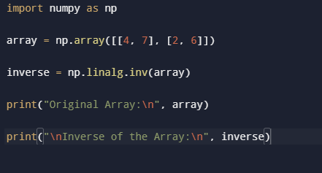
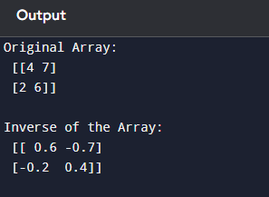

Q. Reversed Array

Example:

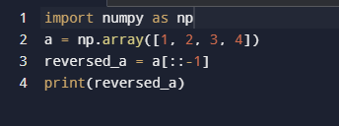

Output:

[4 3 2 1]

Q. Compute the Determinant of a NumPy Array

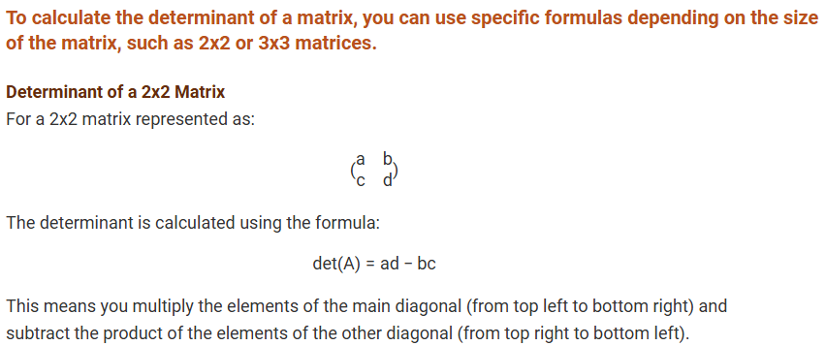
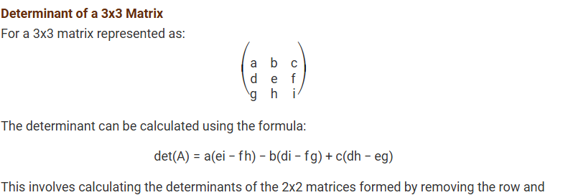
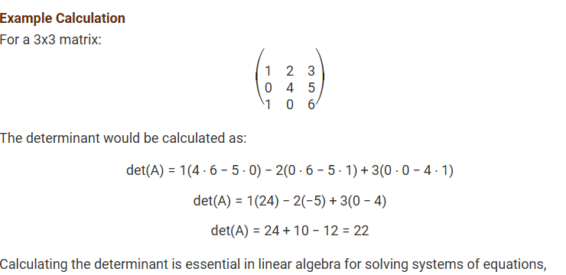
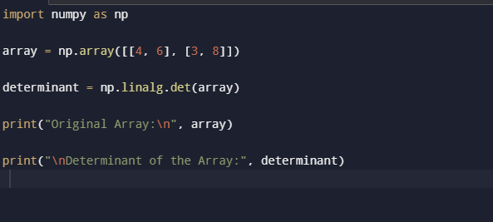
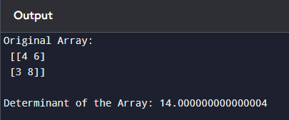

Q.A Concatenate Two NumPy Arrays Horizontally and Vertically
● Library Import: NumPy is imported as np to access array functions.
● Array Creation: Two 2D arrays a and b are created with shape (2, 2).
● Horizontal Concatenation: np.hstack((a, b)) joins both arrays side-by-side (column-wise)
- Vertical Concatenation: np.vstack((a, b)) stacks arrays on top of each other (row-wise).
● Result Storage: The result is stored in result, forming a shape of (2, 4).
● Output Display: print(result) shows the final concatenated array.
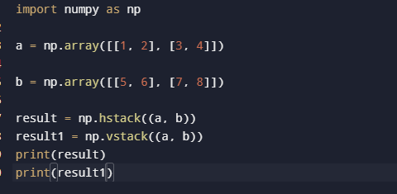
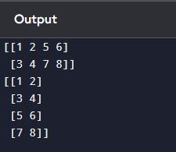

Q.A Sort a NumPy Array in Ascending Order?
● Library Import: numpy is imported as np to use NumPy functions.
● Array Creation: A 1D NumPy array arr is created with unsorted elements.
● Sorting Function: np.sort(arr) sorts the array in ascending order.
● Returns Copy: The function returns a sorted copy of the array without changing the original.
● Store Result: The sorted array is stored in the variable sorted_arr.
● Display Output: print(sorted_arr) prints the sorted array: [1 2 3 4].
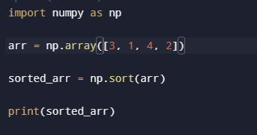

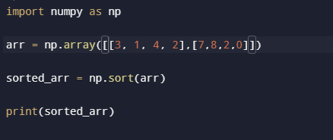
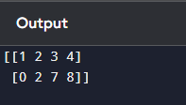

Q.A Sort a NumPy Array in Descending Order?
● Library Import: numpy is imported as np to access NumPy functions.
● Array Creation: A 1D NumPy array arr is created with unordered numbers.
● Sorting in Ascending Order: np.sort(arr) first sorts the array in ascending order: [1 2 3 4].
● Reverse the Array: [::-1] is used to reverse the sorted array, converting it to descending order.
● Store Result: The reversed sorted array is stored in sorted_arr.
● Display Output: print(sorted_arr) prints the final descending array: [4 3 2 1].
