1. Read CSV File and Topic: Using matplotlib with CSV Files in Python
Assume you have a CSV file named sales_data.csv with the following contents:
Month,Sales
January,12000
February,15000
March,17000
April,14000
May,18000
June,20000

Create a csv file like this named sales_data.csv
Question:1
Write a Python program to read sales_data.csv and print each row.

Question:2
Using matplotlib, read the CSV file and plot a line chart showing sales over months.
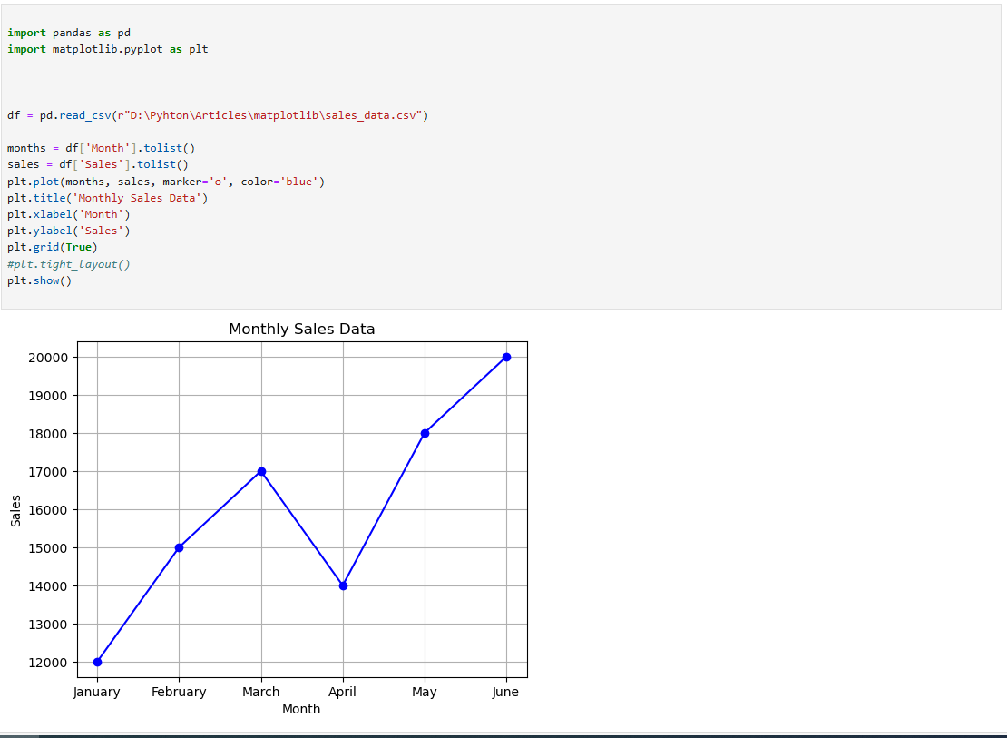

Question:3
Modify the previous code to create a bar chart instead of a line chart.

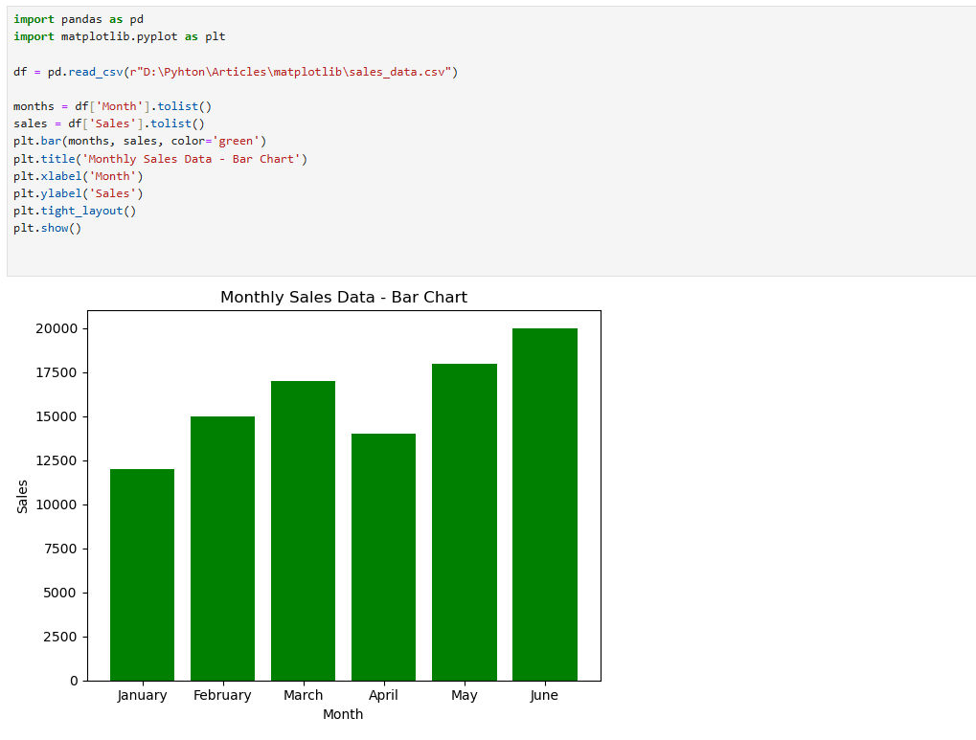

Question:4
Modify the bar chart to highlight the month with the highest sales in red, and the rest in blue.
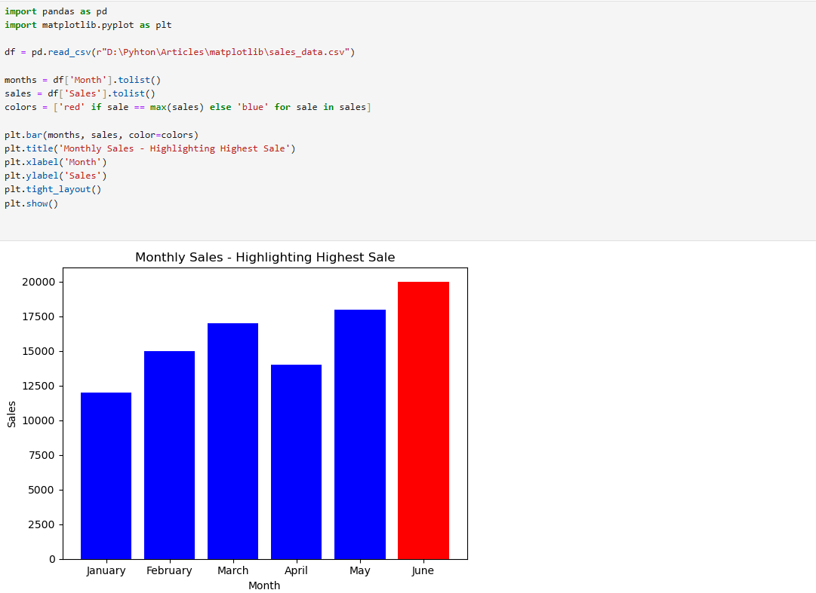

Question:5
Save the sales bar chart to a PNG file called sales_chart.png instead of displaying it.
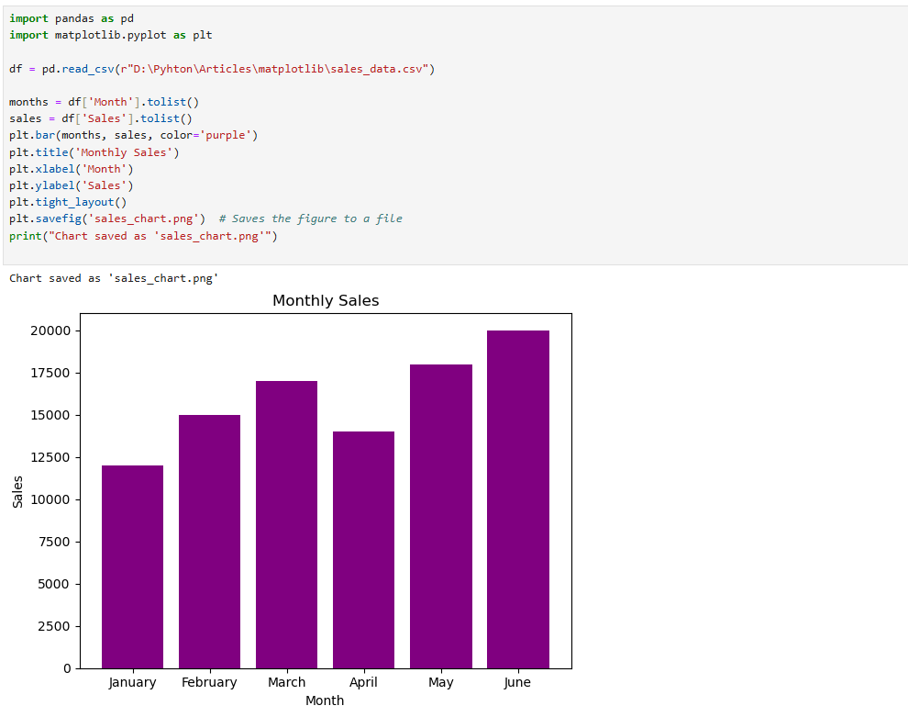

Question:6
Create a pie chart that shows each month's contribution to total sales.
