Experiment 1: Linear Queue using Array
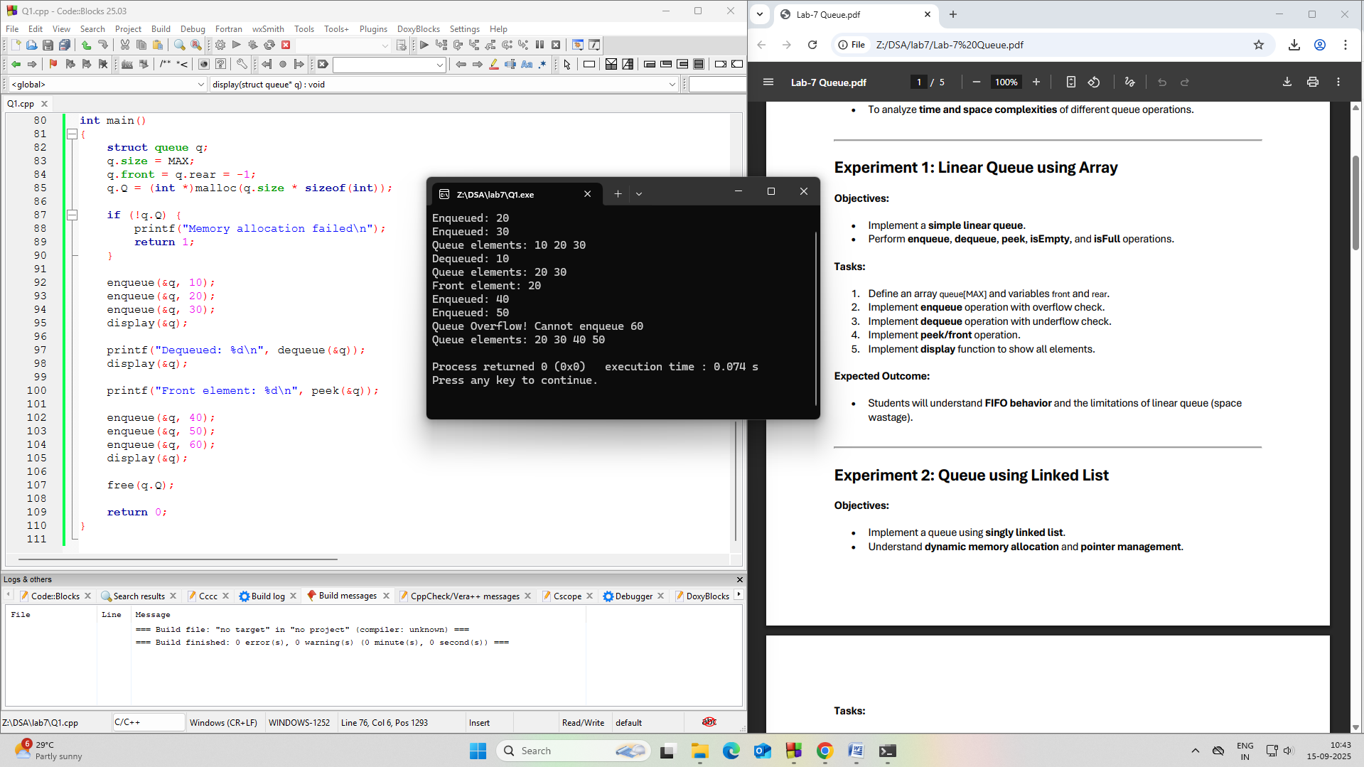

Experiment 2: Queue using Linked List
