- Write two commands to go to home directory.
- Command to display only year like 2023.
- Command to display date in 20_07_2023 format.
- Create a following directory structure with single mkdir command without –p option.
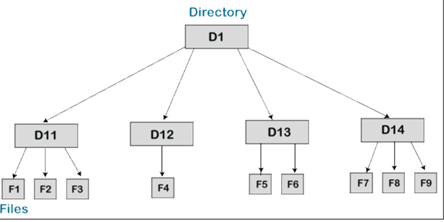
- Create a following directory structure with single mkdir command with –p option.
- Create a file1.txt with cat command add some data.
- Append data to file1.txt
- Display data fo file1.txt
- Empty the data of file1.txt using echo command.
- Check size of file1.txt
- Make file1.txt of 0 bytes
- Create file file2.txt with cat command add some data
- Display the contents of file2.txt using tac and rev command.
- Display first 5 lines of file2.txt
- Display last 5 lines of file2.txt
- Display lines from 3rd to 7th .
- Create a file number.txt that have 30,60,20,10,100 as data.
- Sort the data of number.txt
- Sort the data of number.txt in reverse order.
- Store the result of sorted data of number.txt in somenew.txt file.
- Count the only number of lines of file1.txt
- Create file date_help.txt that contains data of date manual help.
- Use More and less command with different options like f,b,2f,3b etc..
- Create a two files fruits1.txt and fruits2.txt
- Fruits1.txt contains banana,apple,mango,kiwi.
- Fruits2.txt contains apple,grapes,kiwi.
- Find differnces between two files.
- Display common things between two files.
- Display uncommon data between teo files.
- Display the octal represtentation of fruits1.txt
- Copy the contents of fruits1.txt and fruits2.txt in fruit.txt.
- Remove file fruit.txt

