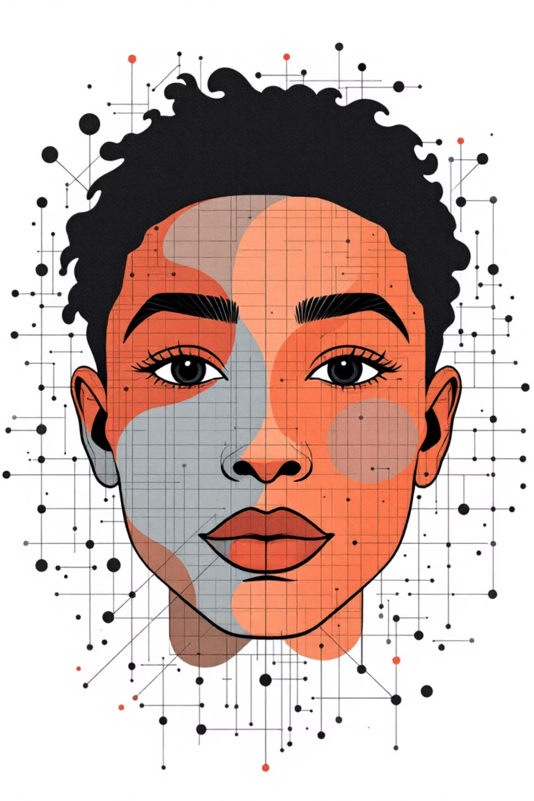

FACIAL EXPRESSION & EMOTION RECOGNITION FOR SOCIAL INTERACTION
Empowering Visually Impaired Individuals through AI

VRAJ BORAD, DEEV SHAH | NFT | 19 NOV’25

1. Introduction
Visually impaired individuals face major challenges in social interaction because they cannot perceive facial expressions or emotional cues. This limits their ability to understand conversations, respond appropriately, and engage confidently in social settings.
To address this issue, the project proposes an AI-based real-time emotion recognition system that detects facial expressions through a camera, interprets emotions using deep learning, and delivers instant audio feedback.
The focus is on developing a solution that is fast, accurate, and supportive for visually impaired users.

2. Literature Review
Facial expression recognition has been widely studied using computer vision and deep learning. Traditional methods relied on handcrafted features like LBP and HOG but lacked robustness to lighting and pose variations.
Modern techniques use Convolutional Neural Networks (CNNs) trained on emotion datasets such as FER2013, offering improved accuracy in identifying seven basic emotions: Happy, Sad, Angry, Fear, Surprise, Disgust, and Neutral.
Face detection has also evolved—from Haar Cascades to more reliable deep-learning detectors like MTCNN, which performs multi-stage detection with high accuracy in real-time.
Recent work integrates fuzzy logic and neural networks, known as neuro-fuzzy systems, to handle uncertainty in emotion prediction. These hybrid models refine probability outputs to generate more reliable decisions—especially useful in ambiguous facial expressions.
This project builds on these advancements and combines CNN-based recognition, MTCNN detection, and neuro-fuzzy interpretation, making the system more intuitive and practical for visually impaired users.

3. Methodology

3.1 System Architecture
The system follows a real-time pipeline:
- Video Capture
  - Webcam input at 30 fps processed using OpenCV.
- Face Detection
  - MTCNN identifies faces and draws bounding boxes.
- Feature Extraction
  - Cropped face images are resized and fed into a custom CNN.
- Emotion Classification
  - CNN outputs probability scores for seven emotions.
- Neuro-Fuzzy Layer
  - Fuzzy rules refine these probabilities to reduce ambiguity.
- Audio Feedback
  - The predicted emotion is converted to speech using gTTS.
- Continuous Loop
  - The system updates every 3 seconds to maintain responsiveness.

3.2 Tools & Technologies
- Frontend: OpenCV, Tkinter UI, gTTS
- Backend: Python + PyTorch
- Models: MTCNN for face detection; Custom CNN for emotion recognition
- Fuzzy Logic: Sci-kit Fuzzy

3.3 Training Details
- Dataset: FER2013
- Epochs: 35
- Average training time: ~590 sec/epoch
Dataset link - https://www.kaggle.com/datasets/xavier00/fer2013-facial-expression-recognition-dataset

4. Results
The performance of the model was evaluated using training and validation metrics from FER2013.

4.1 Training Performance
- Training Accuracy: 92.72%
- Training Loss: 0.2067
- Steady improvement across epochs from ~87% to ~93%
- Training loss reduced from 0.34 → 0.20

4.2 Validation Performance
- Validation Accuracy: 60.46%
- Stable around 60% with no major overfitting
- Shows that the model generalizes reasonably well on unseen data from a challenging dataset

4.3 System Performance
- Real-time detection achieved through MTCNN
- Emotion predictions refined by neuro-fuzzy logic
- Smooth text-to-speech feedback without lag
- 3-second update cycle balances speed and accuracy

4.4 Challenges Addressed
- Tensor size mismatch resolved via preprocessing pipeline
- Lighting variations handled through robust face detection
- Frame rate optimized for real-time operation
- Audio fatigue minimized by confirmation logic
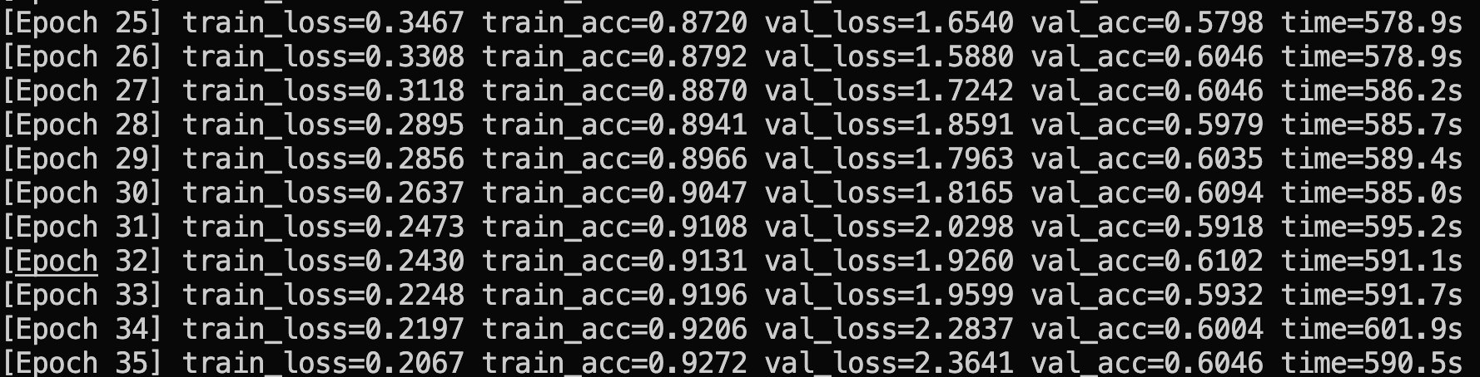

5. Conclusion
The project successfully implements a real-time emotion recognition system aimed at assisting visually impaired individuals in social settings. The integration of MTCNN, CNN-based classification, and a neuro-fuzzy layer results in a stable and practical tool that delivers real-time audio cues with reliable accuracy.
Key Achievements:
- Accurate real-time face detection
- Effective 7-emotion classification
- Neuro-fuzzy decision refinement for better reliability
- Fully operational user interface with live video and audio output
Social Impact:
The system can significantly enhance social confidence for visually impaired users by bridging the communication gap and enabling more meaningful interactions.
Future Scope:
Enhancements like multi-face detection, mobile app development, wearable integration, emotion intensity detection, and cloud-based model updates can transform the system into a widely accessible assistive technology.

