**LINUX LAB- 3 ASSIGNMENT**

Write the UNIX commands for the following:

1. Use the ***cat*** command, and display all the .txt files in the current directory on the screen at one go.

cat * .txt

1. To start any web browser from the command prompt.

gnome-open http://askubuntu.com

1. To list lines that does not include ‘***and’*** in a text file.

Grep -v and ex.txt

1. To compress all .dat files in the current directory and vice versa.  
   gzip *.dat    gunzip *.dat
2. To list all the files in the present working directory including the hidden files.

ls -a

1. To show all the files in the subdirectories of a directory.

ls -LR

1. To make changes into environmental variables.

Env and PATH=$PATH:~/users/

1. To sort the lines of a file into reverse order.

Sort –r ex.txt

1. To create a hard link to myfile.txt in the current directory assuming that it is not public_html.

ln myfile.txt

1. To search for a certain pattern in the files existing in the current directory.

grep t.txt PATTERN

Shell scripts:

1. Write a shell script to scan two variables and to display their sum, mul, div, sub and modulo division.

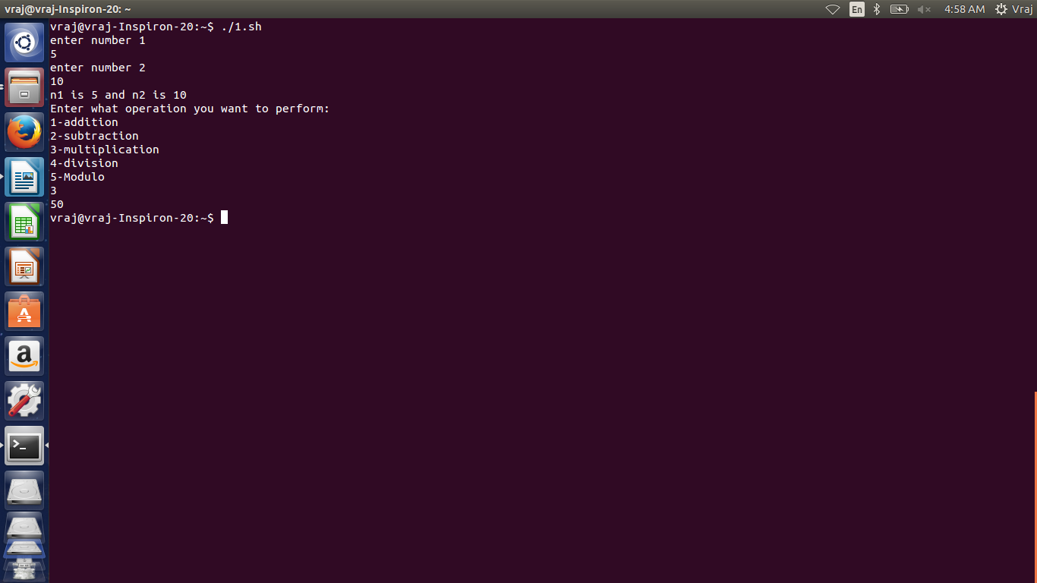

1. Write a shell script to perform all Arithmetic Operations using Command line arguments.

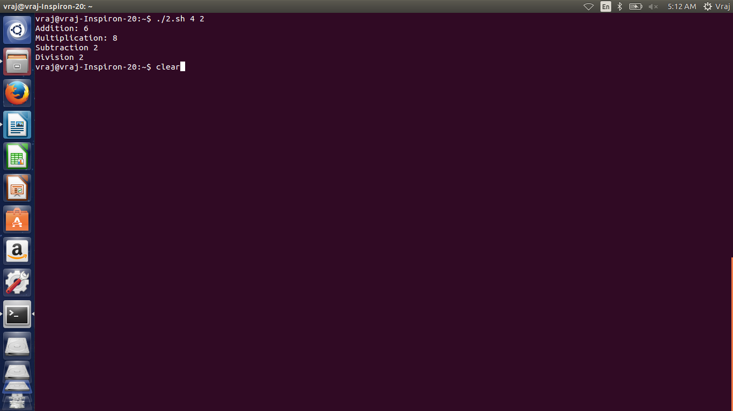

1. Write a shell script to find greatest of two. Script must consider the case where two numbers are equal.

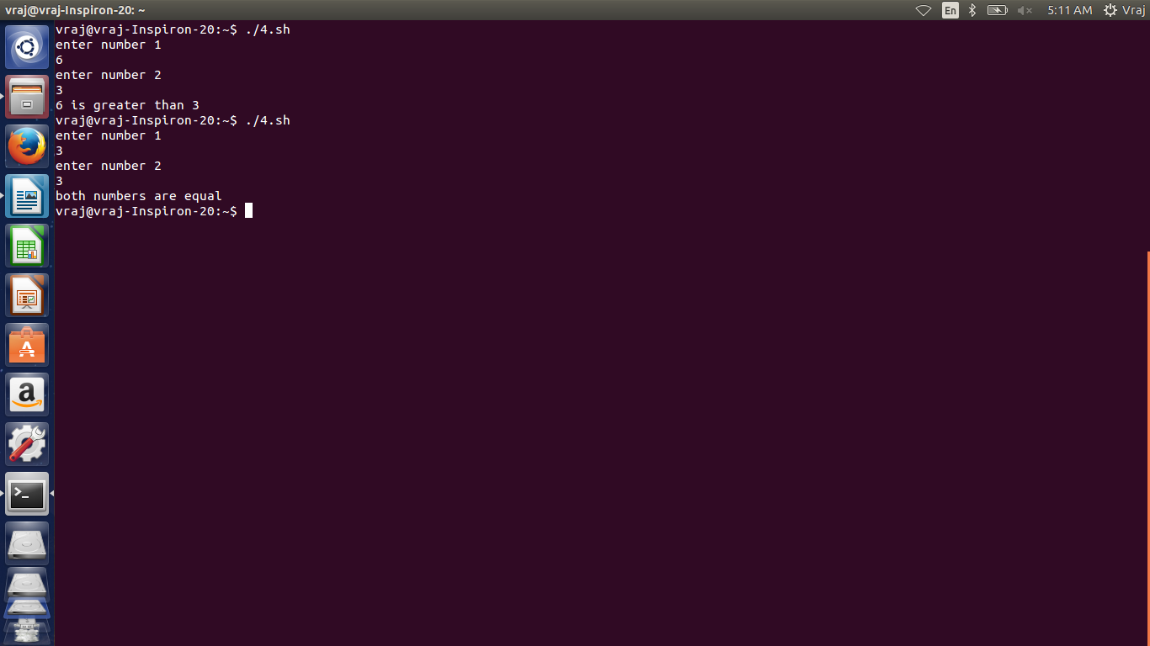

1. Write a shell script to accept numbers below 50 and to display the square of each. This should continue as long as the user wishes.

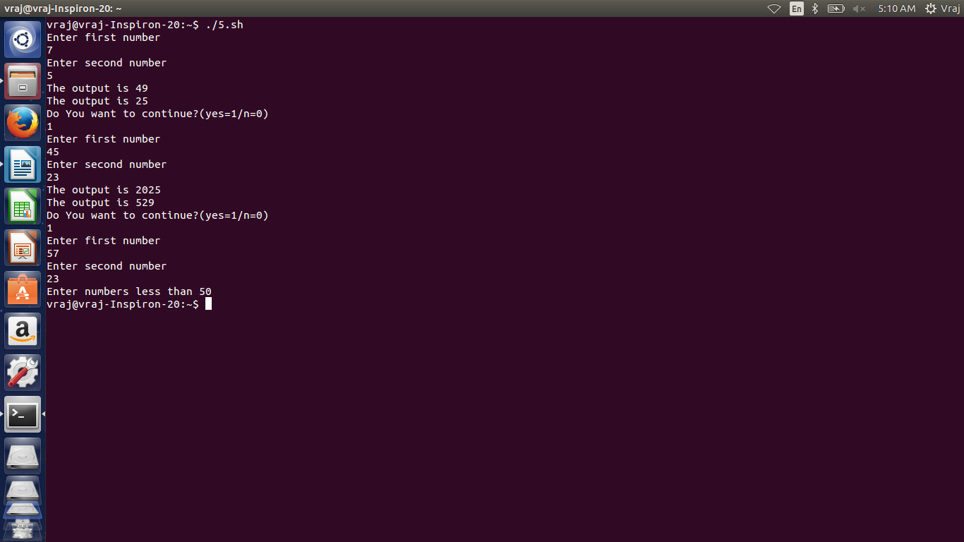

1. Write a shell script, which scans the name of the command and executes it.

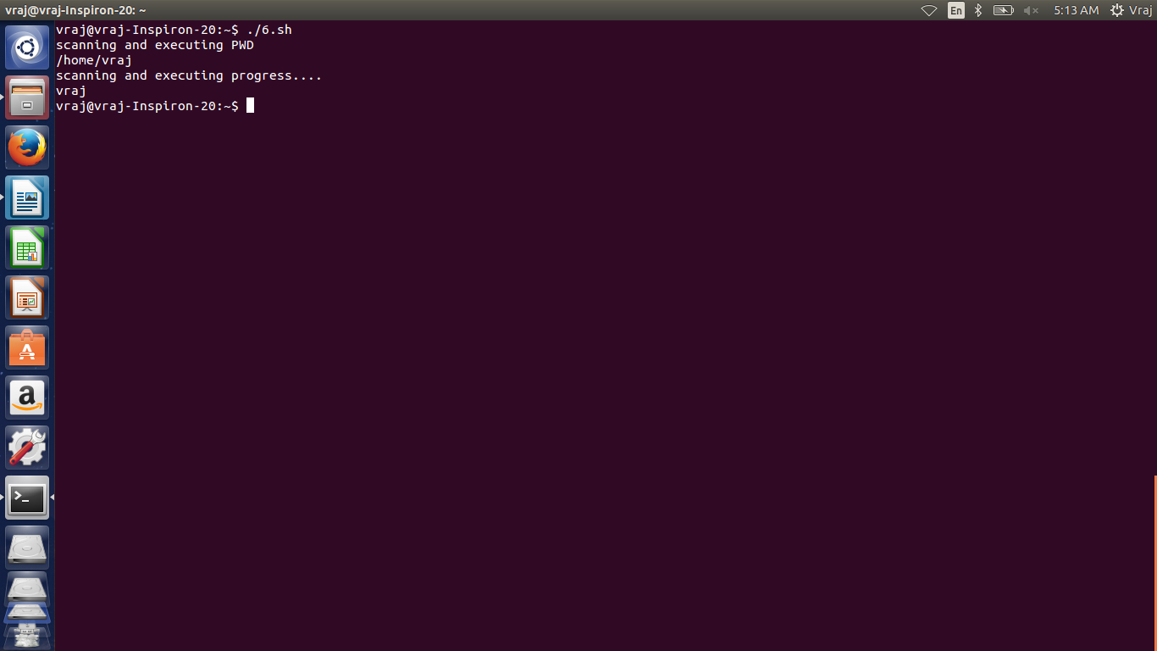

1. Write a shell script which displays January if we enter Jan, Janu, Janua or January.(use of case)

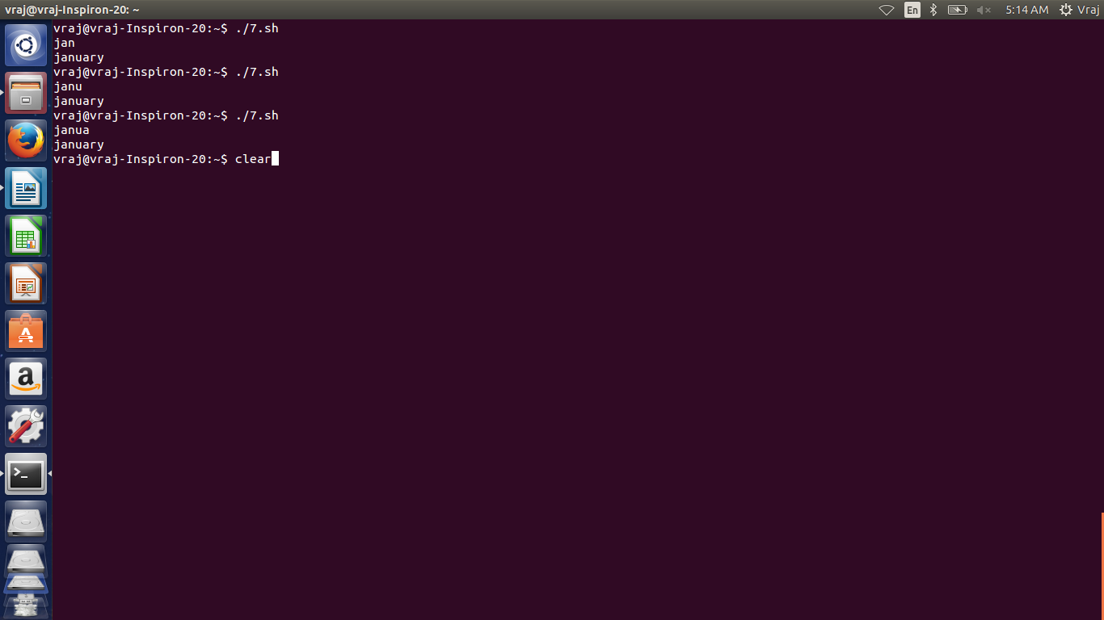

1. Write a shell script to generate Fibonacci series.

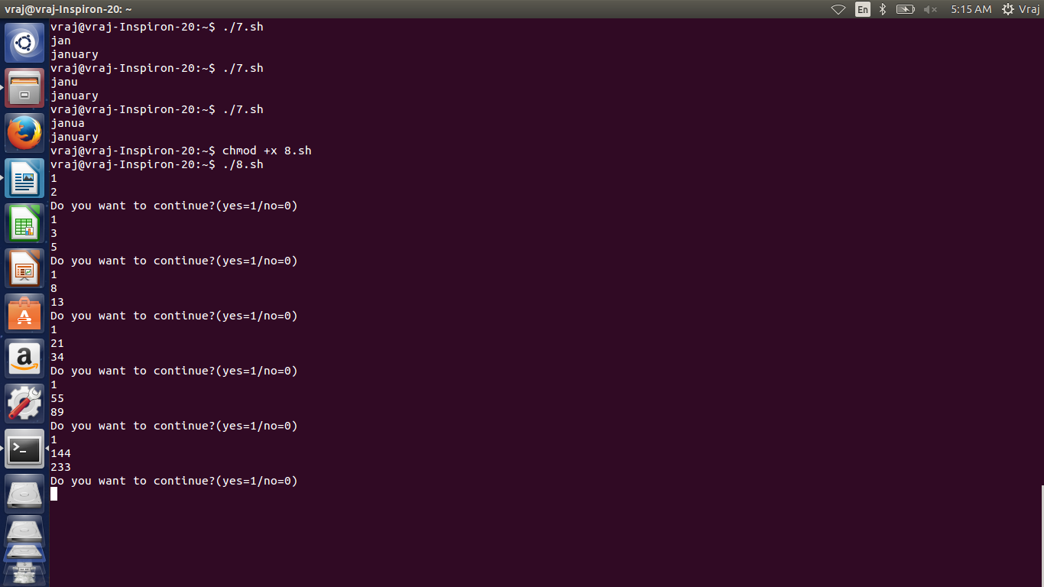

1. Write a shell script that asks the capital of Gujarat and repeats the question until the user gives correct answer.

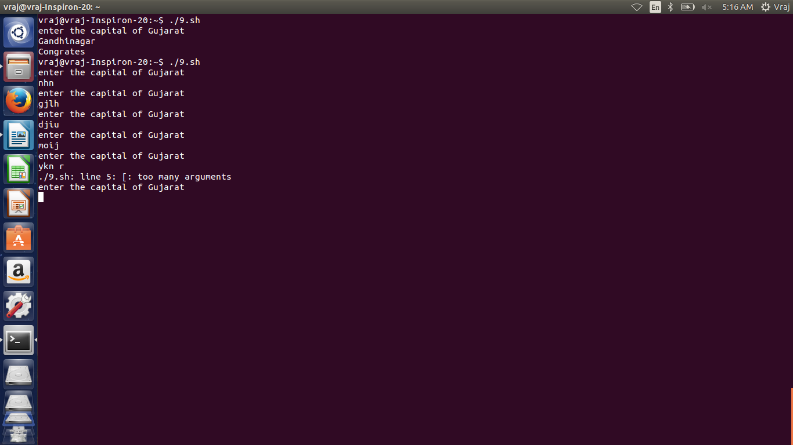

1. Write a shell script program to search whether element is present in the list or not and also display its position in the list.

