Name: Vraj Patel

ID: 101327087

**LAB TEST 02**

POSTMAN API

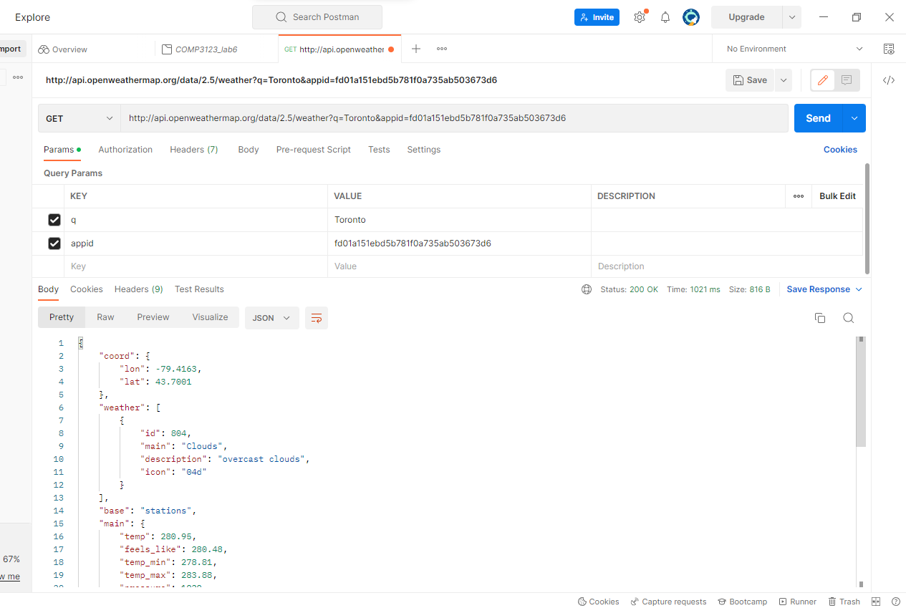

Output Screenshot (Warm):

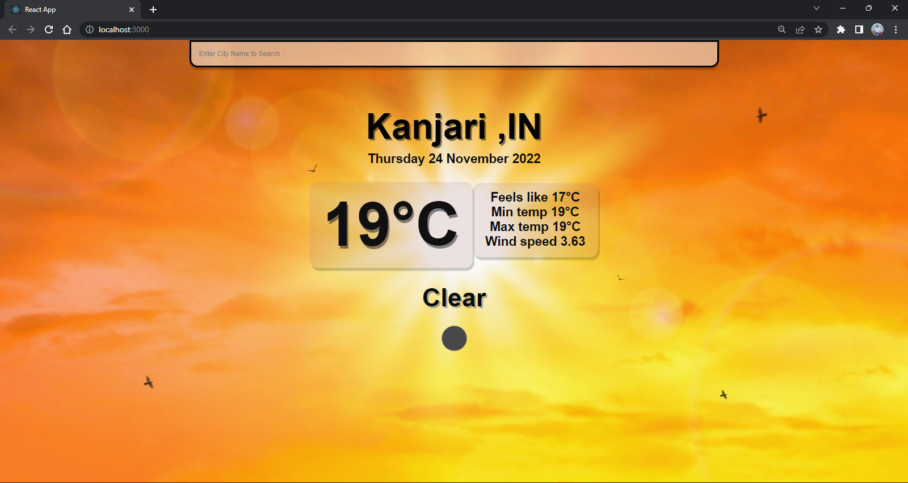

Output Screenshot (Cold):

