RETAIL BANKING
TRANSACTION ANALYSIS
MySQL Business Analytics Project | Portfolio Report

1. Executive summary
This project examines a retail banking dataset spanning customers, accounts, branches, loans, loan payments, cards and transactions. The workflow combines relational database design, data-quality validation, SQL analysis and Python visualizations. The supplied records suggest operational areas to investigate, particularly transaction statuses, repayment performance, KYC completion and card activation. The dataset is treated as a training case study; the findings are not claims about a real bank.

2. Dataset overview
Table | Rows | Analysis focus
customers | 500 | Segment, demographics, income, credit score, KYC
accounts | 700 | Type, branch, balance, interest rate, status
branches | 40 | Location, region, employee count
loans | 300 | Loan type, principal, outstanding, status
loan_payments | 2,000 | Payment status, late days, penalties
cards | 600 | Type, active status, expiry, limits, rewards
transactions | 5,000 | Transaction type, channel, amount, status, date
The supplied dataset contains seven CSV files. No fully duplicated rows were detected. All tested foreign-key references in accounts, transactions, cards, loans and loan payments resolve to existing parent keys.

3. Key performance indicators
KPI | Result
Customers | 500 total; 375 active (75.0%).
Accounts | 700 total; 497 active and 203 closed.
Transactions | 5,000 total; 1,688 completed (33.76%), 1,684 pending (33.68%), 1,628 failed (32.56%).
Completed transaction amount | $10,976,552.36 across completed transactions. This is gross completed amount, not net cash flow or revenue.
Loan exposure | 300 loans; total outstanding balance $53,441,891.25.
Loan risk statuses | 169 loans are Defaulted or In Arrears (56.33% of loans).
Payment performance | 968 of 2,000 payment rows are Late or Missed (48.40%); recorded penalties total $93,961.47.
Card activation | 37 of 600 cards are active (6.17%). 445 expiry dates precede the project reference date.
KYC | 143 of 500 customers are Verified (28.60%).
Project reference date for time-based analysis: 22 February 2025, the latest transaction_date in the supplied data. This follows the project brief.

4. Visual analysis

Transaction status distribution
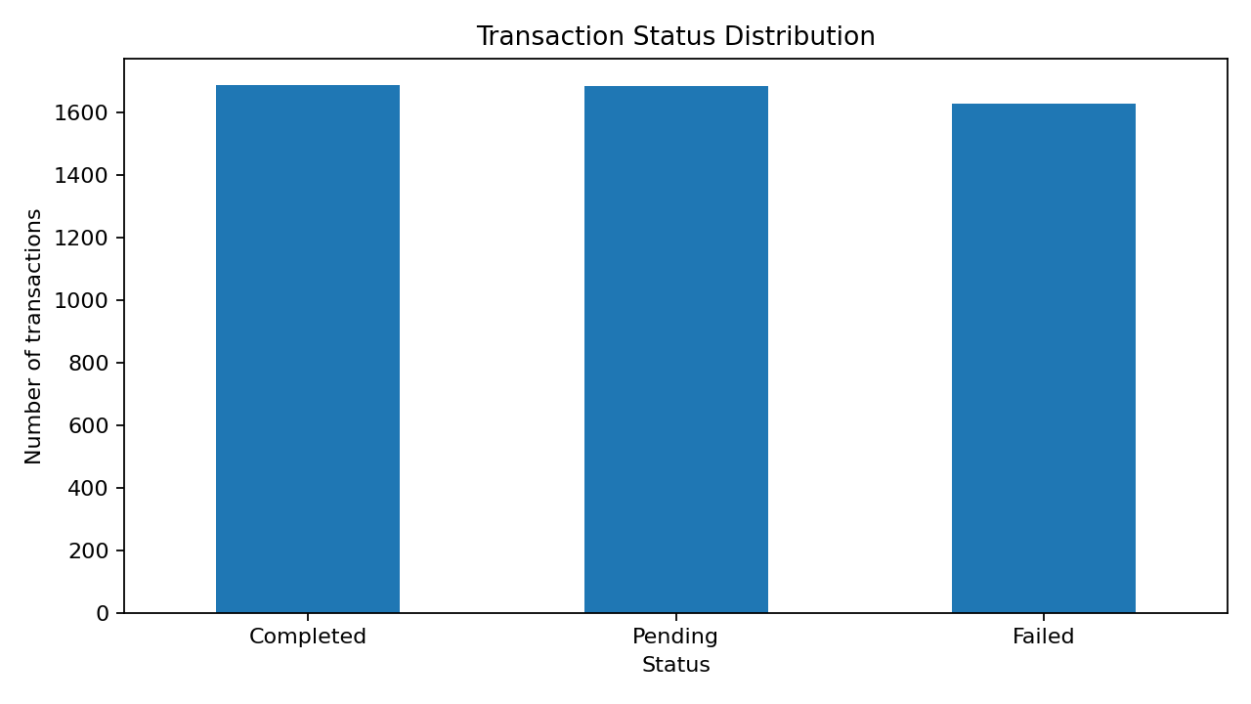

Customer segment distribution
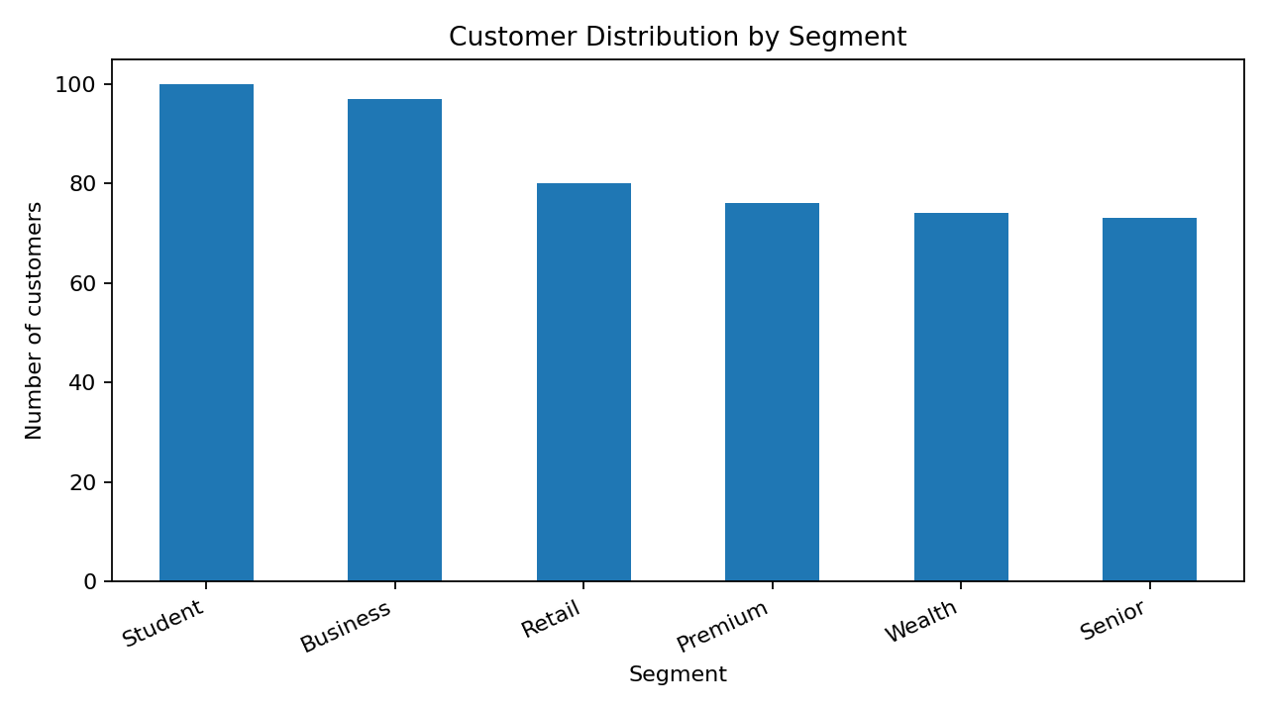

Loan portfolio by status
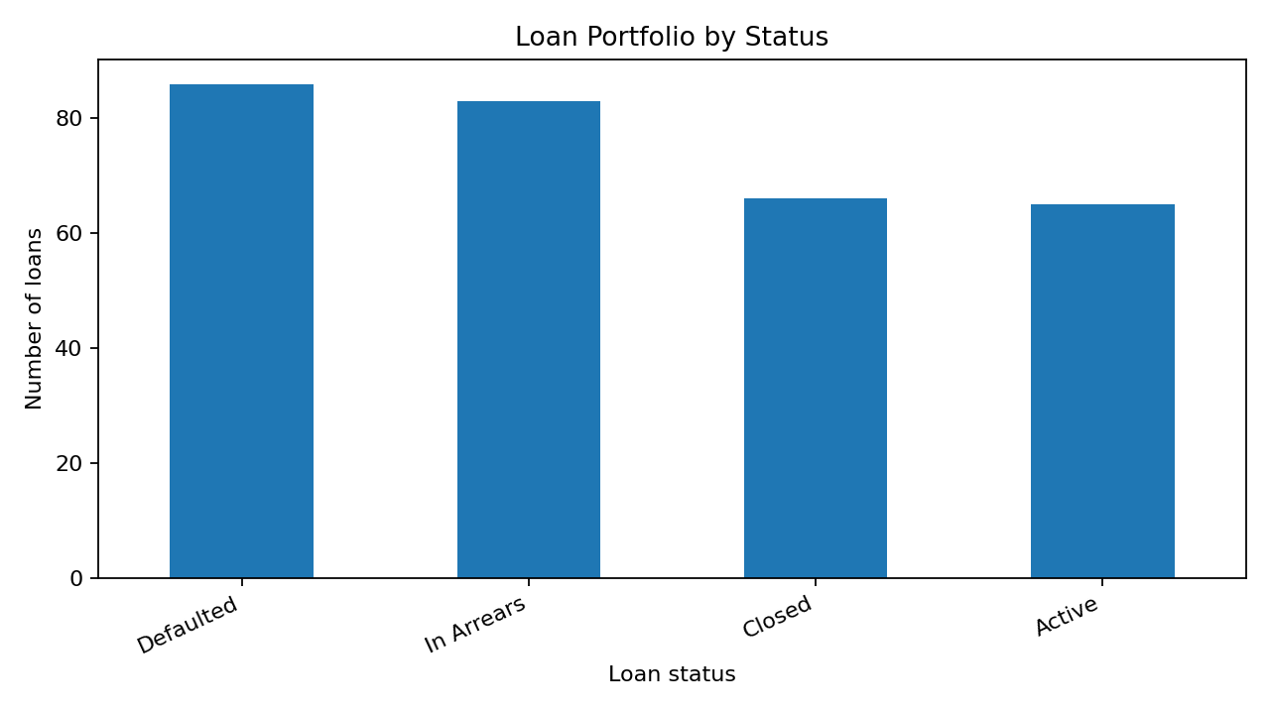

Monthly completed transaction volume
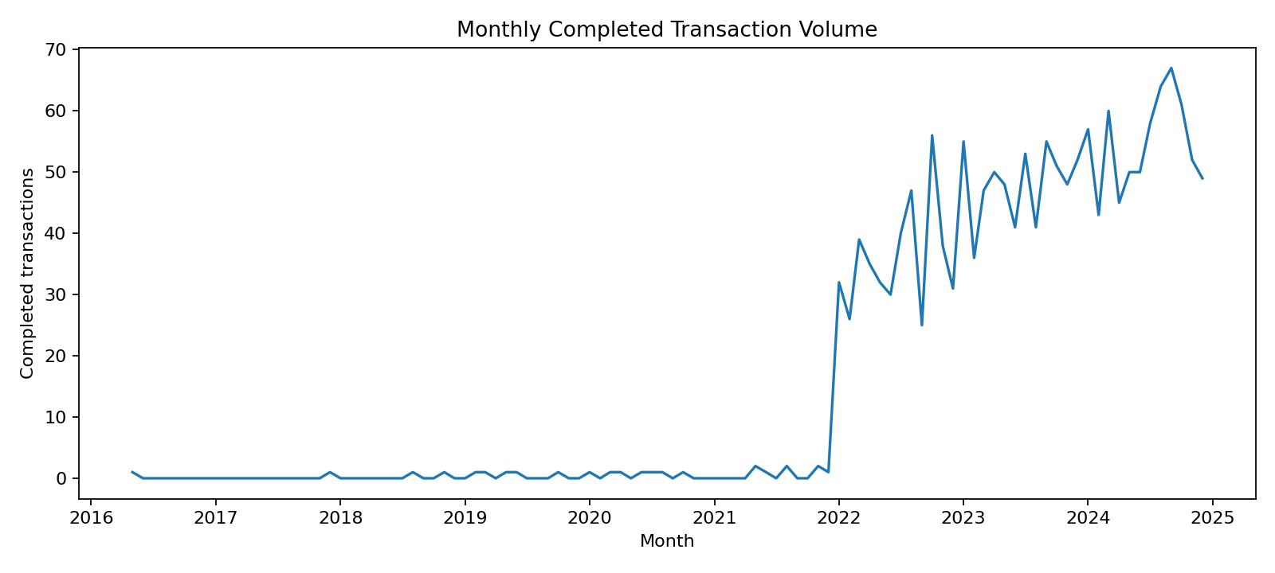

Card activation status
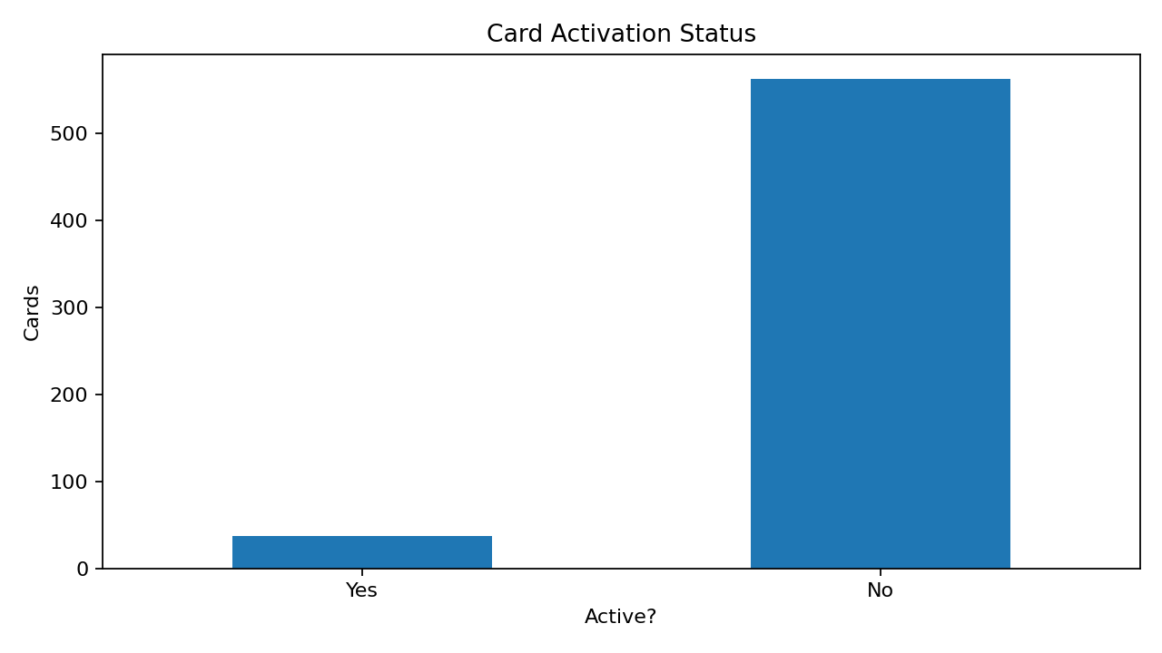

5. Business interpretation

Transaction processing
Completed transactions account for only about one-third of transaction rows. Pending and failed statuses should be investigated by channel, type, date and time. Confirm source-system definitions and whether pending items later resolve.

Loan performance
More than half of loans are labelled Defaulted or In Arrears, and almost half of payment rows are Late or Missed. Segment by loan type, branch, repeated missed payments, days late and penalties to help prioritize a collections review.

Card engagement
Only 37 cards are flagged active while 445 are expired by the project reference date. Reconcile the active flag, expiry date, product type and reissue status before interpreting this as poor engagement.

KYC completeness
Less than one-third of customers are marked Verified. Report the counts in Pending, Partial and Failed categories by segment and location, and develop an exception-resolution process.

Customer segmentation
Use segment-level counts, income and credit-score profiles alongside account and transaction activity to identify groups that may need differentiated service or product communication.

6. Data quality, assumptions and limitations
- Missing values are present in accounts.close_date (497 rows), which can be expected for open accounts. Validate consistency against account status rather than automatically imputing dates.
- Amounts are not accompanied by a definitive signed debit/credit convention; do not calculate net cash flow from the amount column alone.
- Transaction amount KPIs use only status = Completed. Pending and Failed records are excluded from the completed-value measure.
- Card expiry analysis uses 2025-02-22 as the project 'today' date, not the actual current date.
- Loan/payment statuses are retained as supplied. A Late or Missed payment row is a risk indicator, but does not independently prove borrower default.
- Treat the dataset as a case-study dataset and validate business definitions before operational use.

7. Recommendations
- Create a transaction exception dashboard by status, channel, transaction type and month; assign owners and resolution SLAs for pending/failed records.
- Build a loan collections prioritization view using loan status, late/missed payment count, days late, penalties, outstanding balance and branch.
- Reconcile card activation and expiry data; distinguish expired, blocked, inactive, replaced and eligible cards if those fields exist in production.
- Track KYC completion rates and aging by customer segment and branch, with privacy-safe reporting.
- Automate row-count, null, duplicate, domain and foreign-key checks every time data is refreshed.
- Publish a KPI dictionary defining completed transaction value, loan risk categories, active card, KYC verified and project reference date.

8. SQL and technical deliverables
The accompanying project folder includes a MySQL schema script, basic analysis queries for Sprint 3, objective-based queries for all five Sprint 4 areas, a Python EDA script, a Streamlit dashboard, source CSVs, charts and setup instructions in README.md.

9. Conclusion
The analysis workflow converts raw banking tables into reviewable indicators across transaction operations, lending risk, customer segmentation, KYC and card engagement. The strongest next step is to validate the status definitions with business owners, then operationalize a recurring KPI pack with clear definitions and data-quality checks.

