**Business Model Canvas Report**

On

**“GenDrug”**

Submittedby

Moxita Shah - 150810107047

Vrajesh Trivedi - 150810107055

Atul Jose - 150810107003

**B.E. Semester VIII**

**In**

**Department of**

**Computer Engineering**



Aadishwar College of Technology - Venus,

Bhoyan Rathod, Gandhinaagr.

2018-19

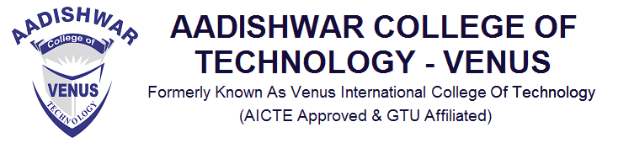

**CERTIFICATE**

This is to certify that the Final Year Project entitled “**GenDrug”** has been carried out by **Moxita Shah (150810107047)** under my guidance in fulfilment of the degree of Bachelor of Engineering in COMPUTER ENGINEERING (8th Semester) of Gujarat Technological University, Ahmedabad during the academic year 2018-19.

Guided By:

Prof. Nehal Rajput Prof. Premal Patel

Prof. CE Department Head of CE Department

Aadishwar College Of Technology Aadishwar College Of Technology



**CERTIFICATE**

This is to certify that the Final Year Project entitled “**GenDrug”** has been carried out by **Vrajesh Trivedi (150810107055)** under my guidance in fulfilment of the degree of Bachelor of Engineering in COMPUTER ENGINEERING (8th Semester) of Gujarat Technological University, Ahmedabad during the academic year 2018-19.

Guided By:

Prof. Nehal Rajput Prof. Premal Patel

Prof. CE Department Head of CE Department

Aadishwar College Of Technology Aadishwar College Of Technology



**CERTIFICATE**

This is to certify that the Final Year Project entitled “**GenDrug”** has been carried out by **Atul Jose (150810107003)** under my guidance in fulfilment of the degree of Bachelor of Engineering in COMPUTER ENGINEERING (8th Semester) of Gujarat Technological University, Ahmedabad during the academic year 2018-19.

Guided By:

Prof. Nehal Rajput Prof. Premal Patel

Prof. CE Department Head of CE Department

Aadishwar College Of Technology Aadishwar College Of Technology

* **INDEX**

|  |  |
| --- | --- |
| **TITLE** | **PAGE NO.** |
| KEY PARTNERS | 6 |
| KEY ACTIVITIES | 6 |
| KEY RESOURCES | 6 |
| VALUE PROPOSITIONS | 6 |
| CUSTOMER RELATIONSHIP | 7 |
| CHANNELS | 7 |
| CUSTOMER SEGMENTS | 7 |
| COST STRUCTURE | 7 |
| REVENUE STREAM | 7 |

* **KEY PARTNERS**
* Chemists
* Generic Medicine Suppliers
* Deliverymen
* **KEY ACTIVITIES**
* Software Development
* Marketing
* Database Management
* **KEY RESOURCES**
* Online Platform
* Mobile
* **VALUE PROPOSITIONS**
* Search Generic Medicines.
* Buy Generic Medicines.
* Search by Symptoms.
* Upload Prescription.
* Home Delivery.
* **CUSTOMER RELATIONSHIP**
* Customer can provide feedback of the seller.
* **CHANNELS**
* Medicine sellers recommend our application.
* Top medicine sellers are showcased on top.
* **COSTOMERS SEGMENTS**
* Middle class and lower-class people.
* Patients
* **COST STRUCTURE**
* Software Development.
* Marketing.
* Database management.
* **REVENUE STREAMS**
* Buyer pays for the medicine.
* Buyer can offer a tip to the deliveryman.