**Azure**

* **Azure App Configuration**

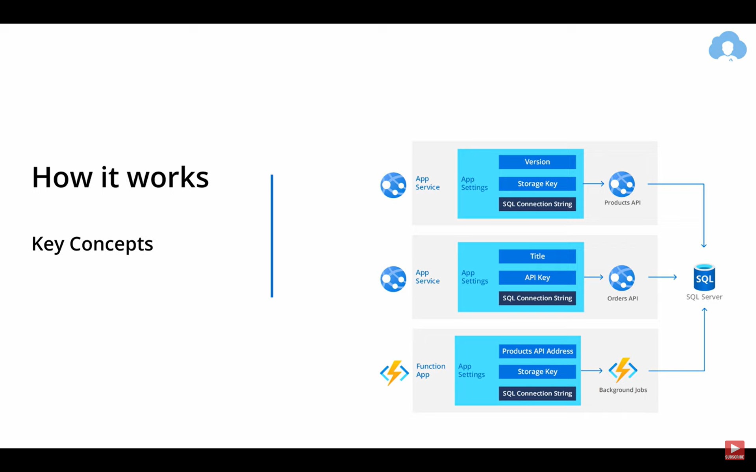

* **Why Azure App configuration ?** : As we see in above , if more than one app service or azure functions use ‘Sql Connection string’ in the configuration and if we want to change the sql connection string then we will need to change all of them in all places. To solve this problem we can create 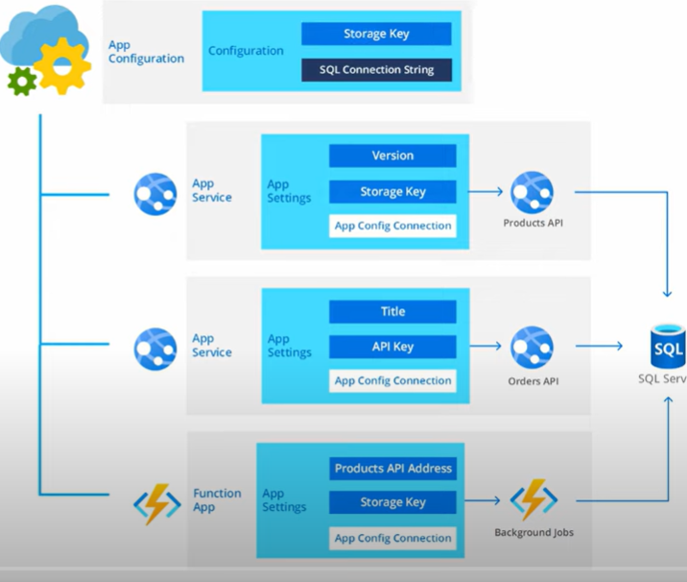 lke this. 