**Angular**

* [Angular (forked) - StackBlitz](https://stackblitz.com/edit/angular-nvmjgf?file=src%2Fmain.ts) is the sandbox for Angular
* In Angular , UI functionality is encapsulated in components. A component can represent anything from a piece of text, button, form etc., and can contain another component. Components communicate with one another with the help of well defined interfaces.
* A TypeScript class is a component using the @Component decorator. Decorators provide additional information by annotating or modifying classes or class members. In this case, the component decorator provides additional metadata to Angular about how the class will behave.

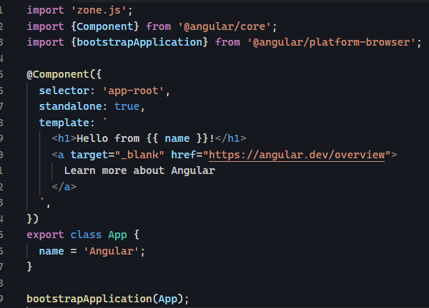

* A ‘selector’ attribute tells this component an accessed with a HTML tag ‘app-root’
* A ‘standalone’ attribute tells that this component doesn’t reside in separate NgModule
* A ‘template’ attribute tells or shows us the actual HTML markup
* The ‘imports’ tag tells us that this component makes use of functionality inside ‘CommonModule’
* The executable portion of the code is found inside the class definition.
* Even though everything is present in a single file still code, mark, styles are all separated from one another. This is called addressing ‘Separation of Concerns’
* Inside the HTML above we can see {{ name }} and during rendering phase Angular sees the expression and binds the value from variable of the class. This is called ‘One-way’ binding in Angular.
* **Import vs imports** 🡪 The TypeScript ‘import’ imports classes, functions, types and other exported items from another typescript or javascript modules. From Angular 15, the @Component decorator has ‘imports’ which includes the components we want to import components, directives, pipes and NgModules into the HTML mark of our current component. **HelloComponent.ts main.ts** A computer screen shot of a program code

  Description automatically generated A computer screen shot of a program code

  Description automatically generated
* The Angular CLI is an indispensable tool for Angular developers, providing a comprehensive set of commands that simplify and streamline the process of creating, scaffolding, and managing Angular applications. The CLI abstracts away much of the complexity and boilerplate code that comes with setting up a new Angular project, allowing you to focus on writing your application logic

npm install -g @angular/cli

* The @Input() decorator tells us that