**BootStrap**

* BootStrap is free front end framework for faster and easier web development to create responsive designs.
* .container 🡪 class for fixed width container. By default containers have 15px padding to the left and right and with no padding to the top & bottom.

.container-fluid 🡪 class for full width container spanning the entire width of viewport

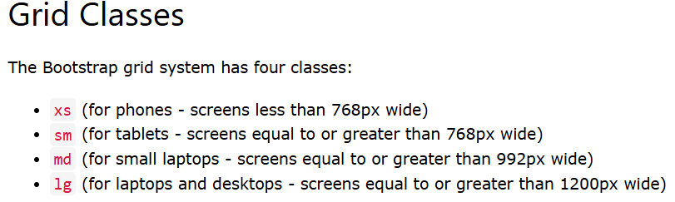

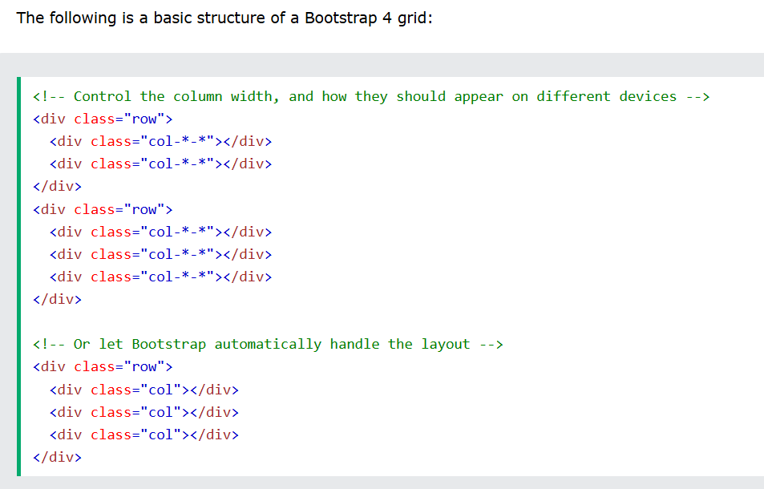

* Bootstrap 4’s default font size is 16px with a default line height of 1.5 and this is applied to <body> element and <p> . All <p> elements have default margin-top : 0 and margin-bottom : 1rem (16 px by default)
* <small> 🡪 create a lighter, secondary text in any heading 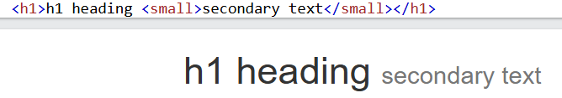
* 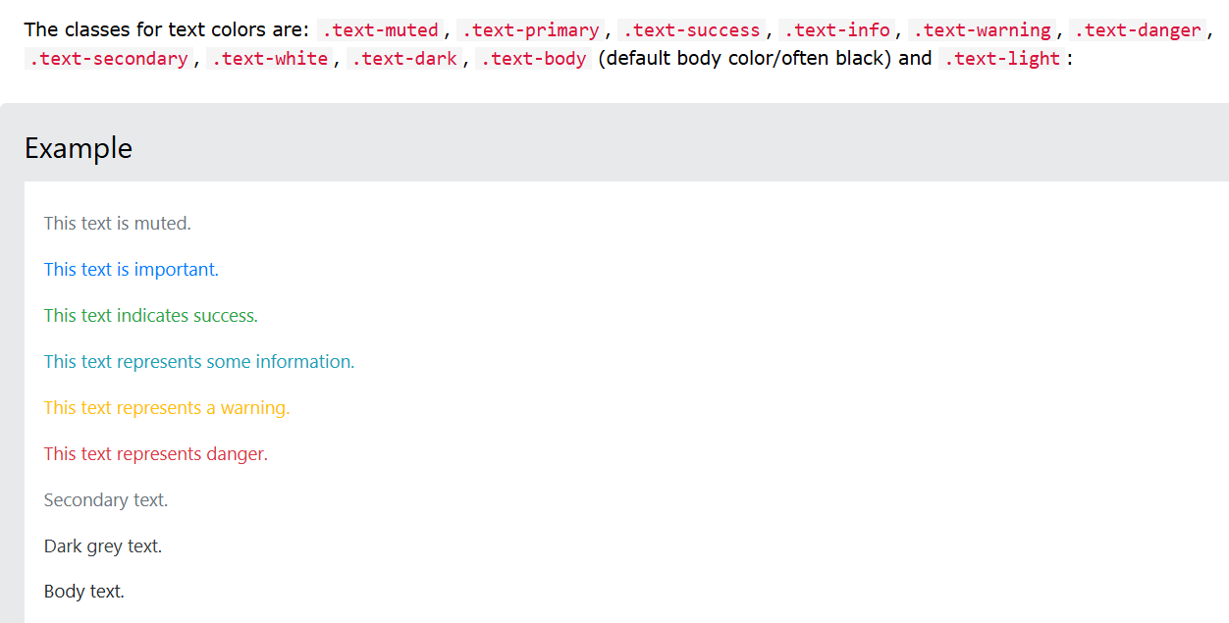
* Background-colors: 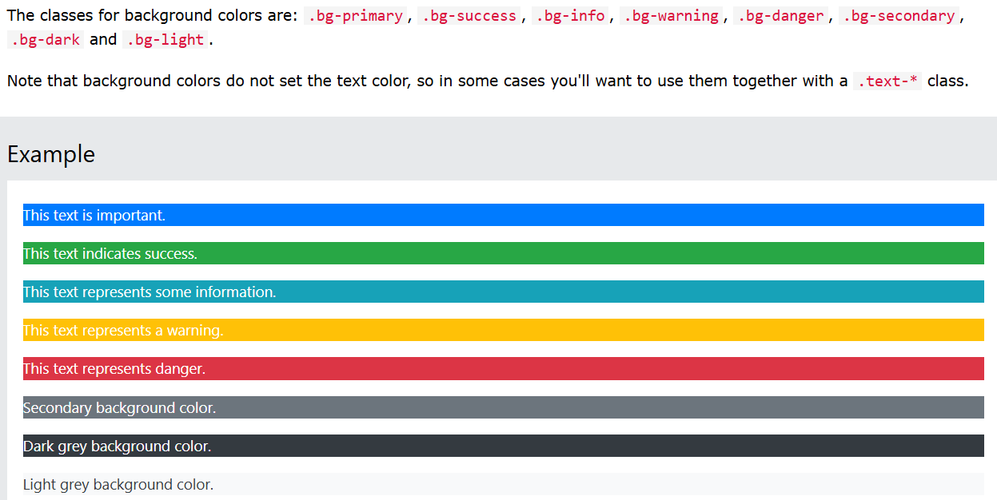
* .table 🡪 has a light padding and horizontal dividers
  + .table-striped 🡪 adds zebra stripes to table
  + .table-bordered 🡪 all borders on all sides of table and cells
  + .table-hover 🡪 adds a hover effect on table rows
  + .table-condensed 🡪 makes a table more impact by cutting cell padding in half

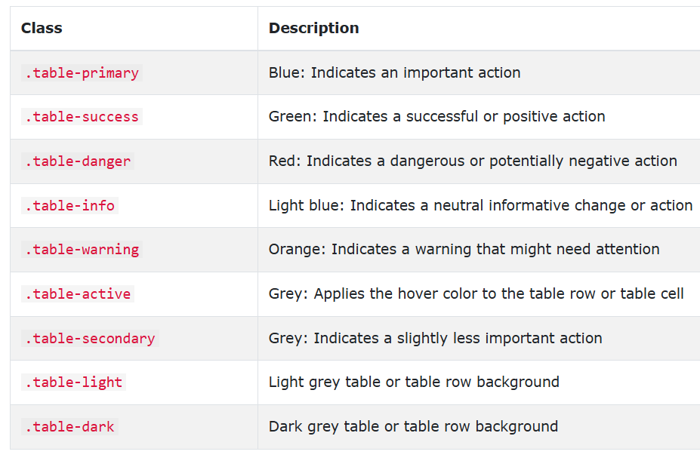

* .img-rounded 🡪 adds rounded corners to an image
  + .img-circle 🡪 class shapes the image to a circle
  + .img-thumbnail 🡪 class shapes the image to a thumbnail
  + .img-responsive 🡪 class applies display: block; and max-width: 100%; and height: auto; to the image.
* Jumbotron 🡪 indicates a big box for calling extra attention to some special content or information. A jumbotron is displayed as a grey box with rounded corners. It also enlarges the font sizes of the text inside it.

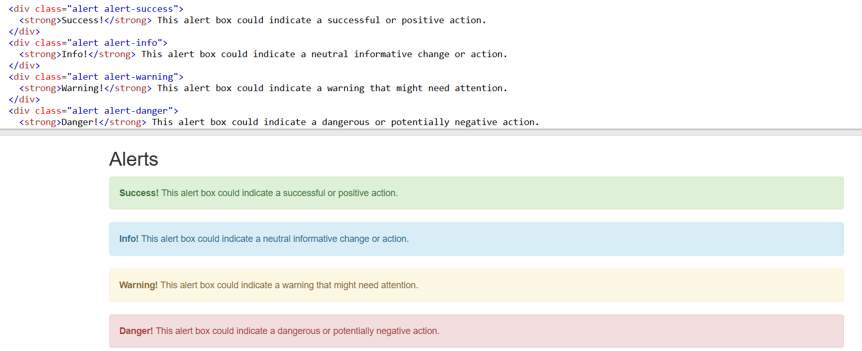

* Alerts are created with alert class, followed by one of the four contextual classes .alert-success, .alert-info, .alert-warning or .alert-danger.
* To close the alert message, add a .**alert-dismissible** class to the alert container. Then add a button with class="close" and data-dismiss="alert" to a link or a button element (when you click on this the alert box will disappear).
* The .fade and .show  classes adds a fading effect when closing the alert message.
* 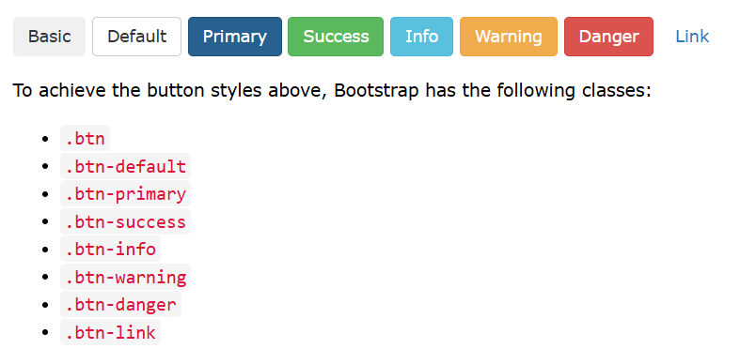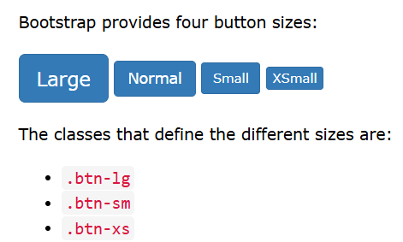
* Button Groups 🡪 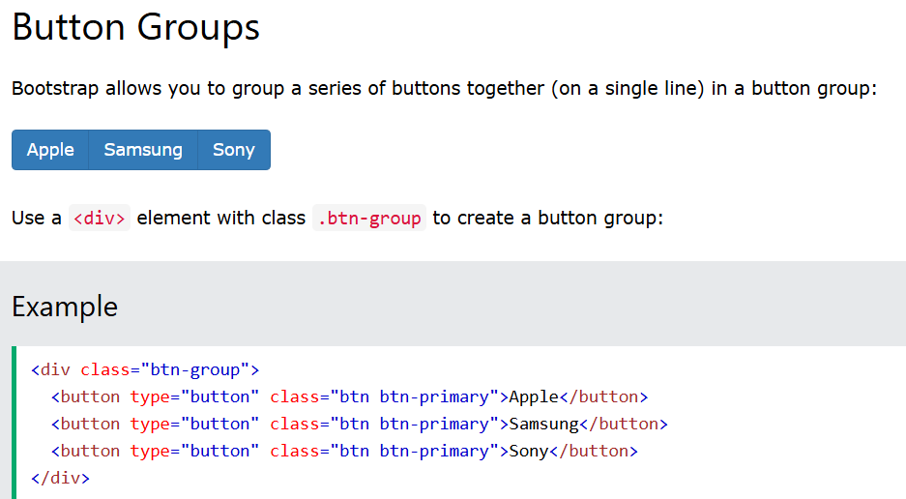
* Badges 🡪 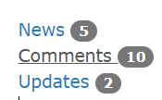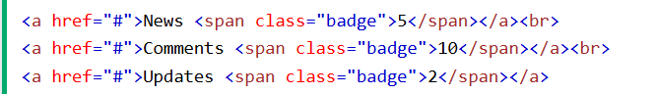
* Progress Bar 🡪 To create a default progress bar, add a .progress class to a <div> element. 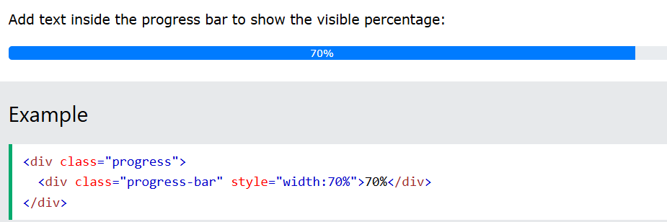

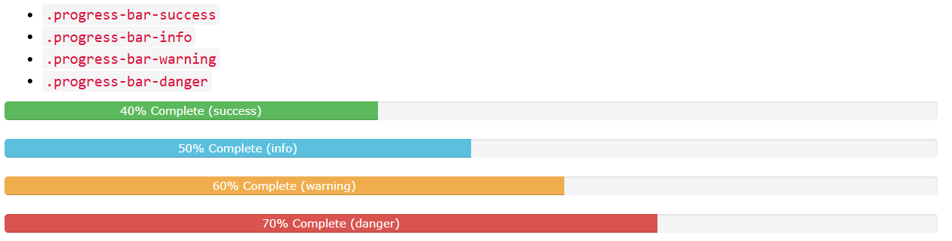

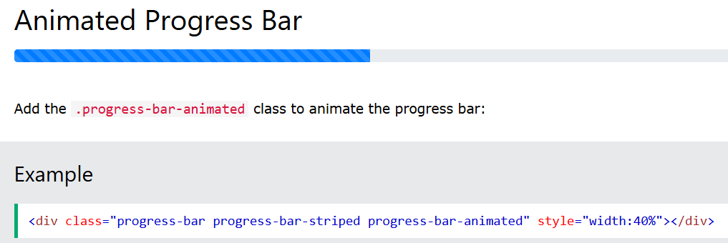

* Pagination 🡪 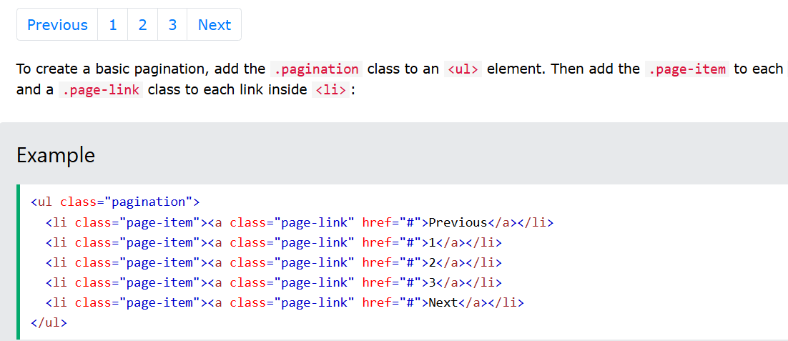
* List Groups 🡪 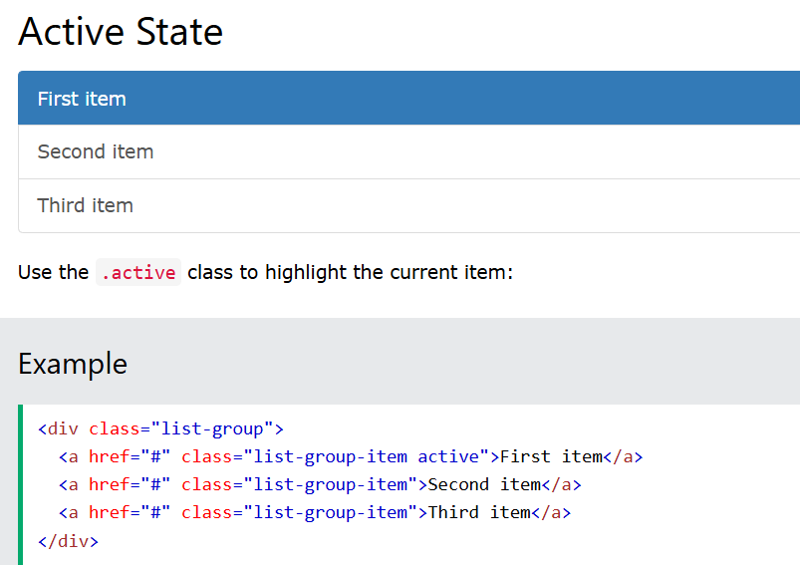
* Dropdowns 🡪 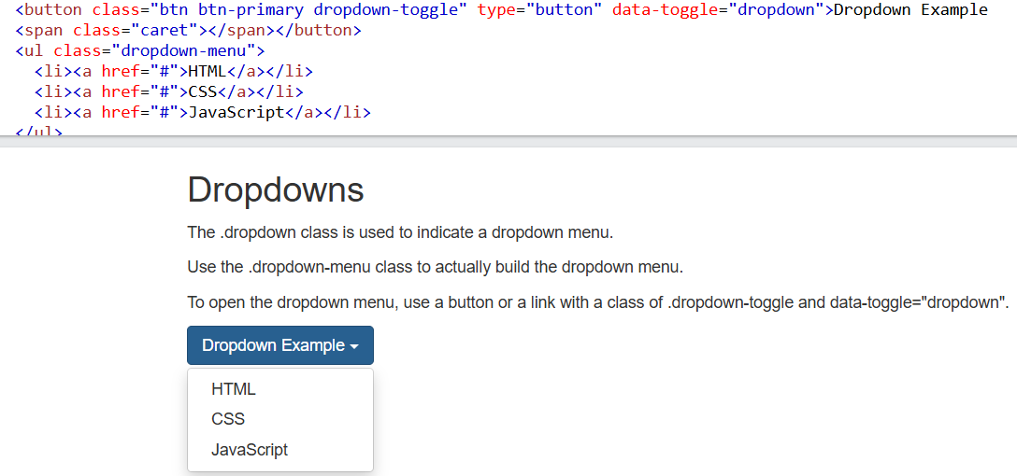
* Accordion 🡪 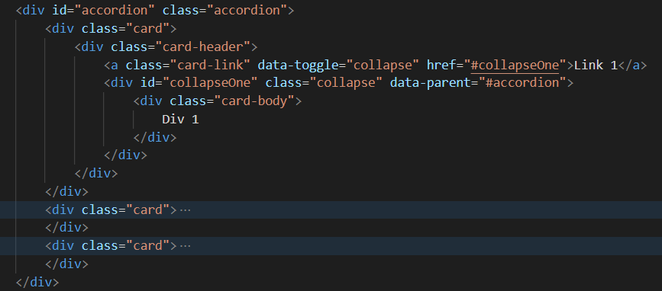
* Navs 🡪 If you want to create a simple horizontal menu, add the .nav class to a <ul> element, followed by .nav-item for each <li> and add the .nav-link class to their links

To turn navigation menu into tabs simply add .nav-tabs class. 