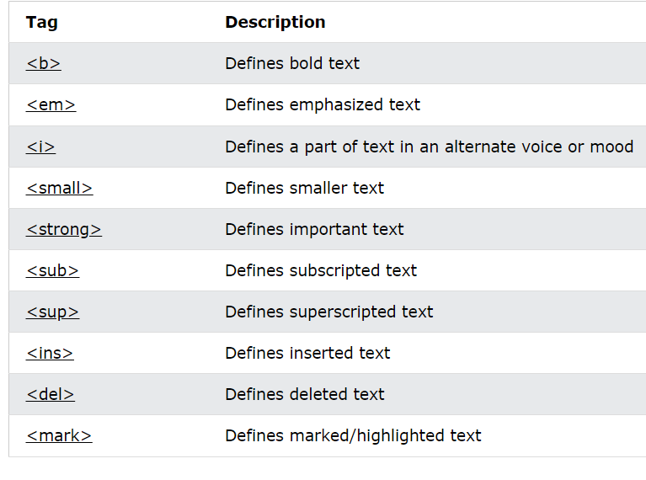

<em> 🡪 Content are displayed in italic. A screen reader will read the text in <em> with emphasis using verbal stress.

