* Javascript accepts both single and double quotes.

|  |  |
| --- | --- |
| * Vars can be redeclared   Var name = “Rajesh”;  Var name; // This will work and name will still be “Rajesh” | * Let or const can’t be redeclared   let name = “Rajesh”;  let name; // This will not work as let is a block scope variable |
| * Var has global scope or can have function scope | * Let has block scope , let is introduced as part of ES6 (since 2015) |
| * Variables declared with Var can be redeclared   Ex : var x = 10;  var x; // x value will be 10 | * Variables declared with let can’t be redeclared.   Ex : let x = 10;  let x; // errors |
|  |  |

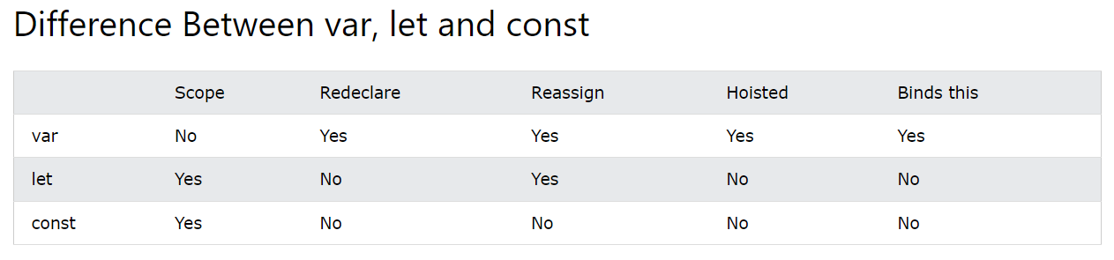

* const value must be assigned when declared.

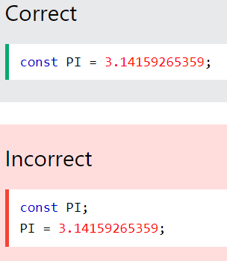

* 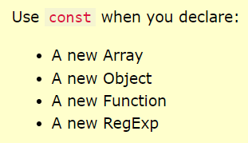
* ‘const’ doesn’t define a constant value, it defines constant reference to a value. We can update the elements of an array, properties of constant object.
* Datatypes: 