IP Address An IP (Internet Protocol) address is a unique number assigned to a device on a network so it can send and receive data. Think of it like a home address for your computer or phone.
Types of IP Addresses
- IPv4 – 32-bit (e.g., 192.168.1.10)
- IPv6 – 128-bit (e.g., 2001:db8:85a3::8a2e:370:7334)
IPv4 is widely used but is older format and due to growth of internet & devices it is becoming exhausting to maintain.
Hence IPv6 is being used recently.
In IPv4 we use 0 to 255 in decimals written as four numbers separated by dots.
Subnet (Subnetwork) It is a smaller network created inside a larger IP network. It helps organize networks and control traffic.
A subnet mask defines which portion of the IP address defines the network portion and host (device) portion.
CIDR (Classless Inter-Domain Routing) It means that we can use variable number of bits at the beginning of an IP address to represent the network portion of that IP address. Ex: 10.60.15.59/24 means 10.60.15 is network portion.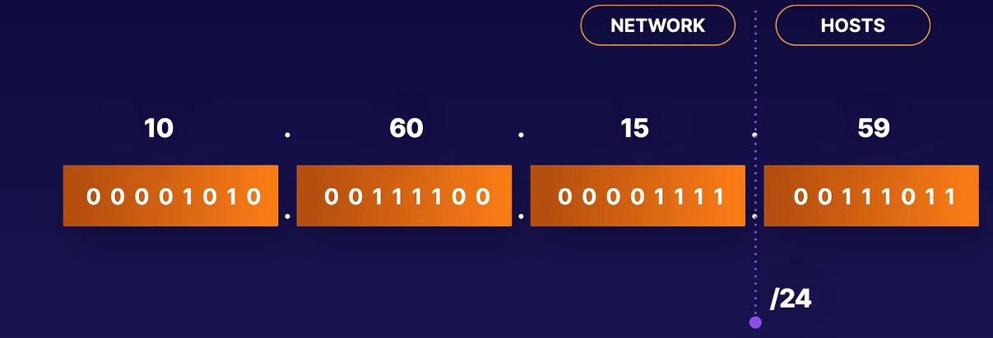
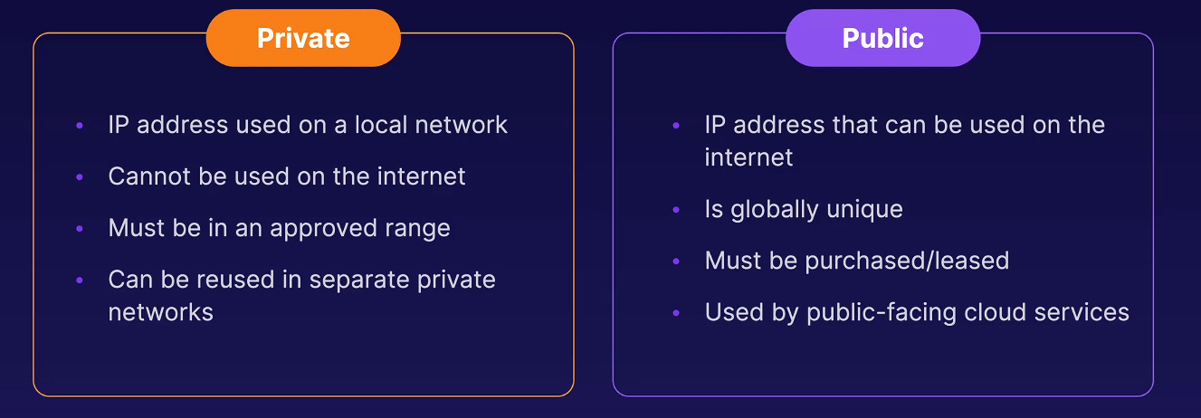
Private IP address range:
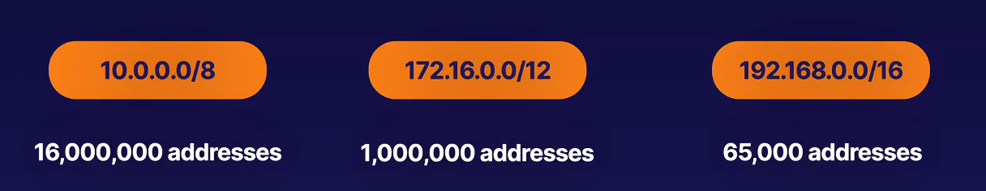
Azure Virtual Network:
- It's defined by an IP address range using that CIDR notation.
- Virtual Networks exist in a single subscription and can’t span across multiple subscriptions and can exist in only one region.
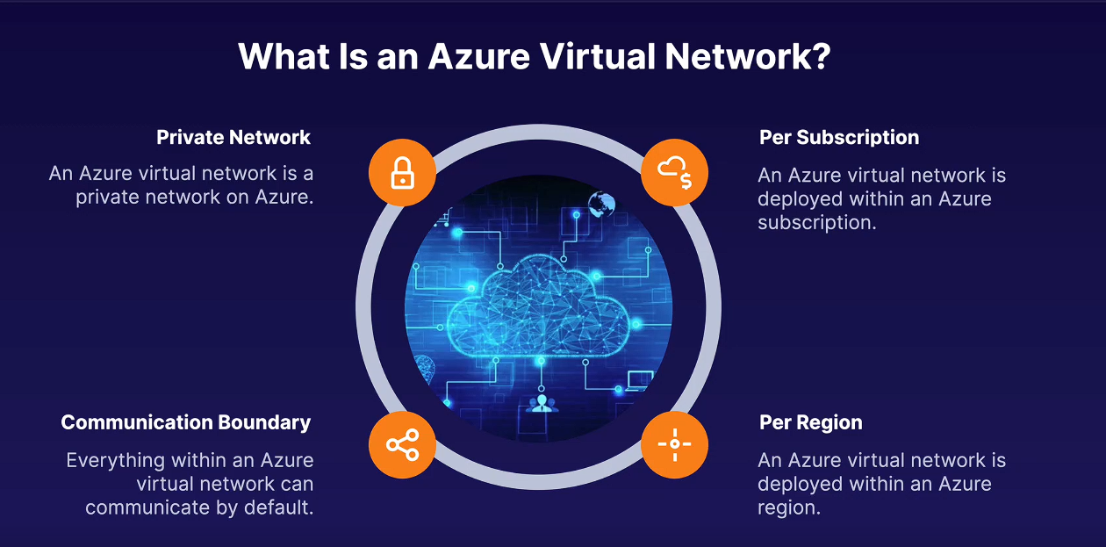
- When should we use Virtual networks ?
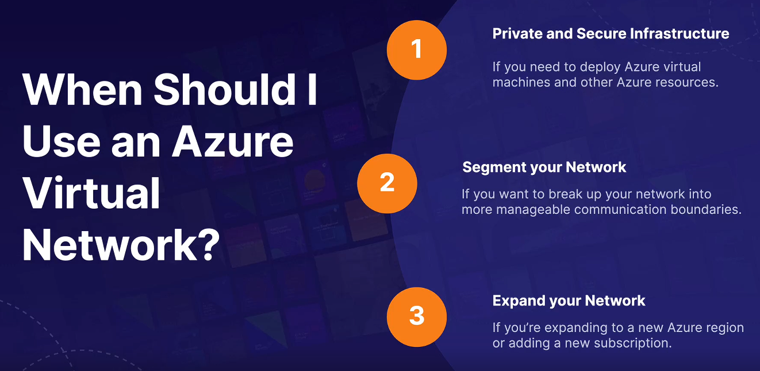
- 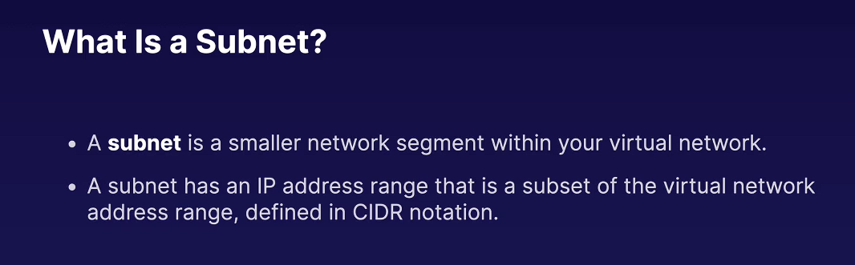

- 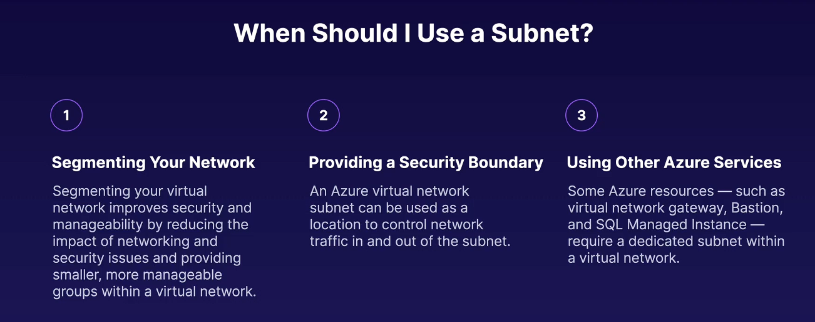
- Azure resources connect to virtual networks using Network interfaces. Network interface is attached to a subnet (with a private IP addresses range) 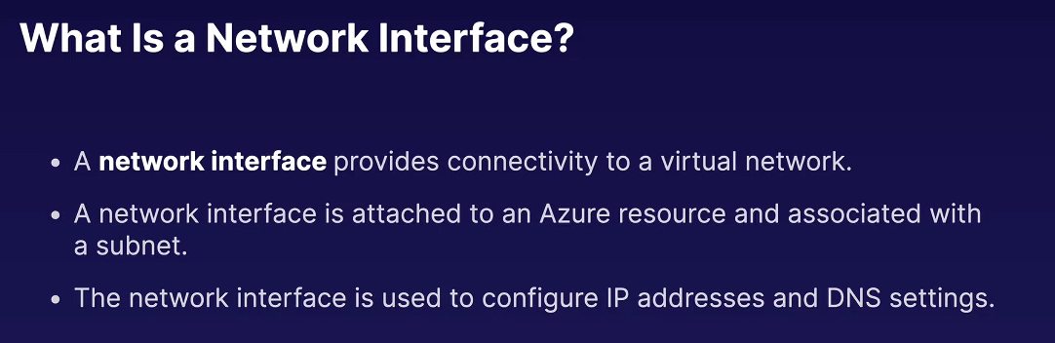

- 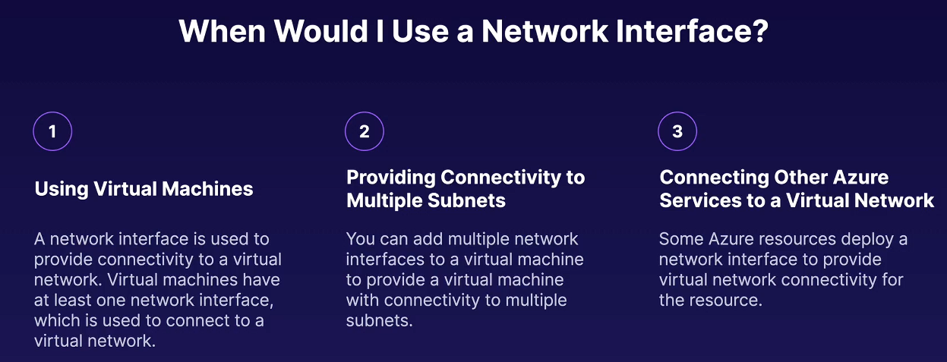
- For example: if a function app or app service wants to connect a to DB inside a subnet under a VNet then this DB needs private end point (via NIC) and function app needs VNet integration to this subnet to allow this app to go inside the subnet.
- So when we create a private endpoint Azure creates a NIC in our subnet for the DB. So DB (inside subnet) needs private end point and function app needs VNet integration.
- 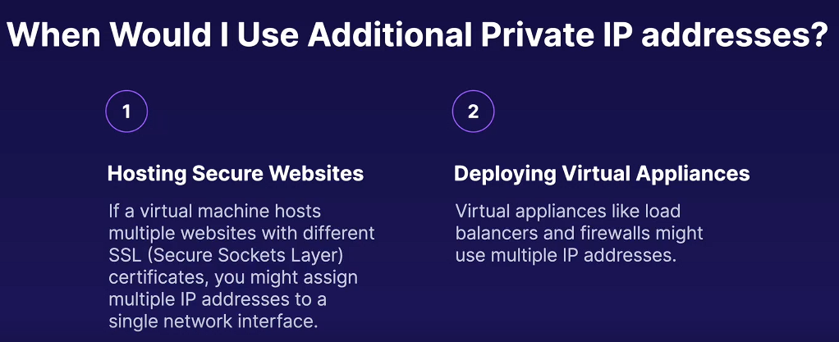
- 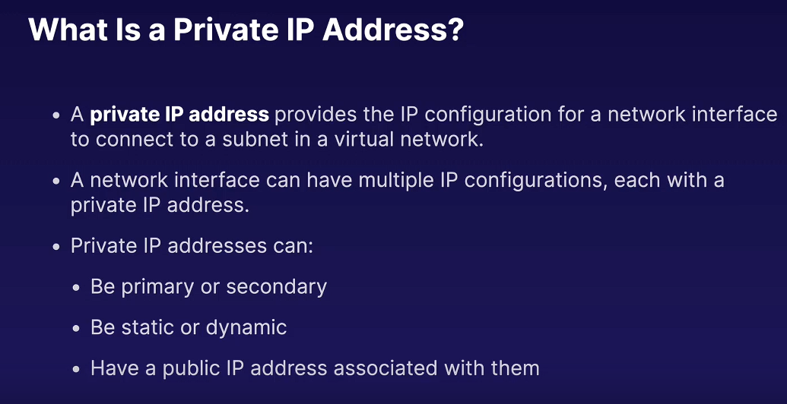
- 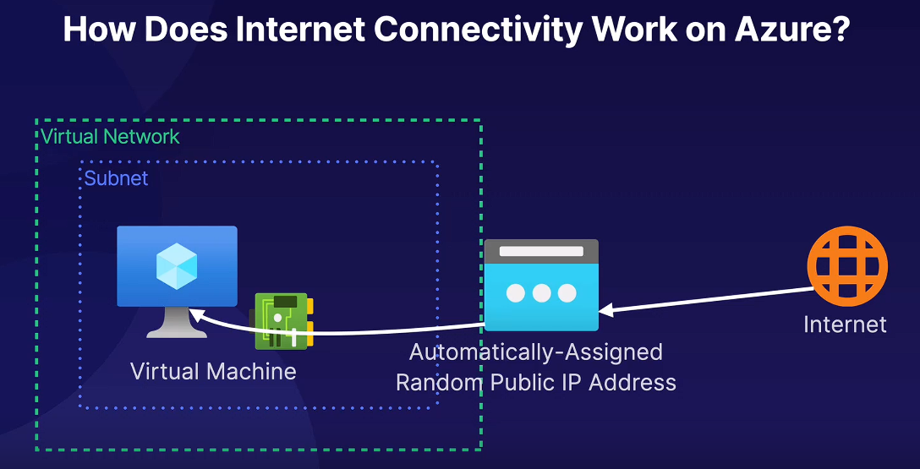
- 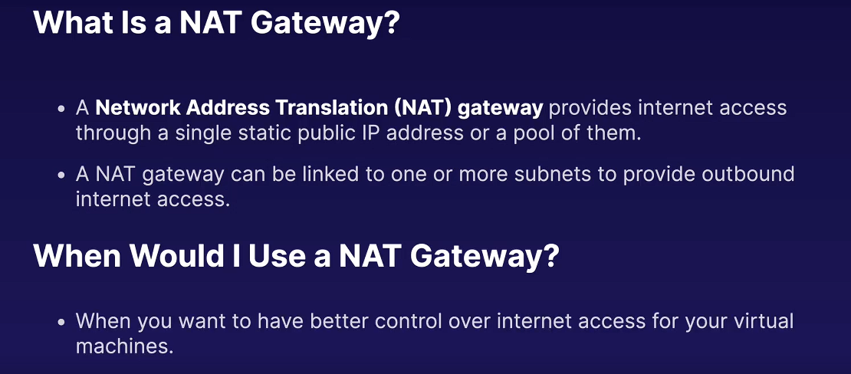
- Network Security Groups: It is used to filter inbound and outbound traffic. 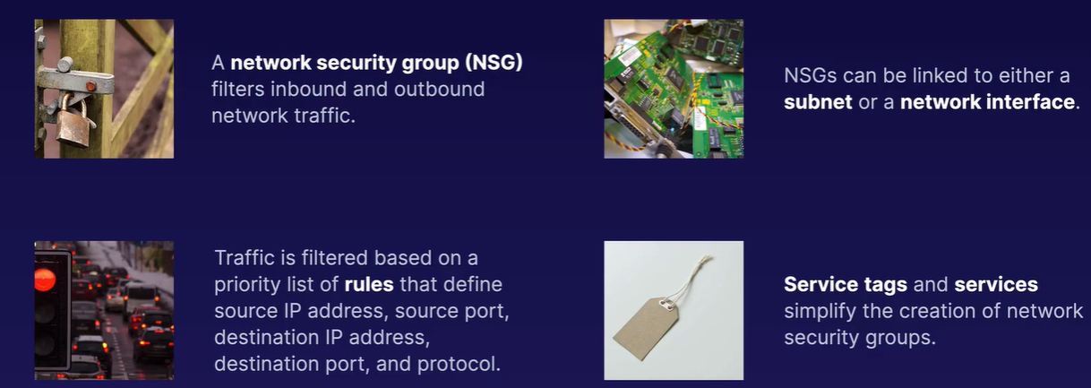
- Network Security Group
  - It filters inbound and outbound network traffic and it can be linked to a subnet or a network interface.
  - Traffic is filtered based on a priority list of rules that contain source IP address, destination IP address, source port and destination port and protocol.
  - For creation of NSG Microsoft provides Service Tags and Services. Service Tags define network destinations that are predefined by Microsoft and they include virtual networks or the internet. Services are port and protocol combinations provided by Microsoft. The include HTTP or HTTPS for the web.
Example: Service Tag
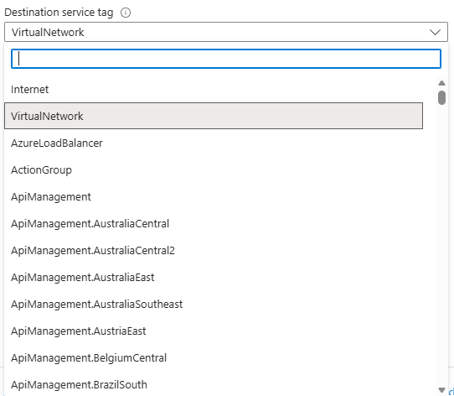
Example: Service
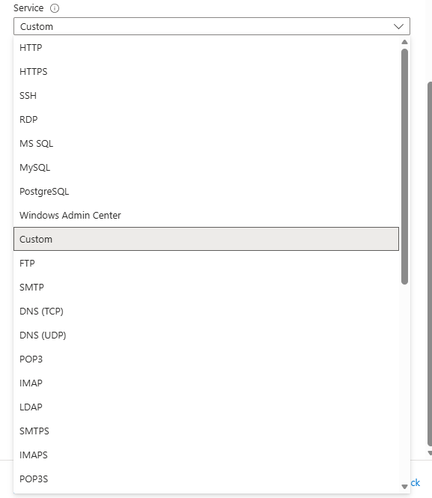

- 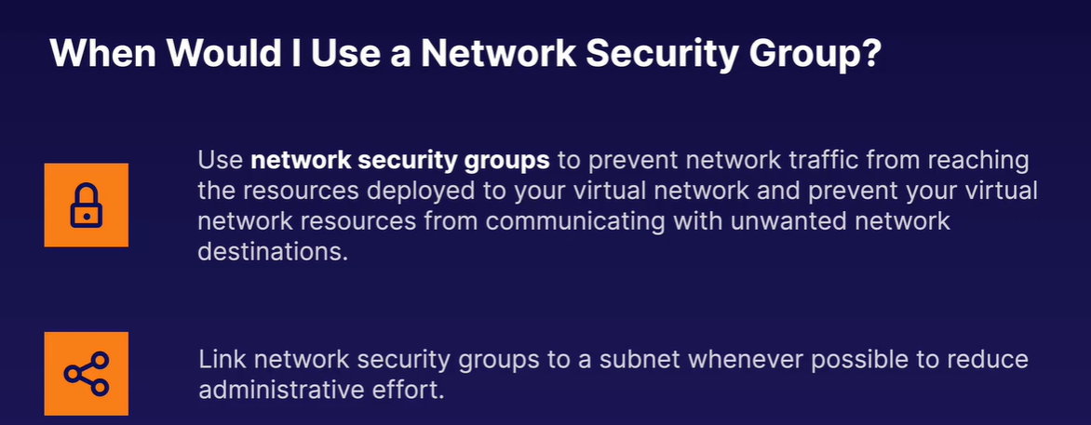
NSGs once defined can be associated with multiple subnets or NICs. This is how rules are set for a NSG:

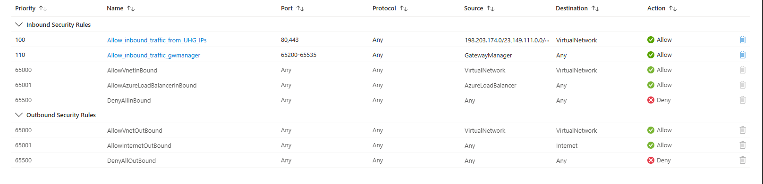

Here lower the priority number higher the priority with 65000+ are default priorities given by Azure. These rules are processed from top to bottom. Inbound rules control traffic coming into our VNet/subnet and outbound rules control traffic going out of VNet/subnet.

For example: the above rule ‘Allow_inbound_traffic_from_UHG_IPs’ says that only IP addresses ranging from ‘198.203.174.0/23,149.111.0.0/’ can communicate with any resource inside VNet on ports 80 & 443.

Now this is how we configure a NSG to a VNet or subnet.
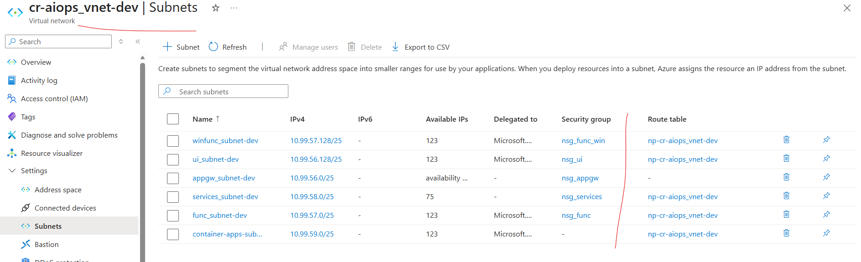

Application Security Groups:
- These allow us to group our virtual machines network interfaces into logical groups and these logical groups when you are defining network security group rules. Application Security Groups (ASGs) are a feature of Azure Network Security Groups (NSGs) that let you group virtual machines by application role and then use those groups directly in NSG rules instead of IP addresses. ASGs are associated with NICs.

- 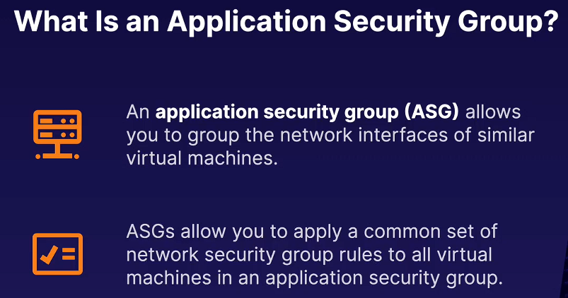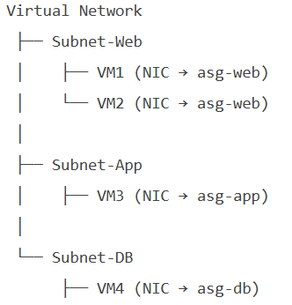
Once Application Security Groups are created we end up selecting them like 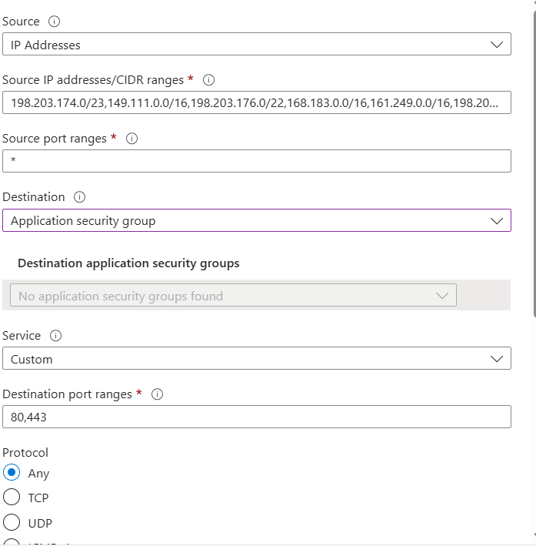

This is how an application securitry group is linked to a virtual machine.

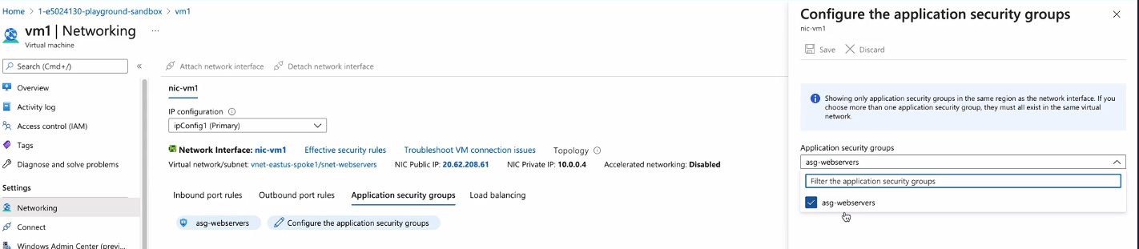

Without ASGs, NSG rules look like this:
- Allow 10.0.1.4, 10.0.1.5 → 10.0.2.7 on port 1433
- Allow 10.0.3.0/24 → 10.0.1.0/24 on port 443

But once we define ASGs we can define the IP addresses range like below:

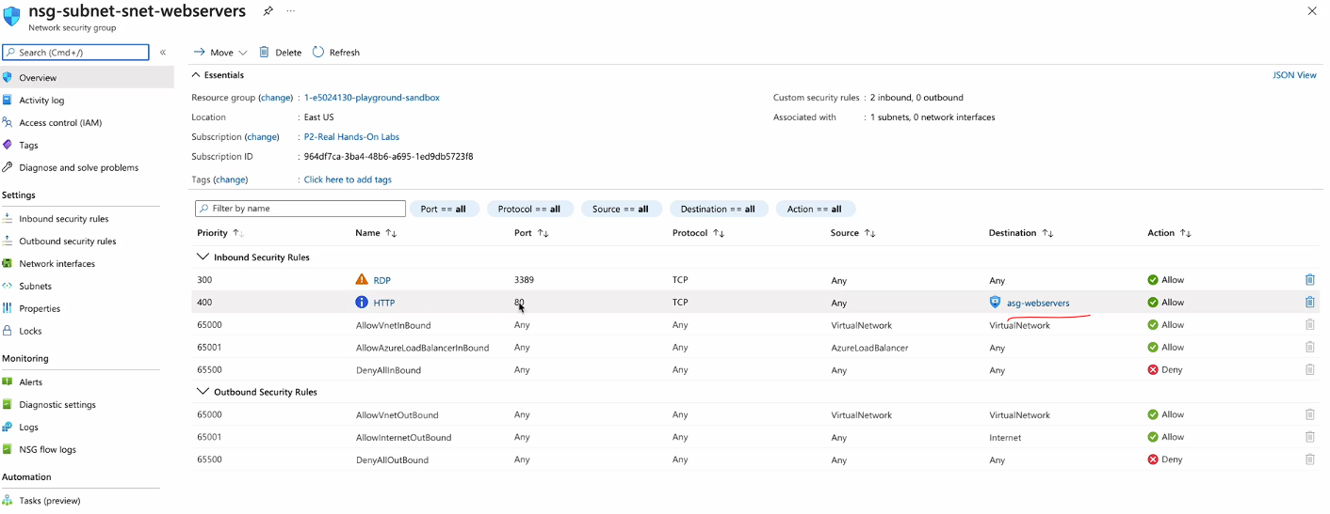
Azure Firewall:
- 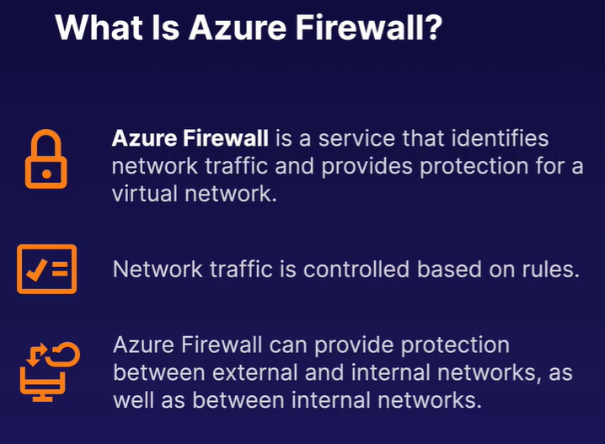

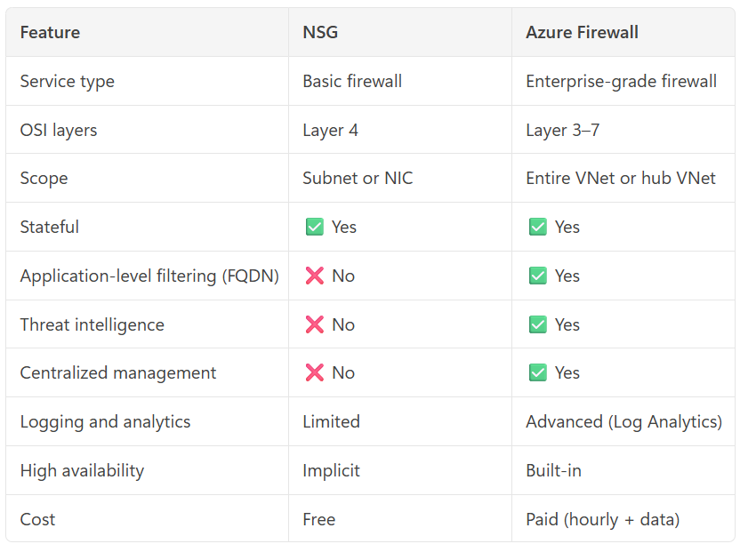
How NSGs work (with example)
Example: Secure a Web VM
You have a VM running a web application.
Requirements :
- Allow HTTP (80) and HTTPS (443) from the internet
- Allow SSH (22) only from your office IP
- Block all other inbound traffic
NSG Rules :
- Allow TCP 80 from Internet → VM
- Allow TCP 443 from Internet → VM
- Allow TCP 22 from 203.0.113.10 → VM
- Deny all inbound (default)

How Azure Firewall works (with example)
Example: Secure Enterprise Outbound Traffic
You have:
- Multiple application subnets
- Developers spinning up VMs and containers
- A compliance requirement:
- Only allow access to microsoft.com and github.com
- Block known malicious IPs
- Log all outbound traffic

Azure Firewall capabilities
Application rules:
- Allow HTTPS to microsoft.com
- Allow HTTPS to github.com
- Deny everything else
Threat Intelligence:
Automatically blocks traffic to known bad IPs
Central logging:
Logs to Azure Monitor / Log Analytics
Routing:
User Defined Routes (UDR) force all internet traffic via firewall
As shown in below pic we can block outgoing traffic from VM to the internet via Azure Firewall
- 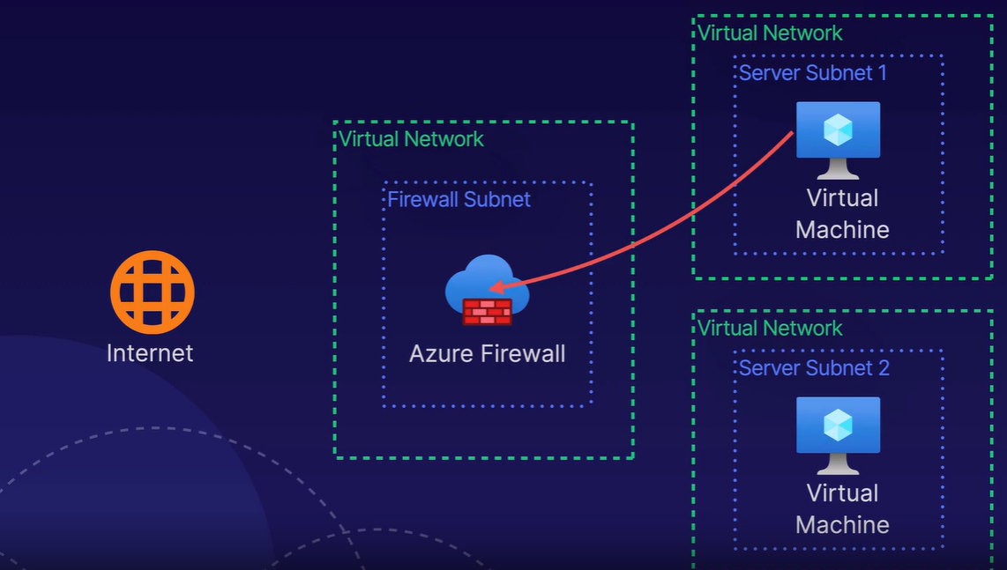
- As shown below this is how two VMs communicate with each other internally via Azure Firewall.
- 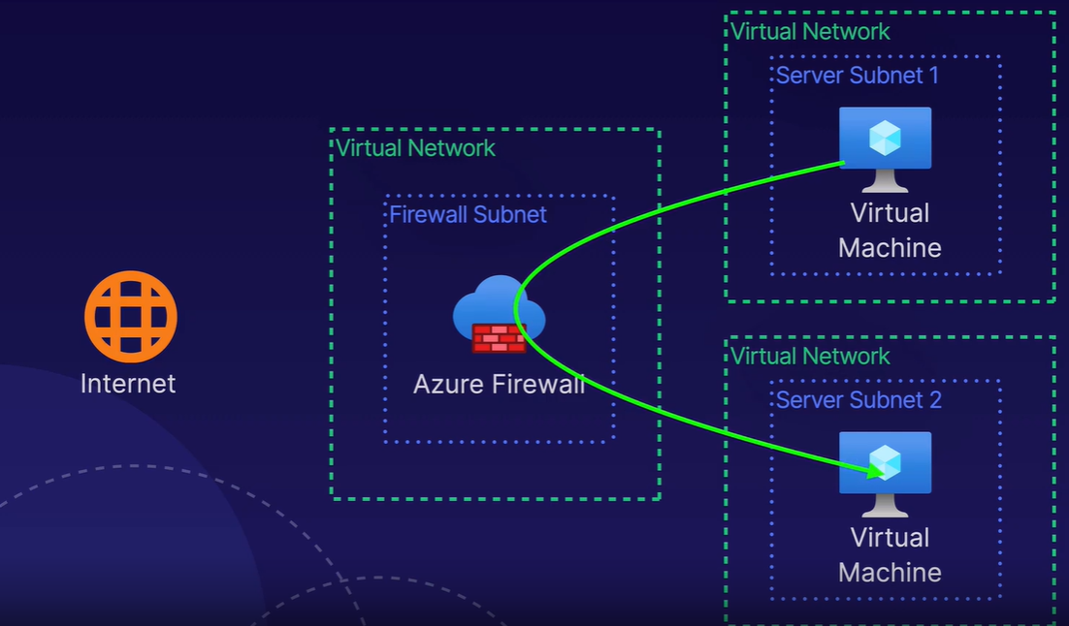

Feature | Normal VM | Jump Box
Purpose | Run apps/services | Secure access gateway
Public IP | Optional | Usually yes
Usage | Application workloads | Admin access
Security hardening | Basic | High (strict controls)
A Jump Box is not a different resource type, it's just a VM used in a specific role (secure access point).
Azure Native Alternative: Azure Bastion
Azure provides a managed version of Jump Box:
✅ Azure Bastion
- Fully managed (PaaS)
- No need for your own Jump VM
- Access VMs via browser (no RDP/SSH exposure)
👉 Key Advantage:
- No public IP needed on target VMs
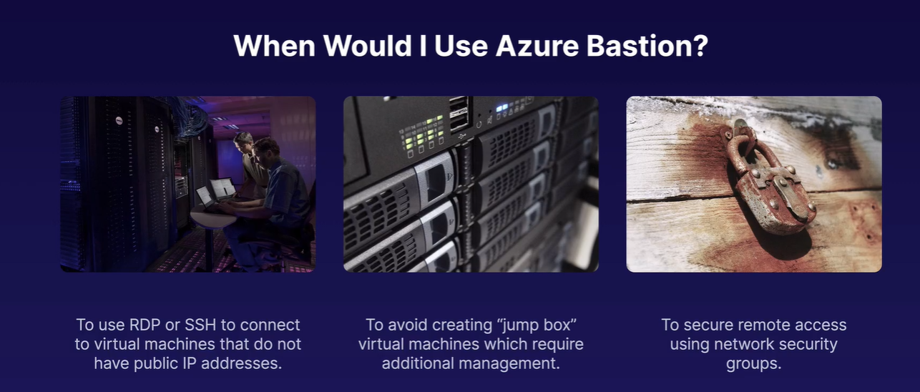
What is Azure DDoS Protection?
Azure DDoS Protection is a security feature provided by Microsoft Azure that helps protect your applications and resources from Distributed Denial-of-Service (DDoS) attacks.
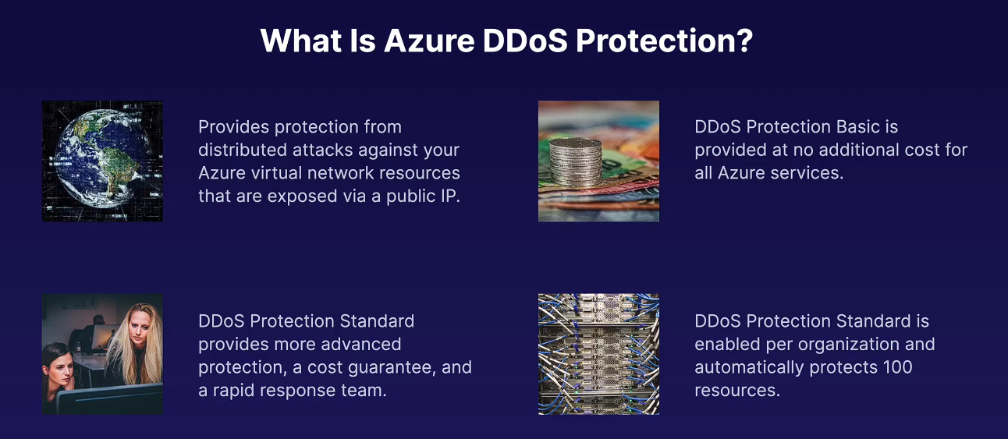

🚨 What is a DDoS Attack?
A DDoS attack happens when multiple compromised systems (like bots or infected machines) flood a server, application, or network with massive traffic.
The goal is to overwhelm the system, making it slow or completely unavailable to legitimate users.

🛡️ How Azure DDoS Protection Works
Azure automatically provides basic DDoS protection for all services running in the cloud. For advanced protection, Azure offers DDoS Protection Standard, which includes:
- Traffic monitoring: Continuously checks network traffic patterns
- Automatic mitigation: Detects abnormal spikes and blocks malicious traffic
- Adaptive tuning: Learns normal application behavior to identify attacks better
- Attack analytics: Provides insights and reports about attacks
- Integration: Works with Azure Monitor, logs, and alerts

Azure VM and Bastion:
In Azure, Azure Bastion and the virtual machine do NOT need to be on the same subnet, but they must be in the same Virtual Network (VNet).
Key points:
✅ Same VNet → Required
- Azure Bastion is deployed into a VNet.
- It can securely connect to any VM within that same VNet (even if the VM is in a different subnet).
❌ Same Subnet → Not allowed
- Azure Bastion must be deployed in a dedicated subnet named:
- AzureBastionSubnet
- This subnet:
  - Cannot contain any other resources (like VMs)
  - Must be at least /26 or larger (recommended)

Typical setup:
VNet: MyVNet
│
├── Subnet: AzureBastionSubnet (contains Bastion)
│
├── Subnet: AppSubnet (contains VM1)
│
└── Subnet: DBSubnet (contains VM2)

VNet Pairing:
Virtual Networks are communication boundaries i.e.. we can’t send traffic between them. VNet pairing allows traffic to flow between two virtual networks by connecting them. We can connect virtual networks across different subscriptions and globally across regions.
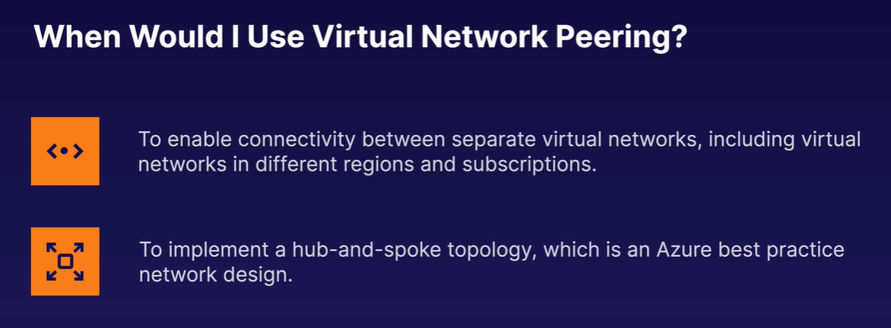
VNet Pairing:
Both the VNets have to open communication i.e.. communication should be two way not one way.
VNet must be paired with other VNet for direct traffic flow.
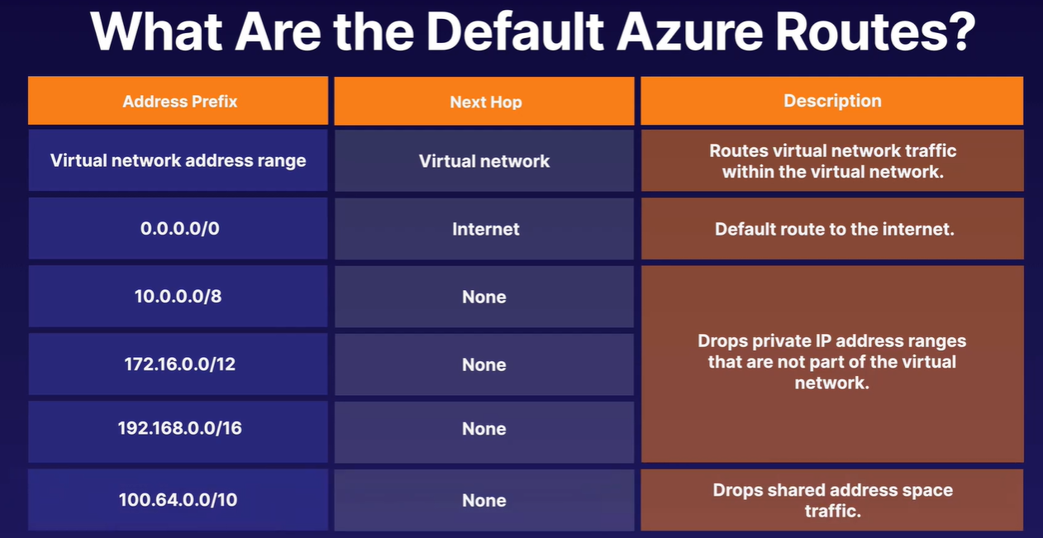
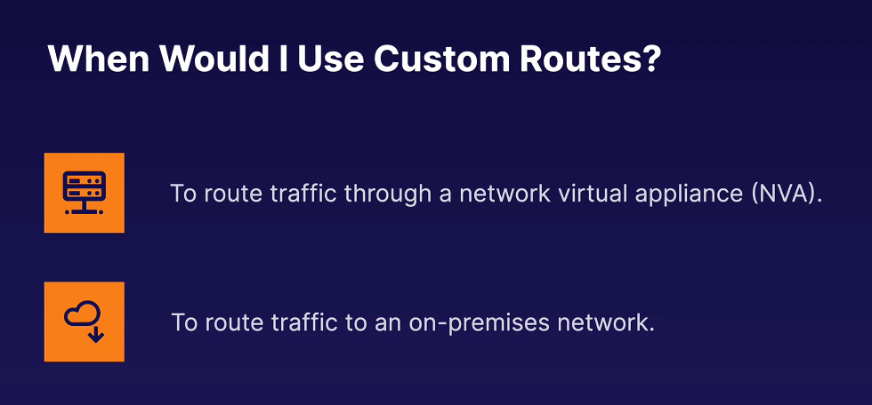
Load balancer:
- cloud-based service from Microsoft Azure that distributes incoming network traffic across multiple resources (like virtual machines). Azure Load Balancer works at VM level (IaaS)
Think of Azure Load Balancer as a traffic controller:
- When many users try to access your app,
- It spreads requests evenly across multiple servers,
- So no single server gets overloaded.
It helps you:
- ✅ Improve application availability
- ✅ Increase scalability
- ✅ Prevent server overload
- ✅ Achieve high performance
How It Works
- Users send requests to your application.
- The load balancer receives the traffic.
- It uses rules and health checks to decide which server (VM) should handle each request.
- Traffic is forwarded only to healthy instances.
Types of Azure Load Balancer
1. Public Load Balancer
- Exposes your application to the internet
- Used for web apps, APIs, etc.
Internal Load Balancer
- Used inside a private network (VNet)
- Not exposed to the internet
Features
- Layer 4 (Transport layer) balancing (TCP/UDP)
- Health probes to monitor VM health
- Automatic failover
- High throughput and low latency
- Supports availability zones
• Azure Load Balancer → Works at network layer (L4)
• Application Gateway → Works at application layer (L7) (better for HTTP/HTTPS routing)
Global Load Balancer:
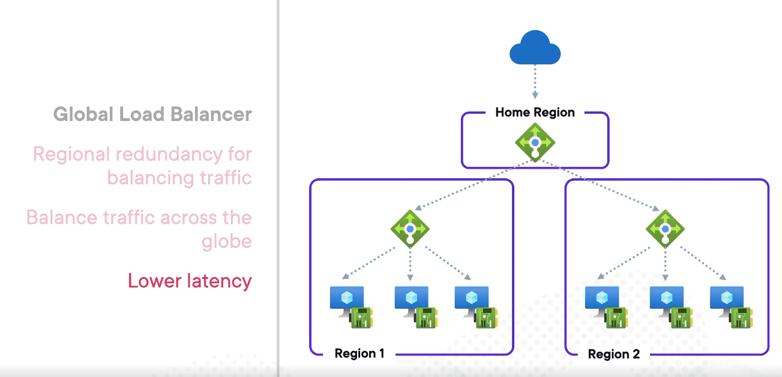

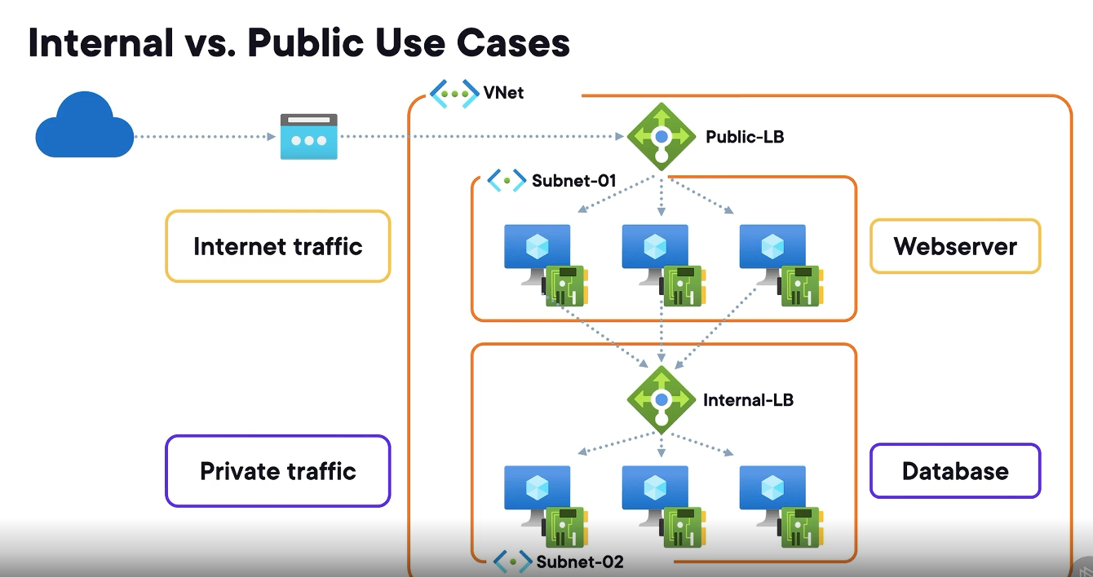

How Load balancer distributes traffic :

Hashing: Azure load balancer uses 5 tuple hash method to send traffic to VMs.
What is the “5-tuple”?
The term refers to five properties of a network packet:
- Source IP address
- Source port
- Destination IP address
- Destination port
- Protocol (TCP or UDP)

• For every incoming request (flow), Azure computes a hash value using the 5-tuple.
• That hash deterministically maps the request to a specific backend VM/instance.
• As long as the 5-tuple remains the same, traffic will consistently go to the same backen

Why it’s used
- Ensures sticky flow behavior (same client session remains on same backend)
- Provides even distribution across VMs
- Avoids per-packet randomness — decisions are flow-based, not packet-based
backend_index = hash(5-tuple) % number_of_backends
- The hash produces a large number
- The LB takes modulo (%) of number of healthy VMs
- That result → selects the VM
🔢 Example
Assume:
- Backend VMs = 3 (VM1, VM2, VM3)
Step 1: Hash computation
hash(5-tuple) = 987654321
Step 2: Modulo
987654321 % 3 = 0
👉 Route to VM1 (if same hash gets computed if reroutes to the same VM again)
Why this design is powerful
✅ 1. No heavy memory dependency
- Doesn’t need to pre-store mappings for all possible users
✅ 2. Scales horizontally
- Works for millions of connections
✅ 3. Fast decision-making
- Hash + modulo = O(1)
Summary: A hash doesn’t store the answer — it recomputes the same answer every time, and the load balancer only remembers active flows, not all mappings.
Network Address Translation (NAT) is a networking technique that maps one IP address space to another. It’s primarily used to:
- Allow private IP addresses inside a network (like VMs) to communicate with the internet using public IP addresses
- Improve security by hiding internal IPs
- Conserve public IPs
👉 In simple terms:
NAT = translating internal (private) IP ↔ external (public) IP

✅ NAT in Azure Load Balancer
Azure Load Balancer uses NAT in two main ways:
1. Inbound NAT (DNAT – Destination NAT)
2. Outbound NAT (SNAT – Source NAT)
Let’s break them down.

🔵 1. Inbound NAT (DNAT)
📌 What it does:
- Maps a public IP + port → private IP + port
- Allows external traffic to reach a VM inside Azure

📊 Example:
Public IP | Port | Private VM IP | Port
52.1.1.1 | 5001 | 10.0.0.4 | 3389
👉 When someone connects to:
52.1.1.1:5001
Azure translates it to:
10.0.0.4:3389 (RDP)

✅ Use cases:
- RDP/SSH access to VMs
- Admin access to backend instances
- Per-VM external access without exposing all ports

🧠 Key concept:
- Port mapping is required
- Each VM typically gets a unique frontend port

✅ In Azure Load Balancer:
- Configured using Inbound NAT Rules
- Used for direct VM access (not load-balanced traffic)

🟢 2. Outbound NAT (SNAT)
📌 What it does:
- Maps a private IP → public IP
- Allows VMs to access the internet

📊 Example:
Private VM IP | Source Port | Public IP (LB) | Translated Port
10.0.0.4 | 34567 | 52.1.1.1 | 60001
👉 When VM sends request to internet:
10.0.0.4 → google.com
Azure translates it to:
52.1.1.1 → google.com

✅ Use cases:
- Installing packages from internet
- Calling external APIs
- Accessing SaaS services

🧠 Key concept:
- Automatic port translation happens
- Called SNAT (Source NAT)

✅ In Azure Load Balancer:
- Done via:
  - Outbound rules
  - OR automatically via load balancing rules (default SNAT)

🔄 Key Differences

Feature | Inbound NAT (DNAT) | Outbound NAT (SNAT)
Purpose | External → Internal access | Internal → External access
Direction | Internet → VM | VM → Internet
Mapping Type | Public IP:Port → Private IP:Port | Private IP → Public IP
Azure Config | Inbound NAT Rules | Outbound Rules / Default SNAT
Common Use | RDP / SSH | Internet access

How it fits in Azure Load Balancer
✅ Scenario:
You have:
- Load Balancer Public IP: 52.x.x.x
- Backend VMs: 10.0.0.x
👉 Azure uses:
✅ For incoming traffic:
- Load balancing rules → distribute traffic
- OR Inbound NAT rules → direct to specific VM
✅ For outgoing traffic:
- SNAT using Load Balancer public IP
- Shared across backend pool VMs

Azure Application Gateway:
- Works at HTTP/HTTPS (Layer 7).
- Deployed regionally (inside a VNet in a specific Azure region).
- Handles:
  - URL/path-based routing
  - TLS termination
  - Web Application Firewall (WAF)
  - Session affinity
👉 It is not a global service.
• Regional limitation
- Application Gateway is tied to a single region + VNet.
- It cannot natively distribute traffic across regions.
• Single point of failure (if forced centralized)
- If you try to route all users globally to one App Gateway:
  - Higher latency (traffic must reach that region first)
  - Risk of outage affecting all users
• Scalability constraints
- App Gateway scales within a region, not globally.
- Not ideal for geo-distributed user traffic.
• No geolocation or latency-based routing
- Unlike Front Door or Traffic Manager.
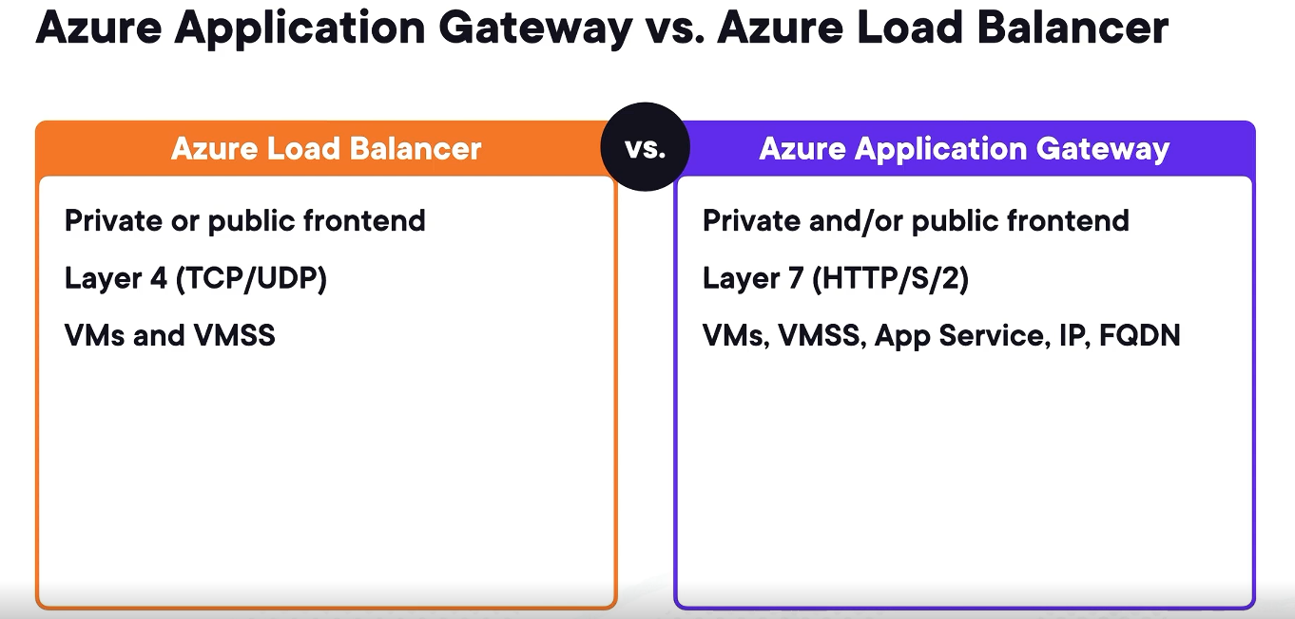
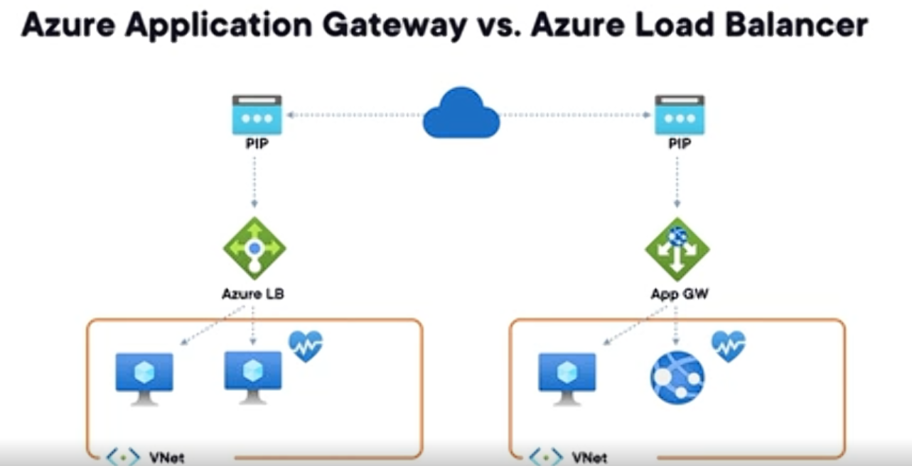
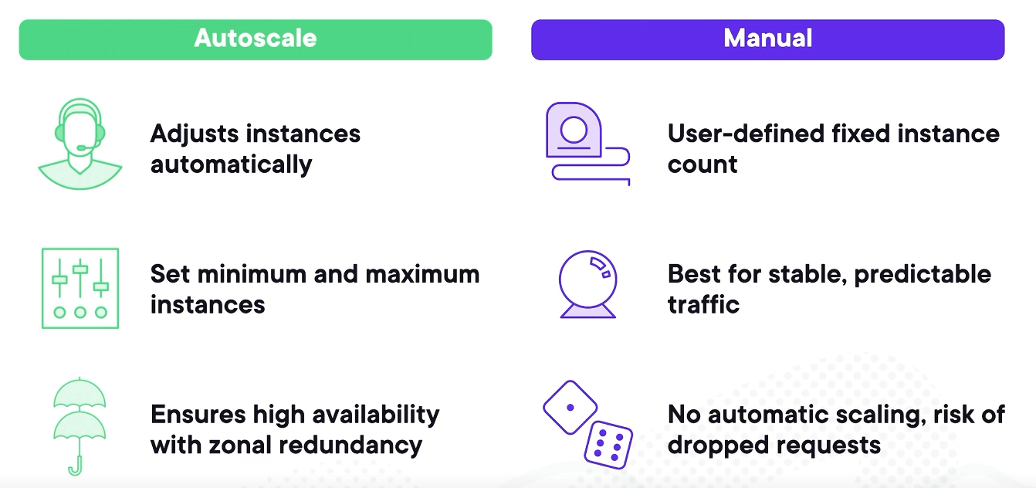
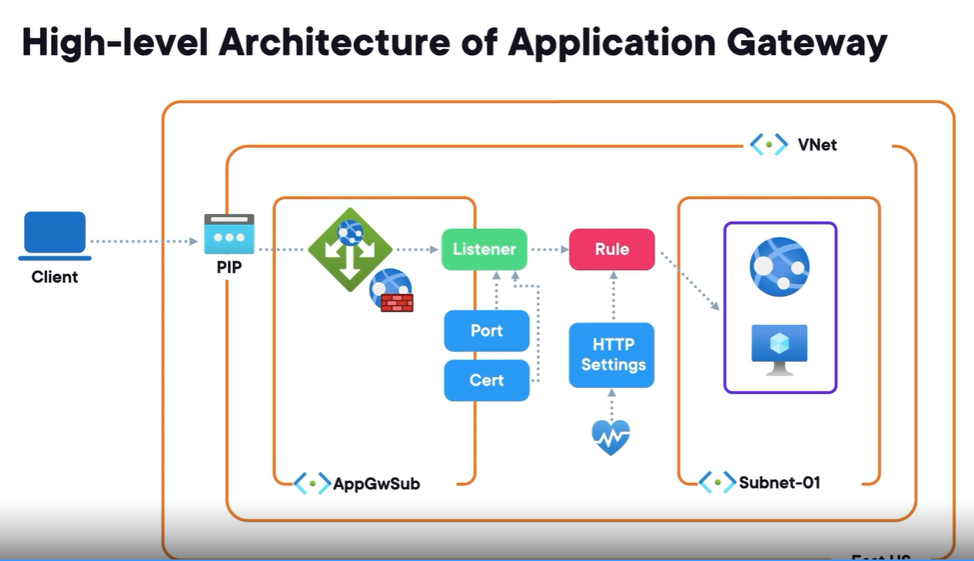
1. What is a “certificate” (SSL/TLS certificate)?
A certificate (commonly called an SSL/TLS certificate) is a digital document that proves a website’s identity.
Think of it like:
🪪 A passport or ID card for a website.
What’s inside a certificate?
- Domain name (e.g., google.com)
- Public key (used for encryption)
- Issuer (who verified the site)
- Expiry date
- Digital signature from the issuer

✅ 2. Why do websites use certificates?
Certificates are used to enable HTTPS, which provides:
(1) 🔒 Encryption
Data sent between your browser and the website is encrypted.
Without HTTPS (just HTTP):
User → (plain text) → Internet → Server
With HTTPS:
User → 🔐 encrypted data → Server
👉 This prevents attackers from reading sensitive info like:
- Passwords
- Credit card numbers
- Cookies/session tokens

(2) ✅ Authentication (identity)
Certificates confirm that:
“You are really talking to amazon.com, not a fake website.”
Without certificates, attackers could easily impersonate websites.

(3) 🛡️ Integrity
Ensures:
Data is not modified during transit.

🏢 3. Who issues certificates?
Certificates are issued by Certificate Authorities (CAs).
Examples:
- Let’s Encrypt (free, very popular)
- DigiCert
- GlobalSign
- Sectigo

How trust works
- Your browser/OS has a list of trusted CAs
- If a website’s certificate is signed by one of them → ✅ trusted
- If not → ⚠️ you get a warning ("Not Secure")

🔑 4. How HTTPS works (simplified)
When you visit https://example.com:
Step-by-step:
1. Client Hello
Your browser says:
“Hi, I want to connect securely.”
2. Server sends certificate
- Includes public key
3. Browser verifies certificate
- Is it signed by a trusted CA?
- Is the domain valid?
4. Key exchange
- Browser generates a session key
- Encrypts it using server’s public key
5. Secure connection established
- Both now use the session key for fast encrypted communication
🌐 5. Why do we need HTTPS instead of HTTP?
HTTP is:
- ❌ Not encrypted
- ❌ Easily intercepted (MITM attacks)
- ❌ Vulnerable on public Wi-Fi
HTTPS solves all of the above.
Real-world analogy:
- HTTP = Sending a postcard (anyone can read it)
- HTTPS = Sending a sealed, signed envelope (private + verified)

🔌 6. Ports: 80 vs 443
Default ports:
Protocol | Port | Description
HTTP | 80 | Unsecured
HTTPS | 443 | Secured (TLS/SSL)

Does HTTPS always use port 443?
👉 By default, yes.
- Browsers automatically use:
  - http:// → port 80
  - https:// → port 443
But technically:
- Servers can run HTTPS on other ports
- Example: https://example.com:8443
🤔 7. Does the computer always send HTTPS instead of HTTP?
👉 Not always—but today, mostly yes.
Depends on:
- What URL you type
  - http:// → HTTP
  - https:// → HTTPS
- Website configuration
  - Most sites redirect HTTP → HTTPS automatically
- Browser behavior
  - Modern browsers prefer HTTPS
  - Some enforce HTTPS first (HSTS / HTTPS-first mode)
Modern web behavior:
- Many browsers try HTTPS automatically
- If fails → fallback to HTTP (sometimes)

🔄 8. What is HSTS?
HTTP Strict Transport Security (HSTS) tells browsers:
“Always use HTTPS for this site.”
This prevents:
- Downgrade attacks (forcing HTTP)

⚠️ 9. What happens without HTTPS?
If a site uses HTTP:
- Attackers can:
  - Sniff traffic
  - Steal cookies/session
  - Inject malicious content
🧠 10. Summary
- A certificate = website identity + encryption key
- Issued by Certificate Authorities
- Enables HTTPS
- HTTPS provides:
  - 🔒 Encryption
  - ✅ Authentication
  - 🛡️ Integrity
- Default ports:
  - HTTP → 80
  - HTTPS → 443
- Modern web strongly prefers HTTPS
When user types https://www.somewebsite.com the following things happen :
User types URL ↓
TCP connection established ↓
TLS Handshake begins ↓
Certificate received (public key) ↓
Certificate verified ↓
Session key created ↓
Secure channel ready ✅ ↓
HTTP request sent (encrypted) ↓
Server responds (encrypted page content)

Backend Pool
A backend pool is a collection of resources to which your application gateway can send traffic. A backend pool can contain virtual machines, virtual machines scale sets, IP addresses, domain names, or an App Service. We can select the necessary App service, Virtual Machine, VMSS, IP address or FQDN.
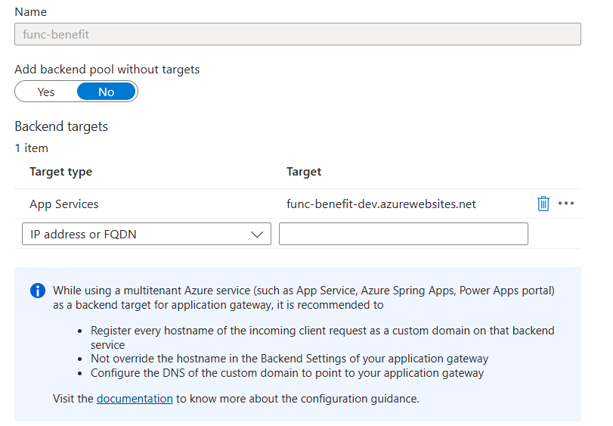
Backend settings:
We can add a new setting where can define the following:
- Protocol (HTTP or HTTPS)
- Port number and certificate and who that certificate issue is public or private
- Select the required ‘Health Probe’ created
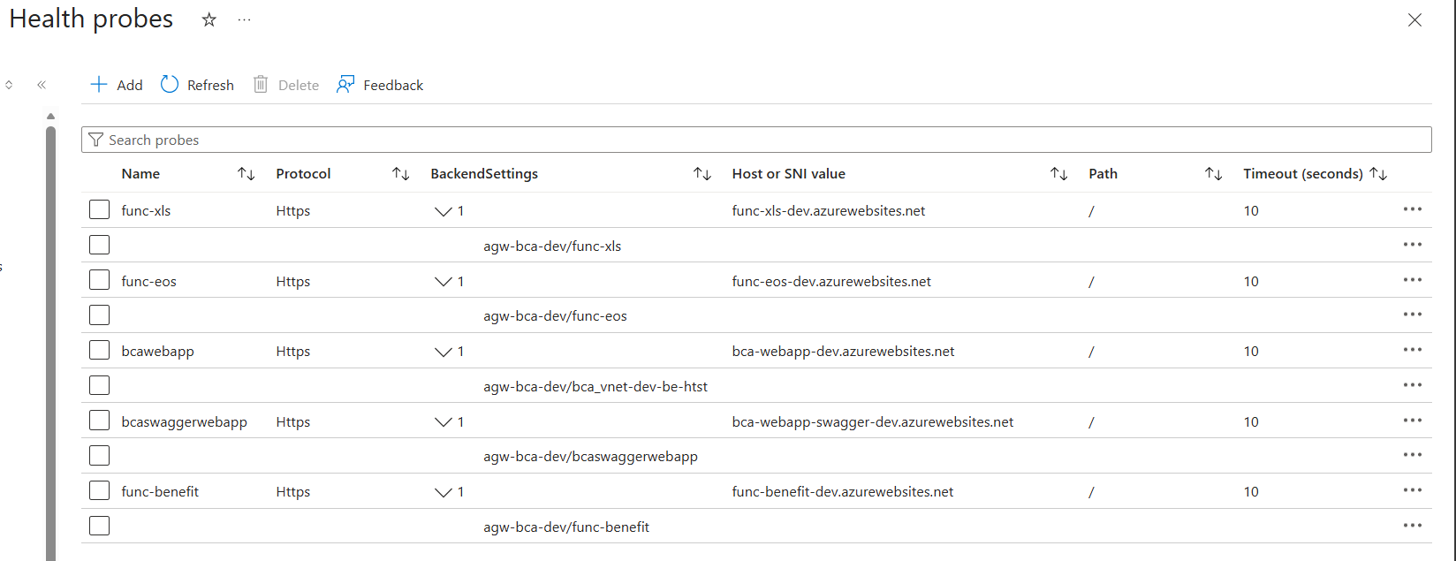
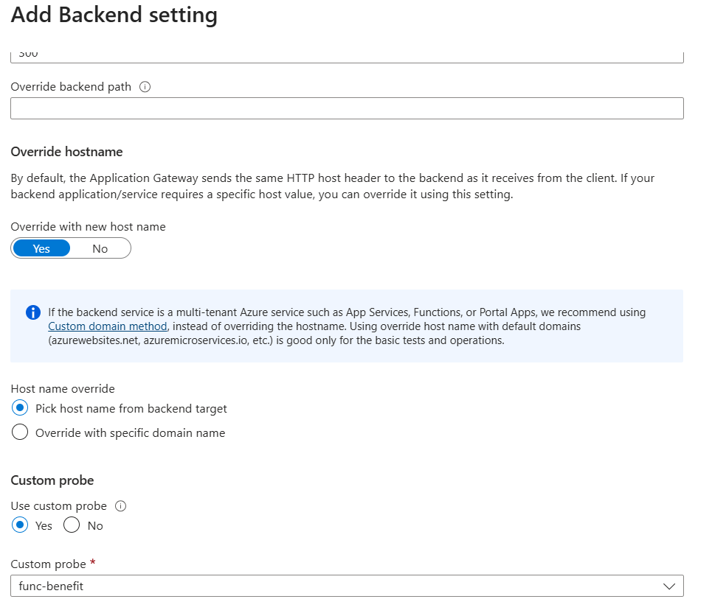
Application Gateway Listener:
A listener in Application Gateway is a configuration entity that:
- Listens for incoming network requests (HTTP or HTTPS)
- Binds to a specific frontend IP address + port + protocol
- Identifies and captures traffic before routing rules are applied
Types of Listeners
There are two main types:
1. Basic Listener
- Listens to all requests on a given port/IP
- Does not differentiate by hostname
- Suitable for simple setups
✅ Example:
- Any request to http://<gateway-ip>:80 is accepted

2. Multi-site Listener (Host-based Listener)
- Listens based on hostname/domain
- Enables hosting multiple websites on the same gateway
✅ Example:
- www.site1.com → Backend pool A
- www.site2.com → Backend pool B
👉 This is critical for multi-tenant or multi-domain apps
Key Components of a Listener
A listener is defined using several parameters:
1. Frontend IP
- Public or private IP where traffic arrives
2. Frontend Port
- Common ports:
  - 80 (HTTP)
  - 443 (HTTPS)
3. Protocol
- HTTP
- HTTPS (requires SSL certificate)
4. SSL Certificate (for HTTPS)
- Needed to decrypt incoming traffic
- Supports TLS termination (ends the HTTPS connection and decrypts the traffic at gateway instead of server)
5. Host Name (optional)
- Used in multi-site listeners

Step-by-step:
- Client hits gateway IP
- Listener receives the request
- Listener identifies:
  - Port
  - Protocol
  - Hostname
- Listener triggers routing rule
- Request is forwarded to backend
Component | Role
Listener | Captures incoming request
Routing Rule | Decides where to send it
Backend Pool | List of servers
HTTP Settings | Defines how to talk to backend

Rules:

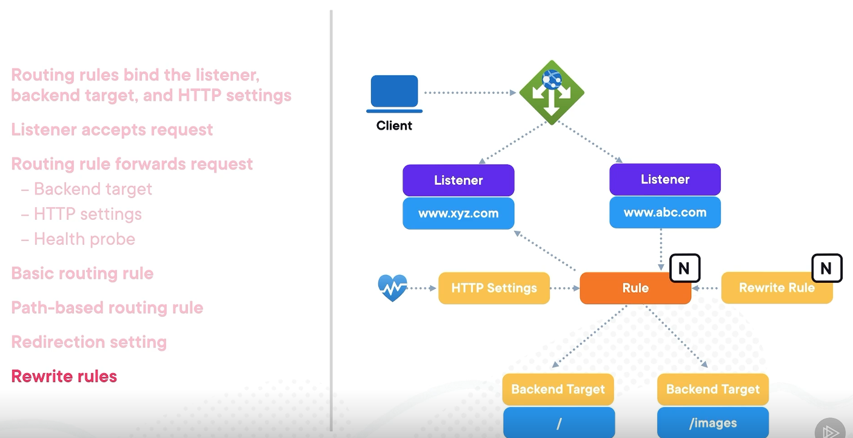
We can redirect a listener like this:
A listener can associated with a rule like this : 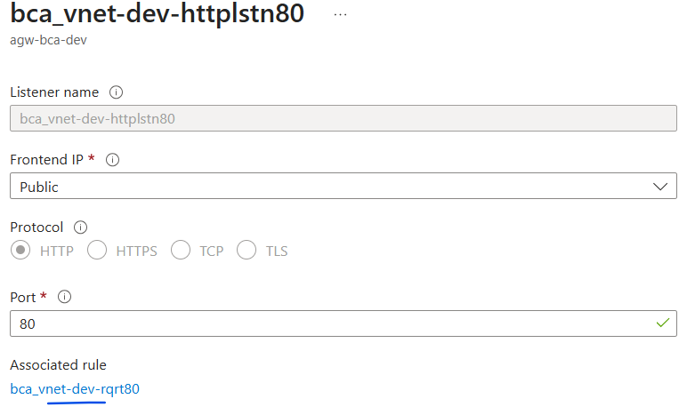
And this rule can have redirection set for backend targets for another listeners like this:
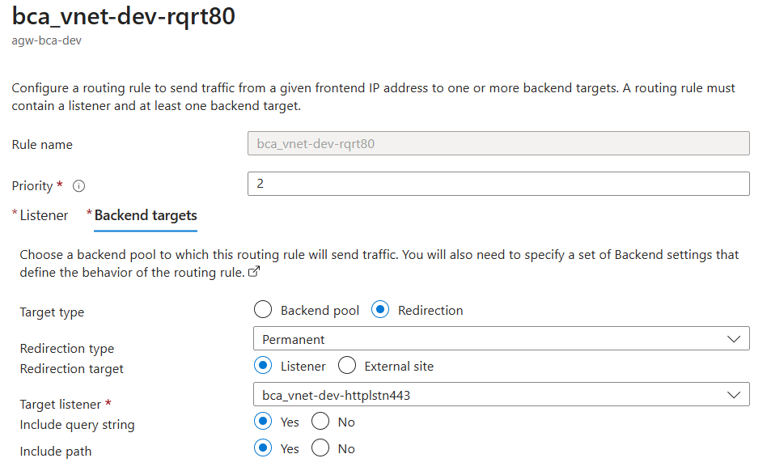
Apart from redirection we can also point the listener to backend pools like this based on paths:
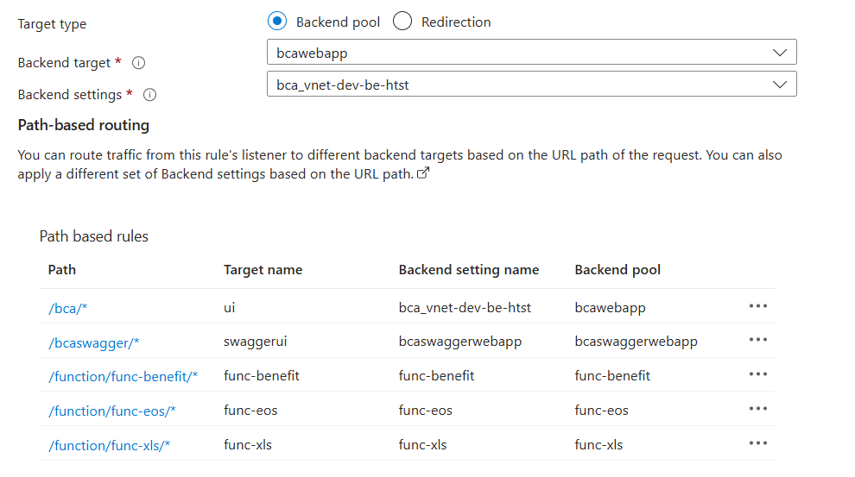

Rewrites:
These allow us to modify HTTP requests and responses as they pass through application gateway.
Request: Client → Listener → Routing Rule → Rewrite Rule Set → Backend Pool
Response: Backend → Rewrite Rule Set → Client
Rewrites can:
- Modify Request headers
- Modify Response headers
- Modify URLs and URL rewrite. We can modify Path & Query String

Example:
Incoming: /api/v1/users
Rewrite → /users
👉 Backend doesn’t need to know about /api/v1
- Conditional Rewriting: You can apply rules only when conditions match
Example:
If header = mobile → change backend path
If query contains debug=true → add header
- Server Variables Usage
You can use built-in variables like:
{http_req_host}
{request_uri}
{client_ip}
👉 Makes rewrites dynamic

BackEnd Settings:
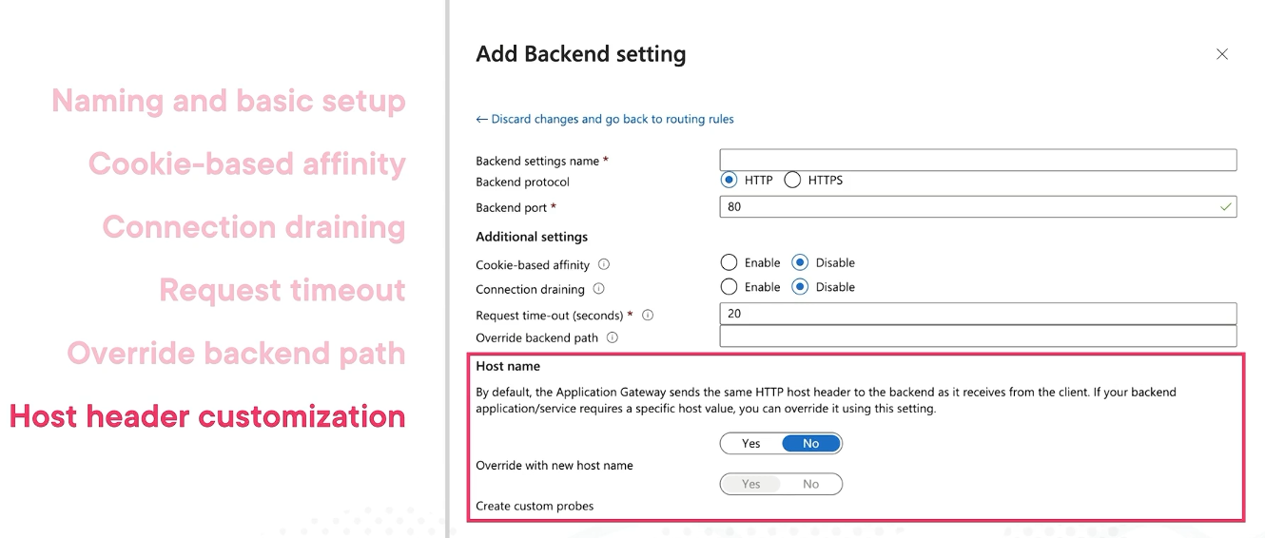

Health Probe:
A health probe is a mechanism used by Application Gateway to check whether backend servers are healthy and able to handle requests.
A health probe is like a periodic health check (ping/test request) sent by the gateway to backend servers.
Application Gateway can have multiple backend servers.
👉 It needs to make sure:
- Which servers are alive
- Which servers are failing
✅ It uses health probes to:
- Send traffic only to healthy instances
- Avoid sending requests to broken ones
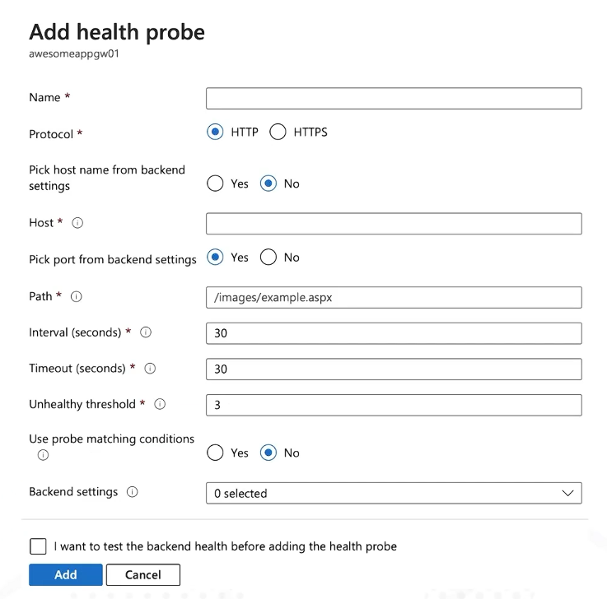
We can specify the regular interval in seconds i.e.. the interval that app gateway checks on backend service and timeout is the timeout it times out.

Azure Front Door
It is specifically designed to load balance for web applications at global scale at layer 7.
Another key feature of Azure Front Door is that it supports not just Azure services, but also those services on‑prem. So we can use Azure Front Door for global layer 7 load balancing in a hybrid network solution.
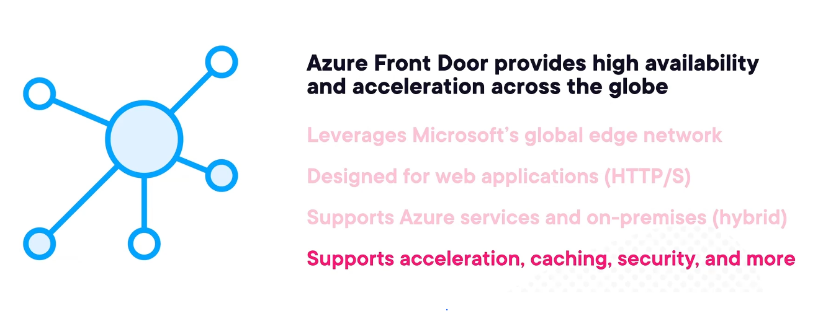
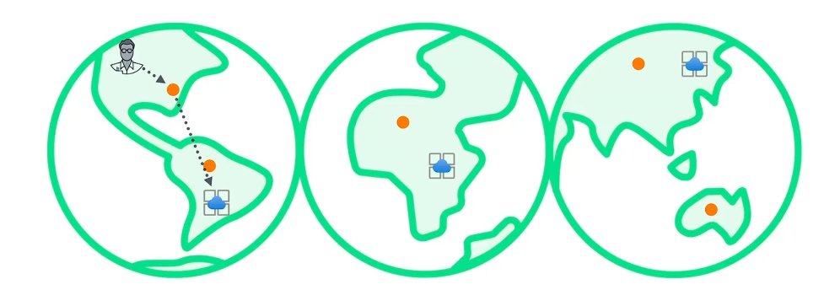
Anycast IP:
A single IP address advertised from multiple locations worldwide, where traffic automatically goes to the nearest or best-performing location.
How Anycast Works
Imagine Azure Front Door has:
- Edge locations in:
  - Hyderabad
  - Mumbai
  - Singapore
  - London
  - US
All of them advertise the same IP address, for example:
40.80.100.10 (Anycast IP)
Now what happens?
🧑‍💻 User in Hyderabad:
- Routes to Hyderabad edge POP
🧑‍💻 User in Singapore:
- Same IP resolves → routes to Singapore POP
🧑‍💻 User in UK:
- Same IP → routes to London POP
✅ Same IP ✅ Different physical destination ✅ Based on network routing (BGP)

⚙️ What decides "nearest"?
It is NOT based on physical distance alone.
It depends on:
- Network latency
- Routing policies (BGP)
- ISP peering
- Congestion
👉 So "nearest" = best network path, not necessarily geographically closest.

- When a user makes a request to a website from browser:
  - The request goes to global Anycast IP of the Azure Front Door and it forwards to the nearest edge location
  - That edge location routes the request over Microsoft’s backbone network
  - It forwards it to your origin (your web app, API, storage, etc.)
So even without caching:
- You benefit from low latency routing
- Traffic stays on Microsoft’s optimized network instead of the public internet
If caching is enabled:
- Static content (images, JS, CSS, etc.) can be stored at edge POPs
- First request:
  - Goes to origin
  - Response is cached
- Subsequent requests:
  - Served directly from nearest edge

when a client makes a request is first, they establish a TCP connection with the point of presence or that edge location. And then once they've established that TCP connection, they establish a TLS encryption. And then from there, they make the request to that edge location, and that edge location forwards that request to that web solution running in the back end, in this case, that web application gateway. Then once it gets that traffic and dishes it out to those resources in its back end, it is then going to send the return traffic back and respond to that client. Now, once it's done, that content will be cached on that edge location so that if another user comes along and makes a request for the same content, well, it's going to be a much quicker response because it doesn't have to go all the way back to that web application gateway. The reason is because it has that cache content on the edge location itself, meaning that these points of presence now have some of that content cached to be able to service requests more quickly in the future. And if a user were to come along and request traffic from a different edge location, well this process would start all over again where they'd establish a TCP and TLS, make a request, which would be forwarded to the back‑end web solution, and then the return traffic would then cache that content there.
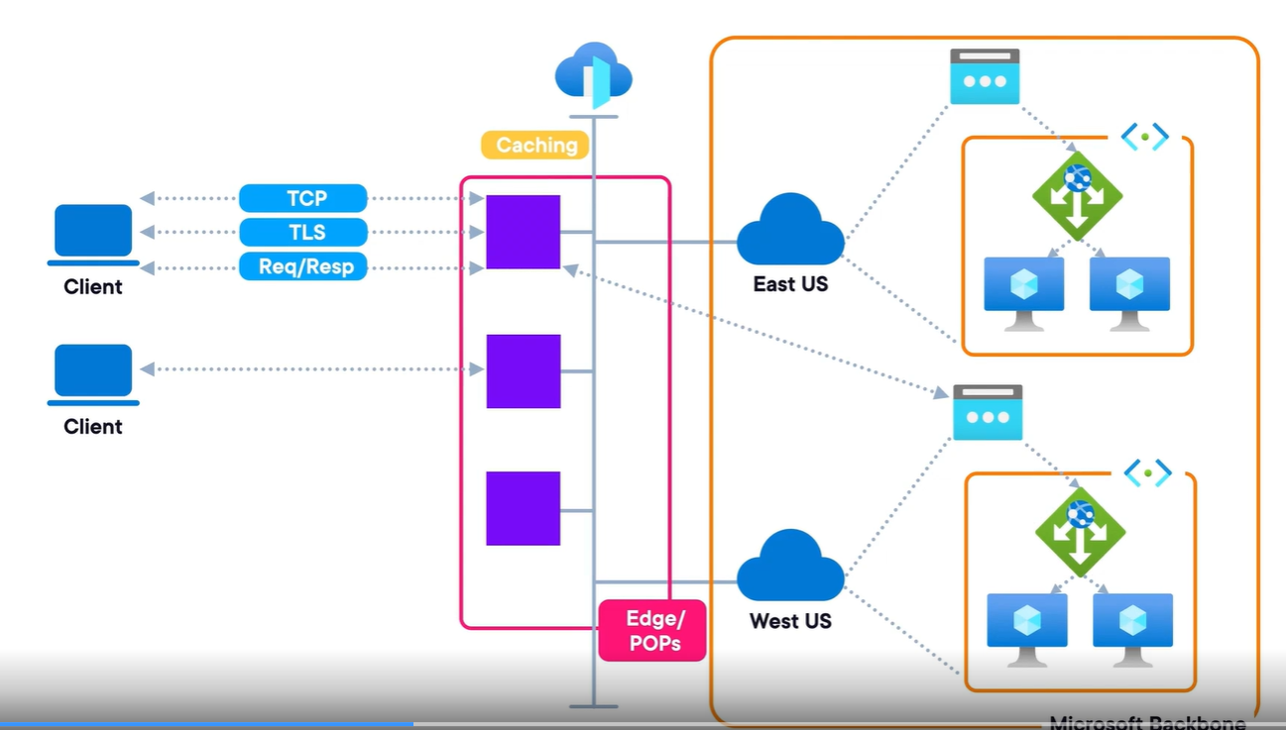
Azure Front Door architecture:
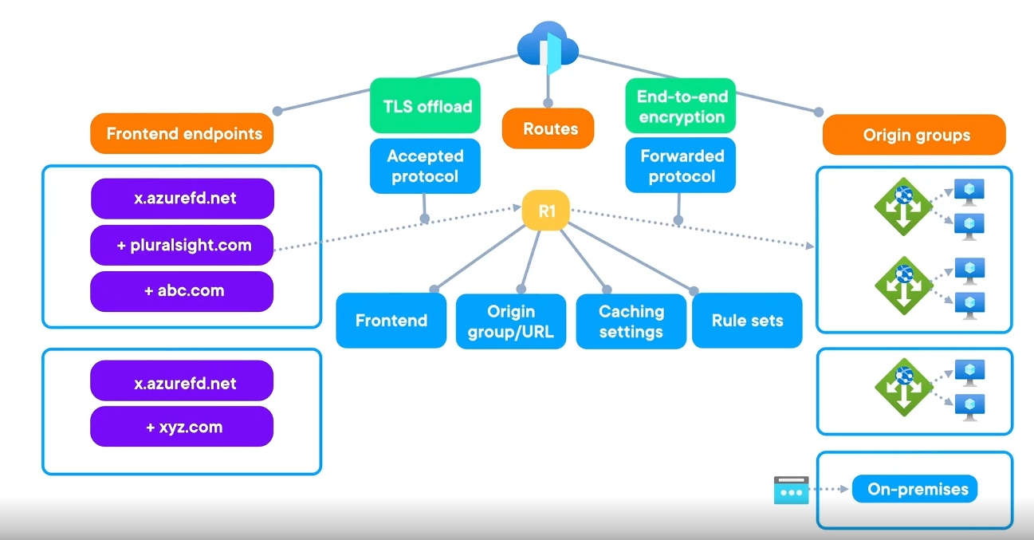
- Azure Front Door architecture consists of front-end endpoints, routes, and origin groups (back-end pools).
- Origin groups contain origins, which are back-end resources such as Azure services or on-premises services reachable via a public IP.
- An Application Gateway and its back-end resources can act as a single origin within an origin group.
- Multiple origin groups and multiple origins per group are supported for flexibility and resiliency.
- Front-end endpoints use an Azure-provided domain (e.g., *.azurefd.net) and can also support custom domains.
- Routing rules define:
  - Which front-end endpoint is used
  - Which origin group traffic is sent to
  - Caching behavior at edge locations
  - Rule sets for request handling
- Accepted and forwarded protocols control TLS behavior:
  - Accepted protocol handles TLS termination at the front end
  - Forwarded protocol enables end-to-end HTTPS encryption
- Health probes monitor origin health to ensure traffic is sent only to healthy back ends.
- Multiple front-end endpoints can map to a single route, and multiple routes can target the same or different origin groups. 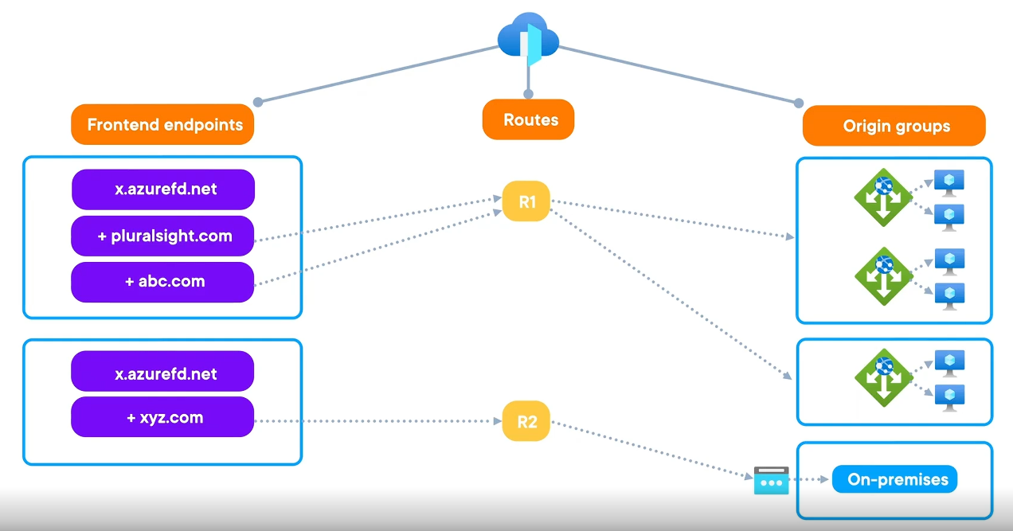
- Azure Front Door is a Layer 7 global load balancer, compared to:
  - Azure Load Balancer: Layer 4, regional and global
  - Azure Application Gateway: Layer 7, regional
Routing Rules:
- Azure Front Door terminology:
  - An Azure Front Door instance/profile represents a deployment of the Azure Front Door service.
  - The front end is called a front-end endpoint or front-end domain, using *.azurefrontdoor.net or custom domains.
- Front-end endpoints are served globally via edge locations (PoPs) using anycast IP.
- Traffic is routed to a back-end pool, known as an origin group, which contains one or more origins.
- Routing rules are responsible for sending traffic from front-end endpoints to origin groups.
  - In newer Azure Front Door SKUs, routing rule is the unified term (formerly routes and rule sets).
- Routing rule structure:
  - Left side (incoming match):
    - Accepted protocol (HTTP/HTTPS)
    - Host name (domain)
    - URL path (for path-based routing)
  - Right side (route action):
    - Forwarded protocol (HTTP/HTTPS for end-to-end encryption)
    - Cache settings
    - Target origin group and origin
    - Rule sets for rewrites and redirects
- Rules engine is part of the routing rule and uses if/then logic to evaluate conditions and take actions.
- Rule evaluation order:
  - Web Application Firewall (WAF) rules are evaluated first
  - Then the rules engine evaluates conditions and routes traffic accordingly
- The rules engine enables intelligent traffic routing, such as sending traffic to different origin groups based on matched conditions.
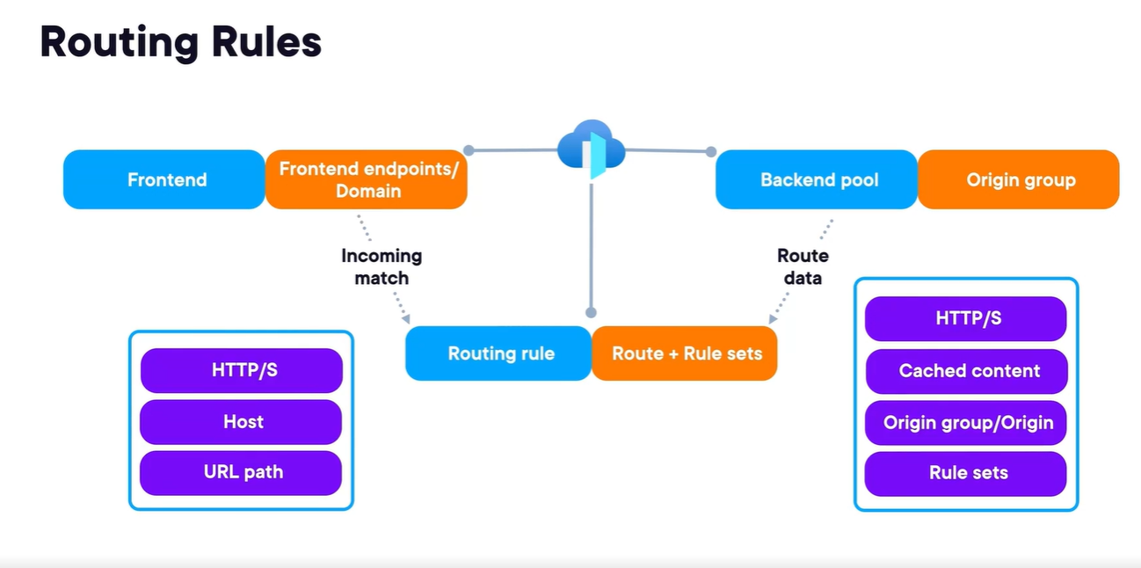
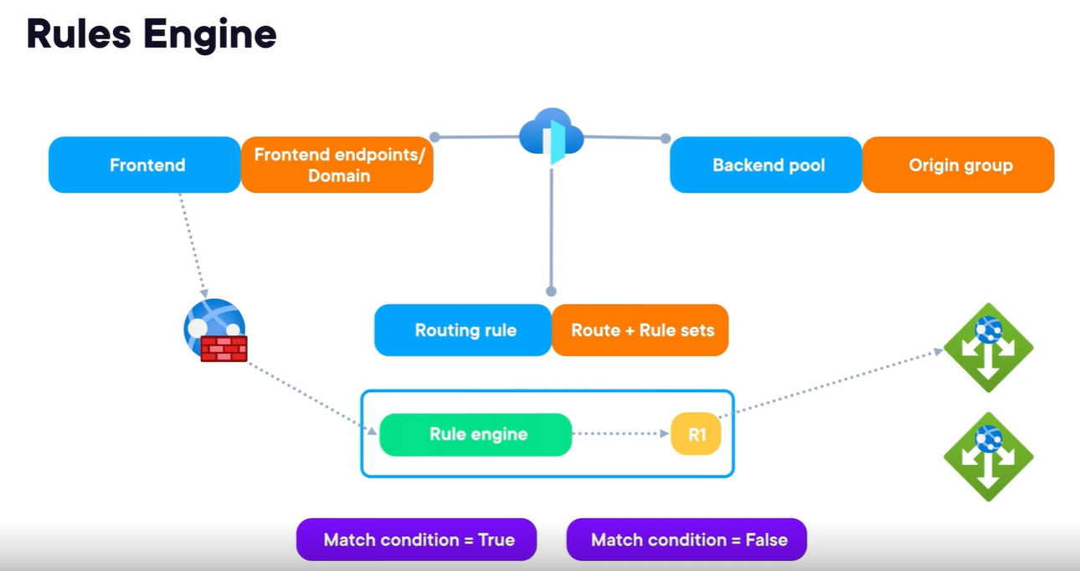
Azure Front Door – Traffic Acceleration
- Uses Microsoft’s global network of 150+ edge locations (points of presence) to route traffic efficiently.
- Combines Anycast, DNS, and HTTP header analysis to direct users to the nearest edge location.
- Employs proximity-based routing to reduce latency and improve connection speed.
- Uses split TCP to shorten connection setup time (vs. traditional TCP with 3–5 round trips).
- Establishes short connections at the nearest edge, reducing latency and improving performance globally.
- Utilizes fallback fiber routes to maintain connectivity if optimal paths fail.
- Overall benefit: faster content delivery by minimizing packet travel distance.
🔒 Azure Private Link – Security & Efficiency
- Enables private internal routing within Azure, bypassing the public internet.
- Prevents unnecessary routing where traffic leaves and re-enters Azure (common with public IP usage).
- Keeps traffic within the Azure backbone network, reducing hops and latency.
- Improves security by avoiding exposure to the public internet.
- Enhances performance through optimized internal routing and bandwidth usage.
- Ideal for scenarios where frontend and backend services are both hosted in Azure.

Azure Traffic Manager:
- Azure Traffic Manager improves app performance and reliability across multiple regions.
- It is a Layer 7 load balancing service similar to Azure Front Door.
- Uses DNS-based traffic distribution to direct clients to appropriate endpoints.
- Supports multiple routing methods to control how traffic is balanced.
- Works with different endpoint types:
  - Azure endpoints
  - On-premises (external) endpoints
  - Nested Traffic Manager endpoints
- Includes health monitoring using HTTP/HTTPS probes to check backend availability.
Components:
- Frontend: DNS name (e.g., x.trafficmanager.net) with support for custom domains.
- Endpoints: Azure, external, or nested resources that handle traffic.
- Routing methods: Define how traffic is distributed across endpoints.
Architecture & Flow:
- Client requests a domain → resolved via DNS → reaches Traffic Manager.
- Traffic Manager returns the optimal endpoint IP based on routing rules.
- Client connects directly to the endpoint (not through Traffic Manager).
- Health probes ensure only healthy endpoints receive traffic.
