FALLARM FINDER TECHNICAL REPORT

A Master's Project Submitted to

The School of Engineering

In Fulfillment for the Degree of

Masters of Science in Computer Science

By

Rajitha Vodela

Anusha Nadipally

Yansong Zhang

Sowjanya Innampudi

Sravanthi Rajapuram

Summer 2014

Prepared Under the Supervision & guidance of Dr. Henry Chang & Mr. Michael Wang



School of Engineering

Northwestern Polytechnic University

47671 Westinghouse Dr, Fremont, CA 94539

# Acknowledgments

We would like to express our deepest appreciation to Professor Dr. Henry Chang who was generous enough to offer us many insightful suggestions for the project improvement. A special gratitude goes to Professor Mr. Michael Wang who has provided invaluable support in database design concepts. Special thanks go to our team members whom have invested their effort and time to work on this project. Thanks to our family members and friends for stimulating suggestions and encouragement.Abstract

According to United Nations in 1950, there were 205 million persons aged 60 or over in the world. By 2012, the number of older persons had increased to almost 810 million. It is projected to more than double by 2050, reaching 2 billion. According to a health report published by Centers for Disease Control and Prevention nearly 1 in every 3 people over age of 65 suffer from severe injuries caused by fall (CDC, 2009). This fall risk factor increase with an increase in age due to change in sense of balance, slow reaction time, muscle weakness, etc. Hospitals have incorporated techniques to prevent reduction of fall. Prevention of fall needs a pro active approach from everyone including patient and staff.

According to a health report published by Centers for Disease Control and Prevention nearly 1 in every 3 people over age of 65 suffer from severe injuries caused by fall (CDC, 2009). This fall risk factor increase with an increase in age due to change in sense of balance, slow reaction time, muscle weakness, etc. Hospitals have incorporated techniques to prevent reduction of fall. Prevention of fall needs a pro active approach from everyone including patient and staff. A wristband to be worn in the wrist will provide the inputs to the system. The sensors in this band will monitor and record the movement and activities of the person, while keeping the person informed of his risk status at all times. The sensors will also detect a fall and report it to the care team so that appropriate action can be taken to minimize the impacts of the fall. The system will continuously update itself based on the data from the sensor and will maintain a risk profile, mobility patterns, adverse events record of its users. This historical data in turn will be provided to the sensors to more accurately identify and prevent a fall. The idea is to enable elderly people to lead an independent life, with the risk of fall being tracked round the clock.

CONTENTS

**Section**  **Page**

Acknowledgments ii

Abstract iii

1.0 INTRODUCTION 1

1.1 The Concept 1

1.2 Background 1

1.3 Objectives 1

1.4 Environment 2

2.0 Design 2

2.1 Introduction 3

2.2 Use Case Diagram 3

2.3 Activity Diagram 5

2.4 Class Diagram 8

3.0 Implementation Details 10

3.1 Introduction 10

3.2 Internet programming – Java 11

3.3 Database – MySQL 14

3.4 Network Programming – Java 14

4.0 Test Result 18

4.1 Introduction 19

4.2 Test Result Summary 20

Bibliography 21

# 1.0 INTRODUCTION

## 1.1 The Concept

Fallarm Finder is a system that monitor patients continuously , identifies sudden falls and alert care providers to take immediate attention and respond to patient's fall incident. By utilizing a mobile device's built-in sensor, it can continuously detect any sudden fall motion based on acceleration and gyroscope patterns and send these activity data to server for analysis and classify patient's risk. Care takers will be notified when a patient falls down.

Fallarm Finder system is also used to send the geo location of the ptient to the care taker so that they can go to the patients location and help the patient. This system is not only used inside the hospital but also anywhere outside the hospital too. As we are sending geo location information along with the fall alert.

## 1.2 Background

Fallarm project was initiated by QIRIS (Quality Innovation Research Instruction Safety), a non-profit organization specializing in developing innovative technology committed to social interests. They developed Fallarm, a wearable fall prevention device especially suitable for the elderly and for hospitalized patients. Fallarm has been endorsed by several hospitals and risk management organizations.

Fallarm Finder is an innovation based on QIRIS' original Fallarm concept and it is and is customized by using Android mobile device for its sensor inputs. This is focused to identify the fall as well as the location of the patient. This project will be researched, designed and developed, to be submitted towards fulfillment of the degree requirements.

## 1.3 Objectives

To develop the software part of the Fallarm Finder project, and later it could be integrated with the device being developed by the electrical engineering team.

## 1.4 Environment

The below listed are the development tools requirements to develop Fallarm Guardian on.

1. Physical hardware specification:

Processor: 1.8 Ghz Intel Core i3

Memory: 4GB

Harddrive: SSD

1. Host operating system platform:

Windows 8 Professional, 64-bit

1. Virtual Machine:

VMware Fusion 6.0.2

1. Workshop guest operating system platform:

Ubuntu Linux 12.04

1. Android Mobile (Android Virtual Device) emulator

CPU: ARM (armeabi-v7a)

Target SDK: Google API level 17

1. Web Server:

Apache Tomcat 7.0.50

1. Database Server:

MySQL 5.6.15

1. Java:

JDK 7

1. Development IDE:

Eclipse Kepler JEE edition, with ADT plug-in

Android Studio SDK bundle

# 2.0 Design

## 2.1 Introduction

This is the preliminary phrase of our project development, after we evaluate features needed for the project; we convey our ideas into visual modeling representations. By using Unified

Modeling Language (UML) we can capture design information more effectively, which helps get the ideas across and serves as a ground work for our next step in the development, the implementation.

Use Case Diagram describes the functionality provided by a system in terms of external specification for users. Class Diagram is a structure diagram for internal specification which describes structure of a system. Sequence Diagram is an interaction diagram which shows how objects communicate with each other.

## 2.2 Use Case Diagram

2.2.1 Use Case Diagram of Network

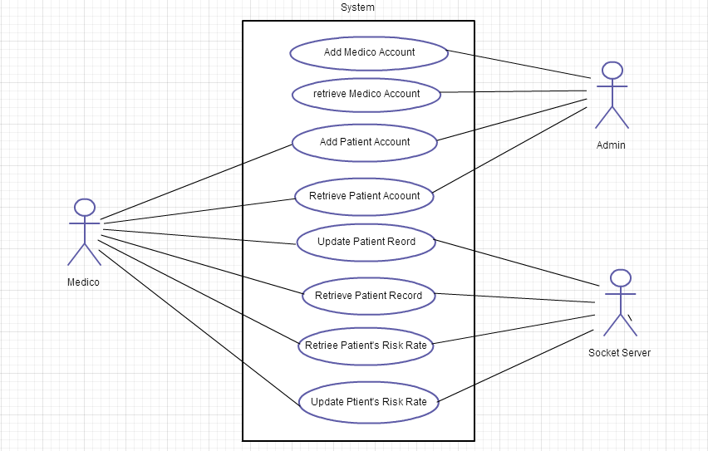

2.2.2 Use Case Diagram of Internet

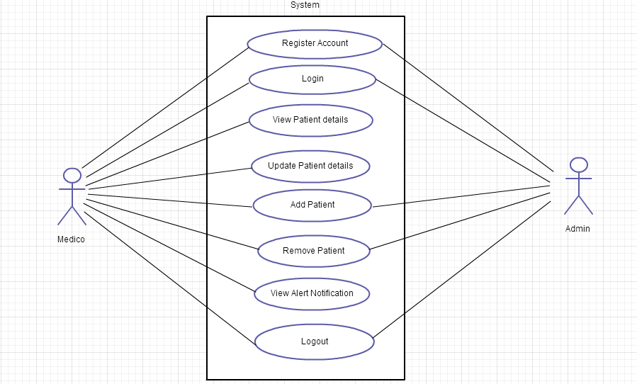

2.2.3 Use Case Diagram of Database

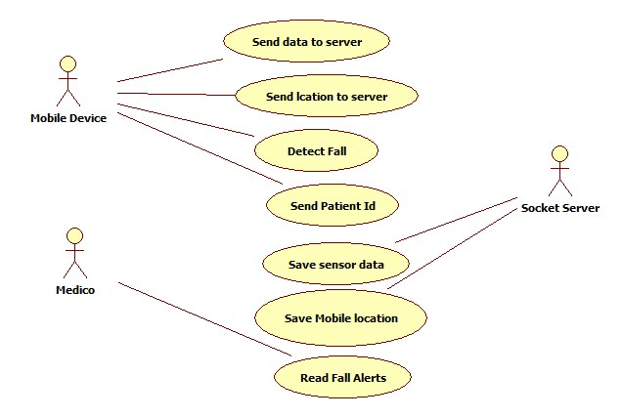

## 2.3 Class Diagram

2.3.1 Class Diagram of Network

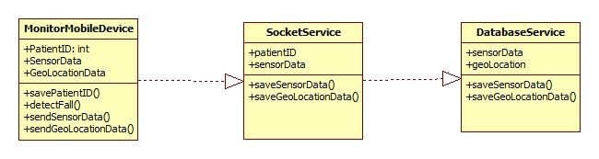

2.3.2 Class Diagram of Internet

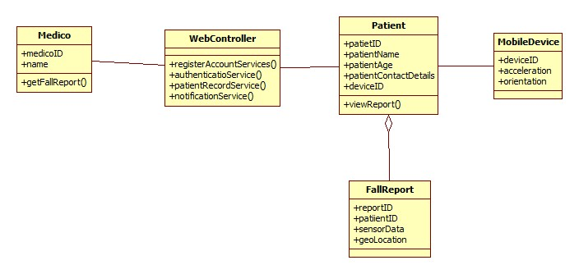

2.3.3 Class Diagram of Database

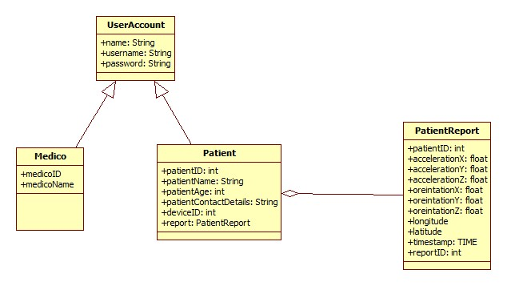

## 2.4 Sequence Diagram

2.4.1 Sequence diagram of Network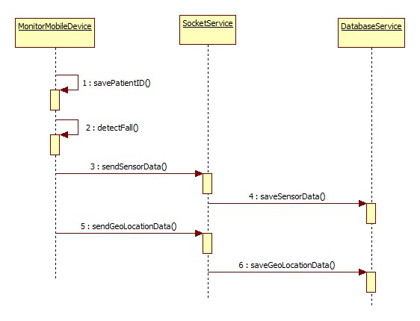

2.4.2 Sequence diagram of Internet

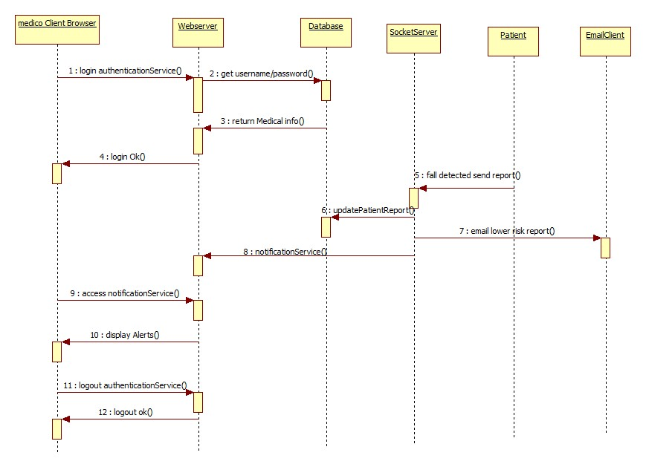

2.4.3 Sequence diagram of Database

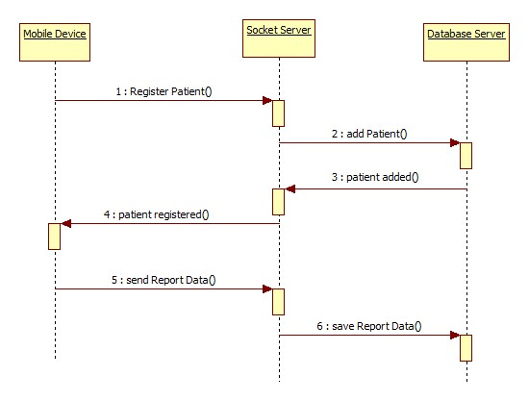

## 3.0 Implementation Details

**3.1 Introduction**

Software includes an android based device to monitor person’s activities. Sensor and device is programmed to detect and track acceleration, orientation, longitude and latitude values. Java based Socket Programming is for communication with server- device and server-staff. Java, J2EE Servlets, JDBC, JSP, html, CSS, Spring Frame Work are used to implement the Web UI and Web Server for the Fallarm Guardian project. We are developing server side programming that will monitor patient activities. Patient’s risk is calculated and related information is stored in database which can be later used to analyze and display specific patterns. Internet based GUI is provided for staff to access patient details.

User Interface should be designed to match the skills, experience and expectations of users and user interface design. In this project, Internet programming mainly includes designing the graphical user interface for the staff at the hospital so that they can view the patient details.

HTML: Web pages must conform to the rules of HTML in order to be displayed correctly in a Web browser. The HTML syntax is based on a list of tags that describe the page's format and what is displayed on the Web page.

JSP: Java Server Pages (JSP) is a technology for developing web pages that support dynamic content which helps developers insert java code in HTML pages by making use of special JSP tags. Using JSP, you can collect input from users through web page forms, present records from a database or another source, and create web pages dynamically. JSP tags can be used for a variety of purposes, such as retrieving information from a database or registering user preferences, accessing JavaBeans components, passing control between pages and sharing information between requests, pages etc.

Servlet: The servlets are used to create web pages, which are called dynamic web pages which mean the content of a web page can change according to the input sent from the web client.

Java Script: JavaScript is a sequence of statements to be executed by the browser. JavaScript statements are "commands" to the browser. The purpose of the statements is to tell the browser what to do.

Server: We use Apache Tomcat server.

## 3.2 Environment Setup

XAMPP, Eclipse IDE

## 3.3 Internet programming – Java

List all patients

<%@ page language="java" contentType="text/html; charset=UTF-8"

pageEncoding="UTF-8"%>

<!DOCTYPE html PUBLIC "-//W3C//DTD HTML 4.01 Transitional//EN" "http://www.w3.org/TR/html4/loose.dtd">

<html>

<head>

<meta http-equiv="Content-Type" content="text/html; charset=UTF-8">

<%@page import="fallArmDB.*" import="config.*" import="fallArmAction.*" import="java.util.*"%>

<title>Insert title here</title>

</head>

<body>

<%

ArrayList<Patient> list = DBUtils.GetAllPatient();

%>

<h2>Patients List</h2>

<table>

<th>

<td>Patient ID</td>

<td>Patient Name</td>

<td>Patient Gender</td>

<td>Patient BirthDay</td>

</th>

<%

for(int i = 0; i < list.size(); i++)

{

Patient oPatient = list.get(i);

%>

<tr>

<td><%=oPatient.getPatient_id() %></td>

<td><%=oPatient.getPerson_firstname() + " " + oPatient.getPerson_lastname() %></td>

<td><%=oPatient.getPerson_gender() %></td>

<td><%=oPatient.getPerson_birth().toString() %></td>

</tr>

<%

}

%>

</table>

</body>

</html>

## UI Screenshots:

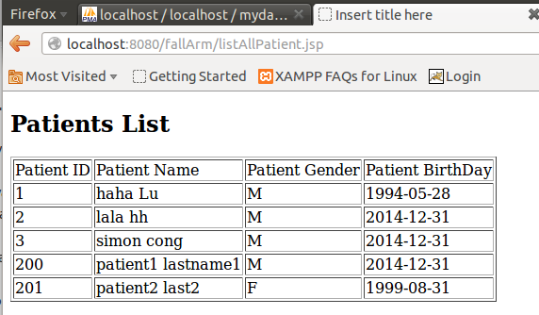

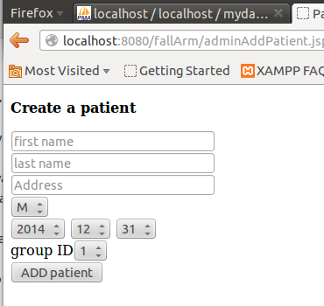

## 3.4 Database – MySQL

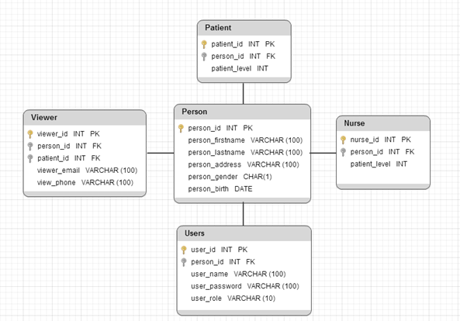

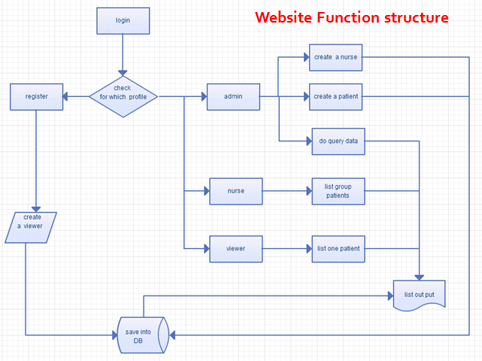

## 3.5 Network Programming – Java

**UDP Communication:**

Sensor in Android device manager listens to activity pattern and sends the activity to server whenever there is a dangerous situation. The data is sent continuously to the server. Server program on the other side analyzes the received data and sends email to nurse if it is considered dangerous. A UDP socket connection is used between the server and client to enable the client to send data to the server. For socket programming Java networking API is used.

The following data is sent from client to server:

* Acceleration x,y,z axis
* Orientation x,y,z axis
* Geo-Location data
* patient ID/Patient info

**Server side Programming:**

This carries out the second part of communication, server side programs receive data from android client and calculates the risk factor, it risk factor is high, it calls the methods to send email to nurse according to patient ID.

**Risk Factor Calculation:**

An algorithm is implemented to calculate the risk after fall detection based on the information given by android client. Acceleration has three values (ax, ay, az). Based on these three values the risk class is estimated.

This algorithm uses only the three coordinates of the accelerometer to find the risk class. First the vector sum is calculated as shown below:

sqrt(Round(pow(ax, 2) + pow(ay, 2)+ pow(az, 2))).

**Implementation of SMTP:**

JavaMail API is used to send alert messages to staff and it is sent via Gmail SMTP server. Sender's email and password is authenticated and email is sent to staff email id retrieved from database. The message includes patient id in it so that staff can login to website for more details.

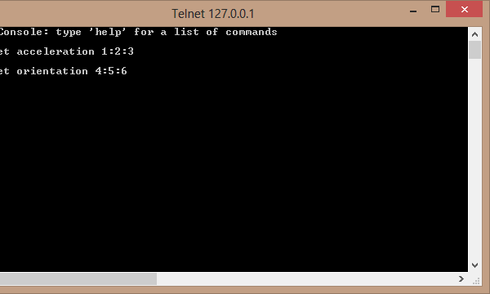

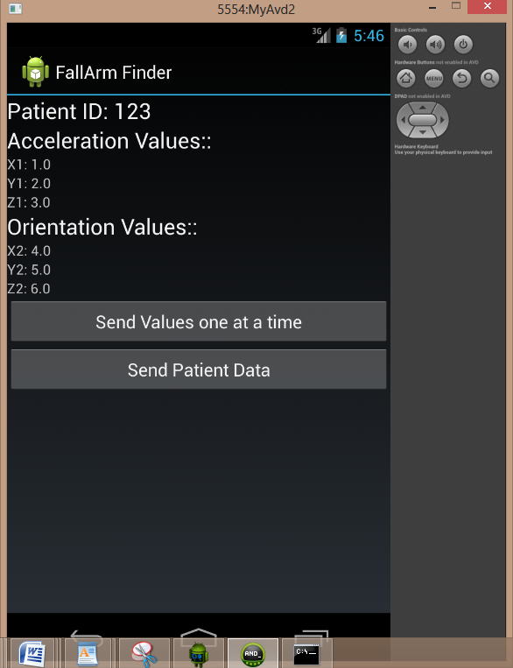

# 4.0 Test Result

## 4.1 Introduction

Software Testing is the process used to help identify the correctness, completeness, security, and quality of developed computer software. Fallarm application requires various levels of testing methodologies as it provides different interfaces to the end user (Web Interface, Database)

Levels of testing

**Acceptance testing**

Acceptance testing performed by the customer .It is also known as User Acceptance Testing

**Integration Testing**

Testing that seeks to verify Interfaces betweenComponents against software design

**Unit Testing**

It is also known as Component Testing. Developers usually do it

**Grey box Testing**

Involves having the knowledge of internal sourcecode for the purpose of designing test

## 4.1 Test Environment

Selenium IDE

JUnit Test Automation

## 4.3 Test Result Summary

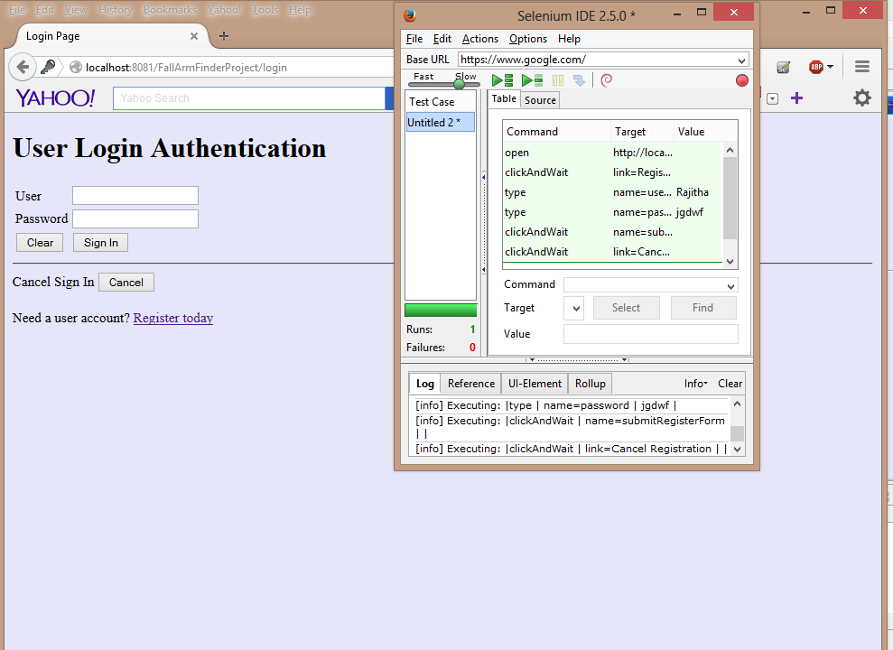

5. Sending Email to staff:

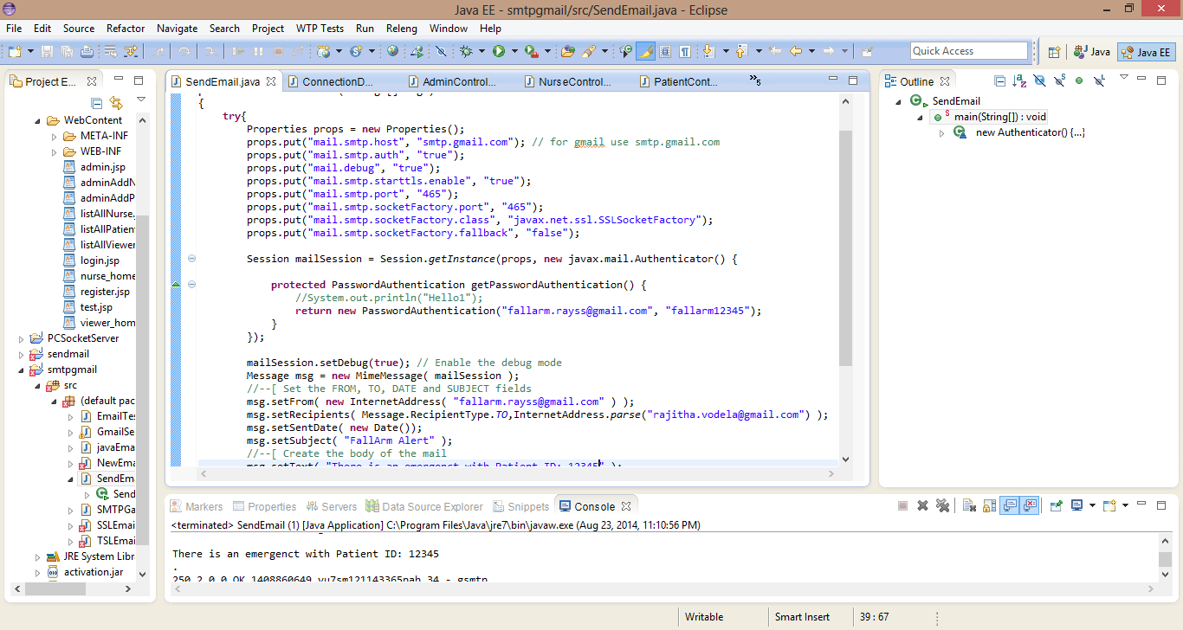

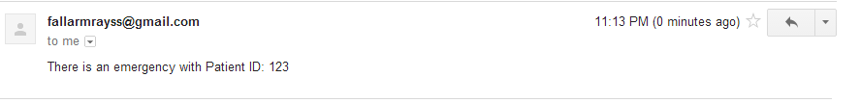

# Bibliography

United Nations, Department of Economic and Social Affairs, Population Division. World Population Prospects: The 2010 Revision, Volume II: Demographic Profiles.2011.

Nicholas Caporusso, Irene Lasorsa , Oliviero Rinaldi, and Leonardo la Pietra. A Pervasive Solution for Risk Awareness in the context of Fall Prevention. 2009.