**OS Lab End Sem Examination**

**Description and Logic of Codes**

**Name: Vraj Parikh**

**Enrolment No: AU1940185**

**Ques 2(b):**

Describe the RoundRobin (RR) and Modified RoundRobin (MRR)

Algorithm. Also mention the difference between the results of both

the algorithms and implement them both in C.

**Round Robin Algorithm**

Round robin is a CPU scheduling algorithm that is designed especially for time sharing systems.

It is more like a FCFS scheduling algorithm with one change that in Round Robin processes are bounded with a quantum time size.

A small unit of time is known as time quantum or time slice (generally from 10 to 100 ms). A ready queue is treated as a circular queue. New processes are added to the tail of ready queue. CPU scheduler goes around the ready queue, allocating CPU to each process for given time interval.

It follows pre-emptive approach because fixed time are allocated to processes.

The only disadvantage of it is overhead of context switching.

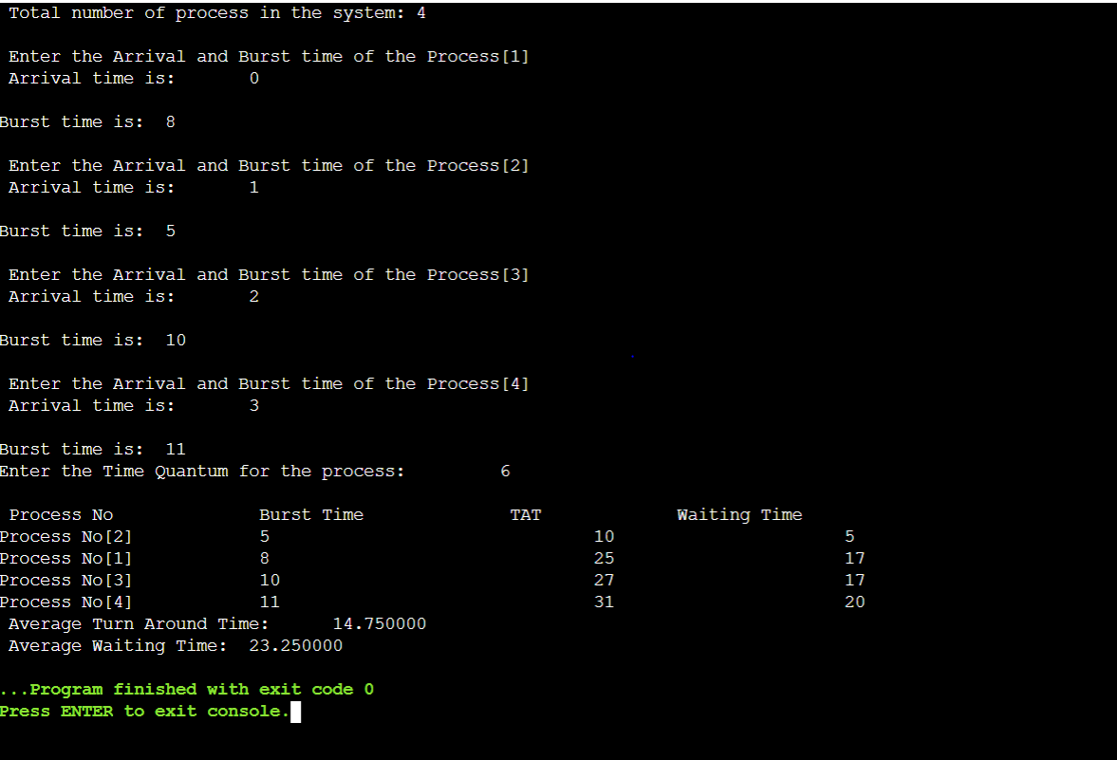

**Modified Round Robin Algorithm**

Now, Round Robin Scheduling has many disadvantages like higher average waiting time, low Throughput, more number of context switches if we take a short time quantum and very high turnaround time.

Modified Round robinalgorithm determines the time quantum on its own.  It is introduced for enhancing CPU performance using dynamic time quantum with RR.

This algorithm diminishes the waiting up time and turnaround time definitely contrasted with basic Round Robin.

In this modified RR algorithm, we assume the following points-

• We assume that the ready queue is empty.

• We assume that all the processes arrived at a same time for execution; arrival time for all the processes is 0.

• We already have number of processes and their respective burst time.

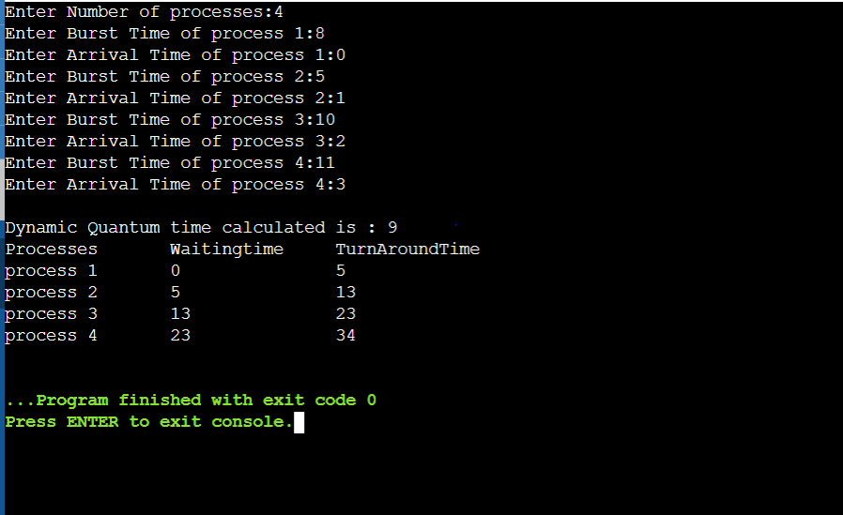

**Difference bet results of both algorithms:**

Modified RR performs way better than existing RR algorithm.

Modified RR algorithm is suitable for real life problems when processes arrive together and have large burst time.

Modified RR can handle around hundred no of processes.