**MODULE : 1**

**1. What is software? What is software engineering?**

**Software :-**

- In a [computer system](https://www.geeksforgeeks.org/basics-of-computer-and-its-operations/), the software is basically a set of instructions or commands that tell a computer what to do.

- Software is a generic term used to refer to applications, [scripts](https://www.techtarget.com/whatis/definition/script) and programs that run on a device.

- The two main categories of software are application software and system software.

**Software Engineering :-**

- Software engineering is the branch of computer science that deals with the design , development , testing and maintenance of software application.

-  It is a systematic and disciplined approach to software development that aims to create high-quality, reliable, and maintainable software.

**2. Explain types of software.**

- Software is the set of instruction or programs used to operate computers and execute specific tasks.

**- Types of Software :-**

- The chart below describes the types of software:-

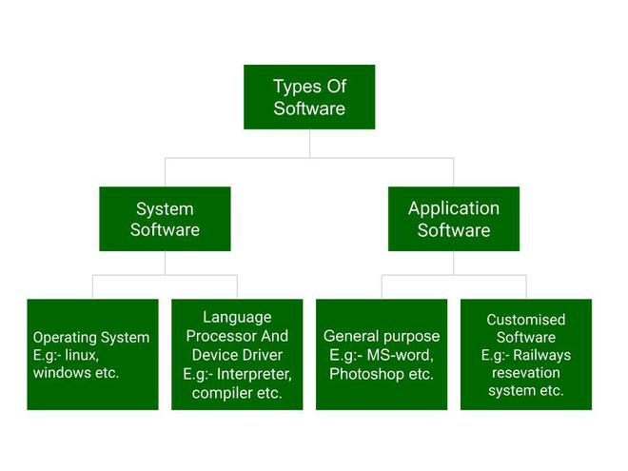

- As per diagram , we will briefly describe each types and its subtypes.

1. **System Software**
   * Operating System
   * Language Processor
   * Device Driver
2. **Application Software**
   * General Purpose Software
   * Customize Software
   * Utility Software

**[1].System Software :-**

**(i) Operating System :-**

- Operating system is a program that acts as an interface between computer hardware and user.

- Basically, it manages all the resources such as computer memory, CPU , memory , hard disk, etc.

- macOS , Linux , Windows are the examples of operating system.

**(ii) Language Processor :-**

**-** we know that system software converts the human-readable language into a machine language.

- So, the conversion is done by the language processor.

- It converts programs which written in high-level programming language like java , c , c++ , python etc (known as source code) into sets of instructions that are easily readable by machines(known as machine code).

**(iii) Device Driver :-**

**-** A device driver is a program or software that controls a device.

- It enable the operating system to communicate with hardware devices.

- Every device like a printer, mouse etc. needs a driver to connect with the computer system eternally.

**[2]. Application Software :-**

**(i) General purpose Software :-**

**-** This type of application software is used for a variety of tasks and it is not limited to performing a specific task only.

- For example, MS-Word, MS-Excel, PowerPoint, etc.

**(ii) Customized Software :-**

- This type of application software is used or designed to perform specific tasks or functions.

- For example, railway reservation system , airline reservation system, invoice management system, etc.

**(iii) Utility Software :-**

- Utility software is a type of system software designed to help manage, maintain, and control computer resources.

- For example, antivirus , memory tester, disk repair, disk cleaners, disk space analyzer, etc.

**3. What is SDLC? Explain each phase of SDLC.**

- Here , SDLC stands for Software Development Life Cycle.

**- SDLC is a structured process that is used to design, develop, and test good-quality software.**

**-** The goal of the SDLC life cycle model is to deliver high-quality, maintainable software that meets the user’s requirements.

**-> Software Development Life Cycle :-**

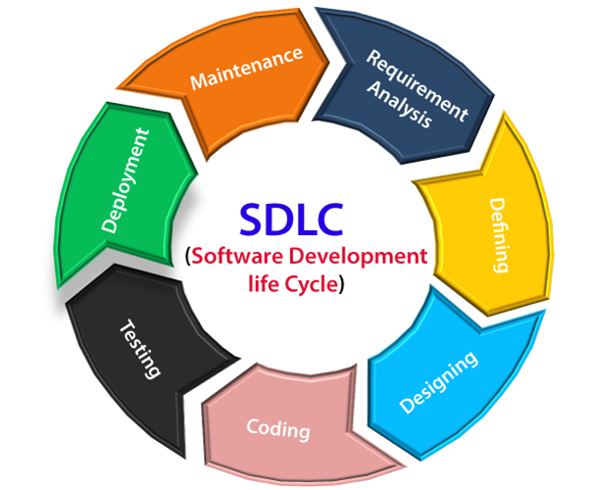

**(i) Planning and requirement analysis :-**

- Requirement Analysis is the most important and necessary stage in SDLC.

- This is attained from customer inputs, and sales department/market surveys.

- The information from this analysis forms the building blocks of a basic project.

- In this stage, the basic project is designed with all the available information.

**(ii)** **Defining Requirements :-**

**-** Once the requirement analysis is done, the next stage is Defining Requirements.

- In this stage, all the requirements for the target software are specified. These requirements get approval from customers, market analysts, and stakeholders.

- This is fulfilled by utilizing SRS (Software Requirement Specification).

**(iii)** **Designing the Software :-**

**-** The next phase is about to bring down all the knowledge of requirements, analysis, and design of the software project.

- This phase is the product of the last two, like inputs from the customer and requirement gathering.

**(iv)** **Developing the project :-**

**-** At this stage, the fundamental development of the product starts.

- For this, developers use a specific programming code as per the design in the DDS.

**(v)** **Testing :-**

**-** After the development of the product, testing of the software is necessary to ensure its smooth execution.

-Although, minimal testing is conducted at every stage of SDLC.

**(vi) Deployment :-**

- Once the software is certified, and no bugs or errors are stated, then it is deployed.

- After the software is deployed, then its maintenance begins.

**(vii) Maintenance :-**

**-** The software will need maintenance to address any issues or bugs that arise, implement new features, and ensure the software remains functional and secure over time.

**4. What is DFD? Create a DFD diagram on Flipkart.**

- DFD stands for Data Flow Diagram.

- Data Flow Diagram (DFD) represents the flow of data within information systems.

- Data Flow Diagrams (DFD) provide a graphical representation of the data flow of a system.

**- DFD diagram on flipkart :**

- **Context level DFD – 0 level**

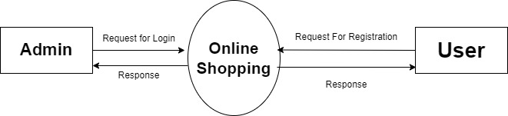

**- 1st Level Admin Side DFD**

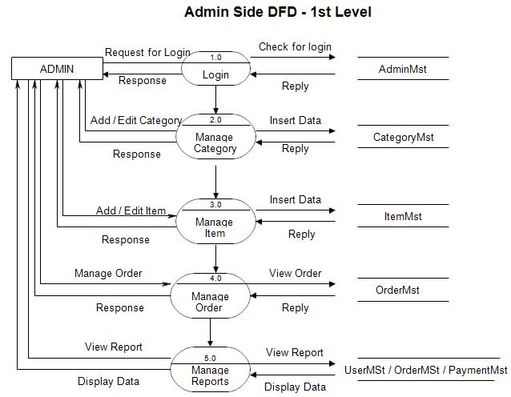

**- 2nd Level – Admin side DFD (3.0)**

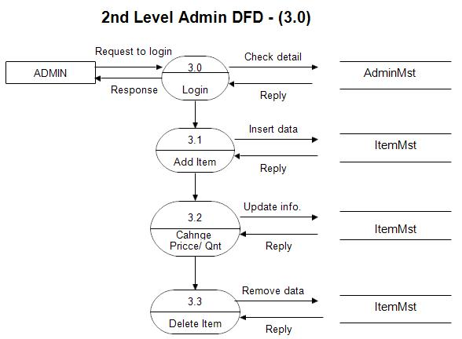

**- 2nd Level – Admin side DFD (4.0)**

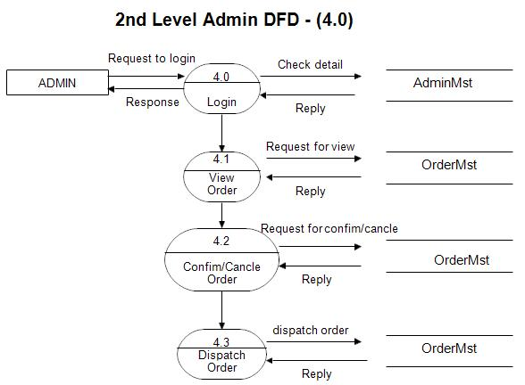

**5. What is Flow chart? Create a flowchart to make addition of two numbers.**

- A flowchart is a type of diagram that represents a workflow or process.

- **Flowcharts** are the graphical representation of the data or the algorithm for a better understanding of the code visually.

-  It displays step-by-step solutions to a problem, algorithm, or

process.

- A flowchart is a picture of boxes that indicates the process flow sequentially.

**- Here is flowchart of addition of two numbers.**

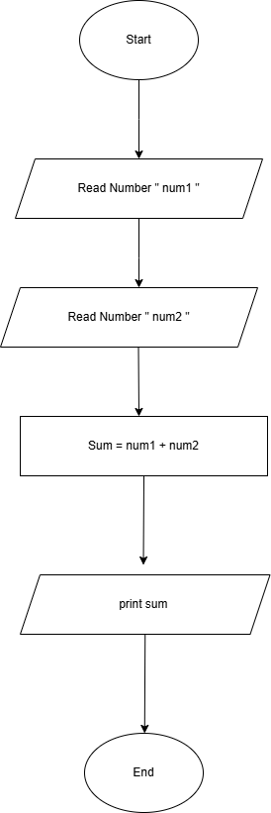

**6. What is Use case Diagram? Create a use-case on bill payment on paytm.**

- A Use Case Diagram is defined as a graphical representation of the interactions between users and a system.

- It illustrates the various ways in which users interact with a system to achieve specific goals or tasks.

- A Use Case Diagram is a type of Unified Modelling Language (UML) diagram.

**- Here is Use case diagram on bill payment on paytm.**

