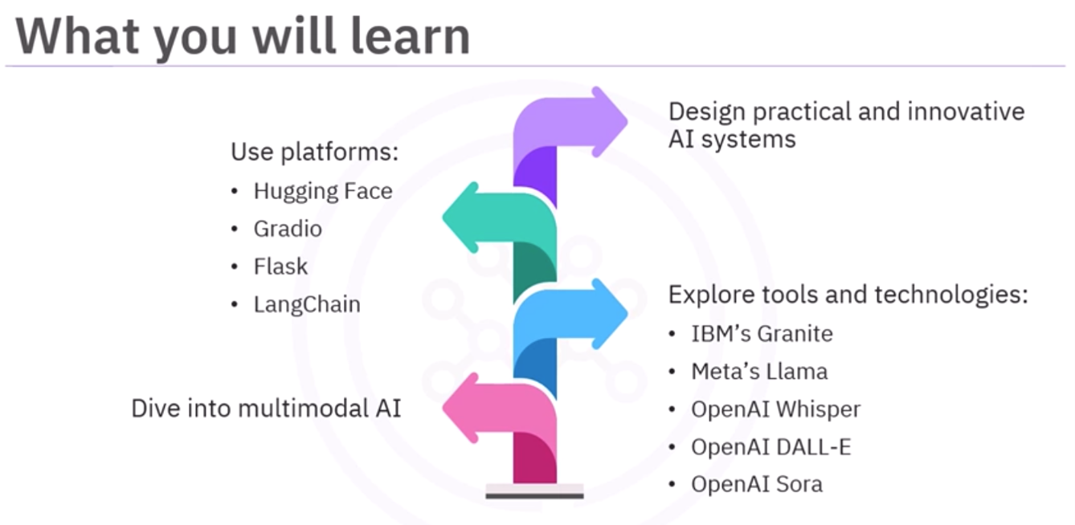
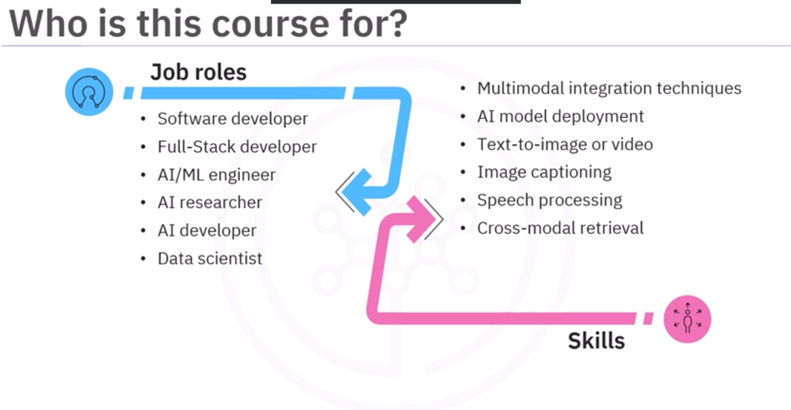
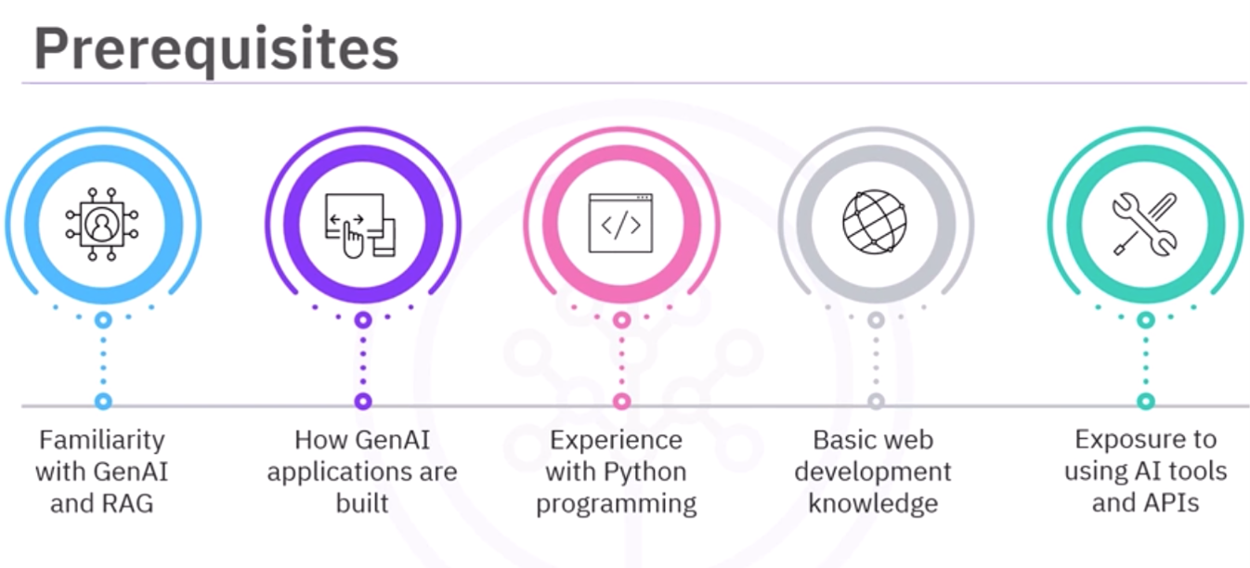
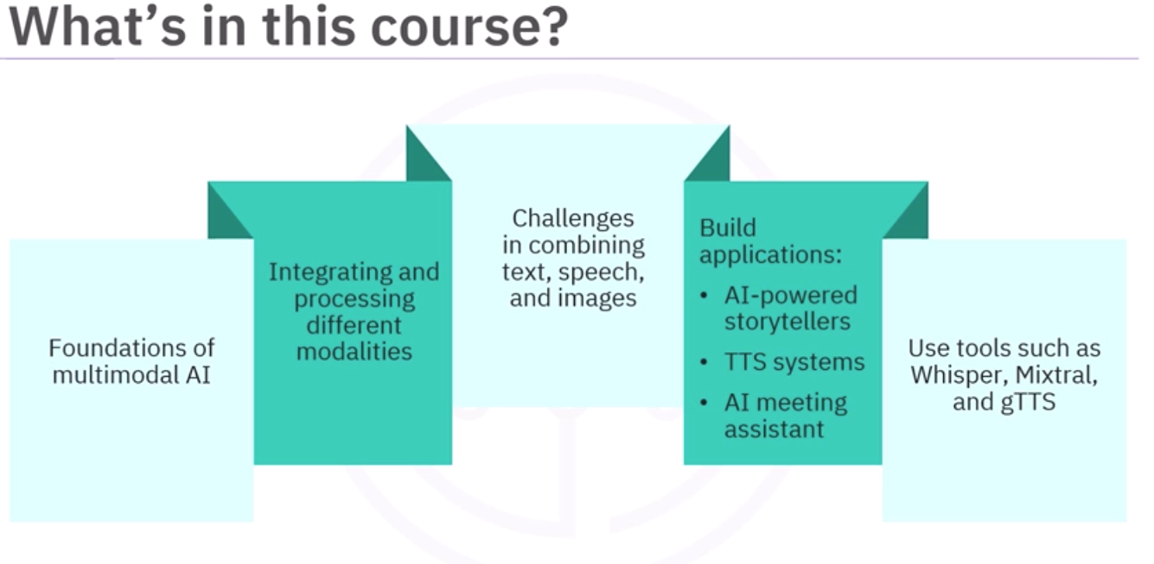
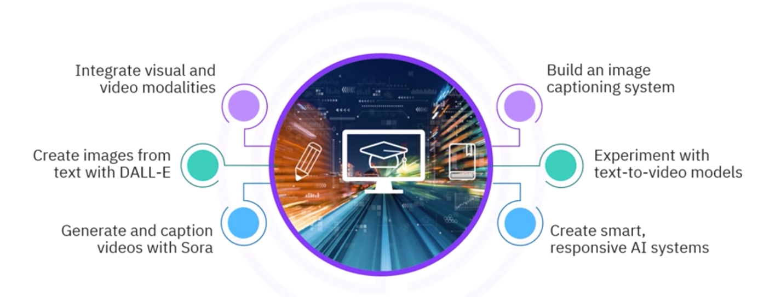
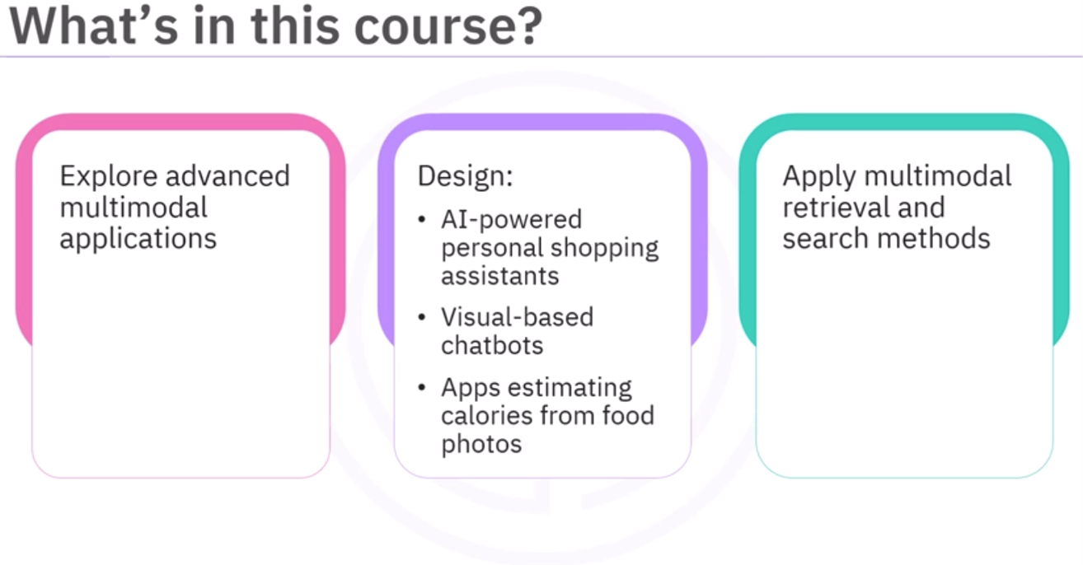


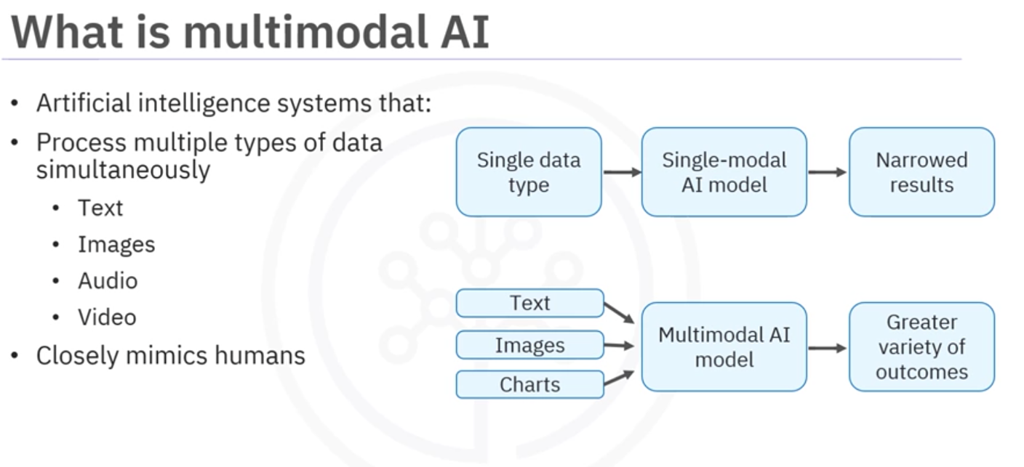
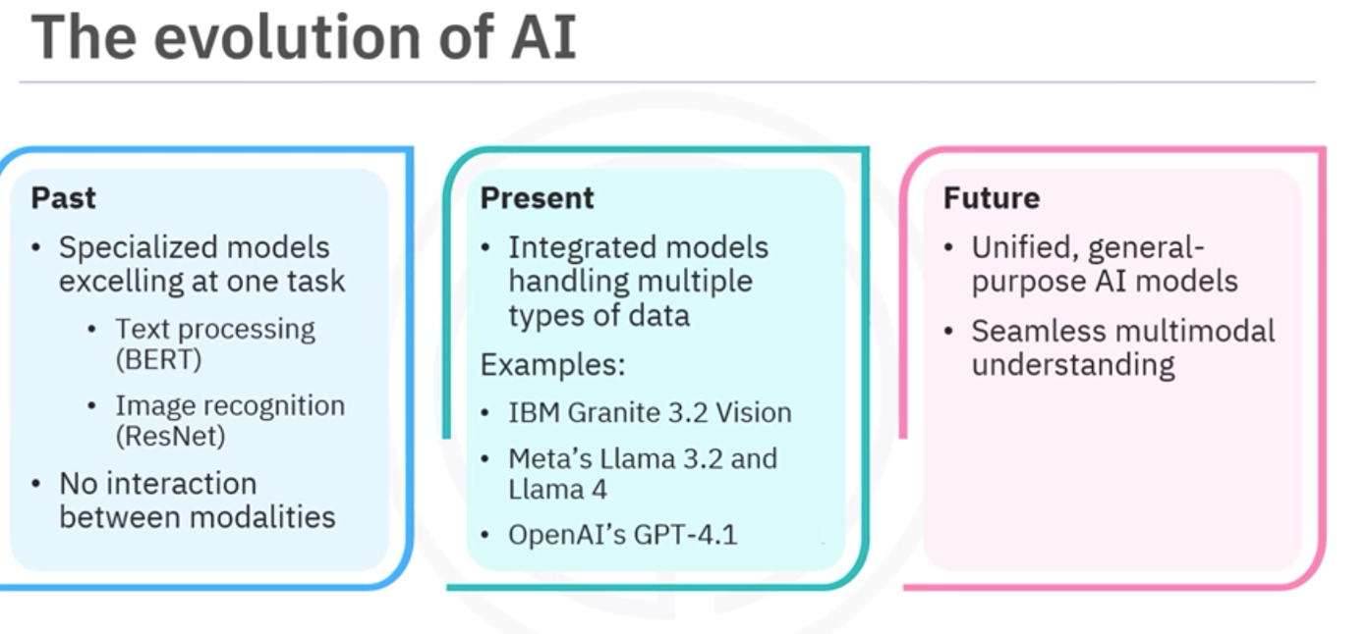
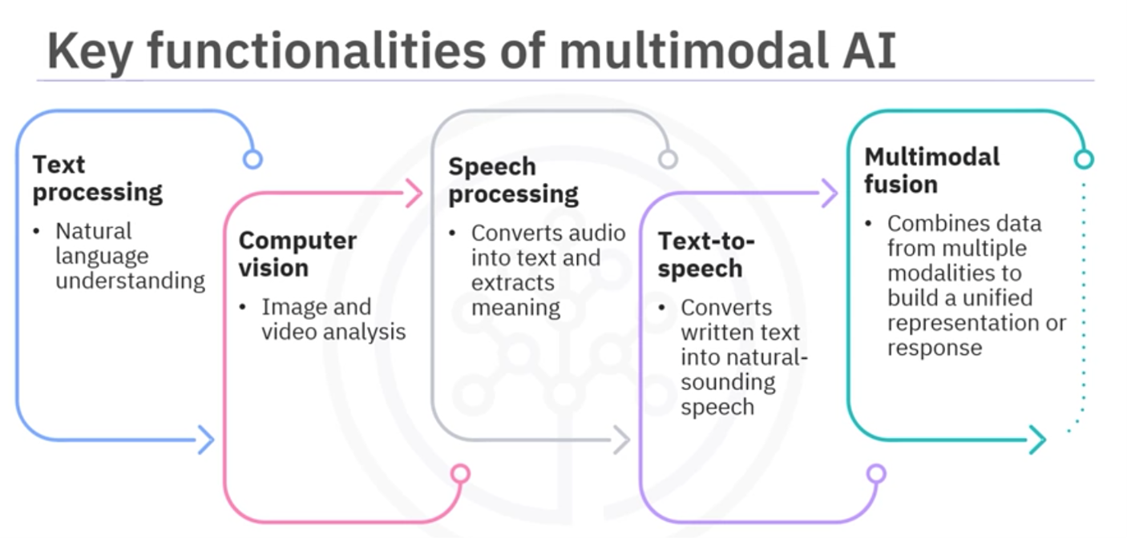

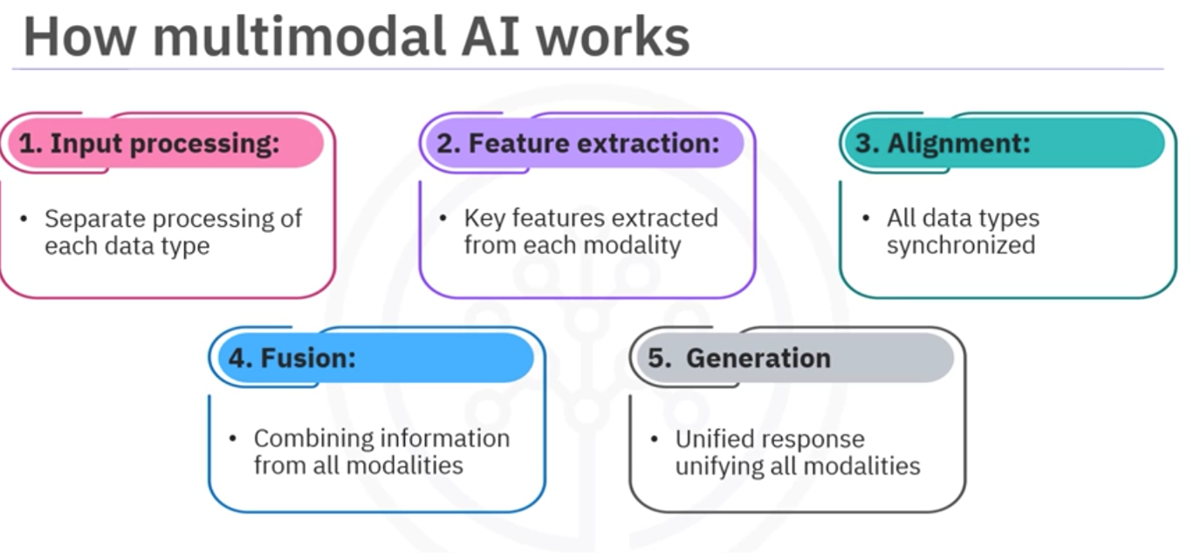
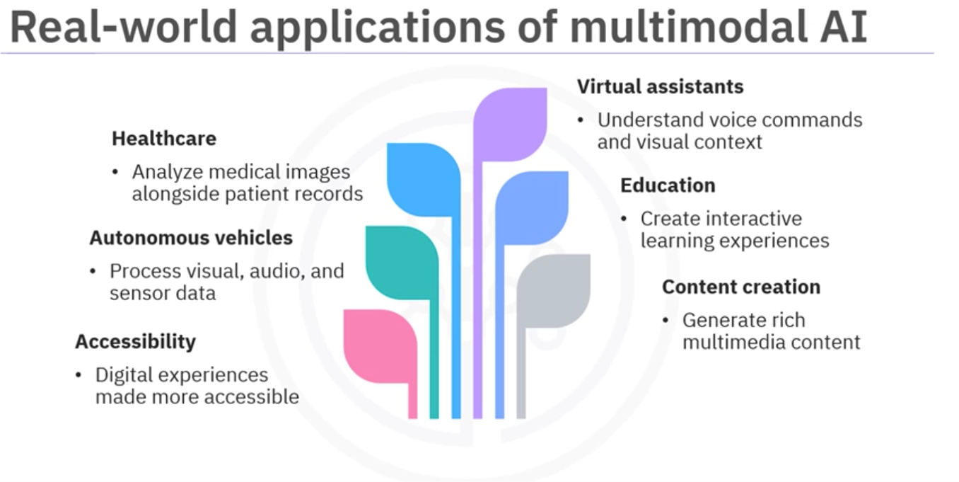
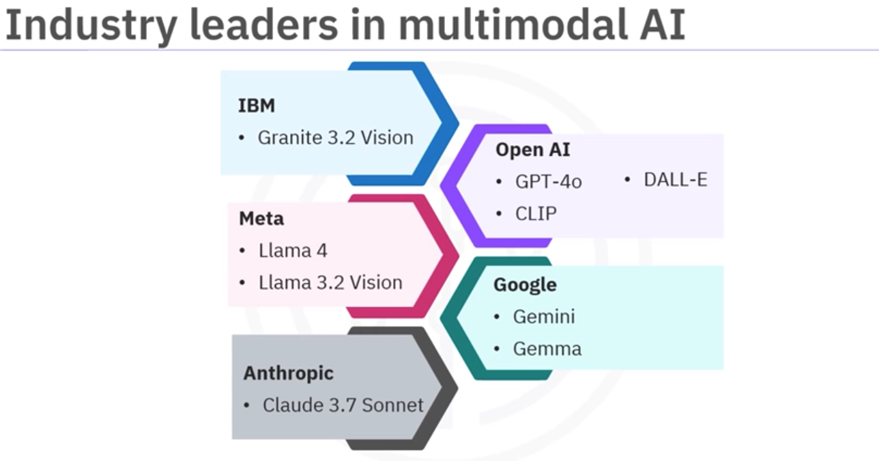

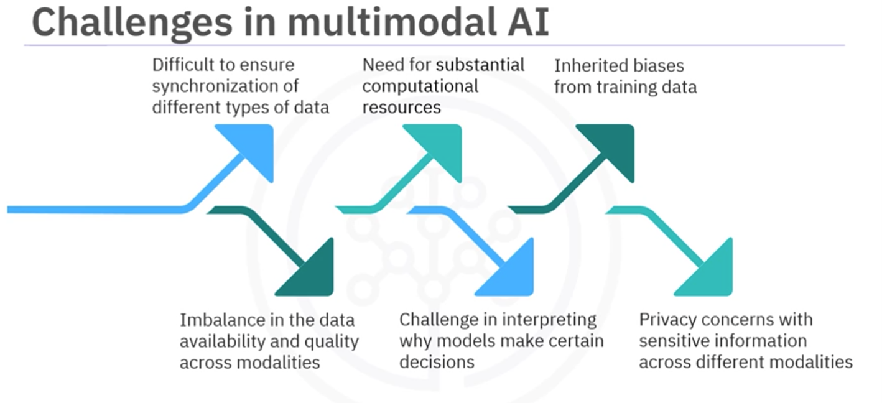
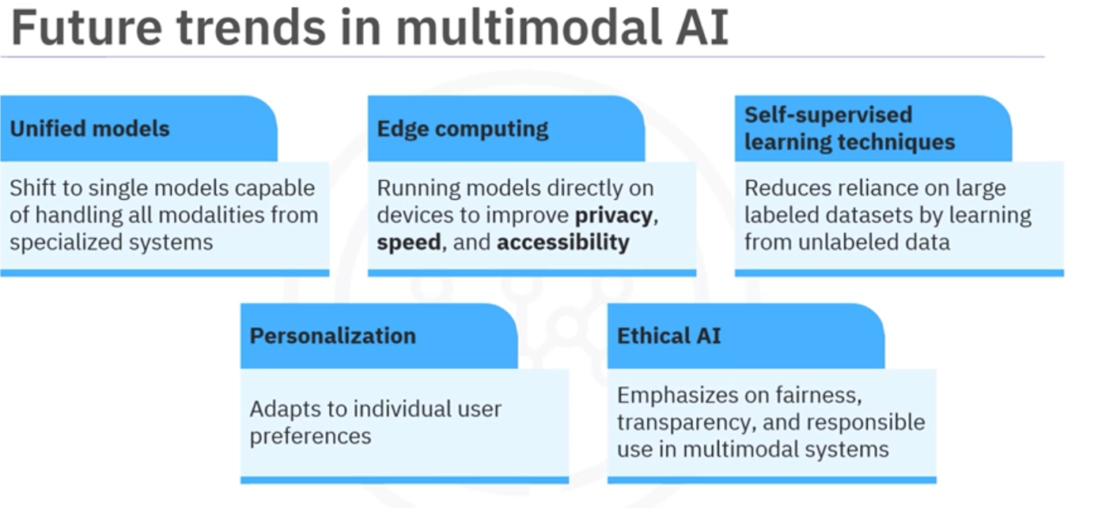

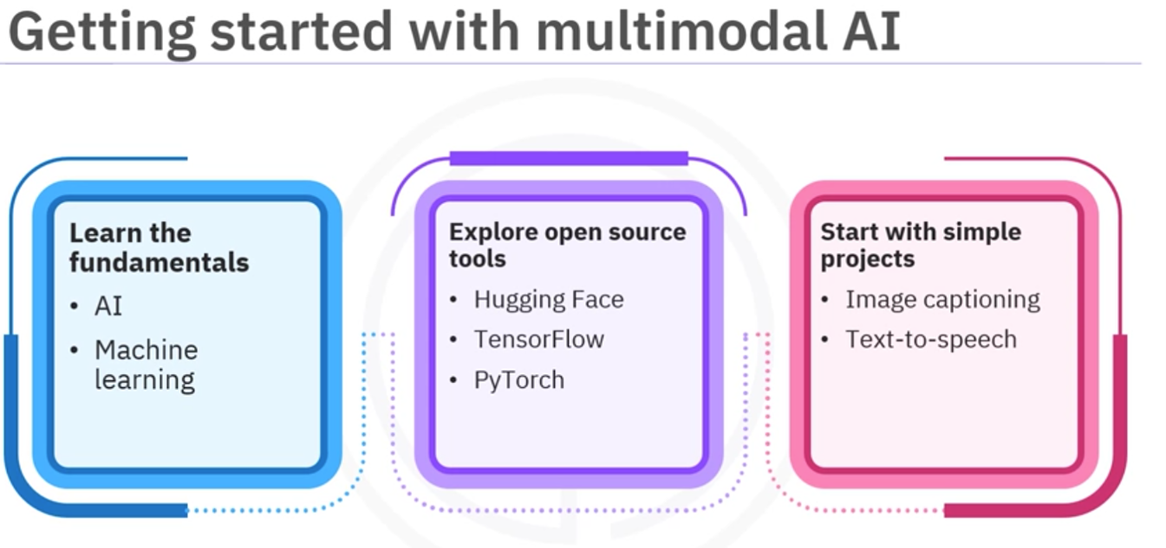
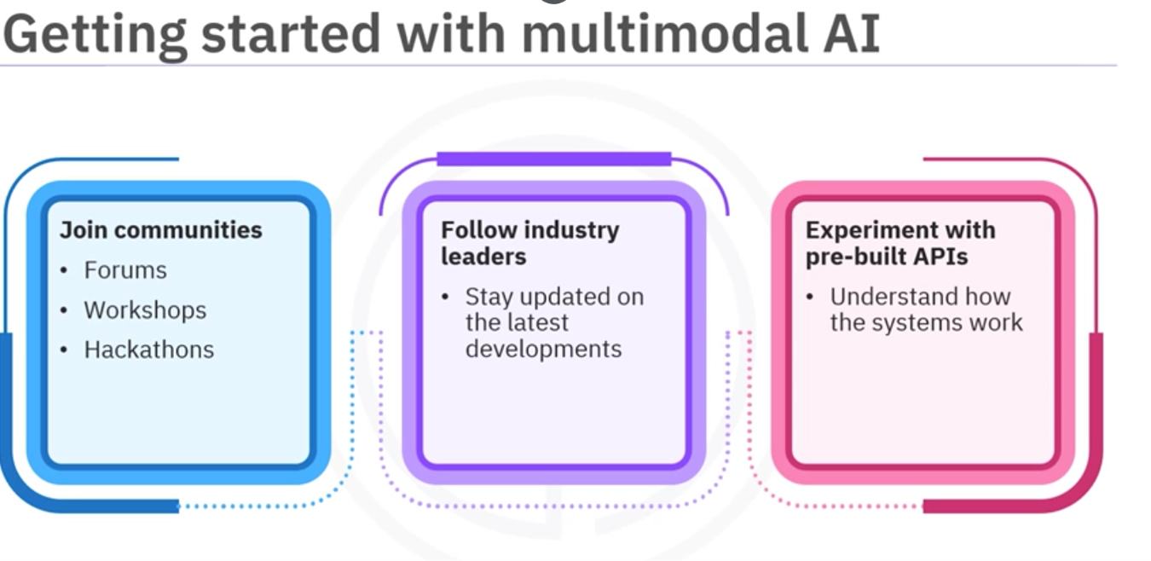

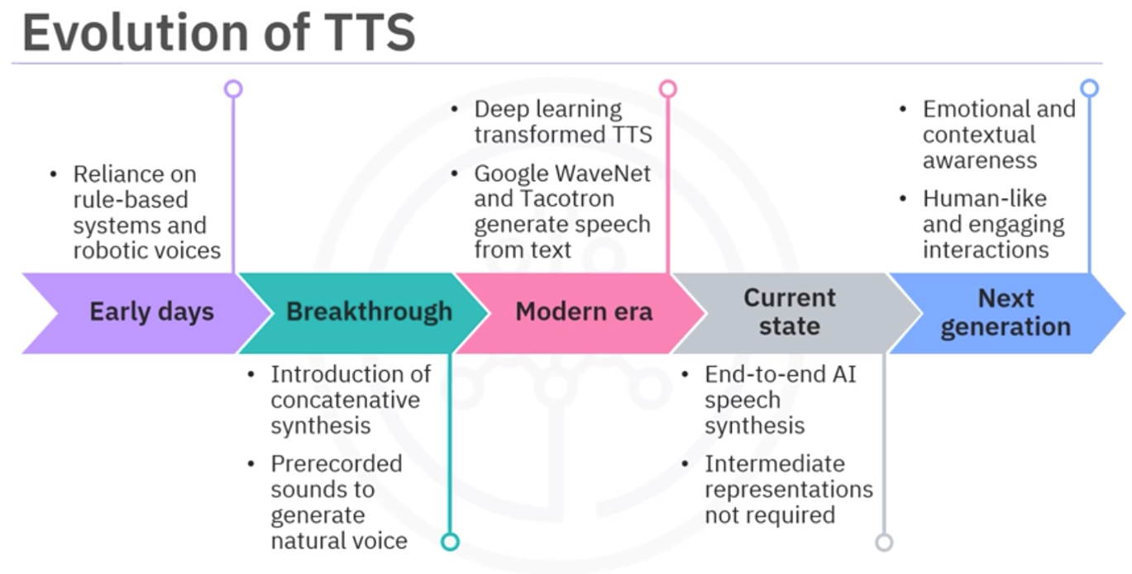
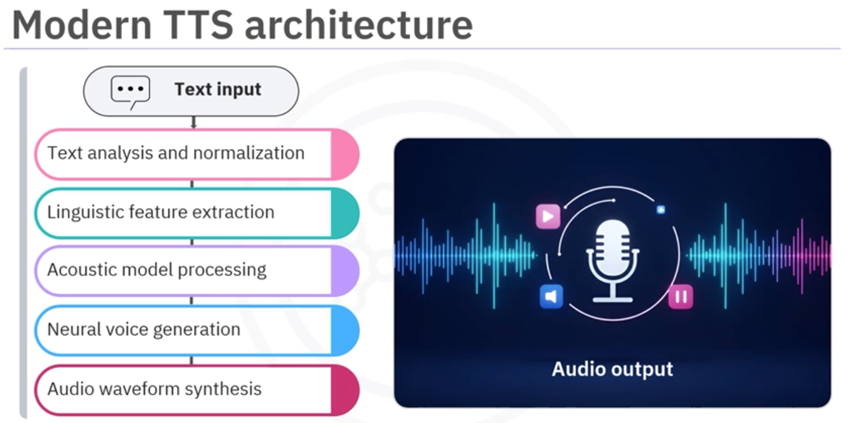
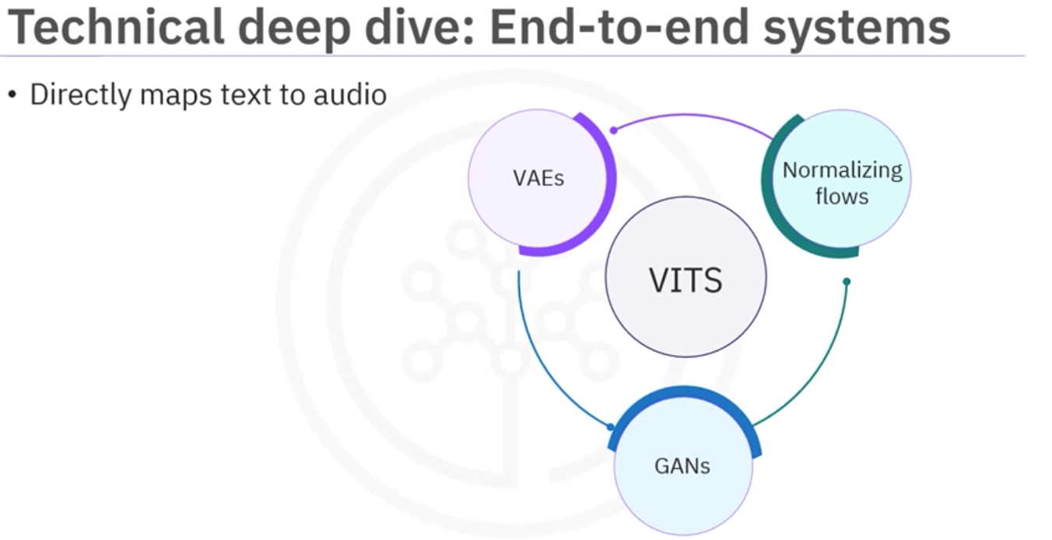
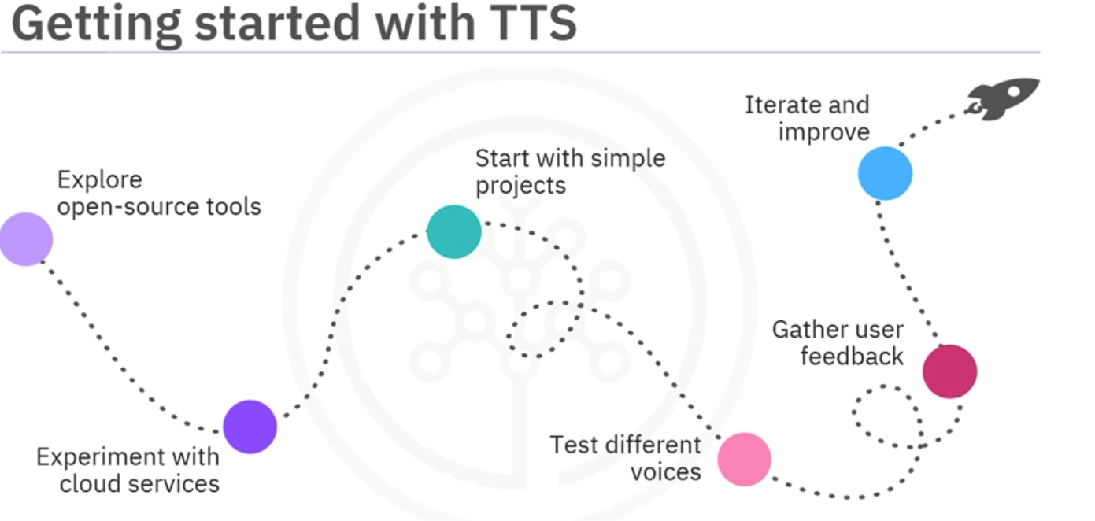
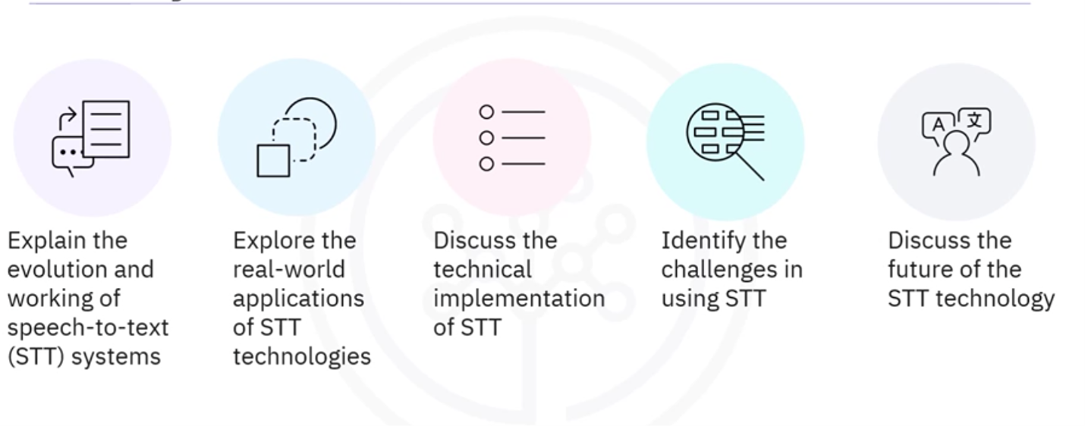
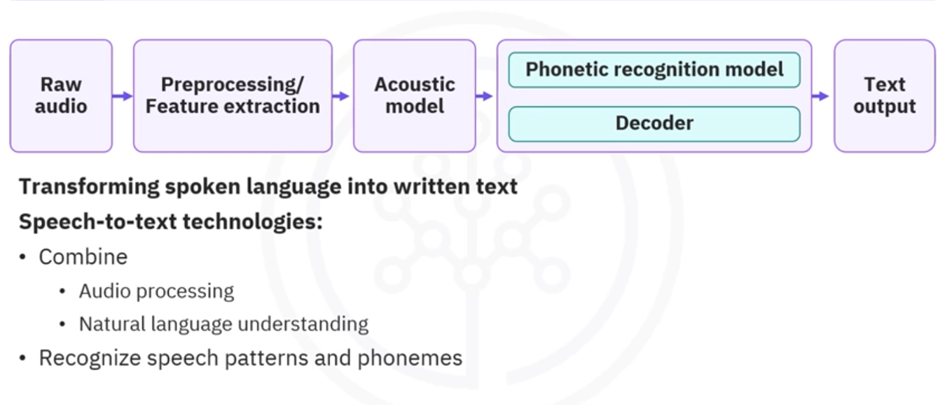
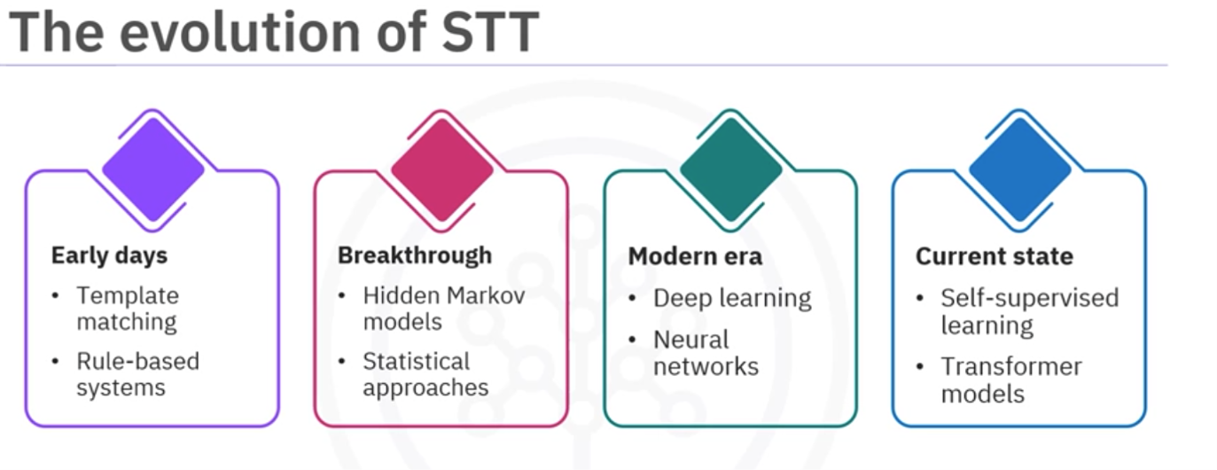
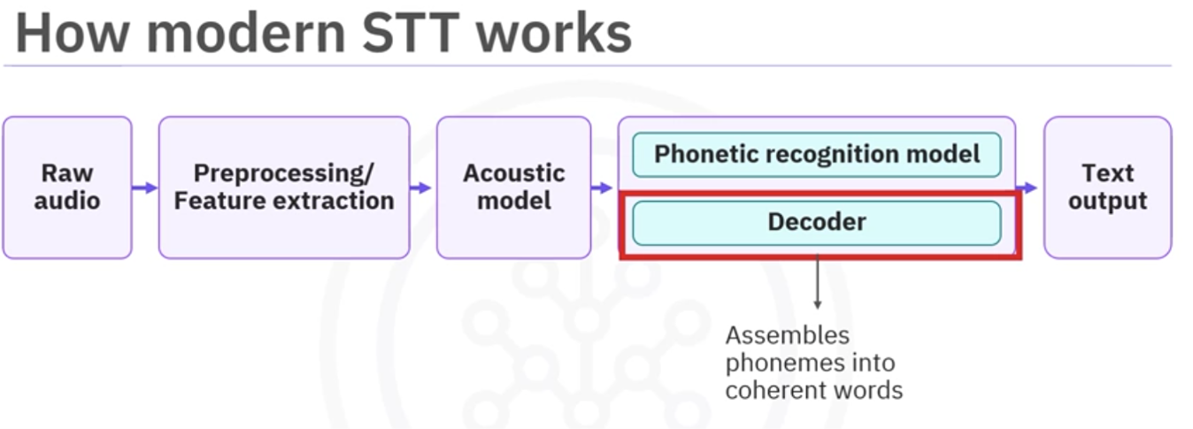
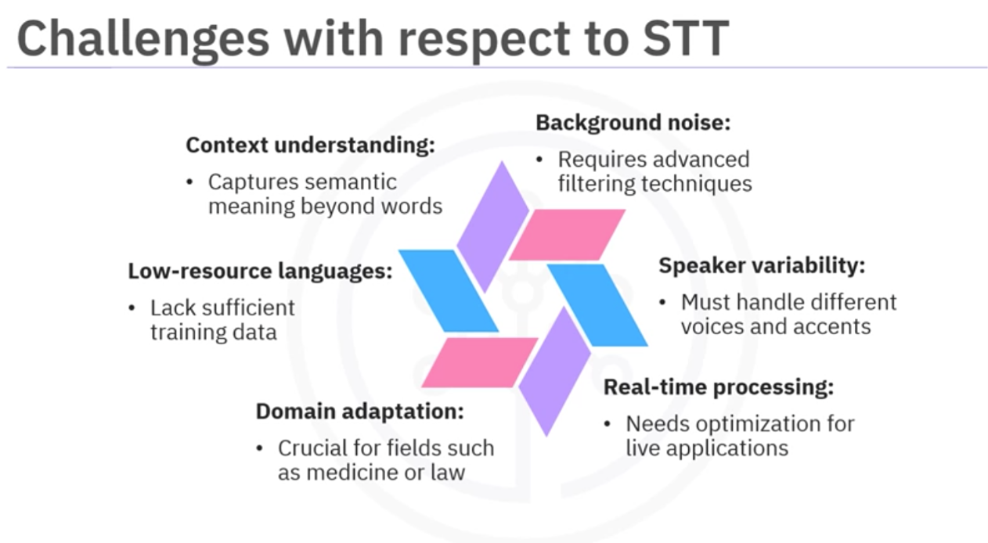
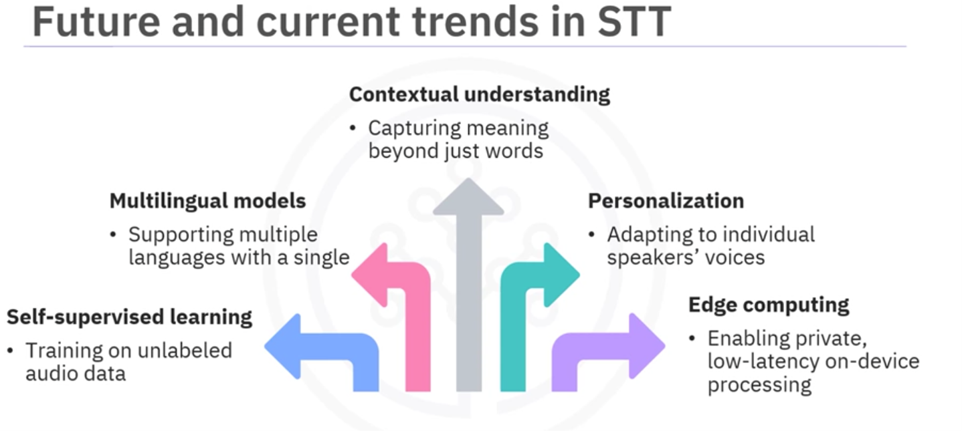
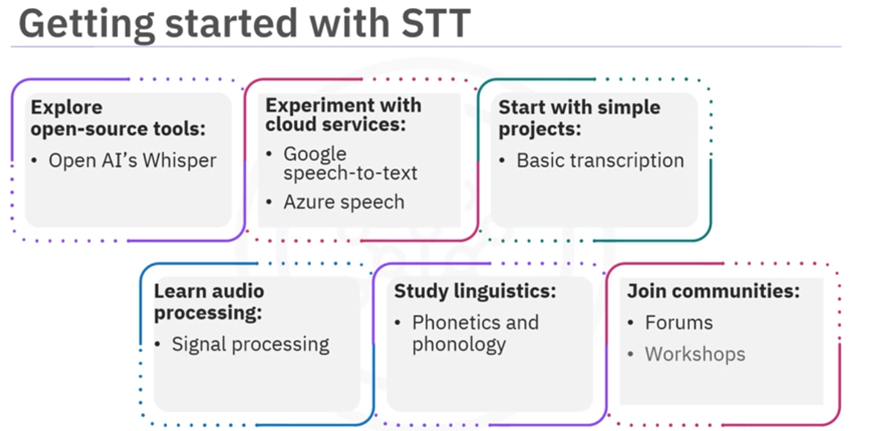

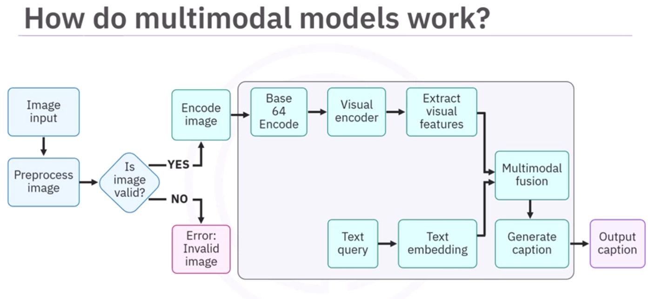

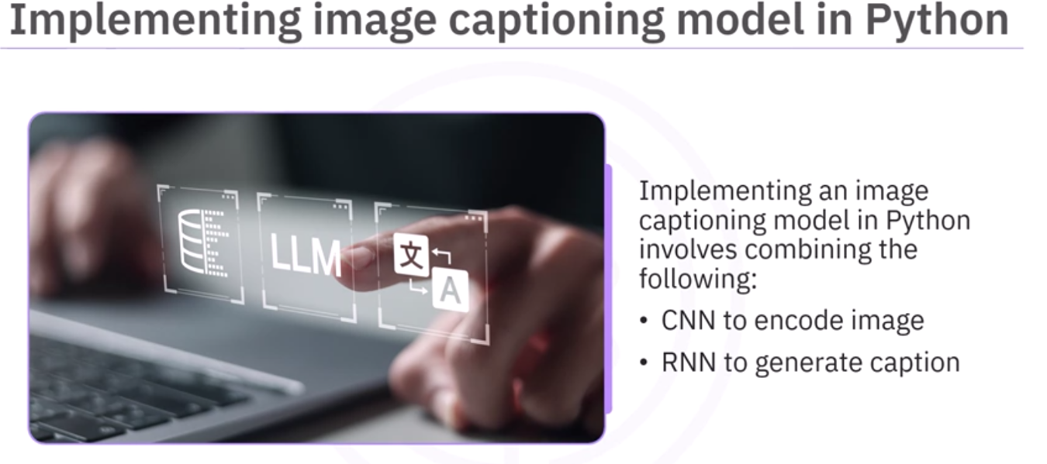
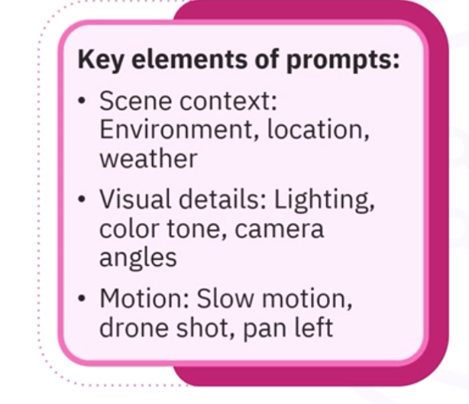

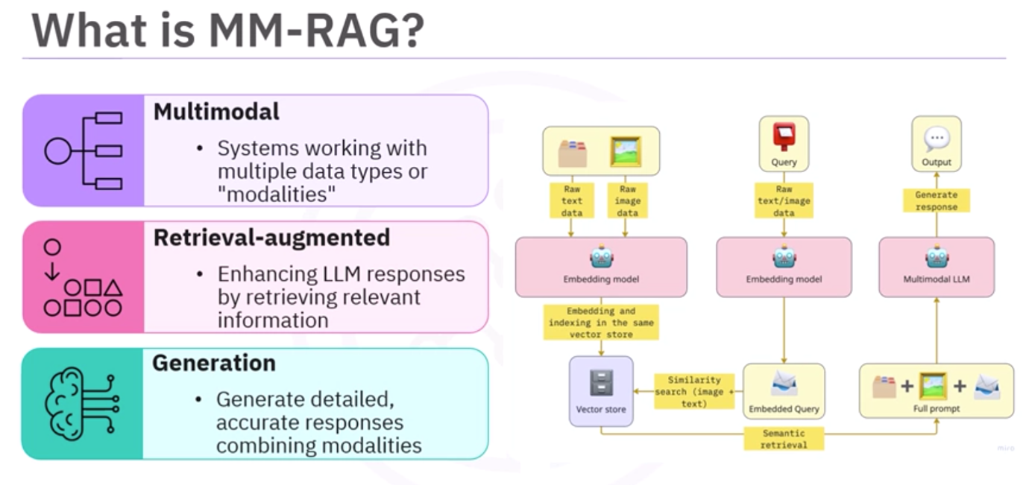
Based on the provided text from the "Graded Quiz: Advanced Multimodal Applications," here are the answers:

---

### Question 1
**At TechFood Inc., the data engineering team is developing an AI-powered personal nutritional coach. They want this assistant to identify nutritional content of a dish based on image inputs. Which AI model and platform should they consider using to achieve this functionality?**

**Answer:**
Llama 4 Maverick model on IBM watsonx

The Llama 4 Maverick model (as mentioned in the course context for image captioning and multimodal tasks) on IBM watsonx is suitable for this use case. The other options (ResNet50, BERT, GPT-3) are either not multimodal or not specifically suited for this task.

---

### Question 2
**Imagine that Data Solutions Corp. is working on an AI application to analyze images and provide dietary recommendations based on the visual content. They want to use a multimodal text-vision model for this purpose. Which step is crucial for preparing images for model processing?**

**Answer:**
Converting images into base64-encoded strings

Base64 encoding is a common method for converting images into a format that can be transmitted and processed by LLM APIs. This is a crucial preprocessing step for multimodal models.

---

### Question 3
**At Visionary Retail, the development team is creating a multimodal AI application to retrieve visually similar images from a large dataset. What technique should they use to ensure accurate similarity matching?**

**Answer:**
Cosine similarity for feature vectors

Cosine similarity is the standard metric used for comparing feature vectors (embeddings) in vector databases for similarity search. It measures the angle between vectors and is effective for high-dimensional data.

---

### Question 4
**Data Innovations is developing a multimodal AI application that processes both text and images for intelligent decision-making. Which component is essential for integrating visual and textual data into a coherent understanding?**

**Answer:**
Integrated understanding across modalities

Multimodal fusion or "integrated understanding across modalities" is the essential component that combines visual and textual information into a unified representation for decision-making.

---

### Question 5
**Imagine that at AI Solutions, the team is tasked with developing a user-friendly interface for a multimodal AI application using Flask. Which step is crucial for preparing the environment before building the application?**

**Answer:**
Importing necessary Python libraries

Before building any Flask application, the first step is to import the necessary Python libraries (Flask, request handling, etc.) as they form the foundation of the application code.

---

### Question 6
**At Smart Health Tech, the team is using multimodal text-vision models to estimate calorie counts and provide dietary recommendations based on image and text inputs. What is a critical step to ensure the model can process these images effectively?**

**Answer:**
Convert images into AI-readable formats

Images must be converted into a format that the AI model can process, such as base64 encoding or byte arrays, before they can be fed into a multimodal model.

---

### Question 7
**A developer team at MedScope AI tries to use MM-RAG-style retrieval to pull user data based on file names. Why is this approach flawed?**

**Answer:**
Retrieval should be based on semantic similarity between embeddings, not file names

MM-RAG retrieves information based on semantic similarity between embeddings (vector representations of content), not on file names or metadata. File names do not capture the semantic content of the data.

---

### Summary of Answers
1. Llama 4 Maverick model on IBM watsonx
2. Converting images into base64-encoded strings
3. Cosine similarity for feature vectors
4. Integrated understanding across modalities
5. Importing necessary Python libraries
6. Convert images into AI-readable formats
7. Retrieval should be based on semantic similarity between embeddings, not file names

