This activity is a great way to practice the "Risk Mindset" by moving from abstract concepts to a concrete Risk Register. Below is an exemplar and a guide on how to calculate these scores based on the scenario provided.

The Risk Formula
As the activity mentions, we use a simple quantitative approach to prioritize our work:
$$Likelihood \times Impact (Severity) = Risk Score$$

Step 2 & 3: Operational Environment Notes
Drafting your response: "The bank's operational environment is vulnerable due to its mix of 120 on-premise and remote employees, creating a large attack surface for phishing and unauthorized access. As a coastal, highly regulated financial institution, security events are possible through both environmental hazards like hurricanes and digital threats like database breaches that could lead to severe regulatory fines and loss of customer trust."

Step 4 & 5: Risk Register Exemplar
Here is how you might score the five primary risks based on the bank's profile (2,200 total accounts and strict Federal Reserve regulations).
Risk | Likelihood (1-3) | Severity (1-3) | Priority Score (1-9)
Business Email Compromise (BEC) | 3 (High) | 2 (Moderate) | 6
Compromised User Database | 2 (Moderate) | 3 (High) | 6
Financial Records Leak | 2 (Moderate) | 3 (High) | 6
Theft (Physical/Digital) | 1 (Low) | 3 (High) | 3
Supply Chain Attack | 1 (Low) | 2 (Moderate) | 2

Logic Behind the Scores
- Business Email Compromise (3x2=6): With 120 employees, the Likelihood is high because phishing is the most common entry point. The Severity is moderate because while it can lead to fraudulent transfers, it usually doesn't take down the entire bank's infrastructure.
- Compromised User Database (2x3=6): The Likelihood is moderate (assuming the bank has some defenses), but the Severity is a 3. If 2,200 account details are leaked, the bank faces massive regulatory fines and a total loss of reputation.
- Theft (1x3=3): Since the bank is in a "low crime area," the Likelihood of physical theft is low (1). However, the Severity remains high (3) because the loss of actual cash directly violates Federal Reserve requirements.
- Supply Chain Attack (1x2=2): While your sports team partners or local vendors could be a vector, they likely don't have direct access to core banking ledgers, making this a lower priority than direct attacks on your database or employees.
- 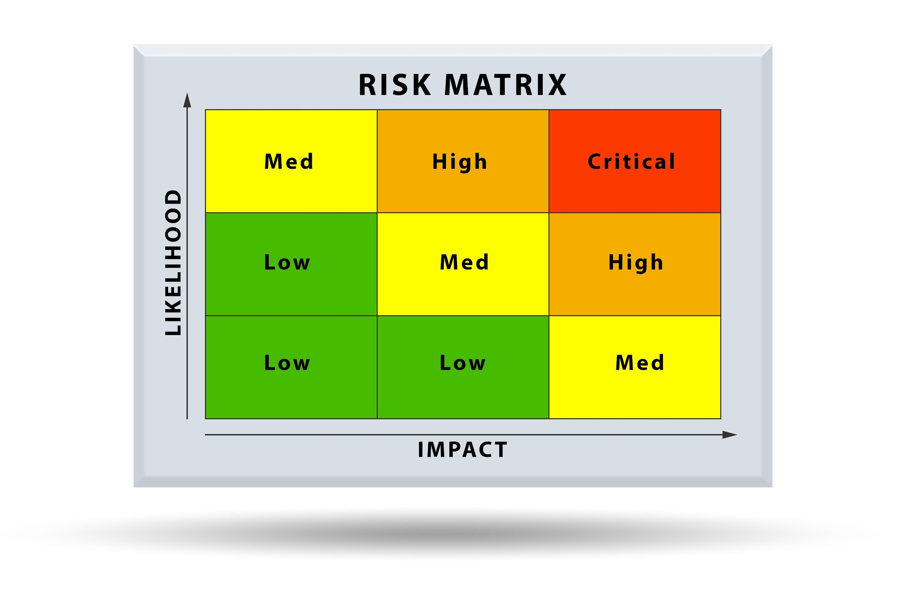
- Shutterstock
- Explore

Prioritization Strategy
After calculating these, you would focus your budget and time on the Score 6 items first.
- For BEC: Implement Multi-Factor Authentication (MFA) and employee training.
- For Database/Record Leaks: Implement encryption at rest and strict IAM (Identity and Access Management) roles.
Did you complete your risk register?
If so, you're ready to hit "Yes" on the Coursera prompt and move to the exemplar comparison! Given that it's Wednesday morning in Thanjavur, you've timed this perfectly to finish Module 1 before the end of the day.
How did your scores differ? Did you rank the Supply Chain attack higher?

