https://docs.aws.amazon.com/whitepapers/latest/aws-overview/analytics.html#amazon-emr

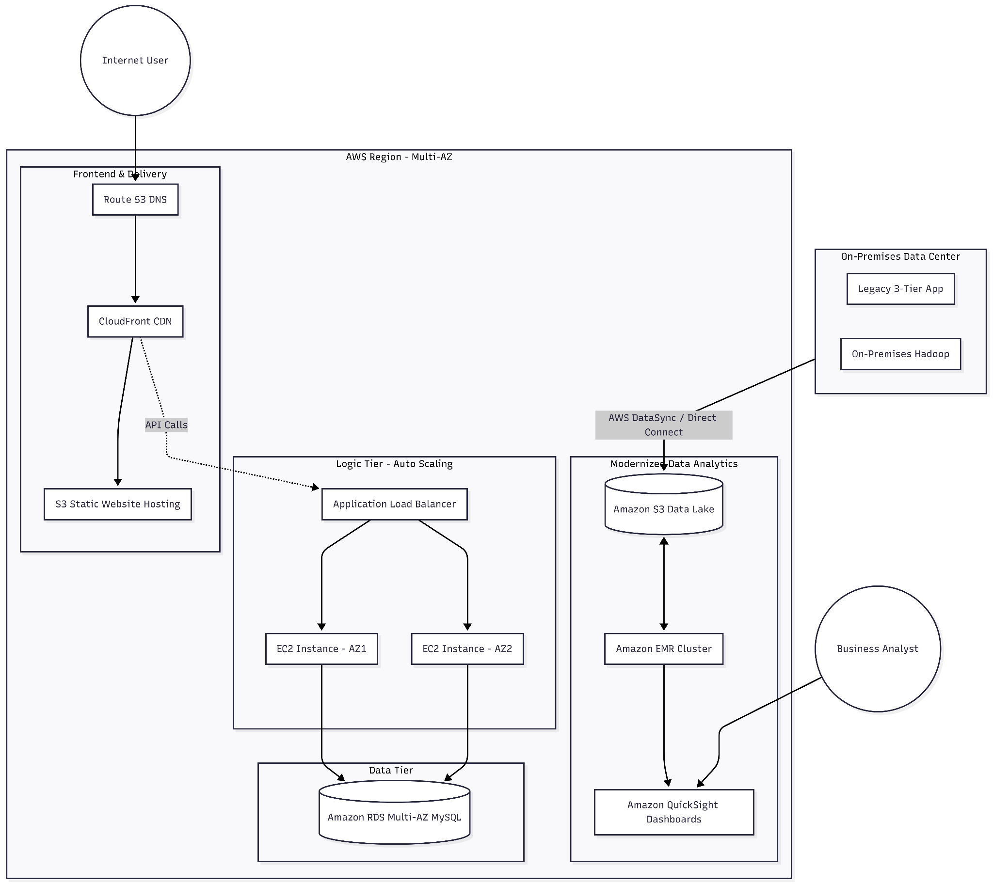

Overview: Two Integrated Solutions in the AWS Cloud

1. Three-Tier Web Application Migration (Refactored)
The objective here is to decouple the layers. The current physical servers are vulnerable. The new AWS architecture uses managed, serverless, and multi-AZ services.
- Frontend (Static Web Site Hosting): Move the HTML/CSS/JS from physical servers to Amazon S3. This makes the frontend serverless, durable, and globally available when paired with Amazon CloudFront for content delivery.
- Backend (App Tier): Instead of one large physical Apache/Java server, use Amazon EC2 instances running in an Auto Scaling Group across two different Availability Zones. This provides High Availability (HA). An Application Load Balancer (ALB) will distribute user traffic.
- Database (MySQL): Replace the on-premises MySQL with Amazon RDS for MySQL (Multi-AZ). This manages replication and failover automatically, solving the single point of failure problem.

2. Data Analytics Workload Migration (Evolved)
The requirement is to use Amazon EMR to replace the local Hadoop cluster. We need to complete the pipeline for data ingestion, storage, and visualization.
- Ingestion: The massive amount of data needs a secure, high-bandwidth bridge. Use AWS Direct Connect to link the Tiruchirappalli data center to the AWS region, supplemented by AWS DataSync for automated data transfer from local servers to S3.
- Storage (The new Data Lake): This is the core. The data should land in Amazon S3. This decouples the "compute" (EMR) from the "storage" (S3), reducing costs and increasing durability.
- Processing: Spin up an Amazon EMR Cluster (Master, Core, and Task nodes) on-demand to run your existing Apache Hadoop and Spark jobs.
- Visualization: Use Amazon QuickSight. It integrates directly with S3 and EMR to create dynamic, serverless dashboards and derive business insights.

Architecture Diagram Components and Connections
Venkatesh, when you open your diagramming tool, place the following AWS Service Icons and connect them as described to depict the flow. This design addresses both scalability and the single point of failure requirement.
Diagram Zone | AWS Service Icons to Use | What they represent / Connection Logic
User & On-Premises | User icon, Corporate Data Center icon, Direct Connect | Users from the internet connect to the web app. The Data Center connects to AWS via a high-speed link.
Web & Edge Tier | Route 53, CloudFront, S3 (as origin) | DNS (Route 53) points to CloudFront, which serves the static frontend from an S3 bucket. This handles massive traffic.
Logic (App) Tier | VPC, Application Load Balancer (ALB), EC2 (multi-AZ), Auto Scaling Group | User traffic from the frontend hits the ALB. The ALB routes to EC2 instances in public/private subnets across multiple AZs.
Database Tier | RDS for MySQL (Multi-AZ icon) | The app instances talk to the managed MySQL database. The "Multi-AZ" ensures automatic failover to a different data center.
Analytics Pipeline | AWS DataSync, Amazon S3 (Data Lake), Amazon EMR, Amazon QuickSight | On-premises data is moved by DataSync. It lands in S3. EMR processes it. QuickSight visuals the result.

Systems Architect's Strategy:
By choosing Multi-AZ RDS and Auto Scaling EC2, you are directly solving the customer's "power outage" problem. Even if an entire AWS Availability Zone goes offline, the other zone automatically takes over. By decoupling storage and compute with S3 and EMR, you avoid having a giant, expensive Hadoop cluster running 24/7 when you only need it for specific analytics runs.

