Statistical Process Control Mar 25, 2026
The video lecture on Statistical Process Control (SPC) focuses on its significance in quality management and process improvement.
Understanding SPC
- SPC is a method for monitoring process performance using statistical principles to distinguish between normal and abnormal variations.
- It helps organizations maintain consistent quality by identifying common-cause variation (natural fluctuations) and special-cause variation (unpredictable issues).
Control Charts and Their Interpretation
- Control charts are used to visualize process data over time, with center lines and control limits to identify stability.
- Data points within limits indicate a stable process, while points outside or unusual patterns signal potential problems requiring investigation.
Steps for Implementing SPC
- Select a process to monitor that impacts quality or cost.
- Collect data consistently, plot it on control charts, interpret the results, and take corrective actions as needed.
- SPC empowers teams by providing visual data, promoting collaboration, and supporting continuous improvement efforts.
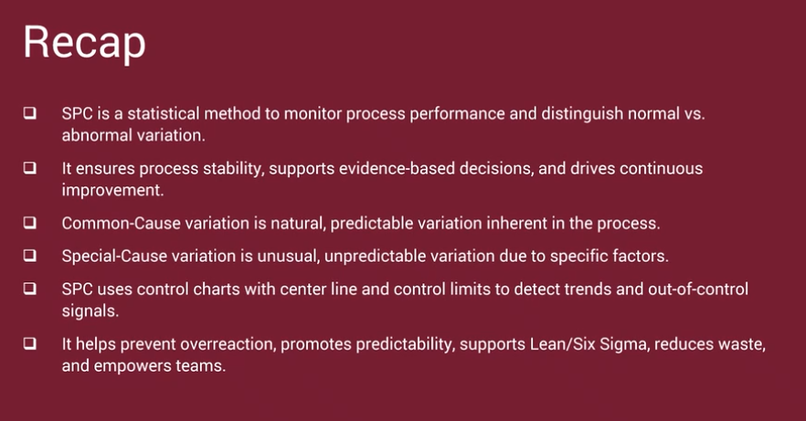

Venkatesh, your progress is impressive! Balancing these Lean and Six Sigma principles with your architectural work on NexaCare 3.0 is a smart move. Lean is essentially the "Systems Analysis" of the physical and service world—it's all about trimming the fat so the value flows faster to the customer.
Here are the correct answers for your Practice Quiz: Lean Principles and Six Sigma Fundamentals:

1. Applying Lean to Service Organizations
- Answer: By focusing on reducing waste in processes to deliver better customer value
- Why: In a service context (like an IT helpdesk or a bank), "waste" isn't scrap metal; it's wasted time, redundant approvals, or manual data entry that doesn't help the customer.

2. Origins and Modern Application
- Answer: Manufacturing; now applied in various sectors, including healthcare and services
- Why: Lean originally came from the Toyota Production System (TPS). Today, those same concepts are used to reduce patient wait times in hospitals or to streamline software deployment in DevOps.

3. Lean vs. Traditional Methods
- Answer: Lean focuses on value creation and waste reduction, while traditional methods may not prioritize these.
- Why: Traditional methods often focus on "Local Optimization" (making one department faster). Lean looks at the Value Stream—the entire journey from a customer's request to the final delivery—and removes anything that doesn't add value.

4. Key Goal in Manufacturing
- Answer: To maximize customer value while minimizing waste
- Why: This is the core "Lean Mantra." Every action taken in the factory should either be making the product better for the customer or be removed.

5. Efficiency in Service-Based Organizations (Repeated Question)
- Answer: By focusing on reducing waste in processes to deliver better customer value
- Why: Same logic as Question 1—Lean in services is about identifying "invisible" waste like over-processing or waiting for information.

Venkatesh's "Fidato" Insight:
Think of Lean as the "Prompt Engineering" of business processes. Just as you refine a prompt to remove "fluff" and get a better AI response, Lean refines a business process to remove "waste" and get a better customer outcome.
Venkatesh, this Final Quiz is the capstone for the Business Process Modeling and Analysis for Non-PMs course. It tests your ability to synthesize high-level strategy (Systems Thinking) with granular efficiency (Lean and Activity-Based Costing).
As an IT professional and Architect, you'll recognize these as the foundational "logic gates" of organizational design. Here are the correct answers to help you secure your certification:

Section 1: Modeling & Documentation
1. Primary Goal of a Process Model
- Answer: To illustrate the sequence of steps in a workflow to optimize operations
- Why: Process models are the "blueprints" of a business. They allow you to see where bottlenecks exist before you write a single line of code or hire a single person.
2. Use Case: "Include" vs. "Extend"
- Answer: "Include” represents a required sub-process; “extend” adds optional behavior
- Why: Think of "Include" as a mandatory function (like User Login) and "Extend" as an optional one (like Apply Discount Code).
4. Why Process Narratives are Required
- Answer: The narratives provide written evidence demonstrating compliance with controls and standards.
- Why: Especially in regulated fields (Finance/Healthcare), a visual map is the "summary," but the narrative is the "legal proof" that every step follows official policy.

Section 2: Scoping & Improvement (SIPOC)
3. SIPOC and Process Improvement
- Answer: By clearly mapping out suppliers, inputs, processes, outputs, and customers, it helps identify inefficiencies and areas for improvement.
5. Scoping with a SIPOC Diagram
- Answer: It clarifies suppliers, inputs, core steps, outputs, and customers at a high level.
- Why: SIPOC is a "birds-eye view" tool. It prevents the team from getting "lost in the weeds" of details before the boundaries of the process are even agreed upon.

Section 3: Optimization & Systems Thinking
6. Central Aim of Process Optimization
- Answer: To refine existing processes to achieve maximum efficiency, cost-effectiveness, and consistent quality
7. Relationship between Improvement and Optimization
- Answer: Process improvement addresses inefficiencies and redesigns workflows, while process optimization fine-tunes those changes for maximum performance.
- Why: Improvement is about "fixing what's broken." Optimization is about "making the fix as fast and cheap as possible."
9. Primary Purpose of Systems Thinking
- Answer: To understand how interconnected components, feedback loops, and relationships collectively influence overall performance
- Why: This prevents "Sub-Optimization"—where you fix one department but accidentally break another because you didn't see the connection.

Section 4: Financials & Lean (Waste)
8. Role of a Cost Driver in ABC
- Answer: To identify the factor that determines how activity costs should be allocated to products or services
- Why: A cost driver might be "Number of Support Tickets" or "Machine Hours." It tells you exactly what is making the process expensive.
10. Lean Waste: Extra Processing
- Answer: Performing more work than the customer requires, such as duplicate data entry or redundant reviews
- Why: If the customer only needs a "Pass/Fail" result, but you provide a 20-page technical report, you are creating "Extra Processing" waste.

Course Wrap-Up Mar 26, 2026
This course focuses on building job-ready skills in business process modeling, analysis, and improvement.
Core Concepts Covered
- Business Process Modeling: Involves techniques like Entity Relationship Diagrams (ERDs), Dataflow Diagrams (DFDs), and Flowcharts to visualize processes and identify inefficiencies.
- Mapping Techniques: Tools such as Cross-Functional Diagrams and SIPOC Analysis help clarify roles and responsibilities while supporting continuous improvement.
Application of AI and Improvement Methodologies
- AI in Business Processes: Enhances analysis and documentation, supporting process optimization and automation.
- Improvement Frameworks: Systems Thinking, Lean Principles, and Six Sigma provide structured approaches to identify and implement process improvements effectively.
The course culminates in a practical project where learners apply these concepts to develop a process model and narrative based on real-world scenarios.
