DocChat: Build a Multi-Agent RAG System
Estimated time needed: 60 minutes

Welcome to DocChat!
Have you ever struggled to extract precise information from long, complex documents? Whether it's a research paper, legal contract, technical report, or environmental study, finding the exact details you need can feel overwhelming.
That's where DocChat comes in—a multi-agent RAG tool designed to help you ask questions about your documents and receive fact-checked, hallucination-free answers.
Sure, you could use ChatGPT or DeepSeek to accomplish this task, but when dealing with long documents containing multiple tables, images, and dense text, these models struggle with retrieval and are prone to hallucinations.
They often misinterpret tables, overlook key data hidden in footnotes, or even fabricate citations, as demonstrated below. The problem? These models lack document-aware reasoning and don't verify their responses against structured sources.
That's why DocChat takes a different approach. Instead of relying on a single LLM, it combines multiple AI agents, each with a specific role:
- A Hybrid Retriever that intelligently combines BM25 keyword search and vector embeddings to retrieve the most relevant passages
- A Research Agent that analyzes the retrieved content and generates an initial response
- A Verification Agent that cross-checks the response against the original document to detect hallucinations and flag unsupported claims
- A Self-Correction Mechanism that re-runs the research step if any contradictions or unsupported statements are found
This multi-step, verification-driven approach ensures that DocChat provides precise, document-grounded answers, even for complex and long-form documents that general-purpose chatbots struggle with. Whether you need to extract specific data points, summarize sections, compare multiple reports, or analyze tables, DocChat is built to help you navigate your documents with confidence.

What you'll learn
In this 60-minute hands-on journey, you'll learn how to:
- Build and deploy a multi-agent RAG (retrieval-augmented generation) system that intelligently retrieves, analyzes, and verifies information from complex documents
- Integrate hybrid retrieval techniques using BM25 and vector search to improve document understanding and relevance
- Implement a verification pipeline that detects hallucinations and ensures factual accuracy in AI-generated responses
- Create an intuitive user interface with Gradio, making your document analysis tool accessible to anyone
By the end, you won't just have a working project—you'll have a powerful multi-agent RAG system that outperforms traditional chatbots on long, structured documents.
If you're eager to see how generative AI, multi-agent systems, and RAG pipelines can be combined to tackle real-world information retrieval challenges, this project is for you! Let's explore how it works—and why single-model chatbots fail where DocChat excels.

A quick look at DocChat

What does the DocChat app do?
With DocChat, you can:
- Upload and analyze long documents (PDFs, Word files, text reports) with ease
- Ask questions about the content and get precise, source-backed answers
- Extract specific details from structured documents, even those with tables, figures, and dense text
- Avoid AI hallucinations—every response goes through a verification step to ensure factual correctness
- Receive an alert when your question is irrelevant to the uploaded documents—so you know when the AI cannot confidently answer based on the provided sources
- Retrieve accurate answers even when multiple documents are uploaded—DocChat intelligently finds the right document to reference
In the demo video above, DocChat was tested with two documents. The first is the Google 2024 Environmental Report, a large document spanning 86 pages with numerous images and tables. The second is the DeepSeek-R1 Technical Report, which, while not as extensive as the first, still contains a significant number of diagrams and tables.
As demonstrated, DocChat accurately retrieves relevant answers from both documents. Below, you can see the extracted portions containing the correct information. You can also check these documents out yourselves to verify the information.
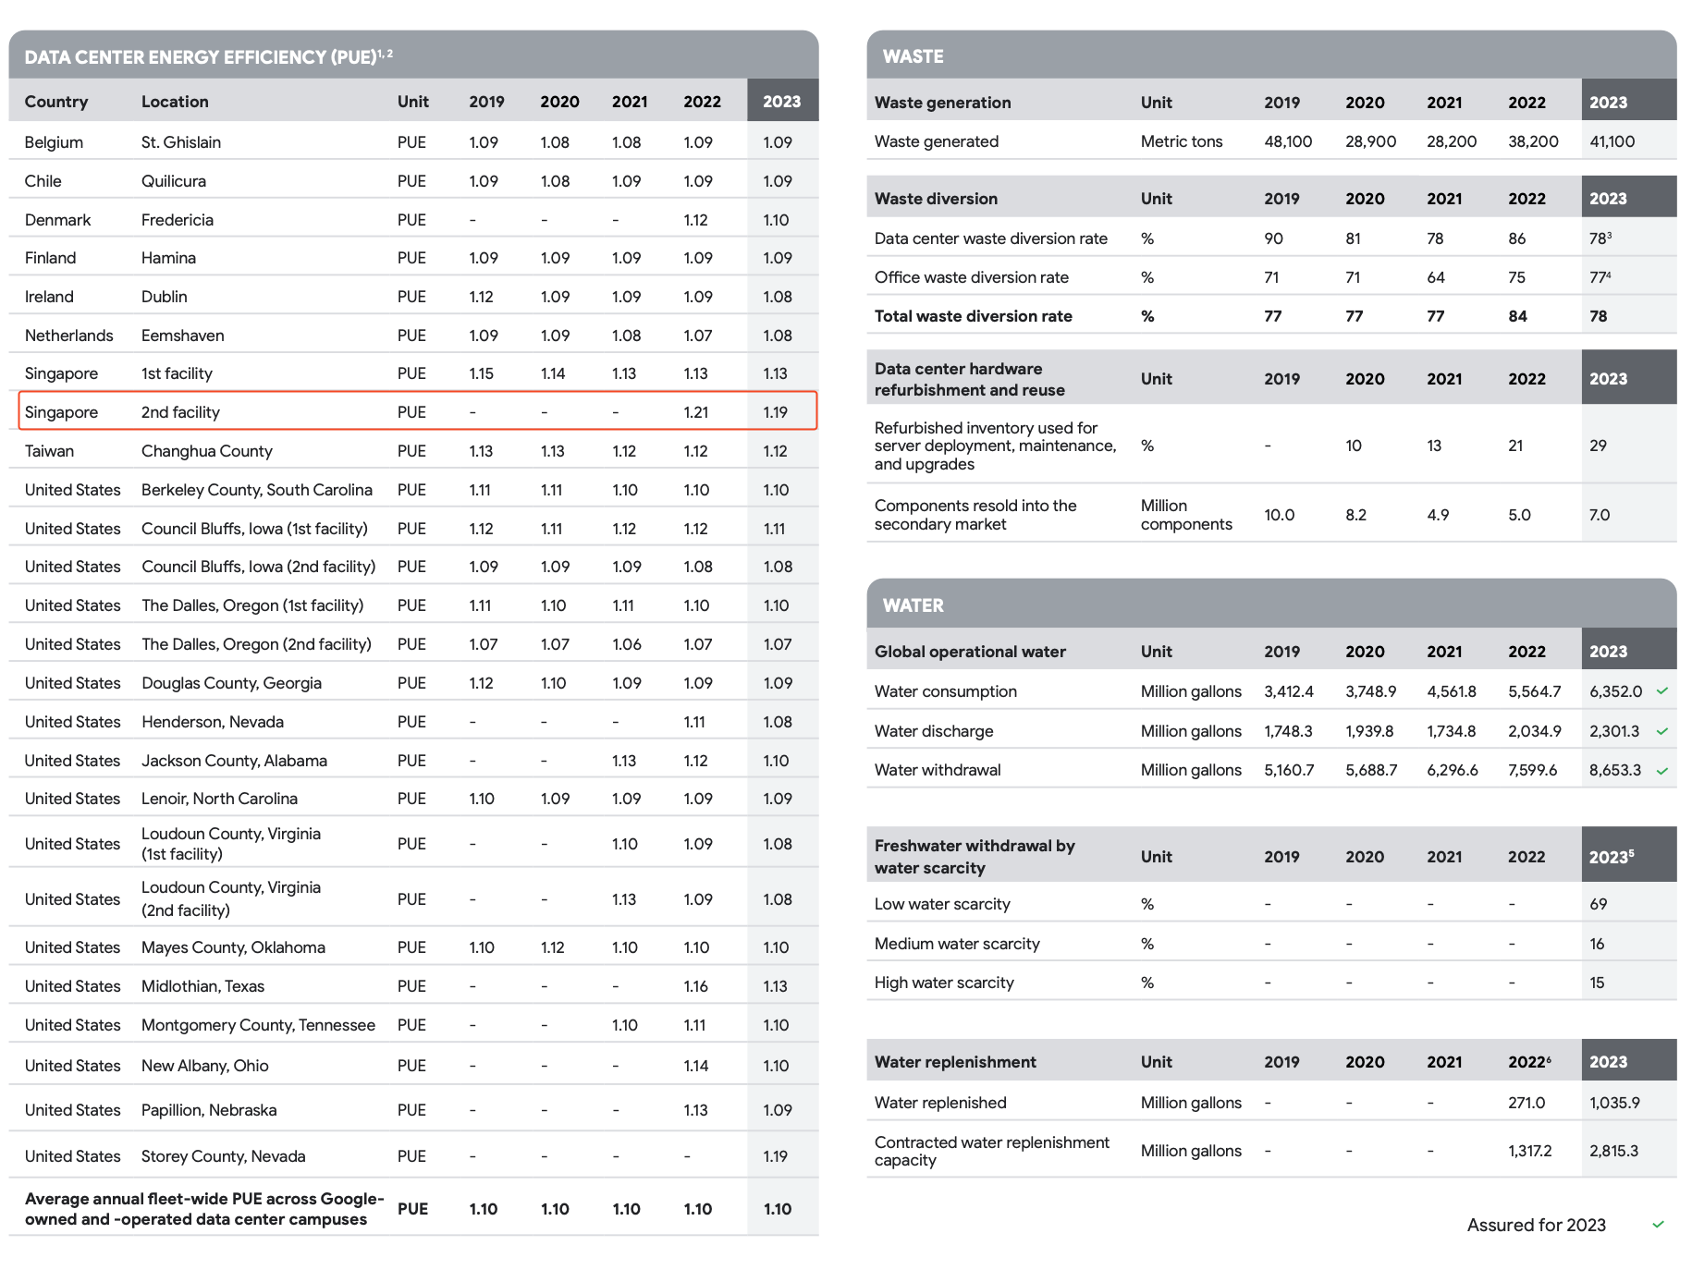
Singapore 2nd Facility PUE
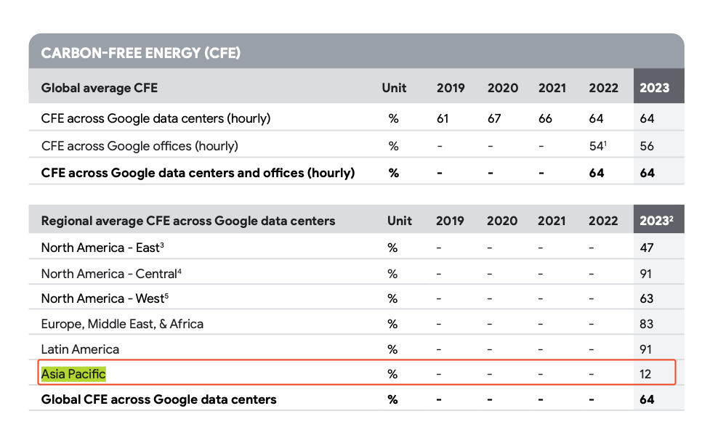
Asia Pacific CFE
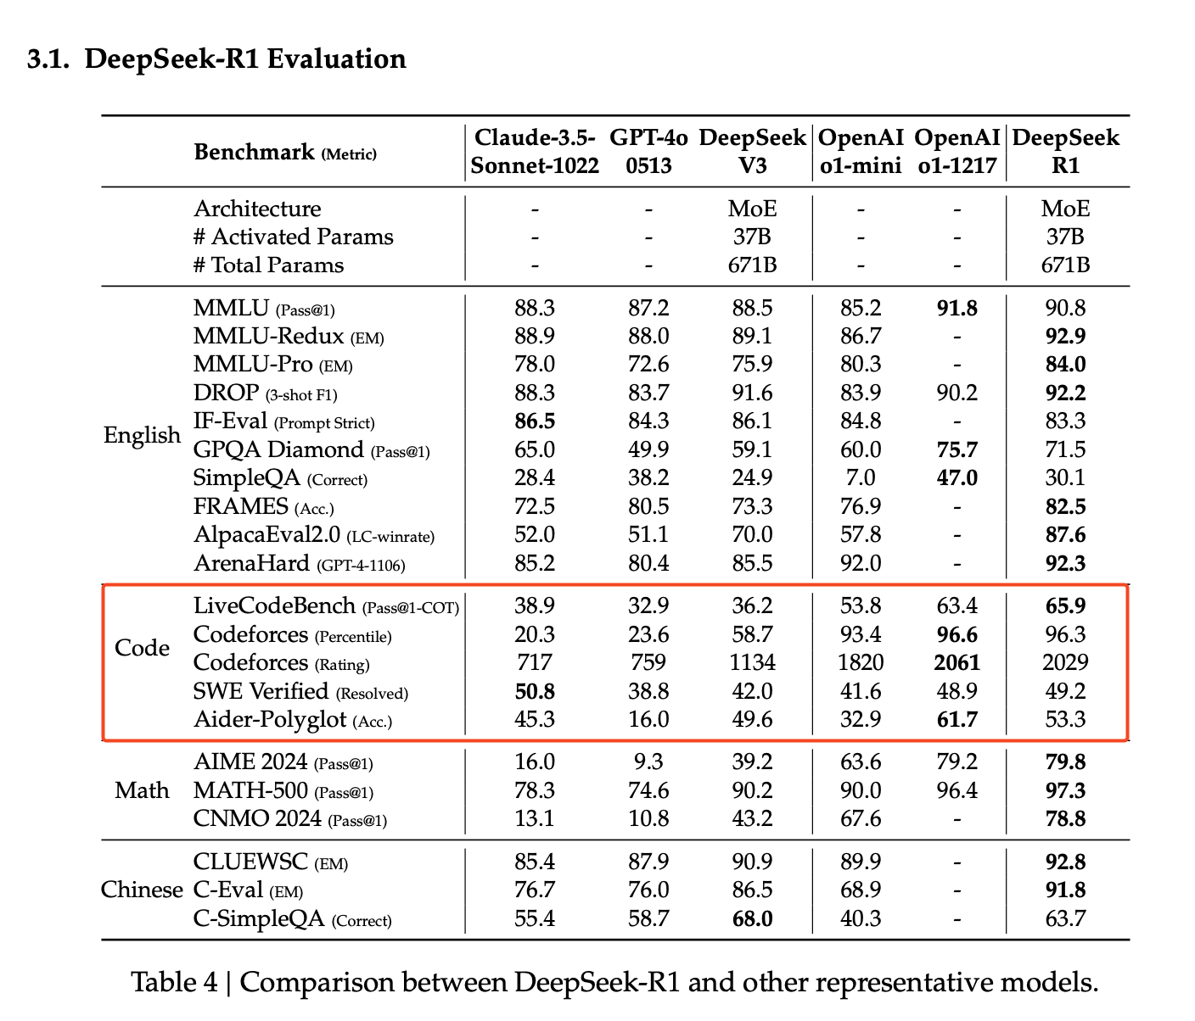
Meanwhile, DeepSeek and ChatGPT fail to retrieve the correct information from these documents.
- DeepSeek cannot read entire documents, and therefore cannot retrieve the answer
- Meanwhile, ChatGPT simply hallucinated the numbers.
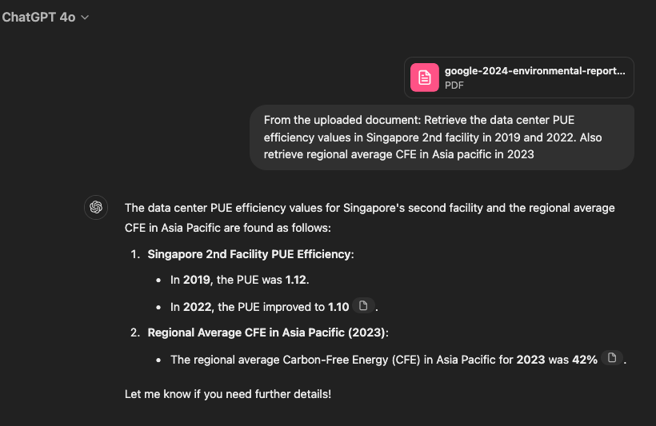
This demonstrates that DocChat excels at reading uploaded documents and providing accurate answers about their content, outperforming both ChatGPT-4o and DeepSeek R1 in document comprehension.
The next section will walk you through:
- How Hybrid Retrieval ensures that the right information is selected, even across multiple documents
- How the Multi-Agent System via LangGraph prevents hallucinations through fact verification
- How the Self-Correction Mechanism iteratively improves answers when contradictions are found
Let's break down how DocChat works under the hood.

Tips for the best experience - Read-only

Keep the following tips handy and refer to them at any point of confusion throughout the tutorial. Do not worry if they seem irrelevant now. We will go through everything step by step later.

Note: this page is read-only, aiming to teach you how to navigate CloudIDE environment. Do NOT run any code on this page.
- You can choose to follow the quick version of building and running the application on the next page if you are in a hurry or you are too excited to test the final result
- Whenever you make changes to a file, be sure to save your work
- At any point throughout the project, if you are lost, click the Table of Contents icon on the top-left of the page and navigate to your desired content
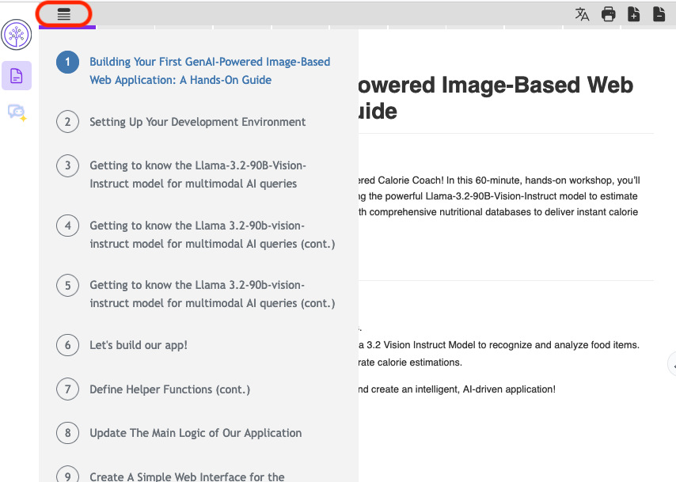
- At the end of each section, you will be given the fully updated script for that part. And at the end of the project, you will be prompted to pull the complete codebase of the project as well
- Cloud IDE automatically saves any changes you make to your files immediately. You can also save from the toolbar
- For running the application, always ensure that app.py is running in the background before opening the Web Application
- You can run a code block by clicking the >_ on the bottom-right
bash
python app.py

Run
- Always ensure that your current directory is /home/project/docchat. If you are not in the docchat folder, certain code files may fail to run. Use the cd command to navigate to the correct location
- Make sure you are accessing the application through port 5000. Clicking the purple Web Application button will run the app through port 5000 automatically

Web Application
- If you get an error about not being able to access another port (e.g., 8888), just refresh the app by clicking the small refresh icon. In case of other errors related to the server, simply refresh the page as well.
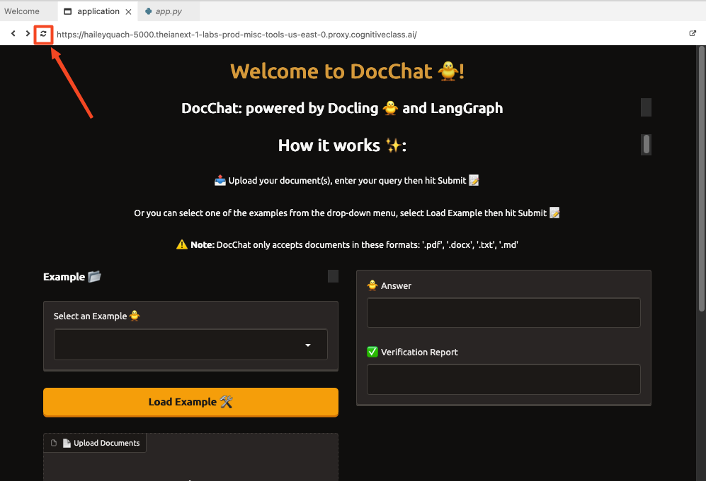
- To stop execution of app.py, in addition to closing the application tab, press Ctrl+C in the terminal
- If you encounter an error running the application or after you enter your desired keyword, try refreshing the app using the button on the top of the application's page. You can try inputting a different query as well
- Typically, using the models provided by Watsonx.ai would require Watsonx credentials, including an API key and a project ID. However, in this lab, these credentials are not needed
- One of the agents uses the Granite 3.1 model, which at the time of writing this lab is unstable and may experience delays in generating responses. If the app takes more than 2-3 minutes to produce an output, press Ctrl + C in the terminal to terminate the process and restart the app.

Quick version: Run the final app
In less than 10 minutes, you can have a functioning app only by following this page's instructions!

Disclaimer: Ignore this page and skip to the next page for the step-by-step tutorial. Follow this page ONLY if you want to get the final application up and running without getting into the learning material.
First, set up the DocChat application in your development environment. By the end of this step, you'll have the final application running and ready to explore.

Step 1: Clone the project's GitHub repository
To begin, clone the DocChat application repository from GitHub. This repository contains all the source code you'll be working with throughout this project.
Run the following command in the terminal to clone the repository by clicking the run button >_:
bash
git clone --no-checkout https://github.com/ibm-developer-skills-network/nlhhh-docchat.git docchat
cd docchat
git checkout 2-final

Run
Next, set up a virtual environment to install the dependencies.

Step 2: Set up a Python virtual environment
Initialize a new Python virtual environment to keep required library versions tidy. You can run the snippet directly by clicking the run button >_.
bash
python3.11 -m venv venv
source venv/bin/activate

Run

Step 3: Install the required libraries
With your virtual environment activated, install all the required libraries via >_. Approximately it will take 3-5 minutes to install all the required libraries. Feel free to go grab a coffee while you wait!
The following command installs the key libraries that power DocChat:
- docling – Handles document processing, chunking, and structured data extraction
- langgraph – Enables the multi-agent workflow, allowing different AI agents to collaborate efficiently
- chromadb – Provides fast, efficient vector search, ensuring accurate document retrieval
- langchain (RAG) – Facilitates retrieval-augmented generation, integrating retrieval strategies with LLM-based reasoning
- gradio - Builds the user-friendly web interface
- ibm_watsonx_ai - Interacts with WatsonX models
bash
pip install -r requirements.txt

Run

Step 4: Run the Gradio app in the terminal
bash
python app.py

Run
Note: After it runs successfully, you will see a message similar to the following example in the terminal:
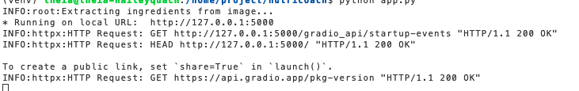

Step 5: Congrats! You can now launch the web application
Since the web application is hosted locally on port 5000, click the following button to view the application you've developed.

Web Application
Note: If this "Web Application" button does not work, follow the following picture instructions to launch the application.
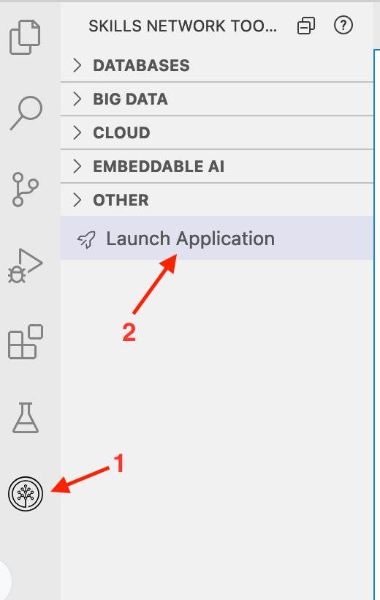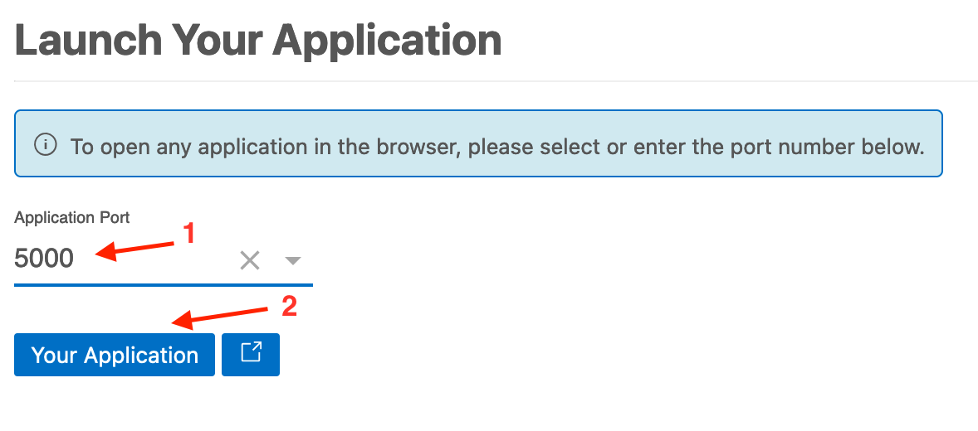
Once you launch your application, a window opens, and you should be able to see the application view similar to the following example:
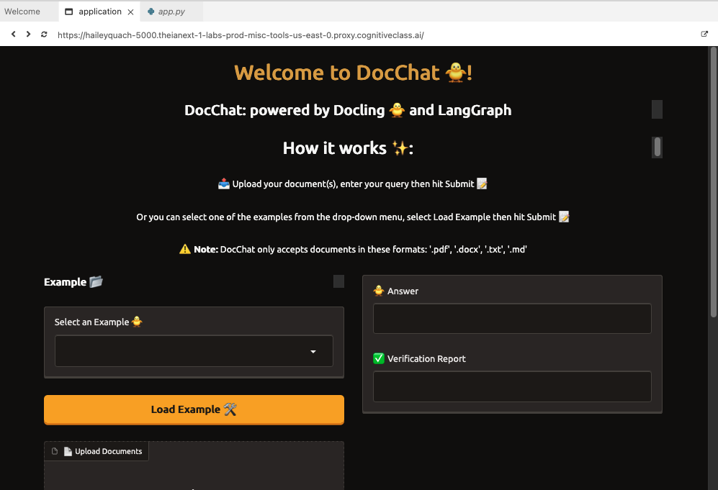
Upload a document and test out the application! After you press the Submit button, it takes around 1-2 minutes for the app (our multi-agent system) to analyze the uploaded document and provide output. If the application fails, refresh it and try again.
To stop execution of app.py, in addition to closing the application tab, press Ctrl+C in the terminal.

Step 6: You have completed the project!
Congratulations on successfully building your DocChat application! You now have two options: continue with the rest of this tutorial to dive deeper into the codebase and enhance your understanding, or stop here if you're satisfied with your progress. The choice is yours!
Tips for the best experience - Read-onlySetting up your development environment
The content of this lab is licensed under Apache 2.0

Setting up your development environment
Before you dive into development, set up your project environment in the Cloud IDE. This environment is based on Ubuntu 22.04 and provides all the tools you need to build your AI-driven Flask application.

Note: If you completed the previous Quick version, run the following command in your terminal before proceeding with the rest of the instructions. If not, you can safely disregard this note.
bash
cd ..
rm -rf docchat
deactivate

Run

Step 1: Create your project directory
- Open the terminal in Cloud IDE and run the following:
bash
git clone --no-checkout https://github.com/ibm-developer-skills-network/nlhhh-docchat.git docchat
cd docchat
git checkout 1-start

Run
Once you are all set up, select File Explorer and then the docchat folder. You should have all the files structured as below.
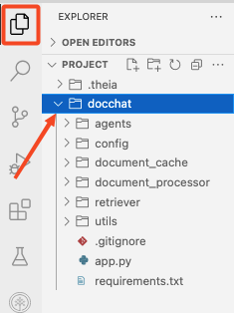
- Next, set up a virtual environment for the project and install the required libraries.
Note you can run the snippet directly by clicking the run button >_. It will take 3-5 minutes to install all the required libraries. Feel free to go grab a coffee while you wait!
The following command installs the key libraries that power DocChat:
- docling – Handles document processing, chunking, and structured data extraction
- langgraph – Enables the multi-agent workflow, allowing different AI agents to collaborate efficiently
- chromadb – Provides fast, efficient vector search, ensuring accurate document retrieval
- langchain (RAG) – Facilitates retrieval-augmented generation, integrating retrieval strategies with LLM-based reasoning
- gradio - Builds the user-friendly web interface
- ibm_watsonx_ai - Interacts with WatsonX models
bash
python3.11 -m venv venv
source venv/bin/activate # activate venv
pip install -r requirements.txt

Run
Now that your environment is set up, you're ready to start building your DocChat!

Understand why multi-agent RAG is used
A Naïve RAG (Retrieval-Augmented Generation) pipeline is often insufficient for handling long, structured documents due to several limitations:
- Limited query understanding: Naïve RAG processes queries at a single level, failing to break down complex questions into multiple reasoning steps. This results in shallow or incomplete answers when dealing with multi-faceted queries.
- No hallucination detection or error handling: Traditional RAG pipelines lack a verification step. This means that if a response contains hallucinated or incorrect information, there's no mechanism to detect, correct, or refine the output.
- Inability to handle out-of-scope queries: Without a proper scope-checking mechanism, Naïve RAG may attempt to generate answers even when no relevant information exists, leading to misleading or fabricated responses.
- Inefficient multi-document retrieval: When multiple documents are uploaded, a Naïve RAG system might retrieve irrelevant or suboptimal passages, failing to select the most relevant content dynamically.
To overcome these challenges, DocChat implements a multi-agent RAG research system, which introduces intelligent agents to enhance retrieval, reasoning, and verification.

How multi-agent RAG solves these issues

Scope checking & routing
- A Scope-Checking Agent first determines whether the user's question is relevant to the uploaded documents. If the query is out of scope, DocChat explicitly informs the user instead of generating hallucinated responses.

Dynamic multi-step query processing
- For complex queries, an Agent Workflow ensures that the question is broken into smaller sub-steps, retrieving the necessary information before synthesizing a complete response.
- For example, if a question requires comparing two sections of a document, an agent-based approach recognizes this need, retrieves both parts separately, and constructs a comparative analysis in the final answer.

Hybrid retrieval for multi-document contexts
When multiple documents are uploaded, the Hybrid Retriever (BM25 + Vector Search) ensures that the most relevant document(s) are selected dynamically, improving accuracy over traditional retrieval pipelines.

Fact verification & self-correction
- After an initial response is generated, a Verification Agent cross-checks the output against the retrieved documents.
- If any contradictions or unsupported claims are found, the Self-Correction Mechanism refines the answer before presenting it to the user.

Shared global state for context awareness
- The Agent Workflow maintains a shared state, allowing each step (retrieval, reasoning, verification) to reference previous interactions and refine responses dynamically.
- This enables context-aware follow-up questions, ensuring that users can refine their queries without losing track of previous answers.

Project overview

Below is a breakdown of DocChat's workflow

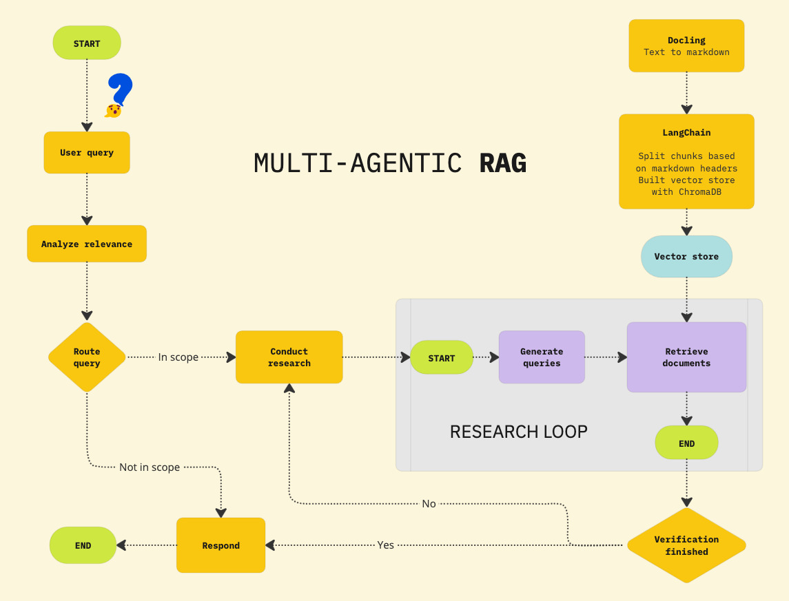

1 - User query processing & relevance analysis
- The system starts when a user submits a question about their uploaded document(s)
- Before retrieving any data, DocChat first analyzes query relevance to determine if the question is within the scope of the uploaded content

2 - Routing & query categorization
- The query is routed through an intelligent agent that decides whether the system can answer it using the document(s):
  - In scope: Proceed with document retrieval and response generation.
  - Not in scope: Inform the user that the question cannot be answered based on the provided documents, preventing hallucinations.

3 - Multi-agent research & document retrieval
- If the query is relevant, DocChat retrieves relevant document sections from a hybrid search system:
  - Docling converts the document into a structured Markdown format for better chunking
  - LangChain splits the document into logical chunks based on headers and stores them in ChromaDB (a vector store)
  - The retrieval module searches for the most contextually relevant document chunks using BM25 and vector search

4 - Answer generation & verification loop
- Conduct research:
  - The research agent generates an initial answer based on retrieved content
  - A sub-process starts where queries are dynamically generated for more precise retrieval
- Verification process:
  - The verification agent cross-checks the generated response against the retrieved content
  - If the response is fully supported, the system finalizes and returns the answer
  - If verification fails (e.g., hallucinations, unsupported claims), the system re-runs the research step until a verifiable response is found

5 - Response finalization
- After verification is complete, DocChat returns the final response to the user
- The workflow ensures that each answer is sourced directly from the provided document(s), preventing fabrication or unreliable outputs
In the next step, start by building the vector database.

Build vector database

1. Document parsing with Docling
Processing PDFs with complex structures, tables, and intricate layouts requires careful selection of a reliable document parsing tool. Many libraries struggle with accuracy when dealing with nested tables, multi-column formats, or scanned PDFs, often resulting in misaligned text, missing data, or broken layouts.
To overcome these challenges, DocChat leverages Docling—an open-source document processing library designed for high-precision parsing and structured data extraction.

Why Docling?
- Accurate table & layout parsing: Recognizes complex table structures, reading sequences, and multi-column layouts
- Multi-format support: Reads and exports documents in Markdown, JSON, PDF, DOCX, PPTX, XLSX, HTML, AsciiDoc, and images
- OCR for scanned PDFs: Extracts text from scanned documents using optical character recognition (OCR)
- Seamless integration with LangChain: Enables structured chunking for better retrieval and vector search in ChromaDB
To showcase Docling's superiority over LangChain in handling complex PDFs, we compare both tools on two types of scanned PDF documents: one saved as an image file and another saved as a standard PDF.
Click the button below to inspect the file test1.py

Open test1.py in IDE
This script compares Docling and LangChain in parsing text from PDF documents. It processes PDFs using both approaches and prints the extracted content for evaluation.

The Docling approach
- Uses DocumentConverter to extract structured content
- Converts the PDF into Markdown format
- Splits the extracted content based on headers using MarkdownHeaderTextSplitter
- Prints the full extracted sections for review

LangChain approach
- Uses PyPDFLoader to load the document
- Extracts raw text from each PDF page
- Prints the entire extracted text
Execute the code below to run the script.
bash
python test/test1.py

Run
After a few minutes, you should see this output in the terminal:
As demonstrated in the results, Docling successfully extracts text from both scanned file versions, whether saved as an image or as a PDF. In contrast, LangChain's built-in PyPDFLoader fails to extract text from both cases, highlighting a major limitation.
This occurs because PyPDFLoader is designed for digitally generated PDFs that contain embedded text, rather than scanned documents where the text is essentially an image. Since LangChain does not have built-in OCR (Optical Character Recognition) capabilities, it cannot process PDFs that contain scanned images of text, making it ineffective for handling historical documents, academic papers, or other non-digitally generated content.
On the other hand, Docling is equipped to handle both structured and unstructured PDFs, including scanned documents, making it a far more versatile and reliable tool for text extraction in complex scenarios. This demonstrates Docling's advantage in working with real-world PDFs, where many documents are scanned rather than digitally created.

2. Building a vector database with ChromaDB
Once documents have been parsed and structured using Docling, the next step is to efficiently store and retrieve relevant document chunks. This is where ChromaDB comes into play—a high-performance vector database optimized for fast and accurate similarity search.

What is Chroma DB?
Chroma DB is an open-source vector database optimized for fast and scalable similarity search. It enables efficient storage, retrieval, and ranking of document embeddings, making it a key component of RAG workflows.

Why ChromaDB?
- Blazing-fast vector search: Finds the most relevant document chunks in milliseconds
- Persistent storage: Keeps embeddings saved for reuse across sessions
- Seamless LangChain integration: Works natively with LangChain for retrieval-augmented generation (RAG)
- Scalable and lightweight: Handles millions of embeddings efficiently without complex infrastructure
Click the button below to open the file_handler.py file, where Docling is used to process uploaded documents.

Open file_handler.py in IDE
Then, click the solution below and copy-paste the code into file_handler.py
python
import os
import hashlib
import pickle
from datetime import datetime, timedelta
from pathlib import Path
from typing import List
from docling.document_converter import DocumentConverter
from langchain_text_splitters import MarkdownHeaderTextSplitter
from config import constants
from config.settings import settings
from utils.logging import logger

class DocumentProcessor:
def init(self):
self.headers = [("#", "Header 1"), ("##", "Header 2")]
self.cache_dir = Path(settings.CACHE_DIR)
self.cache_dir.mkdir(parents=True, exist_ok=True) def validate_files(self, files: List) -> None:
"""Validate the total size of the uploaded files."""
total_size = sum(os.path.getsize(f.name) for f in files)
if total_size > constants.MAX_TOTAL_SIZE:
raise ValueError(f"Total size exceeds {constants.MAX_TOTAL_SIZE//1024//1024}MB limit") def process(self, files: List) -> List:
"""Process files with caching for subsequent queries"""
self.validate_files(files)
all_chunks = []
seen_hashes = set() for file in files:
try:
# Generate content-based hash for caching
with open(file.name, "rb") as f:
file_hash = self._generate_hash(f.read()) cache_path = self.cache_dir / f"{file_hash}.pkl" if self._is_cache_valid(cache_path):
logger.info(f"Loading from cache: {file.name}")
chunks = self._load_from_cache(cache_path)
else:
logger.info(f"Processing and caching: {file.name}")
chunks = self._process_file(file)
self._save_to_cache(chunks, cache_path) # Deduplicate chunks across files
for chunk in chunks:
chunk_hash = self._generate_hash(chunk.page_content.encode())
if chunk_hash not in seen_hashes:
all_chunks.append(chunk)
seen_hashes.add(chunk_hash) except Exception as e:
logger.error(f"Failed to process {file.name}: {str(e)}")
continue logger.info(f"Total unique chunks: {len(all_chunks)}")
return all_chunks def _process_file(self, file) -> List:
"""Original processing logic with Docling"""
if not file.name.endswith(('.pdf', '.docx', '.txt', '.md')):
logger.warning(f"Skipping unsupported file type: {file.name}")
return [] converter = DocumentConverter()
markdown = LangGraph multi-agent system structure

Understanding LangGraph: a multi-agent orchestration framework

1. What is agentic AI?
Agentic AI describes a system or program that can independently execute tasks for a user or another system. It autonomously designs workflows, utilizes available tools, makes decisions, takes actions, solves complex problems, and interacts with external environments, extending its capabilities beyond the data used to train its machine learning (ML) models.

2. What is a multi-agent system (MAS)?
A multi-agent system (MAS) is composed of multiple artificial intelligence (AI) agents collaborating to carry out tasks for a user or another system.

3. Key relationship between agentic AI and MAS
Characteristic | Agentic AI | Multi-agent systems (MAS)
Autonomy | Central focus—autonomous task execution | May include agents with varying levels of autonomy
Interaction | Limited to tools, systems, or environments | Key focus—agents interact, communicate, and coordinate
Scope | Individual agent | Multiple agents in a shared system
Dependency | Agentic AI can exist independently | MAS may involve agentic AI but doesn't require it

4. What is LangGraph?
LangGraph is an open-source Python framework designed for multi-agent workflows in AI applications. It extends LangChain by enabling graph-based state management, making it easier to coordinate multiple AI agents in structured workflows.
LangGraph is particularly useful in RAG and multi-step reasoning, where multiple agents collaborate to refine, verify, and improve responses dynamically.

Key features of LangGraph
- Graph-based execution: Workflows are defined as state machines, allowing structured decision-making
- Multi-agent coordination: Easily integrates multiple agents, each responsible for a specific task
- Dynamic state management: Maintains memory and enables iterative refinement of AI-generated responses
- Supports loops & conditionals: Workflows can adapt based on real-time decisions

5. How does LangGraph work?
LangGraph operates on the principle of stateful workflows, where each step in the process is defined as a node in a directed graph. The edges define transitions between nodes based on logic.
A LangGraph workflow consists of:
- Nodes: They represent individual processing steps (for example, research, verification).
- Edges: They define the flow of execution (for example, go to verification after research).
- State objects: They store data passed between agents.
- Conditional transitions → Allow decision-making between nodes.

6. Graph structure for this project
The AgentWorkflow class constructs the multi-agent system using LangGraph's StateGraph, ensuring a structured approach to information retrieval and verification.
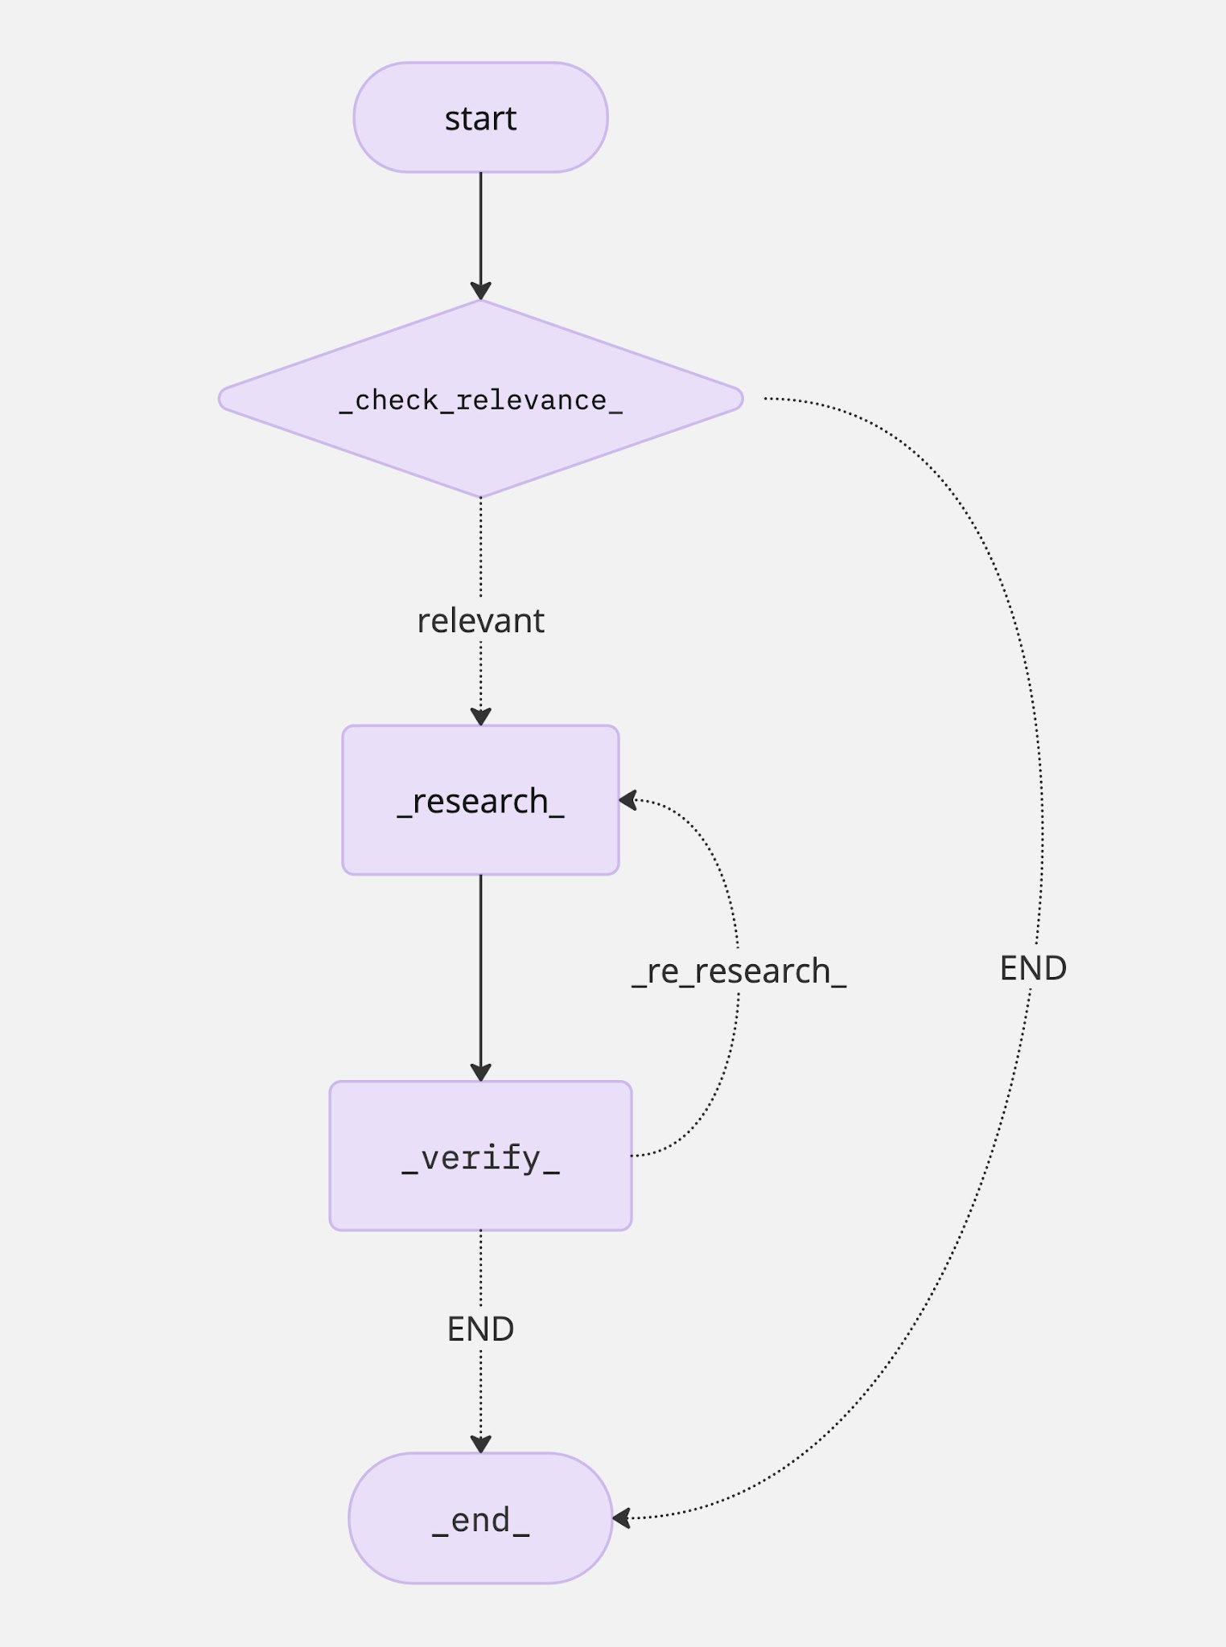

Workflow breakdown
- Check relevance – The RelevanceChecker determines if the query can be answered based on the retrieved documents.
  - If relevant → Proceed to research
  - If irrelevant → Terminate workflow
- Research step – The ResearchAgent generates a draft answer using relevant documents.
- Verification step – The VerificationAgent assesses the draft answer for accuracy and relevance.
- Decision making – Based on verification:
  - If the answer lacks support → Re-research and refine
  - If verified → End workflow

LangGraph implementation
Click the button below to open the workflow.py file.

Open workflow.py in IDE
Then, click the solution below and copy-paste the code into workflow.py
python
from langgraph.graph import StateGraph, END
from typing import TypedDict, List, Dict
from .research_agent import ResearchAgent
from .verification_agent import VerificationAgent
from .relevance_checker import RelevanceChecker
from langchain.schema import Document
from langchain.retrievers import EnsembleRetriever
import logging

logger = logging.getLogger(name)class AgentState(TypedDict):
question: str
documents: List[Document]
draft_answer: str
verification_report: str
is_relevant: bool
retriever: EnsembleRetrieverclass AgentWorkflow:
def init(self):
self.researcher = ResearchAgent()
self.verifier = VerificationAgent()
self.relevance_checker = RelevanceChecker()
self.compiled_workflow = self.build_workflow() # Compile once during initialization def build_workflow(self):
"""Create and compile the multi-agent workflow."""
workflow = StateGraph(AgentState) # Add nodes
workflow.add_node("check_relevance", self._check_relevance_step)
workflow.add_node("research", self._research_step)
workflow.add_node("verify", self._verification_step) # Define edges
workflow.set_entry_point("check_relevance")
workflow.add_conditional_edges(
"check_relevance",
self._decide_after_relevance_check,
{
"relevant": "research",
"irrelevant": END
}
)
workflow.add_edge("research", "verify")
workflow.add_conditional_edges(
"verify",
self._decide_next_step,
{
"re_research": "research",
"end": END
}
)
return workflow.compile() def _check_relevance_step(self, state: AgentState) -> Dict:
retriever = state["retriever"]
classification = self.relevance_checker.check(
question=state["question"],
retriever=retriever,
k=20
) if classification == "CAN_ANSWER":
# We have enough info to proceed
return {"is_relevant": True} elif classification == "PARTIAL":
# There's partial coverage, but we can still proceed
return {
"is_relevant": True
} else: # classification == "NO_MATCH"
return {
"is_relevant": False,
"draft_answer": "This question isn't related (or there's no data) for your query. Please ask another question relevant to the uploaded document(s)."
} def _decide_after_relevance_check(self, state: AgentState) -> str:
decision = "relevant" if state["is_relevant"] else "irrelevant"
print(f"[DEBUG] _decide_after_relevance_check -> {decision}")
return decision def full_pipeline(self, question: str, retriever: EnsembleRetriever):
try:
print(f"[DEBUG] Starting full_pipeline with question='{question}'")
documents = retriever.invoke(question)
logger.info(f"Retrieved {len(documents)} relevant documents (from .invoke)") initial_state = AgentState(
question=question,
documents=documents,
draft_answer="",
verification_report="",
is_relevant=False,
retriever=retriever
) final_state = self.compiled_workflow.invoke(initial_state) return {
"draft_answer": final_state["draft_answer"],
"verification_report": final_state["verification_report"]
}
except Exception as e:
logger.error(f"Workflow execution failed: {e}")
raise def _research_step(self, state: AgentState) -> Dict:
print(f"[DEBUG] Entered _research_step with question='{state['question']}'")
result = self.researcher.generate(state["question"], state["documents"])
print("[DEBUG] Researcher returned draft answer.")
return {"draft_answer": result["draft_answer"]} def _verification_step(self, state: AgentState) -> Dict:
print("[DEBUG] Entered _verification_step. Verifying the draft answer...")
result = self.verifier.check(state["draft_answer"], state["documents"])
print("[DEBUG] VerificationAgent returned a verification report.")
return {"verification_report": result["verification_report"]}
python
def _decide_next_step(self, state: AgentState) -> str:
verification_report = state["verification_report"]
print(f"[DEBUG] _decide_next_step with verification_report='{verification_report}'")
if "Supported: NO" in verification_report or "Relevant: NO" in verification_report:
logger.info("[DEBUG] Verification indicates re-research needed.")
return "re_research"
else:
logger.info("[DEBUG] Verification successful, ending workflow.")
return "end"

In the code, the StateGraph defines the workflow structure:
- Nodes represent different stages (check_relevance, research, verify).
- Edges define transitions based on conditions.
python
workflow = StateGraph(AgentState)

# Define workflow nodes
workflow.add_node("check_relevance", self._check_relevance_step)
workflow.add_node("research", self._research_step)
workflow.add_node("verify", self._verification_step)

# Set entry point
workflow.set_entry_point("check_relevance")

# Define conditional transitions
workflow.add_conditional_edges(
"check_relevance",
self._decide_after_relevance_check,
{
"relevant": "research",
"irrelevant": END
}
)
workflow.add_edge("research", "verify")
workflow.add_conditional_edges(
"verify",
self._decide_next_step,
{
"re_research": "research",
"end": END
}
)

You can check other files in agents/ folder to see how each agent is implemented.
Click the button below to open relevance_checker.py:

Open relevance_checker.py in IDE
Then, click the solution below and copy-paste the code into relevance_checker.py
python
from ibm_watsonx_ai.foundation_models import ModelInference
from ibm_watsonx_ai import Credentials, APIClient
from config.settings import settings
import re
import logging

logger = logging.getLogger(name)credentials = Credentials(
url = "https://us-south.ml.cloud.ibm.com",
)
client = APIClient(credentials)class RelevanceChecker:
def init(self):
# Initialize the WatsonX ModelInference
self.model = ModelInference(
model_id="ibm/granite-4-h-small",
credentials=credentials,
project_id="skills-network",
params={"temperature": 0, "max_tokens": 10},
) def check(self, question: str, retriever, k=3) -> str:
"""
1. Retrieve the top-k document chunks from the global retriever.
2. Combine them into a single text string.
3. Pass that text + question to the LLM for classification. Returns: "CAN_ANSWER", "PARTIAL", or "NO_MATCH".
""" logger.debug(f"RelevanceChecker.check called with question='{question}' and k={k}") # Retrieve doc chunks from the ensemble retriever
top_docs = retriever.invoke(question)
if not top_docs:
logger.debug("No documents returned from retriever.invoke(). Classifying as NO_MATCH.")
return "NO_MATCH" # Combine the top k chunk texts into one string
document_content = "\n\n".join(doc.page_content for doc in top_docs[:k]) # Create a prompt for the LLM to classify relevance
prompt = f"""
You are an AI relevance checker between a user's question and provided document content. Instructions:
- Classify how well the document content addresses the user's question.
- Respond with only one of the following labels: CAN_ANSWER, PARTIAL, NO_MATCH.
- Do not include any additional text or explanation. Labels:
1) "CAN_ANSWER": The passages contain enough explicit information to fully answer the question.
2) "PARTIAL": The passages mention or discuss the question's topic but do not provide all the details needed for a complete answer.
3) "NO_MATCH": The passages do not discuss or mention the question's topic at all. Important: If the passages mention or reference the topic or timeframe of the question in any way, even if incomplete, respond with "PARTIAL" instead of "NO_MATCH". Question: {question}
Passages: {document_content} Respond ONLY with one of the following labels: CAN_ANSWER, PARTIAL, NO_MATCH
""" # Call the LLM
try:
response = self.model.chat(
messages=[
{
"role": "user",
"content": prompt # Changed from list to string
}
]
)
except Exception as e:
logger.error(f"Error during model inference: {e}")
return "NO_MATCH" # Extract the content from the response
try:
llm_response = response['choices'][0]['message']['content'].strip().upper()
logger.debug(f"LLM response: {llm_response}")
except (IndexError, KeyError) as e:
logger.error(f"Unexpected response structure: {e}")
return "NO_MATCH" print(f"Checker response: {llm_response}") # Validate the response
valid_labels = {"CAN_ANSWER", "PARTIAL", "NO_MATCH"}
if llm_response not in valid_labels:
logger.debug("LLM did not respond with a valid label. Forcing 'NO_MATCH'.")
classification = "NO_MATCH"
else:
logger.debug(f"Classification recognized as '{llm_response}'.")
classification = llm_response
python
return classification

**
Question**
Answer
CancelSave

Relevance checker: ensuring query-document alignment
The RelevanceChecker is responsible for determining whether retrieved documents contain relevant information to answer a given question. It uses an ensemble retriever to fetch document chunks and then leverages IBM watsonX AI for classification. The goal is to categorize relevance into three possible labels:
- "CAN_ANSWER" – The documents provide sufficient information for a full answer.
- "PARTIAL" – The documents mention the topic but lack complete details.
- "NO_MATCH" – The documents do not discuss the question at all.
This classification helps filter out irrelevant queries, ensuring that further processing is only performed on useful data.

How it works

1. Retrieving relevant documents
The check() method first retrieves document chunks from an ensemble retriever:
python
top_docs = retriever.invoke(question)
if not top_docs:
return "NO_MATCH"

If no documents are retrieved, it immediately classifies the query as "NO_MATCH".

2. Constructing the LLM prompt
If relevant documents are found, the system concatenates the top-k document chunks into a single string:
python
document_content = "\n\n".join(doc.page_content for doc in top_docs[:k])

Then, it generates a prompt for the watsonX AI model:
python
prompt = f"""
You are an AI relevance checker between a user's question and provided document content.

**Instructions:**
- Classify how well the document content addresses the user's question.
- Respond with only one of the following labels: CAN_ANSWER, PARTIAL, NO_MATCH.
...
**Question:** {question}
**Passages:** {document_content}
...
"""

- The prompt clearly instructs the AI model to strictly return one of the three labels.
- The AI considers both explicit answers and partial mentions before making a decision.

3. Running the classification model
The ModelInference API is used to query IBM watsonX AI:
python
response = self.model.chat(
messages=[
{
"role": "user",
"content": prompt
}
]
)

- The LLM processes the question and passages to determine relevance.
- If an error occurs (e.g., API failure), the function defaults to "NO_MATCH" to prevent crashes.

4. Extracting and validating the LLM response
Once the AI returns a classification:
python
llm_response = response['choices'][0]['message']['content'].strip().upper()

- The function ensures that the response is one of the three valid labels:
python
valid_labels = {"CAN_ANSWER", "PARTIAL", "NO_MATCH"}
if llm_response not in valid_labels:
classification = "NO_MATCH"
else:
classification = llm_response

- If the model returns unexpected text, the function forces "NO_MATCH" to maintain consistency.

Research agent: generating initial responses using document context
Click the button below to open research_agent.py:

Open research_agent.py in IDE
Then, click the solution below and copy-paste the code into research_agent.py
python
from ibm_watsonx_ai.foundation_models import ModelInference
from ibm_watsonx_ai import Credentials, APIClient
from typing import Dict, List
from langchain.schema import Document
from config.settings import settings
import json

credentials = Credentials(
url = "https://us-south.ml.cloud.ibm.com",
)
client = APIClient(credentials)class ResearchAgent:
def init(self):
"""
Initialize the research agent with the IBM WatsonX ModelInference.
"""
# Initialize the WatsonX ModelInference
print("Initializing ResearchAgent with IBM WatsonX ModelInference...")
self.model = ModelInference(
model_id="ibm/granite-4-h-small",
credentials=credentials,
project_id="skills-network",
params={
"max_tokens": 300, # Adjust based on desired response length
"temperature": 0.3, # Controls randomness; lower values make output more deterministic
}
)
print("ModelInference initialized successfully.") def sanitize_response(self, response_text: str) -> str:
"""
Sanitize the LLM's response by stripping unnecessary whitespace.
"""
return response_text.strip() def generate_prompt(self, question: str, context: str) -> str:
"""
Generate a structured prompt for the LLM to generate a precise and factual answer.
"""
prompt = f"""
You are an AI assistant designed to provide precise and factual answers based on the given context. Instructions:
- Answer the following question using only the provided context.
- Be clear, concise, and factual.
- Return as much information as you can get from the context. Question: {question}
Context:
{context} Provide your answer below:
"""
return prompt def generate(self, question: str, documents: List[Document]) -> Dict:
"""
Generate an initial answer using the provided documents.
"""
print(f"ResearchAgent.generate called with question='{question}' and {len(documents)} documents.") # Combine the top document contents into one string
context = "\n\n".join([doc.page_content for doc in documents])
print(f"Combined context length: {len(context)} characters.") # Create a prompt for the LLM
prompt = self.generate_prompt(question, context)
print("Prompt created for the LLM.") # Call the LLM to generate the answer
try:
print("Sending prompt to the model...")
response = self.model.chat(
messages=[
{
"role": "user",
"content": prompt # Ensure content is a string
}
]
)
print("LLM response received.")
except Exception as e:
print(f"Error during model inference: {e}")
raise RuntimeError("Failed to generate answer due to a model error.") from e # Extract and process the LLM's response
try:
llm_response = response['choices'][0]['message']['content'].strip()
print(f"Raw LLM response:\n{llm_response}")
except (IndexError, KeyError) as e:
print(f"Unexpected response structure: {e}")
llm_response = "I cannot answer this question based on the provided documents." # Sanitize the response
draft_answer = self.sanitize_response(llm_response) if llm_response else "I cannot answer this question based on the provided documents." print(f"Generated answer: {draft_answer}")
python
return {
"draft_answer": draft_answer,
"context_used": context
}

**
Question**
Answer
CancelSave
The ResearchAgent is responsible for generating an initial draft answer using retrieved documents. It interacts with IBM watsonX AI to synthesize responses based on relevant content. This step is crucial in the RAG pipeline, ensuring that AI-generated answers are grounded in the provided data.

Key functions of the research agent
- Context-aware answer generation: Produces fact-based responses using retrieved documents
- Structured prompting: Ensures that the AI model adheres to precise instructions for accurate outputs
- Response sanitization: Cleans and formats LLM responses for better readability

How it works

1. Initializing the model
The ResearchAgent is initialized with IBM watsonX ModelInference, specifically using the granite model:
python
self.model = ModelInference(
model_id="ibm/granite-4-h-small",
credentials=credentials,
project_id="skills-network",
params={
"max_tokens": 300, # Controls response length
"temperature": 0.3 # Low randomness for consistent answers
}
)

- The temperature parameter controls the model's creativity.
- Max tokens define how long the generated response can be.

2. Constructing a prompt for the LLM
The agent generates a structured prompt to ensure fact-based and context-aware responses:
python
def generate_prompt(self, question: str, context: str) -> str:
prompt = f"""
You are an AI assistant designed to provide precise and factual answers based on the given context.

**Instructions:**
- Answer the following question using only the provided context.
- Be clear, concise, and factual.
- Return as much information as you can get from the context.

**Question:** {question}
**Context:**
{context}

**Provide your answer below:**
"""
return prompt

- The AI must rely solely on the retrieved documents (no hallucinations).
- It is explicitly instructed to return as much information as possible while staying factual.

3. Generating a response
The agent aggregates relevant document content before sending it to the AI:
python
context = "\n\n".join([doc.page_content for doc in documents])
prompt = self.generate_prompt(question, context)

- Combines multiple document excerpts into a single context block
- Prepares a query tailored for the WatsonX AI model
The LLM is then queried:
python
response = self.model.chat(
messages=[
{
"role": "user",
"content": prompt
}
]
)

- The AI model processes the question + context to generate an informed response.

4. Extracting and cleaning the LLM response
The raw response from the LLM is extracted:
python
llm_response = response['choices'][0]['message']['content'].strip()

- If the response is unexpected or malformed, the function returns a fallback message:
python
if not llm_response:
draft_answer = "I cannot answer this question based on the provided documents."

Finally, the response is sanitized for readability:
python
def sanitize_response(self, response_text: str) -> str:
return response_text.strip()

The final output includes both:
- The generated draft answer
- The context used for generation
python
return {
"draft_answer": draft_answer,
"context_used": context
}

Verification agent: ensuring answer accuracy and relevance
Click the button below to open verification_agent.py:

Open verification_agent.py in IDE
Then, click the solution below and copy-paste the code into verification_agent.py
python
import json # Import for JSON serialization
from ibm_watsonx_ai.foundation_models import ModelInference
from ibm_watsonx_ai import Credentials, APIClient
from typing import Dict, List
from langchain.schema import Document

credentials = Credentials(
url = "https://us-south.ml.cloud.ibm.com",
)
client = APIClient(credentials)class VerificationAgent:
def init(self):
"""
Initialize the verification agent with the IBM WatsonX ModelInference.
"""
# Initialize the WatsonX ModelInference
print("Initializing VerificationAgent with IBM WatsonX ModelInference...")
self.model = ModelInference(
model_id="ibm/granite-4-h-small",
credentials=credentials,
project_id="skills-network",
params={
"max_tokens": 200, # Adjust based on desired response length
"temperature": 0.0, # Remove randomness for consistency
}
)
print("ModelInference initialized successfully.") def sanitize_response(self, response_text: str) -> str:
"""
Sanitize the LLM's response by stripping unnecessary whitespace.
"""
return response_text.strip() def generate_prompt(self, answer: str, context: str) -> str:
"""
Generate a structured prompt for the LLM to verify the answer against the context.
"""
prompt = f"""
You are an AI assistant designed to verify the accuracy and relevance of answers based on the provided context. Instructions:
- Verify the following answer against the provided context.
- Check for:
1. Direct/indirect factual support (YES/NO)
2. Unsupported claims (list any if present)
3. Contradictions (list any if present)
4. Relevance to the question (YES/NO)
- Provide additional details or explanations where relevant.
- Respond in the exact format specified below without adding any unrelated information. Format:
Supported: YES/NO
Unsupported Claims: [item1, item2, ...]
Contradictions: [item1, item2, ...]
Relevant: YES/NO
Additional Details: [Any extra information or explanations] Answer: {answer}
Context:
{context} Respond ONLY with the above format.
"""
return prompt def parse_verification_response(self, response_text: str) -> Dict:
"""
Parse the LLM's verification response into a structured dictionary.
"""
try:
lines = response_text.split('\n')
verification = {}
for line in lines:
if ':' in line:
key, value = line.split(':', 1)
key = key.strip().capitalize()
value = value.strip()
if key in {"Supported", "Unsupported claims", "Contradictions", "Relevant", "Additional details"}:
if key in {"Unsupported claims", "Contradictions"}:
# Convert string list to actual list
if value.startswith('[') and value.endswith(']'):
items = value[1:-1].split(',')
# Remove any surrounding quotes and whitespace
items = [item.strip().strip('"').strip("'") for item in items if item.strip()]
verification[key] = items
else:
verification[key] = []
elif key == "Additional details":
verification[key] = value
else:
verification[key] = value.upper()
# Ensure all keys are present
for key in ["Supported", "Unsupported Claims", "Contradictions", "Relevant", "Additional Details"]:
if key not in verification:
if key in {"Unsupported Claims", "Contradictions"}:
verification[key] = []
elif key == "Additional Details":
verification[key] = ""
else:
verification[key] = "NO" return verification
except Exception as e:
print(f"Error parsing verification response: {e}")
return None def format_verification_report(self, verification: Dict) -> str:
"""
Format the verification report dictionary into a readable paragraph.
"""
supported = verification.get("Supported", "NO")
unsupported_claims = verification.get("Unsupported Claims", [])
contradictions = verification.get("Contradictions", [])
relevant = verification.get("Relevant", "NO")
additional_details = verification.get("Additional Details", "") report = f"Supported: {supported}\n"
if unsupported_claims:
report += f"Unsupported Claims: {', '.join(unsupported_claims)}\n"
else:
report += f"Unsupported Claims: None\n" if contradictions:
report += f"Contradictions: {', '.join(contradictions)}\n"
else:
report += f"Contradictions: None\n" report += f"Relevant: {relevant}\n" if additional_details:
report += f"Additional Details: {additional_details}\n"
else:
report += f"Additional Details: None\n" return report def check(self, answer: str, documents: List[Document]) -> Dict:
"""
Verify the answer against the provided documents.
"""
print(f"VerificationAgent.check called with answer='{answer}' and {len(documents)} documents.") # Combine all document contents into one string without truncation
context = "\n\n".join([doc.page_content for doc in documents])
print(f"Combined context length: {len(context)} characters.") # Create a prompt for the LLM to verify the answer
prompt = self.generate_prompt(answer, context)
print("Prompt created for the LLM.") # Call the LLM to generate the verification report
try:
print("Sending prompt to the model...")
response = self.model.chat(
messages=[
{
"role": "user",
"content": prompt # Ensure content is a string
}
]
)
print("LLM response received.")
except Exception as e:
print(f"Error during model inference: {e}")
raise RuntimeError("Failed to verify answer due to a model error.") from e # Extract and process the LLM's response
try:
llm_response = response['choices'][0]['message']['content'].strip()
print(f"Raw LLM response:\n{llm_response}")
except (IndexError, KeyError) as e:
print(f"Unexpected response structure: {e}")
verification_report = {
"Supported": "NO",
"Unsupported Claims": [],
"Contradictions": [],
"Relevant": "NO",
"Additional Details": "Invalid response structure from the model."
}
verification_report_formatted = self.format_verification_report(verification_report)
print(f"Verification report:\n{verification_report_formatted}")
print(f"Context used: {context}")
return {
"verification_report": verification_report_formatted,
"context_used": context
} # Sanitize the response
sanitized_response = self.sanitize_response(llm_response) if llm_response else ""
if not sanitized_response:
print("LLM returned an empty response.")
verification_report = {
"Supported": "NO",
"Unsupported Claims": [],
"Contradictions": [],
"Relevant": "NO",
"Additional Details": "Empty response from the model."
}
else:
# Parse the response into the expected format
verification_report = self.parse_verification_response(sanitized_response)
if verification_report is None:
print("LLM did not respond with the expected format. Using default verification report.")
verification_report = {
"Supported": "NO",
"Unsupported Claims": [],
"Contradictions": [],
"Relevant": "NO",
"Additional Details": "Failed to parse the model's response."
} # Format the verification report into a paragraph
verification_report_formatted = self.format_verification_report(verification_report)
print(f"Verification report:\n{verification_report_formatted}")
print(f"Context used: {context}")
python
return {
"verification_report": verification_report_formatted,
"context_used": context
}

The VerificationAgent is responsible for fact-checking and validating generated answers using the retrieved documents. This agent ensures that the AI-generated response is:
- Supported by factual evidence from the documents
- Free from contradictions or misinformation
- Relevant to the original question
It interacts with IBM watsonX AI to analyze the relationship between the answer and its source documents, producing a structured verification report.

How it works

1. Initializing the verification model
The VerificationAgent initializes the IBM watsonX ModelInference with a predefined configuration:
python
self.model = ModelInference(
model_id="ibm/granite-4-h-small",
credentials=credentials,
project_id="skills-network",
params={
"max_tokens": 200, # Controls response length
"temperature": 0.0 # Removes randomness for consistency
}
)

- A low temperature (0.0) ensures that responses remain consistent and deterministic.
- The model is specifically tuned for verification and validation tasks.

2. Constructing a verification prompt
To ensure structured validation, the agent formulates a prompt that asks the model to:
- Confirm factual support for the generated answer
- List unsupported claims or contradictions if found
- Determine whether the answer is relevant to the question
python
def generate_prompt(self, answer: str, context: str) -> str:
prompt = f"""
You are an AI assistant designed to verify the accuracy and relevance of answers based on the provided context.

**Instructions:**
- Verify the following answer against the provided context.
- Check for:
1. Direct/indirect factual support (YES/NO)
2. Unsupported claims (list any if present)
3. Contradictions (list any if present)
4. Relevance to the question (YES/NO)
- Provide additional details where relevant.
- Respond in the exact format below.

**Format:**
Supported: YES/NO
Unsupported Claims: [item1, item2, ...]
Contradictions: [item1, item2, ...]
Relevant: YES/NO
Additional Details: [Any extra information]

**Answer:** {answer}
**Context:**
{context}

**Respond ONLY with the above format.**
"""
return prompt

- This ensures that the AI model follows a structured output format for easy parsing.
- The AI must strictly adhere to the given labels (YES/NO, lists, or additional explanations).

3. Executing the verification check
Once the prompt is generated, the agent combines retrieved document content and queries the AI model:
python
context = "\n\n".join([doc.page_content for doc in documents])
prompt = self.generate_prompt(answer, context)

Then, the LLM is called to analyze the context and verify the answer:
python
response = self.model.chat(
messages=[
{
"role": "user",
"content": prompt
}
]
)

- The AI model checks whether the answer is properly supported by the given documents
- If the API call fails, the system defaults to "NO" for support and relevance to prevent false positives

4. Parsing the AI response
Once the AI generates a verification report, it is parsed into a structured dictionary:
python
def parse_verification_response(self, response_text: str) -> Dict:
lines = response_text.split('\n')
verification = {}
for line in lines:
if ':' in line:
key, value = line.split(':', 1)
key = key.strip().capitalize()
value = value.strip()
if key in {"Supported", "Unsupported claims", "Contradictions", "Relevant", "Additional details"}:
if key in {"Unsupported claims", "Contradictions"}:
if value.startswith('[') and value.endswith(']'):
items = value[1:-1].split(',')
items = [item.strip().strip('"').strip("'") for item in items if item.strip()]
verification[key] = items
else:
verification[key] = []
elif key == "Additional details":
verification[key] = value
else:
verification[key] = value.upper()

- This function extracts structured information from the AI's raw response.
- Lists unsupported claims and contradictions separately for clarity.
- Defaults to "NO" if a field is missing or not formatted correctly.

5. Formatting the verification report
The parsed verification response is then formatted into a readable report:
python
def format_verification_report(self, verification: Dict) -> str:
supported = verification.get("Supported", "NO")
unsupported_claims = verification.get("Unsupported Claims", [])
contradictions = verification.get("Contradictions", [])
relevant = verification.get("Relevant", "NO")
additional_details = verification.get("Additional Details", "")

report = f"**Supported:** {supported}\n"
if unsupported_claims:
report += f"**Unsupported Claims:** {', '.join(unsupported_claims)}\n"
else:
report += f"**Unsupported Claims:** None\n"

if contradictions:
report += f"**Contradictions:** {', '.join(contradictions)}\n"
else:
report += f"**Contradictions:** None\n"

report += f"**Relevant:** {relevant}\n"

if additional_details:
report += f"**Additional Details:** {additional_details}\n"
else:
report += f"**Additional Details:** None\n"

return report

- The verification results are formatted for easy interpretation.
- If no unsupported claims or contradictions are found, "None" is displayed.
converter.convert(file.name).document.export_to_markdown()
splitter = MarkdownHeaderTextSplitter(self.headers)
return splitter.split_text(markdown) def _generate_hash(self, content: bytes) -> str:
return hashlib.sha256(content).hexdigest() def _save_to_cache(self, chunks: List, cache_path: Path):
with open(cache_path, "wb") as f:
pickle.dump({
"timestamp": datetime.now().timestamp(),
"chunks": chunks
}, f) def _load_from_cache(self, cache_path: Path) -> List:
with open(cache_path, "rb") as f:
data = pickle.load(f)
return data["chunks"] def _is_cache_valid(self, cache_path: Path) -> bool:
if not cache_path.exists():
return False
python
cache_age = datetime.now() - datetime.fromtimestamp(cache_path.stat().st_mtime)
return cache_age < timedelta(days=settings.CACHE_EXPIRE_DAYS)

Overview
The DocumentProcessor class is responsible for handling document parsing, caching, and chunking. It ensures efficient processing by:
- Validating file sizes before processing
- Using caching to avoid redundant processing of previously uploaded files
- Extracting structured content from documents using Docling
- Splitting text into chunks using MarkdownHeaderTextSplitter for better retrieval in vector databases

Function breakdown

__init__(self)
- Initializes the document processor with:
  - A predefined header structure for Markdown-based chunking
  - A cache directory for storing processed document chunks
  - Ensures that the cache directory exists

validate_files(self, files: List) -> None
- Purpose: Ensures that the total size of uploaded files does not exceed a predefined limit
- How it works:
  - Computes the total size of all uploaded files
  - Compares the total size against constants.MAX_TOTAL_SIZE
  - Raises a ValueError if the limit is exceeded

process(self, files: List) -> List
- Purpose: Handles the entire document processing pipeline, including caching and deduplication
- How it works:
  - Validates the uploaded files
  - Generates a hash of each file's content to check if it has been processed before
  - If cached, loads the data from cache
  - If not cached, processes the file using _process_file() and stores the results in cache
  - Ensures that no duplicate chunks are stored across multiple files

_process_file(self, file) -> List
- Purpose: Converts the document into Markdown and splits it into structured text chunks
- How it works:
  - Skips unsupported file types (only processes .pdf, .docx, .txt, and .md)
  - Uses Docling's DocumentConverter to convert the file to Markdown.
  - Splits the extracted Markdown text using MarkdownHeaderTextSplitter.

_generate_hash(self, content: bytes) -> str
- Purpose: Generates a unique SHA-256 hash from document content
- Use case: Helps in detecting duplicate files and chunks.

_save_to_cache(self, chunks: List, cache_path: Path)
- Purpose: Saves the processed document chunks in a pickle file for future use
- How it works:
  - Stores the chunks along with a timestamp for expiration checking

_load_from_cache(self, cache_path: Path) -> List
- Purpose: Loads cached document chunks from a previously processed file
- How it works:
  - Opens the cached pickle file and extracts stored document chunks

_is_cache_valid(self, cache_path: Path) -> bool
- Purpose: Checks if the cached file is still valid (not expired)
- How it works:
  - Compares the modification timestamp of the cached file against the CACHE_EXPIRE_DAYS setting.
  - If the file is older than the expiration threshold, it is considered invalid.

Quick function recap
Function | Purpose
init() | Initializes cache directory and header settings.
validate_files(files: List) | Ensures that uploaded files do not exceed the size limit.
process(files: List) -> List | Handles document processing, caching, and deduplication.
_process_file(file) -> List | Converts a document into Markdown and splits it into chunks.
_generate_hash(content: bytes) -> str | Creates a unique hash of file content.
_save_to_cache(chunks: List, cache_path: Path) | Saves processed document chunks to cache.
_load_from_cache(cache_path: Path) -> List | Loads cached document chunks if available.
_is_cache_valid(cache_path: Path) -> bool | Checks if a cached file is still valid.

Summary
The DocumentProcessor class ensures efficient document parsing and retrieval by leveraging:
- Docling for structured content extraction
- ChromaDB-compatible chunking for vector search
- A caching system to avoid redundant processing
By using this approach, DocChat can efficiently retrieve relevant document chunks, making AI-powered retrieval-augmented generation (RAG) more scalable.

LangGraph multi-agent system structure

Understanding LangGraph: a multi-agent orchestration framework

1. What is agentic AI?
Agentic AI describes a system or program that can independently execute tasks for a user or another system. It autonomously designs workflows, utilizes available tools, makes decisions, takes actions, solves complex problems, and interacts with external environments, extending its capabilities beyond the data used to train its machine learning (ML) models.

2. What is a multi-agent system (MAS)?
A multi-agent system (MAS) is composed of multiple artificial intelligence (AI) agents collaborating to carry out tasks for a user or another system.

3. Key relationship between agentic AI and MAS
Characteristic | Agentic AI | Multi-agent systems (MAS)
Autonomy | Central focus—autonomous task execution | May include agents with varying levels of autonomy
Interaction | Limited to tools, systems, or environments | Key focus—agents interact, communicate, and coordinate
Scope | Individual agent | Multiple agents in a shared system
Dependency | Agentic AI can exist independently | MAS may involve agentic AI but doesn't require it

4. What is LangGraph?
LangGraph is an open-source Python framework designed for multi-agent workflows in AI applications. It extends LangChain by enabling graph-based state management, making it easier to coordinate multiple AI agents in structured workflows.
LangGraph is particularly useful in RAG and multi-step reasoning, where multiple agents collaborate to refine, verify, and improve responses dynamically.

Key features of LangGraph
- Graph-based execution: Workflows are defined as state machines, allowing structured decision-making
- Multi-agent coordination: Easily integrates multiple agents, each responsible for a specific task
- Dynamic state management: Maintains memory and enables iterative refinement of AI-generated responses
- Supports loops & conditionals: Workflows can adapt based on real-time decisions

5. How does LangGraph work?
LangGraph operates on the principle of stateful workflows, where each step in the process is defined as a node in a directed graph. The edges define transitions between nodes based on logic.
A LangGraph workflow consists of:
- Nodes: They represent individual processing steps (for example, research, verification).
- Edges: They define the flow of execution (for example, go to verification after research).
- State objects: They store data passed between agents.
- Conditional transitions → Allow decision-making between nodes.

6. Graph structure for this project
The AgentWorkflow class constructs the multi-agent system using LangGraph's StateGraph, ensuring a structured approach to information retrieval and verification.

Workflow breakdown
- Check relevance – The RelevanceChecker determines if the query can be answered based on the retrieved documents.
  - If relevant → Proceed to research
  - If irrelevant → Terminate workflow
- Research step – The ResearchAgent generates a draft answer using relevant documents.
- Verification step – The VerificationAgent assesses the draft answer for accuracy and relevance.
- Decision making – Based on verification:
  - If the answer lacks support → Re-research and refine
  - If verified → End workflow

LangGraph implementation
Click the button below to open the workflow.py file.

Open workflow.py in IDE
Then, click the solution below and copy-paste the code into workflow.py
python
from langgraph.graph import StateGraph, END
from typing import TypedDict, List, Dict
from .research_agent import ResearchAgent
from .verification_agent import VerificationAgent
from .relevance_checker import RelevanceChecker
from langchain.schema import Document
from langchain.retrievers import EnsembleRetriever
import logging

logger = logging.getLogger(name)class AgentState(TypedDict):
question: str
documents: List[Document]
draft_answer: str
verification_report: str
is_relevant: bool
retriever: EnsembleRetrieverclass AgentWorkflow:
def init(self):
self.researcher = ResearchAgent()
self.verifier = VerificationAgent()
self.relevance_checker = RelevanceChecker()
self.compiled_workflow = self.build_workflow() # Compile once during initialization def build_workflow(self):
"""Create and compile the multi-agent workflow."""
workflow = StateGraph(AgentState) # Add nodes
workflow.add_node("check_relevance", self._check_relevance_step)
workflow.add_node("research", self._research_step)
workflow.add_node("verify", self._verification_step) # Define edges
workflow.set_entry_point("check_relevance")
workflow.add_conditional_edges(
"check_relevance",
self._decide_after_relevance_check,
{
"relevant": "research",
"irrelevant": END
}
)
workflow.add_edge("research", "verify")
workflow.add_conditional_edges(
"verify",
self._decide_next_step,
{
"re_research": "research",
"end": END
}
)
return workflow.compile() def _check_relevance_step(self, state: AgentState) -> Dict:
retriever = state["retriever"]
classification = self.relevance_checker.check(
question=state["question"],
retriever=retriever,
k=20
) if classification == "CAN_ANSWER":
# We have enough info to proceed
return {"is_relevant": True} elif classification == "PARTIAL":
# There's partial coverage, but we can still proceed
return {
"is_relevant": True
} else: # classification == "NO_MATCH"
return {
"is_relevant": False,
"draft_answer": "This question isn't related (or there's no data) for your query. Please ask another question relevant to the uploaded document(s)."
} def _decide_after_relevance_check(self, state: AgentState) -> str:
decision = "relevant" if state["is_relevant"] else "irrelevant"
print(f"[DEBUG] _decide_after_relevance_check -> {decision}")
return decision def full_pipeline(self, question: str, retriever: EnsembleRetriever):
try:
print(f"[DEBUG] Starting full_pipeline with question='{question}'")
documents = retriever.invoke(question)
logger.info(f"Retrieved {len(documents)} relevant documents (from .invoke)") initial_state = AgentState(
question=question,
documents=documents,
draft_answer="",
verification_report="",
is_relevant=False,
retriever=retriever
) final_state = self.compiled_workflow.invoke(initial_state) return {
"draft_answer": final_state["draft_answer"],
"verification_report": final_state["verification_report"]
}
except Exception as e:
logger.error(f"Workflow execution failed: {e}")
raise def _research_step(self, state: AgentState) -> Dict:
print(f"[DEBUG] Entered _research_step with question='{state['question']}'")
result = self.researcher.generate(state["question"], state["documents"])
print("[DEBUG] Researcher returned draft answer.")
return {"draft_answer": result["draft_answer"]} def _verification_step(self, state: AgentState) -> Dict:
print("[DEBUG] Entered _verification_step. Verifying the draft answer...")
result = self.verifier.check(state["draft_answer"], state["documents"])
print("[DEBUG] VerificationAgent returned a verification report.")
return {"verification_report": result["verification_report"]}
python
def _decide_next_step(self, state: AgentState) -> str:
verification_report = state["verification_report"]
print(f"[DEBUG] _decide_next_step with verification_report='{verification_report}'")
if "Supported: NO" in verification_report or "Relevant: NO" in verification_report:
logger.info("[DEBUG] Verification indicates re-research needed.")
return "re_research"
else:
logger.info("[DEBUG] Verification successful, ending workflow.")
return "end"

In the code, the StateGraph defines the workflow structure:
- Nodes represent different stages (check_relevance, research, verify).
- Edges define transitions based on conditions.
python
workflow = StateGraph(AgentState)

# Define workflow nodes
workflow.add_node("check_relevance", self._check_relevance_step)
workflow.add_node("research", self._research_step)
workflow.add_node("verify", self._verification_step)

# Set entry point
workflow.set_entry_point("check_relevance")

# Define conditional transitions
workflow.add_conditional_edges(
"check_relevance",
self._decide_after_relevance_check,
{
"relevant": "research",
"irrelevant": END
}
)
workflow.add_edge("research", "verify")
workflow.add_conditional_edges(
"verify",
self._decide_next_step,
{
"re_research": "research",
"end": END
}
)

You can check other files in agents/ folder to see how each agent is implemented.
Click the button below to open relevance_checker.py:

Open relevance_checker.py in IDE
Then, click the solution below and copy-paste the code into relevance_checker.py
python
from ibm_watsonx_ai.foundation_models import ModelInference
from ibm_watsonx_ai import Credentials, APIClient
from config.settings import settings
import re
import logging

logger = logging.getLogger(name)credentials = Credentials(
url = "https://us-south.ml.cloud.ibm.com",
)
client = APIClient(credentials)class RelevanceChecker:
def init(self):
# Initialize the WatsonX ModelInference
self.model = ModelInference(
model_id="ibm/granite-4-h-small",
credentials=credentials,
project_id="skills-network",
params={"temperature": 0, "max_tokens": 10},
) def check(self, question: str, retriever, k=3) -> str:
"""
1. Retrieve the top-k document chunks from the global retriever.
2. Combine them into a single text string.
3. Pass that text + question to the LLM for classification. Returns: "CAN_ANSWER", "PARTIAL", or "NO_MATCH".
""" logger.debug(f"RelevanceChecker.check called with question='{question}' and k={k}") # Retrieve doc chunks from the ensemble retriever
top_docs = retriever.invoke(question)
if not top_docs:
logger.debug("No documents returned from retriever.invoke(). Classifying as NO_MATCH.")
return "NO_MATCH" # Combine the top k chunk texts into one string
document_content = "\n\n".join(doc.page_content for doc in top_docs[:k]) # Create a prompt for the LLM to classify relevance
prompt = f"""
You are an AI relevance checker between a user's question and provided document content. Instructions:
- Classify how well the document content addresses the user's question.
- Respond with only one of the following labels: CAN_ANSWER, PARTIAL, NO_MATCH.
- Do not include any additional text or explanation. Labels:
1) "CAN_ANSWER": The passages contain enough explicit information to fully answer the question.
2) "PARTIAL": The passages mention or discuss the question's topic but do not provide all the details needed for a complete answer.
3) "NO_MATCH": The passages do not discuss or mention the question's topic at all. Important: If the passages mention or reference the topic or timeframe of the question in any way, even if incomplete, respond with "PARTIAL" instead of "NO_MATCH". Question: {question}
Passages: {document_content} Respond ONLY with one of the following labels: CAN_ANSWER, PARTIAL, NO_MATCH
""" # Call the LLM
try:
response = self.model.chat(
messages=[
{
"role": "user",
"content": prompt # Changed from list to string
}
]
)
except Exception as e:
logger.error(f"Error during model inference: {e}")
return "NO_MATCH" # Extract the content from the response
try:
llm_response = response['choices'][0]['message']['content'].strip().upper()
logger.debug(f"LLM response: {llm_response}")
except (IndexError, KeyError) as e:
logger.error(f"Unexpected response structure: {e}")
return "NO_MATCH" print(f"Checker response: {llm_response}") # Validate the response
valid_labels = {"CAN_ANSWER", "PARTIAL", "NO_MATCH"}
if llm_response not in valid_labels:
logger.debug("LLM did not respond with a valid label. Forcing 'NO_MATCH'.")
classification = "NO_MATCH"
else:
logger.debug(f"Classification recognized as '{llm_response}'.")
classification = llm_response
python
return classification

**
Question**
Answer
CancelSave

Relevance checker: ensuring query-document alignment
The RelevanceChecker is responsible for determining whether retrieved documents contain relevant information to answer a given question. It uses an ensemble retriever to fetch document chunks and then leverages IBM watsonX AI for classification. The goal is to categorize relevance into three possible labels:
- "CAN_ANSWER" – The documents provide sufficient information for a full answer.
- "PARTIAL" – The documents mention the topic but lack complete details.
- "NO_MATCH" – The documents do not discuss the question at all.
This classification helps filter out irrelevant queries, ensuring that further processing is only performed on useful data.

How it works

1. Retrieving relevant documents
The check() method first retrieves document chunks from an ensemble retriever:
python
top_docs = retriever.invoke(question)
if not top_docs:
return "NO_MATCH"

If no documents are retrieved, it immediately classifies the query as "NO_MATCH".

2. Constructing the LLM prompt
If relevant documents are found, the system concatenates the top-k document chunks into a single string:
python
document_content = "\n\n".join(doc.page_content for doc in top_docs[:k])

Then, it generates a prompt for the watsonX AI model:
python
prompt = f"""
You are an AI relevance checker between a user's question and provided document content.

**Instructions:**
- Classify how well the document content addresses the user's question.
- Respond with only one of the following labels: CAN_ANSWER, PARTIAL, NO_MATCH.
...
**Question:** {question}
**Passages:** {document_content}
...
"""

- The prompt clearly instructs the AI model to strictly return one of the three labels.
- The AI considers both explicit answers and partial mentions before making a decision.

3. Running the classification model
The ModelInference API is used to query IBM watsonX AI:
python
response = self.model.chat(
messages=[
{
"role": "user",
"content": prompt
}
]
)

- The LLM processes the question and passages to determine relevance.
- If an error occurs (e.g., API failure), the function defaults to "NO_MATCH" to prevent crashes.

4. Extracting and validating the LLM response
Once the AI returns a classification:
python
llm_response = response['choices'][0]['message']['content'].strip().upper()

- The function ensures that the response is one of the three valid labels:
python
valid_labels = {"CAN_ANSWER", "PARTIAL", "NO_MATCH"}
if llm_response not in valid_labels:
classification = "NO_MATCH"
else:
classification = llm_response

- If the model returns unexpected text, the function forces "NO_MATCH" to maintain consistency.

Research agent: generating initial responses using document context
Click the button below to open research_agent.py:

Open research_agent.py in IDE
Then, click the solution below and copy-paste the code into research_agent.py
python
from ibm_watsonx_ai.foundation_models import ModelInference
from ibm_watsonx_ai import Credentials, APIClient
from typing import Dict, List
from langchain.schema import Document
from config.settings import settings
import json

credentials = Credentials(
url = "https://us-south.ml.cloud.ibm.com",
)
client = APIClient(credentials)class ResearchAgent:
def init(self):
"""
Initialize the research agent with the IBM WatsonX ModelInference.
"""
# Initialize the WatsonX ModelInference
print("Initializing ResearchAgent with IBM WatsonX ModelInference...")
self.model = ModelInference(
model_id="ibm/granite-4-h-small",
credentials=credentials,
project_id="skills-network",
params={
"max_tokens": 300, # Adjust based on desired response length
"temperature": 0.3, # Controls randomness; lower values make output more deterministic
}
)
print("ModelInference initialized successfully.") def sanitize_response(self, response_text: str) -> str:
"""
Sanitize the LLM's response by stripping unnecessary whitespace.
"""
return response_text.strip() def generate_prompt(self, question: str, context: str) -> str:
"""
Generate a structured prompt for the LLM to generate a precise and factual answer.
"""
prompt = f"""
You are an AI assistant designed to provide precise and factual answers based on the given context. Instructions:
- Answer the following question using only the provided context.
- Be clear, concise, and factual.
- Return as much information as you can get from the context. Question: {question}
Context:
{context} Provide your answer below:
"""
return prompt def generate(self, question: str, documents: List[Document]) -> Dict:
"""
Generate an initial answer using the provided documents.
"""
print(f"ResearchAgent.generate called with question='{question}' and {len(documents)} documents.") # Combine the top document contents into one string
context = "\n\n".join([doc.page_content for doc in documents])
print(f"Combined context length: {len(context)} characters.") # Create a prompt for the LLM
prompt = self.generate_prompt(question, context)
print("Prompt created for the LLM.") # Call the LLM to generate the answer
try:
print("Sending prompt to the model...")
response = self.model.chat(
messages=[
{
"role": "user",
"content": prompt # Ensure content is a string
}
]
)
print("LLM response received.")
except Exception as e:
print(f"Error during model inference: {e}")
raise RuntimeError("Failed to generate answer due to a model error.") from e # Extract and process the LLM's response
try:
llm_response = response['choices'][0]['message']['content'].strip()
print(f"Raw LLM response:\n{llm_response}")
except (IndexError, KeyError) as e:
print(f"Unexpected response structure: {e}")
llm_response = "I cannot answer this question based on the provided documents." # Sanitize the response
draft_answer = self.sanitize_response(llm_response) if llm_response else "I cannot answer this question based on the provided documents." print(f"Generated answer: {draft_answer}")
python
return {
"draft_answer": draft_answer,
"context_used": context
}

**
Question**
Answer
CancelSave
The ResearchAgent is responsible for generating an initial draft answer using retrieved documents. It interacts with IBM watsonX AI to synthesize responses based on relevant content. This step is crucial in the RAG pipeline, ensuring that AI-generated answers are grounded in the provided data.

Key functions of the research agent
- Context-aware answer generation: Produces fact-based responses using retrieved documents
- Structured prompting: Ensures that the AI model adheres to precise instructions for accurate outputs
- Response sanitization: Cleans and formats LLM responses for better readability

How it works

1. Initializing the model
The ResearchAgent is initialized with IBM watsonX ModelInference, specifically using the granite model:
python
self.model = ModelInference(
model_id="ibm/granite-4-h-small",
credentials=credentials,
project_id="skills-network",
params={
"max_tokens": 300, # Controls response length
"temperature": 0.3 # Low randomness for consistent answers
}
)

- The temperature parameter controls the model's creativity.
- Max tokens define how long the generated response can be.

2. Constructing a prompt for the LLM
The agent generates a structured prompt to ensure fact-based and context-aware responses:
python
def generate_prompt(self, question: str, context: str) -> str:
prompt = f"""
You are an AI assistant designed to provide precise and factual answers based on the given context.

**Instructions:**
- Answer the following question using only the provided context.
- Be clear, concise, and factual.
- Return as much information as you can get from the context.

**Question:** {question}
**Context:**
{context}

**Provide your answer below:**
"""
return prompt

- The AI must rely solely on the retrieved documents (no hallucinations).
- It is explicitly instructed to return as much information as possible while staying factual.

3. Generating a response
The agent aggregates relevant document content before sending it to the AI:
python
context = "\n\n".join([doc.page_content for doc in documents])
prompt = self.generate_prompt(question, context)

- Combines multiple document excerpts into a single context block
- Prepares a query tailored for the WatsonX AI model
The LLM is then queried:
python
response = self.model.chat(
messages=[
{
"role": "user",
"content": prompt
}
]
)

- The AI model processes the question + context to generate an informed response.

4. Extracting and cleaning the LLM response
The raw response from the LLM is extracted:
python
llm_response = response['choices'][0]['message']['content'].strip()

- If the response is unexpected or malformed, the function returns a fallback message:
python
if not llm_response:
draft_answer = "I cannot answer this question based on the provided documents."

Finally, the response is sanitized for readability:
python
def sanitize_response(self, response_text: str) -> str:
return response_text.strip()

The final output includes both:
- The generated draft answer
- The context used for generation
python
return {
"draft_answer": draft_answer,
"context_used": context
}

Verification agent: ensuring answer accuracy and relevance
Click the button below to open verification_agent.py:

Open verification_agent.py in IDE
Then, click the solution below and copy-paste the code into verification_agent.py
python
import json # Import for JSON serialization
from ibm_watsonx_ai.foundation_models import ModelInference
from ibm_watsonx_ai import Credentials, APIClient
from typing import Dict, List
from langchain.schema import Document

credentials = Credentials(
url = "https://us-south.ml.cloud.ibm.com",
)
client = APIClient(credentials)class VerificationAgent:
def init(self):
"""
Initialize the verification agent with the IBM WatsonX ModelInference.
"""
# Initialize the WatsonX ModelInference
print("Initializing VerificationAgent with IBM WatsonX ModelInference...")
self.model = ModelInference(
model_id="ibm/granite-4-h-small",
credentials=credentials,
project_id="skills-network",
params={
"max_tokens": 200, # Adjust based on desired response length
"temperature": 0.0, # Remove randomness for consistency
}
)
print("ModelInference initialized successfully.") def sanitize_response(self, response_text: str) -> str:
"""
Sanitize the LLM's response by stripping unnecessary whitespace.
"""
return response_text.strip() def generate_prompt(self, answer: str, context: str) -> str:
"""
Generate a structured prompt for the LLM to verify the answer against the context.
"""
prompt = f"""
You are an AI assistant designed to verify the accuracy and relevance of answers based on the provided context. Instructions:
- Verify the following answer against the provided context.
- Check for:
1. Direct/indirect factual support (YES/NO)
2. Unsupported claims (list any if present)
3. Contradictions (list any if present)
4. Relevance to the question (YES/NO)
- Provide additional details or explanations where relevant.
- Respond in the exact format specified below without adding any unrelated information. Format:
Supported: YES/NO
Unsupported Claims: [item1, item2, ...]
Contradictions: [item1, item2, ...]
Relevant: YES/NO
Additional Details: [Any extra information or explanations] Answer: {answer}
Context:
{context} Respond ONLY with the above format.
"""
return prompt def parse_verification_response(self, response_text: str) -> Dict:
"""
Parse the LLM's verification response into a structured dictionary.
"""
try:
lines = response_text.split('\n')
verification = {}
for line in lines:
if ':' in line:
key, value = line.split(':', 1)
key = key.strip().capitalize()
value = value.strip()
if key in {"Supported", "Unsupported claims", "Contradictions", "Relevant", "Additional details"}:
if key in {"Unsupported claims", "Contradictions"}:
# Convert string list to actual list
if value.startswith('[') and value.endswith(']'):
items = value[1:-1].split(',')
# Remove any surrounding quotes and whitespace
items = [item.strip().strip('"').strip("'") for item in items if item.strip()]
verification[key] = items
else:
verification[key] = []
elif key == "Additional details":
verification[key] = value
else:
verification[key] = value.upper()
# Ensure all keys are present
for key in ["Supported", "Unsupported Claims", "Contradictions", "Relevant", "Additional Details"]:
if key not in verification:
if key in {"Unsupported Claims", "Contradictions"}:
verification[key] = []
elif key == "Additional Details":
verification[key] = ""
else:
verification[key] = "NO" return verification
except Exception as e:
print(f"Error parsing verification response: {e}")
return None def format_verification_report(self, verification: Dict) -> str:
"""
Format the verification report dictionary into a readable paragraph.
"""
supported = verification.get("Supported", "NO")
unsupported_claims = verification.get("Unsupported Claims", [])
contradictions = verification.get("Contradictions", [])
relevant = verification.get("Relevant", "NO")
additional_details = verification.get("Additional Details", "") report = f"Supported: {supported}\n"
if unsupported_claims:
report += f"Unsupported Claims: {', '.join(unsupported_claims)}\n"
else:
report += f"Unsupported Claims: None\n" if contradictions:
report += f"Contradictions: {', '.join(contradictions)}\n"
else:
report += f"Contradictions: None\n" report += f"Relevant: {relevant}\n" if additional_details:
report += f"Additional Details: {additional_details}\n"
else:
report += f"Additional Details: None\n" return report def check(self, answer: str, documents: List[Document]) -> Dict:
"""
Verify the answer against the provided documents.
"""
print(f"VerificationAgent.check called with answer='{answer}' and {len(documents)} documents.") # Combine all document contents into one string without truncation
context = "\n\n".join([doc.page_content for doc in documents])
print(f"Combined context length: {len(context)} characters.") # Create a prompt for the LLM to verify the answer
prompt = self.generate_prompt(answer, context)
print("Prompt created for the LLM.") # Call the LLM to generate the verification report
try:
print("Sending prompt to the model...")
response = self.model.chat(
messages=[
{
"role": "user",
"content": prompt # Ensure content is a string
}
]
)
print("LLM response received.")
except Exception as e:
print(f"Error during model inference: {e}")
raise RuntimeError("Failed to verify answer due to a model error.") from e # Extract and process the LLM's response
try:
llm_response = response['choices'][0]['message']['content'].strip()
print(f"Raw LLM response:\n{llm_response}")
except (IndexError, KeyError) as e:
print(f"Unexpected response structure: {e}")
verification_report = {
"Supported": "NO",
"Unsupported Claims": [],
"Contradictions": [],
"Relevant": "NO",
"Additional Details": "Invalid response structure from the model."
}
verification_report_formatted = self.format_verification_report(verification_report)
print(f"Verification report:\n{verification_report_formatted}")
print(f"Context used: {context}")
return {
"verification_report": verification_report_formatted,
"context_used": context
} # Sanitize the response
sanitized_response = self.sanitize_response(llm_response) if llm_response else ""
if not sanitized_response:
print("LLM returned an empty response.")
verification_report = {
"Supported": "NO",
"Unsupported Claims": [],
"Contradictions": [],
"Relevant": "NO",
"Additional Details": "Empty response from the model."
}
else:
# Parse the response into the expected format
verification_report = self.parse_verification_response(sanitized_response)
if verification_report is None:
print("LLM did not respond with the expected format. Using default verification report.")
verification_report = {
"Supported": "NO",
"Unsupported Claims": [],
"Contradictions": [],
"Relevant": "NO",
"Additional Details": "Failed to parse the model's response."
} # Format the verification report into a paragraph
verification_report_formatted = self.format_verification_report(verification_report)
print(f"Verification report:\n{verification_report_formatted}")
print(f"Context used: {context}")
python
return {
"verification_report": verification_report_formatted,
"context_used": context
}

The VerificationAgent is responsible for fact-checking and validating generated answers using the retrieved documents. This agent ensures that the AI-generated response is:
- Supported by factual evidence from the documents
- Free from contradictions or misinformation
- Relevant to the original question
It interacts with IBM watsonX AI to analyze the relationship between the answer and its source documents, producing a structured verification report.

How it works

1. Initializing the verification model
The VerificationAgent initializes the IBM watsonX ModelInference with a predefined configuration:
python
self.model = ModelInference(
model_id="ibm/granite-4-h-small",
credentials=credentials,
project_id="skills-network",
params={
"max_tokens": 200, # Controls response length
"temperature": 0.0 # Removes randomness for consistency
}
)

- A low temperature (0.0) ensures that responses remain consistent and deterministic.
- The model is specifically tuned for verification and validation tasks.

2. Constructing a verification prompt
To ensure structured validation, the agent formulates a prompt that asks the model to:
- Confirm factual support for the generated answer
- List unsupported claims or contradictions if found
- Determine whether the answer is relevant to the question
python
def generate_prompt(self, answer: str, context: str) -> str:
prompt = f"""
You are an AI assistant designed to verify the accuracy and relevance of answers based on the provided context.

**Instructions:**
- Verify the following answer against the provided context.
- Check for:
1. Direct/indirect factual support (YES/NO)
2. Unsupported claims (list any if present)
3. Contradictions (list any if present)
4. Relevance to the question (YES/NO)
- Provide additional details where relevant.
- Respond in the exact format below.

**Format:**
Supported: YES/NO
Unsupported Claims: [item1, item2, ...]
Contradictions: [item1, item2, ...]
Relevant: YES/NO
Additional Details: [Any extra information]

**Answer:** {answer}
**Context:**
{context}

**Respond ONLY with the above format.**
"""
return prompt

- This ensures that the AI model follows a structured output format for easy parsing.
- The AI must strictly adhere to the given labels (YES/NO, lists, or additional explanations).

3. Executing the verification check
Once the prompt is generated, the agent combines retrieved document content and queries the AI model:
python
context = "\n\n".join([doc.page_content for doc in documents])
prompt = self.generate_prompt(answer, context)

Then, the LLM is called to analyze the context and verify the answer:
python
response = self.model.chat(
messages=[
{
"role": "user",
"content": prompt
}
]
)

- The AI model checks whether the answer is properly supported by the given documents
- If the API call fails, the system defaults to "NO" for support and relevance to prevent false positives

4. Parsing the AI response
Once the AI generates a verification report, it is parsed into a structured dictionary:
python
def parse_verification_response(self, response_text: str) -> Dict:
lines = response_text.split('\n')
verification = {}
for line in lines:
if ':' in line:
key, value = line.split(':', 1)
key = key.strip().capitalize()
value = value.strip()
if key in {"Supported", "Unsupported claims", "Contradictions", "Relevant", "Additional details"}:
if key in {"Unsupported claims", "Contradictions"}:
if value.startswith('[') and value.endswith(']'):
items = value[1:-1].split(',')
items = [item.strip().strip('"').strip("'") for item in items if item.strip()]
verification[key] = items
else:
verification[key] = []
elif key == "Additional details":
verification[key] = value
else:
verification[key] = value.upper()

- This function extracts structured information from the AI's raw response.
- Lists unsupported claims and contradictions separately for clarity.
- Defaults to "NO" if a field is missing or not formatted correctly.

5. Formatting the verification report
The parsed verification response is then formatted into a readable report:
python
def format_verification_report(self, verification: Dict) -> str:
supported = verification.get("Supported", "NO")
unsupported_claims = verification.get("Unsupported Claims", [])
contradictions = verification.get("Contradictions", [])
relevant = verification.get("Relevant", "NO")
additional_details = verification.get("Additional Details", "")

report = f"**Supported:** {supported}\n"
if unsupported_claims:
report += f"**Unsupported Claims:** {', '.join(unsupported_claims)}\n"
else:
report += f"**Unsupported Claims:** None\n"

if contradictions:
report += f"**Contradictions:** {', '.join(contradictions)}\n"
else:
report += f"**Contradictions:** None\n"

report += f"**Relevant:** {relevant}\n"

if additional_details:
report += f"**Additional Details:** {additional_details}\n"
else:
report += f"**Additional Details:** None\n"

return report

- The verification results are formatted for easy interpretation.
- If no unsupported claims or contradictions are found, "None" is displayed.

Hybrid retriever: combining BM25 and vector search for optimal document retrieval
The RetrieverBuilder class implements a hybrid retrieval system by combining:
- BM25 (Lexical Search): Traditional keyword-based retrieval
- Vector Search (Embedding-based): Semantic retrieval using embeddings
This combination enhances the accuracy of RAG by leveraging the strengths of both approaches.

Why use a hybrid retriever?
- Improves recall: Captures both exact keyword matches and semantically similar content
- Balances precision & relevance: BM25 retrieves highly precise keyword matches, while vector retrieval finds related concepts
- Handles misspellings & variations: Vector embeddings allow for fuzzy matching beyond exact keyword searches
- Optimized for multi-agent systems: Ensures robust document retrieval before passing data to AI agents

Why is this is essential for RAG?
- Ensures high-quality document retrieval for multi-agent research workflows
- Improves AI response accuracy by providing both keyword-based and semantic matches
- Enhances retrieval diversity, ensuring that no relevant document is overlooked
With hybrid retrieval, the system achieves a balance between precision and recall, ensuring that AI-generated responses are grounded in the most relevant information.

How the hybrid retriever works
Click the button below to open builder.py:

Open builder.py in IDE
Then, click the solution below and copy-paste the code into builder.py
python
from langchain_community.vectorstores import Chroma
from langchain_openai import OpenAIEmbeddings
from ibm_watsonx_ai.metanames import EmbedTextParamsMetaNames
from langchain_ibm import WatsonxEmbeddings
from langchain_community.retrievers import BM25Retriever
from langchain.retrievers import EnsembleRetriever
from config.settings import settings
import logging

logger = logging.getLogger(name)class RetrieverBuilder:
def init(self):
"""Initialize the retriever builder with embeddings."""
embed_params = {
EmbedTextParamsMetaNames.TRUNCATE_INPUT_TOKENS: 3,
EmbedTextParamsMetaNames.RETURN_OPTIONS: {"input_text": True},
} watsonx_embedding = WatsonxEmbeddings(
model_id="ibm/slate-125m-english-rtrvr-v2",
url="https://us-south.ml.cloud.ibm.com",
project_id="skills-network",
params=embed_params
)
self.embeddings = watsonx_embedding def build_hybrid_retriever(self, docs):
"""Build a hybrid retriever using BM25 and vector-based retrieval."""
try:
# Create Chroma vector store
vector_store = Chroma.from_documents(
documents=docs,
embedding=self.embeddings,
persist_directory=settings.CHROMA_DB_PATH
)
logger.info("Vector store created successfully.") # Create BM25 retriever
bm25 = BM25Retriever.from_documents(docs)
logger.info("BM25 retriever created successfully.") # Create vector-based retriever
vector_retriever = vector_store.as_retriever(search_kwargs={"k": settings.VECTOR_SEARCH_K})
logger.info("Vector retriever created successfully.")
python
# Combine retrievers into a hybrid retriever
hybrid_retriever = EnsembleRetriever(
retrievers=[bm25, vector_retriever],
weights=settings.HYBRID_RETRIEVER_WEIGHTS
)
logger.info("Hybrid retriever created successfully.")
return hybrid_retriever
except Exception as e:
logger.error(f"Failed to build hybrid retriever: {e}")
raise

1. Initializing watsonX embeddings
The retriever initializes IBM watsonX embeddings to enable semantic vector retrieval:
python
embed_params = {
EmbedTextParamsMetaNames.TRUNCATE_INPUT_TOKENS: 3,
EmbedTextParamsMetaNames.RETURN_OPTIONS: {"input_text": True},
}

watsonx_embedding = WatsonxEmbeddings(
model_id="ibm/slate-125m-english-rtrvr-v2",
url="https://us-south.ml.cloud.ibm.com",
project_id="skills-network",
params=embed_params
)
self.embeddings = watsonx_embedding

- watsonX converts documents into dense vector embeddings.
- These embeddings are later used for semantic similarity search.

2. Building the hybrid retriever
The build_hybrid_retriever() method constructs a dual-mode retriever using BM25 and vector-based retrieval.

Step 1: Creating a vector store with ChromaDB
python
vector_store = Chroma.from_documents(
documents=docs,
embedding=self.embeddings,
persist_directory=settings.CHROMA_DB_PATH
)

- Stores document embeddings using ChromaDB
- Enables fast vector-based similarity search

Step 2: Initializing BM25 retriever
python
bm25 = BM25Retriever.from_documents(docs)

- Uses term frequency-inverse document frequency (TF-IDF) scoring
- Ranks documents based on keyword relevance

Step 3: Creating the vector retriever
python
vector_retriever = vector_store.as_retriever(search_kwargs={"k": settings.VECTOR_SEARCH_K})

- Retrieves documents based on vector similarity
- Returns top-k most relevant results

Step 4: Combining both retrievers
python
hybrid_retriever = EnsembleRetriever(
retrievers=[bm25, vector_retriever],
weights=settings.HYBRID_RETRIEVER_WEIGHTS
)

- Merges BM25 and vector retrieval results into a single ranked list
- Uses HYBRID_RETRIEVER_WEIGHTS to adjust the importance of lexical vs. vector search

Defining the main logic of the application
In this step, we will define the main logic of the application in app.py, which integrates all the components of the MAS. To get started, click the button below to open app.py.

Open app.py in IDE
Then, click the solution below and copy-paste the code into app.py
python
import gradio as gr
import hashlib
from typing import List, Dict
import os

from document_processor.file_handler import DocumentProcessor
from retriever.builder import RetrieverBuilder
from agents.workflow import AgentWorkflow
from config import constants, settings
from utils.logging import logger1) Define some example data(i.e., question + paths to documents relevant to that question).EXAMPLES = {
"Google 2024 Environmental Report": {
"question": "Retrieve the data center PUE efficiency values in Singapore 2nd facility in 2019 and 2022. Also retrieve regional average CFE in Asia pacific in 2023",
"file_paths": ["examples/google-2024-environmental-report.pdf"] },
"DeepSeek-R1 Technical Report": {
"question": "Summarize DeepSeek-R1 model's performance evaluation on all coding tasks against OpenAI o1-mini model",
"file_paths": ["examples/DeepSeek Technical Report.pdf"]
}
}def main():
processor = DocumentProcessor()
retriever_builder = RetrieverBuilder()
workflow = AgentWorkflow() # Define custom CSS for styling
css = """
.title {
font-size: 1.5em !important;
text-align: center !important;
color: #FFD700;
} .subtitle {
font-size: 1em !important;
text-align: center !important;
color: #FFD700;
} .text {
text-align: center;
}
""" js = """
function createGradioAnimation() {
var container = document.createElement('div');
container.id = 'gradio-animation';
container.style.fontSize = '2em';
container.style.fontWeight = 'bold';
container.style.textAlign = 'center';
container.style.marginBottom = '20px';
container.style.color = '#eba93f'; var text = 'Welcome to DocChat 🐥!';
for (var i = 0; i < text.length; i++) {
(function(i){
setTimeout(function(){
var letter = document.createElement('span');
letter.style.opacity = '0';
letter.style.transition = 'opacity 0.1s';
letter.innerText = text[i]; container.appendChild(letter); setTimeout(function() {
letter.style.opacity = '0.9';
}, 50);
}, i * 250);
})(i);
} var gradioContainer = document.querySelector('.gradio-container');
gradioContainer.insertBefore(container, gradioContainer.firstChild); return 'Animation created';
}
""" with gr.Blocks(theme=gr.themes.Citrus(), title="DocChat 🐥", css=css, js=js) as demo:
gr.Markdown("## DocChat: powered by Docling 🐥 and LangGraph", elem_classes="subtitle")
gr.Markdown("# How it works ✨:", elem_classes="title")
gr.Markdown("📤 Upload your document(s), enter your query then press Submit 📝", elem_classes="text")
gr.Markdown("Or you can select one of the examples from the drop-down menu, select Load Example then press Submit 📝", elem_classes="text")
gr.Markdown("⚠️ Note: DocChat only accepts documents in these formats: '.pdf', '.docx', '.txt', '.md'", elem_classes="text") # 2) Maintain the session state for retrieving doc changes
session_state = gr.State({
"file_hashes": frozenset(),
"retriever": None
}) # 3) Layout
with gr.Row():
with gr.Column():
# Section for Examples
gr.Markdown("### Example 📂")
example_dropdown = gr.Dropdown(
label="Select an Example 🐥",
choices=list(EXAMPLES.keys()),
value=None, # initially unselected
)
load_example_btn = gr.Button("Load Example 🛠️") # Standard input components
files = gr.Files(label="📄 Upload Documents", file_types=constants.ALLOWED_TYPES)
question = gr.Textbox(label="❓ Question", lines=3) submit_btn = gr.Button("Submit 🚀") with gr.Column():
answer_output = gr.Textbox(label="🐥 Answer", interactive=False)
verification_output = gr.Textbox(label="✅ Verification Report") # 4) Helper function to load example into the UI
def load_example(example_key: str):
"""
Given a key like 'Example 1',
read the relevant docs from disk and return
them as file-like objects, plus the example question.
"""
if not example_key or example_key not in EXAMPLES:
return [], "" # blank if not found ex_data = EXAMPLES[example_key]
question = ex_data["question"]
file_paths = ex_data["file_paths"] # Prepare the file list to return. We read them from disk to
# give Gradio something it can handle as "uploaded" files.
loaded_files = []
for path in file_paths:
if os.path.exists(path):
# Gradio can accept a path directly, or a file-like object
loaded_files.append(path)
else:
logger.warning(f"File not found: {path}") # The function can return lists matching the outputs we define below
return loaded_files, question load_example_btn.click(
fn=load_example,
inputs=[example_dropdown],
outputs=[files, question]
) # 5) Standard flow for question submission
def process_question(question_text: str, uploaded_files: List, state: Dict):
"""Handle questions with document caching."""
try:
if not question_text.strip():
raise ValueError("❌ Question cannot be empty")
if not uploaded_files:
raise ValueError("❌ No documents uploaded") current_hashes = _get_file_hashes(uploaded_files) if state["retriever"] is None or current_hashes != state["file_hashes"]:
logger.info("Processing new/changed documents...")
chunks = processor.process(uploaded_files)
retriever = retriever_builder.build_hybrid_retriever(chunks) state.update({
"file_hashes": current_hashes,
"retriever": retriever
}) result = workflow.full_pipeline(
question=question_text,
retriever=state["retriever"]
) return result["draft_answer"], result["verification_report"], state except Exception as e:
logger.error(f"Processing error: {str(e)}")
return f"❌ Error: {str(e)}", "", state submit_btn.click(
fn=process_question,
inputs=[question, files, session_state],
outputs=[answer_output, verification_output, session_state]
) demo.launch(server_name="127.0.0.1", server_port=5000, share=True)def _get_file_hashes(uploaded_files: List) -> frozenset:
"""Generate SHA-256 hashes for uploaded files."""
hashes = set()
for file in uploaded_files:
with open(file.name, "rb") as f:
hashes.add(hashlib.sha256(f.read()).hexdigest())
return frozenset(hashes)
python
if name == "main":
main()

In this section, we will break down the app.py file to understand its components and how it connects the DocChat backend to a user-friendly Gradio interface. This file allows users to interact with the DocChat system by uploading document(s), then having a Q&A session about the document(s).

Why use Gradio?
Gradio is a powerful Python library for building web-based interfaces for machine learning and AI models. While we provide a simple Gradio-based interface to start with, customizing the interface further is beyond the scope of this project. You are welcome to explore more advanced Gradio features to enhance the user experience.

DocChat application: Bringing RAG-based question answering to life
The app.py script serves as the main entry point for DocChat, a multi-agent RAG (retrieval-augmented generation) system powered by Gradio, LangGraph, and IBM watsonX AI. It provides a user-friendly interface for uploading documents, submitting queries, and retrieving AI-generated answers along with verification reports.

How the application works
The app follows a structured workflow:
- Users upload documents or select a predefined example.
- The hybrid retriever extracts relevant document chunks.
- The multi-agent system (LangGraph) processes the query.
- The AI generates an answer & a verification report.
- The response is displayed in the Gradio interface.

Key components in app.py

1. Predefined example data
The application provides example questions and documents for demonstration:
python
EXAMPLES = {
"Google 2024 Environmental Report": {
"question": "Retrieve the data center PUE efficiency values in Singapore...",
"file_paths": ["examples/google-2024-environmental-report.pdf"]
},
"DeepSeek-R1 Technical Report": {
"question": "Summarize DeepSeek-R1 model's performance...",
"file_paths": ["examples/DeepSeek Technical Report.pdf"]
}
}

- Users can load these examples instead of manually uploading documents.

2. Initializing core components
The script initializes the three core components responsible for document processing, retrieval, and query handling:
python
processor = DocumentProcessor()
retriever_builder = RetrieverBuilder()
workflow = AgentWorkflow()

- DocumentProcessor: Extracts structured content from uploaded files
- RetrieverBuilder: Constructs a hybrid retrieval system (BM25 + Vector Search)
- AgentWorkflow: Orchestrates the multi-agent processing pipeline using LangGraph

3. Creating the Gradio interface
The app is built using Gradio Blocks, which provides a clean, interactive UI:
python
with gr.Blocks(theme=gr.themes.Citrus(), title="DocChat 🐥", css=css, js=js) as demo:
gr.Markdown("## DocChat: powered by Docling 🐥 and LangGraph", elem_classes="subtitle")
gr.Markdown("📤 Upload your document(s), enter your query then press Submit 📝", elem_classes="text")

- Uses Markdown descriptions to guide users
- Implements custom CSS & JavaScript for enhanced styling

UI elements
Component | Purpose
gr.Files() | Allows users to upload documents
gr.Textbox() | Accepts user queries
gr.Button("Submit 🚀") | Processes the request and retrieves results
gr.Dropdown() | Lets users select predefined example questions
gr.Button("Load Example 🛠️") | Loads the selected example into the UI
gr.Textbox(interactive=False) | Displays the AI-generated answer and verification report
gr.Markdown() | Provides instructions and UI labels

4. Managing document caching & retrieval
To avoid reprocessing unchanged documents, the app maintains a session state:
python
session_state = gr.State({
"file_hashes": frozenset(),
"retriever": None
})

- When users submit a query, the system checks if the uploaded documents have changed:
python
current_hashes = _get_file_hashes(uploaded_files)

if state["retriever"] is None or current_hashes != state["file_hashes"]:
logger.info("Processing new/changed documents...")
chunks = processor.process(uploaded_files)
retriever = retriever_builder.build_hybrid_retriever(chunks)

state.update({
"file_hashes": current_hashes,
"retriever": retriever
})

- If documents have not changed, the existing retriever will be reused.
- If documents have changed, the system reprocesses them and updates the retriever.

5. Processing queries with the multi-agent workflow
Once the retriever is ready, the LangGraph-based agent system processes the query:
python
result = workflow.full_pipeline(
question=question_text,
retriever=state["retriever"]
)

- The relevance checker determines if the question can be answered.
- The research agent generates a response using retrieved documents.
- The verification agent validates the response and flags inconsistencies.
Finally, the AI-generated answer and verification report are displayed in the UI.

6. File hashing for efficient processing
To prevent redundant processing, file contents are hashed using SHA-256:
python
def _get_file_hashes(uploaded_files: List) -> frozenset:
"""Generate SHA-256 hashes for uploaded files."""
hashes = set()
for file in uploaded_files:
with open(file.name, "rb") as f:
hashes.add(hashlib.sha256(f.read()).hexdigest())
return frozenset(hashes)

- This ensures that the same document is not processed multiple times unnecessarily.

7. Launching the application
The Gradio app is deployed locally:
python
demo.launch(server_name="127.0.0.1", server_port=5000, share=True)

- Runs on localhost (127.0.0.1) at port 5000.
- The share=True flag allows external users to test the application.

Congratulations on completing the implementation of app.py! You've now built a functional interface for the DocChat app, enabling users to chat with uploaded document(s) through a seamless and user-friendly Gradio interface. In the next step, we will launch the application and test it out!

Launching the application

Step 1: Set up the files
Return to the terminal and verify that the virtual environment venv label appears at the start of the line. This means that you are in the venv environment that you just created. Next, run the following command to pull the complete code of the application.
bash
git reset --hard
git checkout 2-final
git pull

Run

Step 2: Run the Gradio app in the terminal
bash
python app.py

Run
Note: After it runs successfully, you will see a message similar to the following example in the terminal:

Step 3: Congrats! You can now launch the web application
Since the web application is hosted locally on port 5000, click the following button to view the application you've developed.

Web Application
Note: If this "Web Application" button does not work, follow the following picture instructions to launch the application.
Once you launch your application. A window opens, and you should be able to see the application view similar to the following example:
Upload an image and test out the application! After you press the Analyze button, it takes around 20-30 seconds for the dietary crew (our multi-agent system) to analyze the uploaded image and provide output according to the selected workflow. If the application fails, refresh it and try again.
To stop execution of app.py in addition to closing the application tab, press Ctrl+C in the terminal.

Conclusion and next steps

Conclusion
Congratulations on completing the DocChat project!
By building this application, you have successfully explored the power of multi-agent retrieval-augmented generation (RAG) using LangGraph, Docling, watsonX AI, and ChromaDB. This project integrates multiple components—document processing, hybrid retrieval, structured AI workflows, and verification agents—into a seamless, interactive AI-driven application.
With the Gradio-powered UI, users can intuitively upload documents, ask complex questions, and receive fact-checked, AI-generated responses in real time. This marks the culmination of combining retrieval techniques, structured AI interactions, and LLM-based response generation into a production-ready system.

What you can do next
Now that you've built the core system, here are some next steps to further enhance your project:
- Try different embedding models: Experiment with OpenAI, Hugging Face, or custom-trained embeddings to compare retrieval performance
- Enhance the RAG pipeline: Improve the retriever's ranking logic, adjust retrieval weights, or add post-processing for better answer formulation
- Implement Guardrails & AI trust mechanisms: Use Llama Guard, AI moderation tools, or manual review processes to ensure responsible AI usage
- Optimize the multi-agent workflow: Tune verification heuristics, introduce feedback loops, or implement self-improving AI responses
- Scale & deploy the app: Deploy DocChat on a cloud service (e.g., Hugging Face Spaces, AWS, or IBM Cloud) to make it widely accessible
- Customize the UI: Modify the Gradio interface to improve user experience, add chat history tracking, or enable document annotations.

Final thoughts
This project demonstrates how advanced AI retrieval techniques, multi-agent collaboration, and structured workflows can be combined to build real-world, AI-driven applications. Whether you're enhancing business intelligence, legal document analysis, or research assistance, this framework provides a solid foundation for creating intelligent document retrieval systems.
Keep experimenting, pushing boundaries, and expanding your AI capabilities—there's so much more to explore!

Author(s)
Hailey Quach

Other Contributor(s)
Ricky Shi Wojciech \\\\"Victor\\\\" Fulmyk

