**Drawing and Generative AI in Art**

Vram Davtyan   
 Faculdade de Ciências da Universidade de Lisboa  
 Lisbon Portugal  
[fc64691@alunos.fc.ul.pt](mailto:fc64691@alunos.fc.ul.pt) [**GitHub**](https://github.com/vramdavtyan/ImageAnalysis)

**PREFACE**

**Generative AI: A Double-Edged Sword for the Art World**

Generative AI has rapidly emerged as a technological marvel, offering the promise of revolutionizing the creative industries. Tools like [**DALL·E**](https://openart.ai/home?utm_source=google&utm_medium=cpc&utm_campaign=Ser_EU_Midjourney_Dalle&utm_content=Dalle_Exact&utm_source=google&utm_medium=cpc&utm_campaign=21049810241&utm_term=dall%20e&gad_source=1&gclid=EAIaIQobChMIxuq_sf6OiwMVJZRoCR3oWTOyEAAYASAAEgKTV_D_BwE), [**MidJourney**](https://www.midjourney.com/explore?tab=top), and [**Sora**](https://openai.com/sora/) have made waves by generating stunning artwork from simple text prompts, enabling anyone—from amateur creators to professional designers—to produce high-quality visuals. However, despite the excitement surrounding these innovations, the current state of generative AI is far from perfect. In its present form, the technology is often criticized for being superficial, lacking true artistic depth, and raising concerns about authenticity and the future of human creativity.

One of the most pressing issues is that while these AI tools can generate aesthetically pleasing images, they do so without a genuine understanding of culture, history, or context. The results, while impressive at first glance, often feel mechanical and devoid of the emotional resonance that comes from human artistry. Many of these generated images flood platforms like **Pinterest**, which are traditionally used for finding inspiration. This overwhelming influx of AI-created content creates a distorted landscape where it becomes increasingly difficult for artists to find genuine, original inspiration. With so much AI-generated material available, it's easy to become bogged down in images that may look beautiful on the surface but lack the quality and nuance that artists need to spark authentic creativity.

For the untrained eye, these images may appear visually stunning or even realistic. However, from an artistic standpoint, they often fall short in

terms of anatomical accuracy, color composition, and the subtleties that make art resonate. Many

AI-generated works contain glaring flaws—incorrect proportions, awkward lighting, or clashing color schemes—that are not immediately noticeable to casual viewers but are glaringly obvious to seasoned artists. These imperfections not only diminish the artistic value of the work but also make it harder for artists to engage meaningfully with the content. Instead of being inspired by unique and thoughtfully composed art, they are inundated with images that are technically incorrect or poorly executed, undermining the very idea of artistic inspiration.

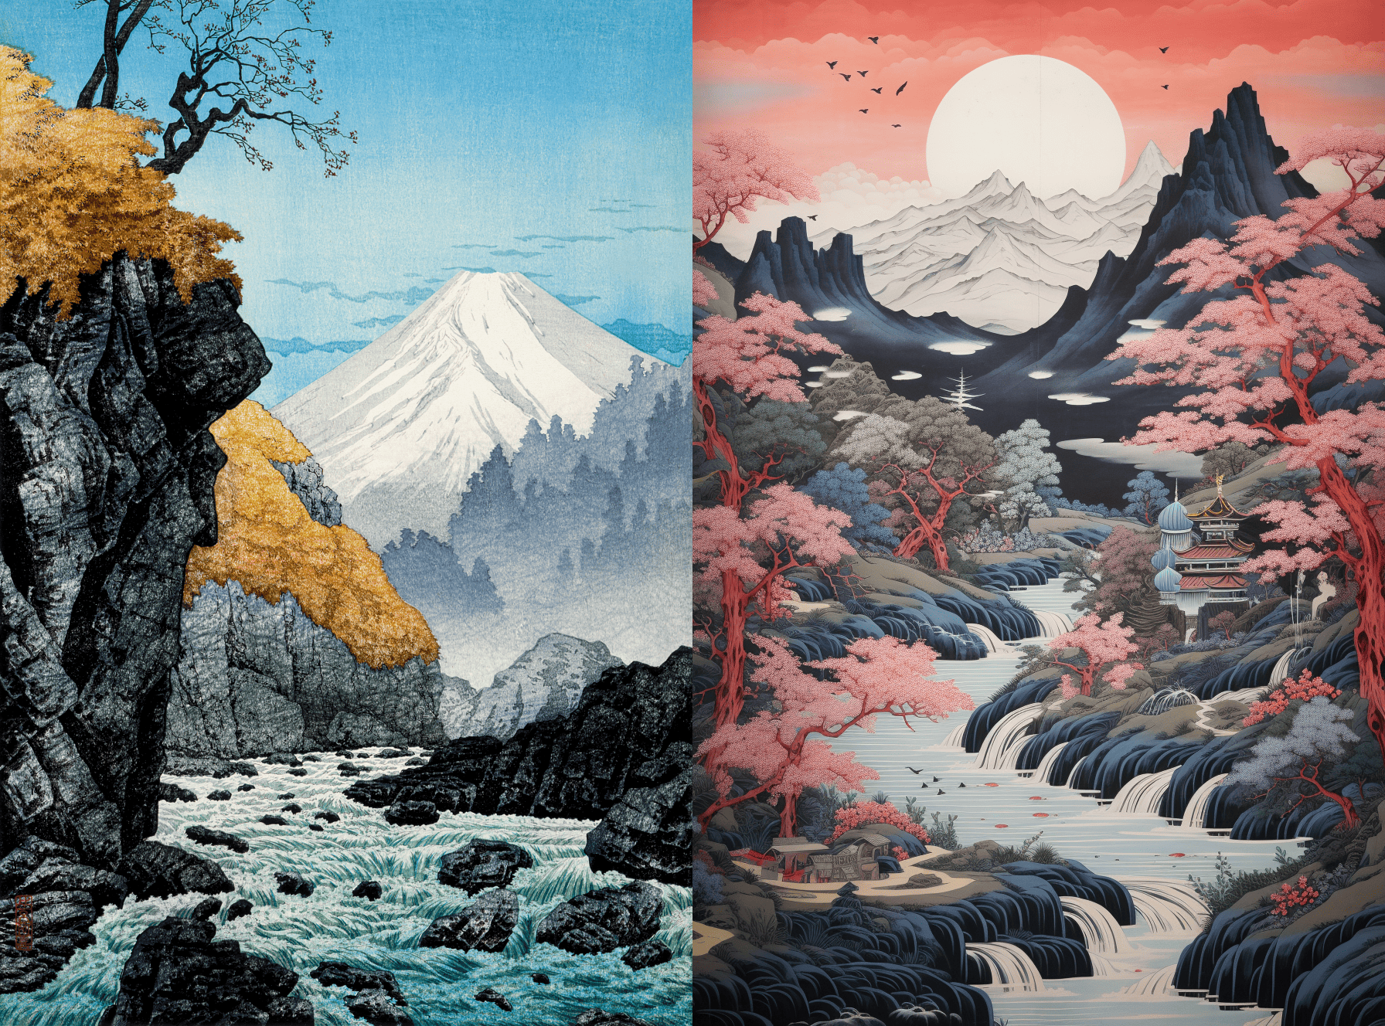Fig.1 Human (Left) Vs AI (Right)

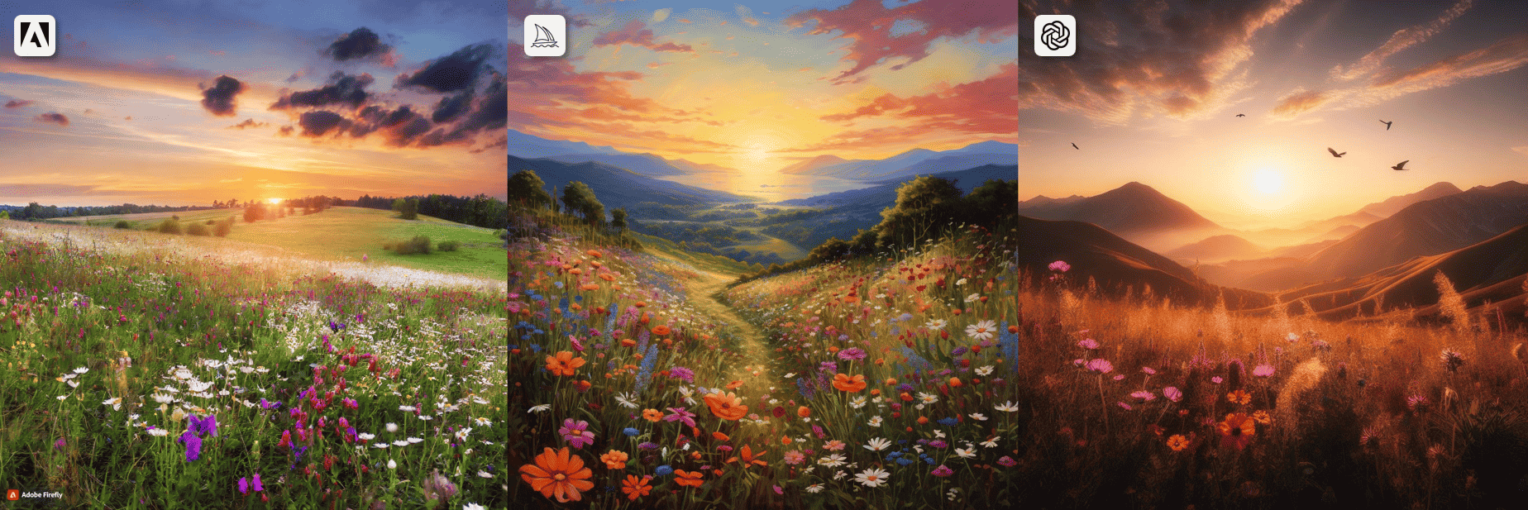Fig.2 Adobe Firefly vs. Midjourney vs. DALL-E 3

That being said, there is a time and place for using generative AI tools. When applied properly, these technologies can be incredibly useful for tasks like brainstorming, creating rough drafts, or experimenting with different visual ideas. For instance, graphic designers or illustrators may find value in using AI to quickly generate mock-ups or concept images before refining them manually. However, for the purpose of this discussion, we will focus on the more concerning aspects of generative AI that have raised alarms within the artist community. The ethical implications, the flooding of digital platforms with subpar content, and the potential harm to traditional art practices are the focal points of this essay.  
  
**Possible Solutions: AI Filtering Mechanisms and Detection Tools**

To address the concerns surrounding AI-generated content, several potential solutions have been proposed, focusing on the implementation of AI filtering mechanisms and image detection tools. One promising approach is the use of AI image recognition systems designed to detect AI-generated content. Tools like [**Sensity**](https://sensity.ai), [**Deepware Scanner**](https://scanner.deepware.ai), and [**Hugging Face’s AI Content Detection**](https://huggingface.co/spaces/PirateXX/AI-Content-Detector) offer ways to analyze and identify images that may have been generated by neural networks. These platforms look for subtle patterns and inconsistencies—such as unnatural lighting, disproportionate body parts, or unusual textures—that are often present in AI-generated images. The rise of **deepfakes**, in particular, has brought attention to the potential misuse of AI in creating highly realistic but fabricated media. Initially used to manipulate images and videos, deepfake technology now extends to **voice cloning**, such as [BARK AI](https://github.com/serp-ai/bark-with-voice-clone) allowing AI to replicate someone's voice with startling accuracy. This makes it possible to produce videos or audio clips that sound like real individuals, but which may not have been created by the person themselves. Deepfakes and voice cloning technology have been used for malicious purposes, such as creating false narratives or spreading disinformation, highlighting the urgent need for reliable detection methods. By employing these AI filtering and detection systems, artists, content platforms, and copyright holders can better distinguish between human-created and machine-generated content, ensuring that AI-generated works do not unfairly flood platforms or mislead users, whether through visuals or voice.

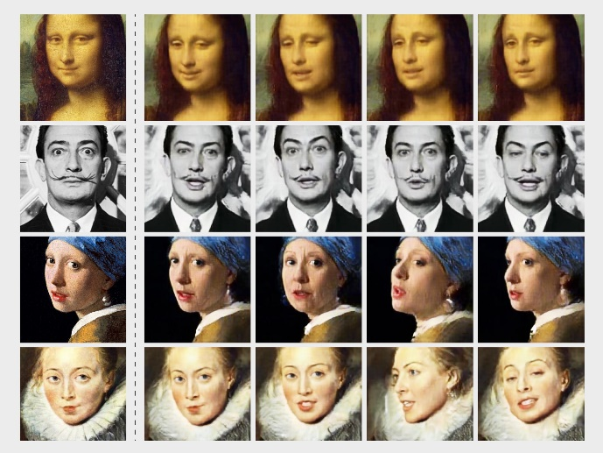Fig.3

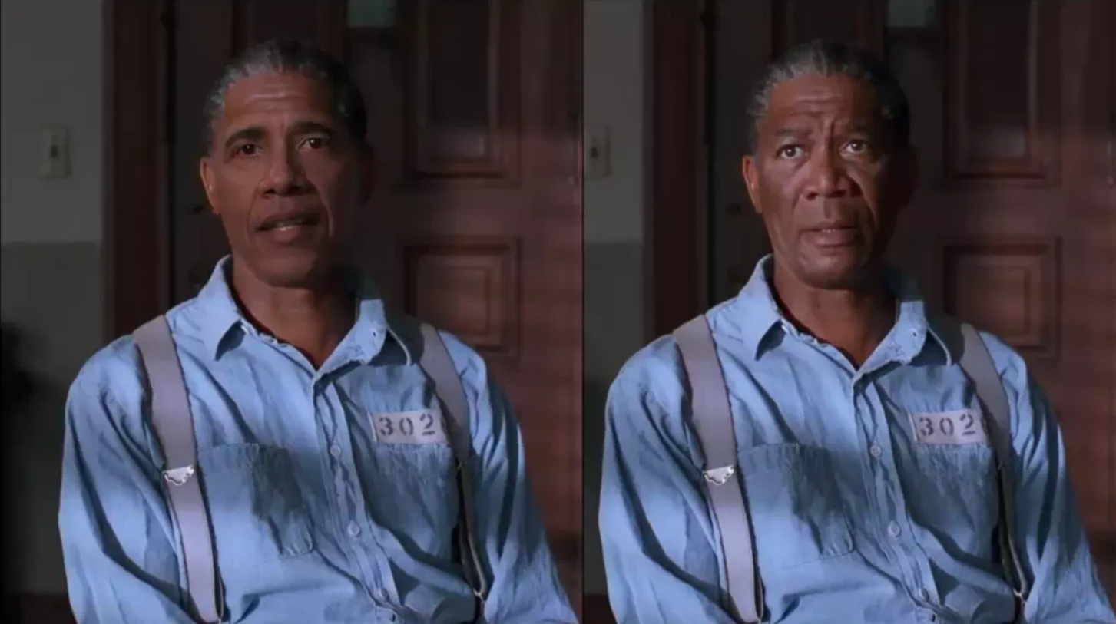Fig.4 Examples of Deepfake technology

Another tool that can play a role in detecting AI-generated images, particularly those involving human poses, is [OpenPose](https://github.com/CMU-Perceptual-Computing-Lab/openpose?tab=readme-ov-file). OpenPose is a human pose detection tool that breaks down images of people into simplified, stick-figure-like gestures. By detecting key body joints, such as the position of the head, shoulders, elbows, and knees, OpenPose can generate a skeletal representation of a human pose. This method could help identify unrealistic or awkward poses that might be indicative of AI generation. Many AI-generated artworks struggle with realistic human poses, often displaying unnatural body movements or disproportionate anatomy, which OpenPose can flag. By analyzing the poses and comparing them to human norms, OpenPose can help highlight AI-generated images, providing an additional layer of verification.

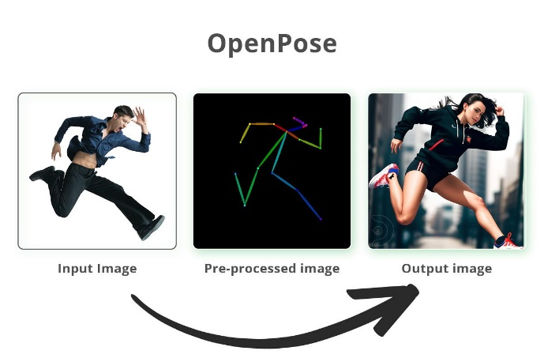Fig.5 Using OpenPose for a finished product

Fig.6 OpenPose Examples

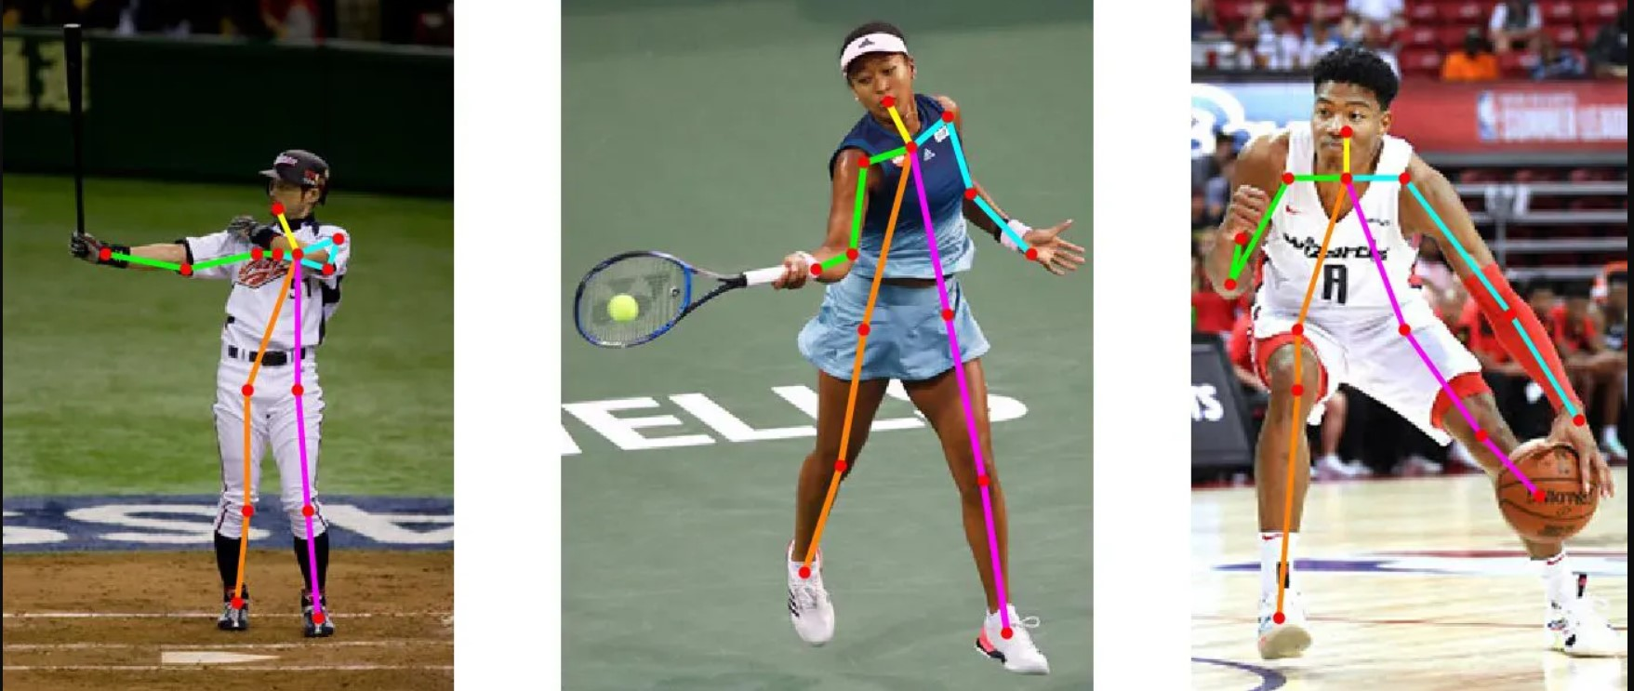

Incorporating **computer vision** technologies could enhance the detection of inconsistencies or irregularities that might be typical of AI-generated content. Computer vision uses advanced algorithms to interpret and analyze visual data, and when applied to image analysis, it can detect things like unnatural shading, inconsistent depth, or geometric anomalies in AI-created images. Unlike human perception, computer vision algorithms can process vast amounts of visual information to identify patterns, making them especially useful for spotting even subtle signs of AI involvement, such as artifacts from neural network limitations. Combining computer vision with AI image recognition systems could provide a more robust framework for identifying AI-generated works and filtering them from human-generated content on digital platforms.

Additionally, initiatives like Adobe’s **Content Authenticity Initiative** aim to establish a system for verifying the origin of digital content. By embedding metadata into images, this system would allow creators to prove the authenticity of their work and trace its history. This could be a key tool for artists seeking to protect their intellectual property and for users who want to differentiate between original art and AI-generated images.

Another solution lies in developing more sophisticated **AI filtering mechanisms** that could be integrated into platforms like Pinterest or Instagram to automatically identify and flag AI-generated content. This could help reduce the oversaturation of platforms with AI-generated images, ensuring that human-created art remains prominent and easily discoverable. In addition, clearer copyright laws for AI-generated content would help establish ownership rights, preventing the unauthorized use of an artist’s work to train AI models.

While these solutions are still in development, they offer promising ways to mitigate the negative impact of generative AI on the art world. However, as AI technology continues to evolve, it is clear that there will need to be ongoing dialogue and innovation to balance the benefits of AI with the preservation of human creativity and artistic integrity.

**Using AI as an Artistic Assistant**

With the rapid advancements in generative AI, there is a growing interest in using AI as a tool for enhancing creativity rather than replacing it entirely. While AI can generate impressive artworks, the real potential lies in using AI as an assistant that helps artists refine and improve their work, rather than creating the final piece from scratch. The idea is not to rely on AI to produce the finished product but to use it as a powerful tool for analysis, feedback, and enhancement, helping artists push the boundaries of their craft while maintaining full control over the creative process.

The approach outlined here suggests a way to train a model on a specific drawing style and then use that model to assist with improving and refining an artist's own work. This process can act as a bridge between traditional artistic techniques and the possibilities opened up by machine learning, offering a new way for artists to explore their creativity with AI as an active collaborator.

### **Using Streamlit and Ollama for Image Analysis and Feedback**

This simple code (**GitHub**) integrates [Streamlit](https://pypi.org/project/streamlit/) with the [Ollama API](https://pypi.org/project/ollama/) to allow users to upload images, display them, and receive an AI-generated description and analysis of the artwork.

* **Image Upload**: The code uses Streamlit’s file uploader to allow users to upload an image (in PNG, JPG, or JPEG format). Once an image is uploaded, it is displayed on the app using st.image().
* **Image Preprocessing**: The uploaded image is then processed. It is converted into a base64-encoded string using the PIL library and base64 encoding. This step is necessary to send the image data to the Ollama API for analysis.
* **AI Analysis with Ollama**: The ollama.chat() function calls the **Llama 3.2 Vision Model** to analyze the image. The model receives a set of instructions, including requests for a detailed description of the image, an analysis of its style, and an evaluation of the proportions of the character. The AI is also asked to suggest improvements if needed.
* **Displaying the Results**: The AI’s response is displayed within an expandable section in the app. The result includes a detailed description, possible artist recognition, style analysis, and suggested improvements.

This code is a practical demonstration of how AI can assist in the analysis and enhancement of artwork, highlighting its potential as a creative assistant rather than a content generator. By providing immediate feedback on artistic elements like proportions and style, it empowers artists to refine their work with AI-based insights.

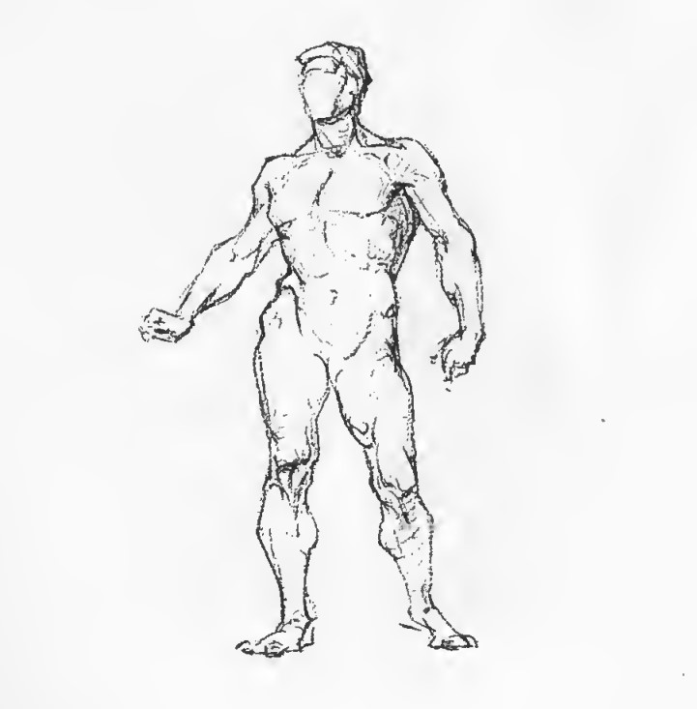

Fig.7 figure drawing by George Bridgman

Using the image above, **Ollama** produced the following output. Although this is far from what I initially intended, I expect this vision model to improve over time. It’s interesting how AI can sometimes misinterpret or offer suggestions on works that are already highly regarded, like this one by George Bridgman. AI tends to look for patterns or technical improvements that might not always apply to a work that's already been perfected by a skilled artist. I wasn't expecting the AI to recognize this image either, especially since it was probably not trained on something like this. It's definitely a testament to how far AI has come, though.

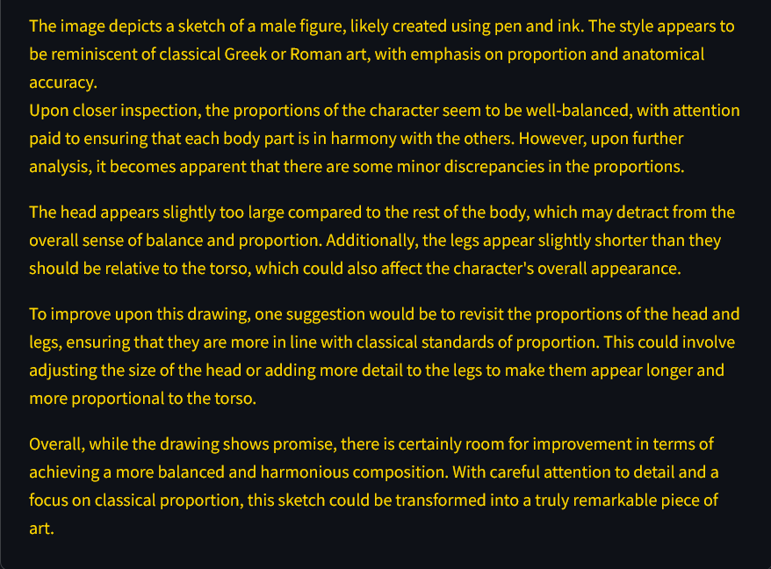  
Fig.8 Ollama output

For a fully developed project, I would begin by utilizing web scraping techniques, such as Scrapy, to collect a diverse set of images that embody a particular artistic style. Once the data is gathered, I would train a custom model to recognize and replicate the key elements of that style. Additionally, to better understand the underlying structure of the artwork, I would integrate tools like OpenPose, which can analyze the human gestures and poses in the images. This would allow the model to not only mimic the style but also gain a deeper understanding of the anatomy and motion of the figures, leading to more accurate and refined outputs.

### **References**

1. [Github](https://github.com/vramdavtyan/ImageAnalysis) **including code, video, slides and this pdf**
2. [**DALL·E**](https://openart.ai/home?utm_source=google&utm_medium=cpc&utm_campaign=Ser_EU_Midjourney_Dalle&utm_content=Dalle_Exact&utm_source=google&utm_medium=cpc&utm_campaign=21049810241&utm_term=dall%20e&gad_source=1&gclid=EAIaIQobChMIxuq_sf6OiwMVJZRoCR3oWTOyEAAYASAAEgKTV_D_BwE)
3. [**MidJourney**](https://www.midjourney.com/explore?tab=top)
4. [**Sora**](https://openai.com/sora/)
5. [OpenPose](https://github.com/CMU-Perceptual-Computing-Lab/openpose?tab=readme-ov-file)
6. [Streamlit](https://pypi.org/project/streamlit/)
7. [Ollama API](https://pypi.org/project/ollama/)
8. [AI vs Human Art](https://goldpenguin.org/blog/ai-vs-human-art/)
9. [**Sensity**](https://sensity.ai)
10. [**Deepware Scanner**](https://scanner.deepware.ai)
11. [**Hugging Face’s AI Content Detection**](https://huggingface.co/spaces/PirateXX/AI-Content-Detector)
12. [BARK AI](https://github.com/serp-ai/bark-with-voice-clone)
13. [Quiz](https://www.foundmyself.com/blog/ai-art-quiz/?srsltid=AfmBOor4OU9fJzq1dW_aoSWRssL_Grz1WQxMTErKQxOt1DGNRnss-9j2)