## Assignment 1: Package Delivery System Simulation Framework.

Create a java application and a background simulation framework to display tracking information for the package delivery system of FedEx.

Requirements:

* Implement a database of 100,000 packages with attributes shown in the snapshot attached below (Figure 1).
* A user should be able to query the system with a unique tracking number and get results similar to what is shown in the snapshot attached below (Figure 1).
* The system should compute shortest path for delivery of a package through the list of Fedex distribution centers shown below:

**List of Fedex Distribution Centers**

Northborough, MA

Edison, NJ

Pittsburgh, PA

Allentown, PA

Martinsburg, WV

Charlotte, NC

Atlanta, GA

Orlando, FL

Memphis, TN

Grove City, OH

Indianapolis, IN

Detroit, MI

New Berlin, WI

Minneapolis, MN

St. Louis, MO

Kansas, KS

Dallas, TX

Houston, TX

Denver, CO

Salt Lake City, UT

Phoenix, AZ

Los Angeles, CA

Chino, CA

Sacramento, CA

Seattle, WA

* The application should take as an input a tracking no and print the tracking details of the package as shown below. (No GUI or custom graphics required)

Sample Output:

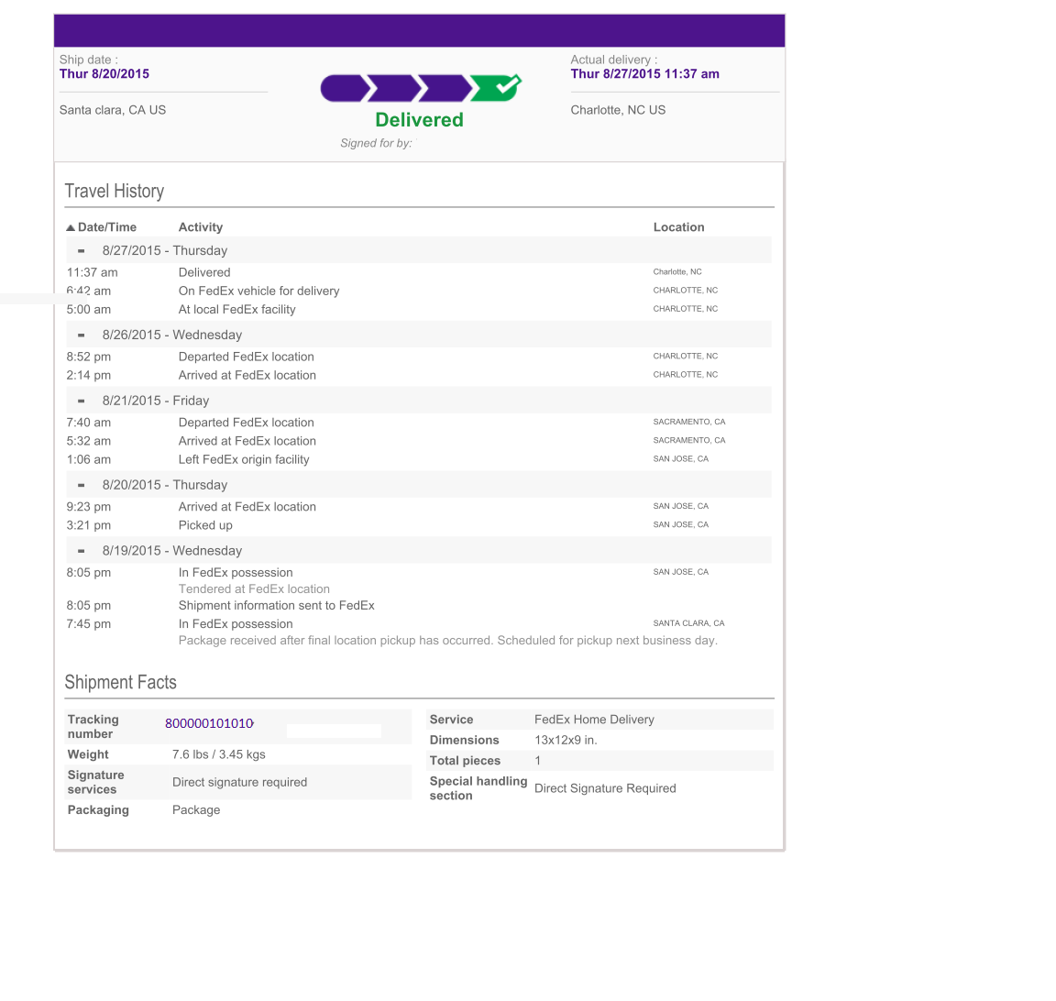

Figure 1

[Ref:www.fedex.com]