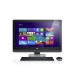
Dell XPS 27 Touch

Best all-in-one computer
The Dell XPS 27 Touch earns rave reviews as the best Windows all-in-one computer, and one of the best desktop computers overall for most users. It sports an elegant design and enough computational firepower to handle serious work and all but the most serious play.
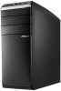
Asus M51AC

Best desktop computer
If you want the best bang for the buck, a traditional tower desktop computer like the Asus M51AC is your best choice. It's available in a ton of different configurations, but all feature top-notch components and the flexibility to grow as your needs change.
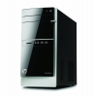
HP Pavilion 500

Best cheap desktop computer
For those on a budget, it's hard to ignore the value proposition offered by the HP Pavilion 500. Lots of configurations are available, but a price tag of $500 will net a traditional tower with modern components -- including the latest Intel Core processor -- a huge hard drive, an optical drive and plenty of memory
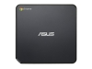
Asus Chromebox M004U

Chrome desktop computer
For light-duty computing, the Asus Chromebox M004U might be all the computer you need. The hardware is unimpressive compared with the Windows desktop computers above, but is a perfect match for the Chrome operating system it runs. Just make sure you can live with Chrome's limitations.
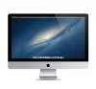
Apple iMac 27-inch

Best Apple desktop computer
The 27-inch iMac is certainly a head-turner. The design is simply gorgeous -- looking impossibly thin even if the rear of the system does have a bit of a bulge. Performance is good even in the iMac's base configuration, and available upgrades can transform it into a powerhouse that can stand toe-to-toe with anything short of a dedicated gaming rig.

