**Software Requirements Specification**

**(SRS) Document**

|  |
| --- |
| **Revisions** |

| Version | Primary Author(s) | Description of Version | Date Completed |
| --- | --- | --- | --- |
| Final Draft | Team | All sections being Filled | 10/20/23 |

1. Introduction

* 1. **Introduction**

The purpose of this document is to define and describe the requirements of the project and to spell out the system’s functionality and its constraints.

* 1. **Scope of this Document**

The customer and the user for the system are the employees of the IDANRV, including Mrs. Sheila Roop, and the developers of the system is the Shock Force Software Team. Our constraints for this section includes our deadline for the document which is due 10/29/09

* 1. **Overview**

The product is an Access Database with import/export capabilities from Excel that will hold information on auctions, bid items and their bidders, including auction income, auction expenses, bid amount, bid increment, bid ID, item donor, item’s original value, payment type, bidder name, and bidder email.

## 2. General Description

**2.1 Product Functions**

The product should make input of data and the entire checkout process easier and streamlined for the users (employees) and time efficient for the bidder.

**2.2** **Similar System Information**

The product is being developed with Access, so there are a large number of similar databases or systems and they are used for a wide array of different purposes. The possible strength our system has over the majority is the Excel import/export feature of the program.

**2.3 User Characteristics**

The users include the employees of the IDA as they input data on bids and their bidders. For this system, the user is required to know the basic usability of Excel as well as a very base level understanding of access, which hopefully will be facilitated by the software team through training.

**2.4 User Problem Statement**

The users system, currently, is slow and inefficient as it relates to the checkout process. Bidders must wait hours to check out the item they have won. Too many man hours have been needed to enter the wealth of information collected.

**2.5 User Objectives**

The user wants a database that will store information on a silent auction. The program must faciliatate the speed and ease of input. It also must store the items the IDANRV needs to store.

**2.6 General Constraints**

Constraints include an easy to use interface for the program through forms, a Windows platform or, at bare minimum, a Mac with Access and Excel for Mac installed. Also, it must be constructed in Access, Excel, or another related program that is easily learnable.

## 3. Functional Requirements

1. **Items provided to the IDANRV shall be stored in the Access Database.**
   1. Items shall be stored on the laptop machine and have complete fields.
   2. Very high criticality
   3. Limited network / wi-fi availability could present a technical challenge
   4. The above stated factor is a risk we have encountered. Eliminate it by reducing the dependency of our program on these things.
   5. This requirement is the basis of the project; all other aspects depend on it.
2. **The items shall be accessible via queries and reports.**
   1. Users of the database should be able to run reports on the data that has been put into the database. They should also be able to run queries.
   2. Very high criticality
   3. We do not foresee any technical issues preventing the implementation of this.
   4. Given the capabilities of Access, this requirement is able to be satisfied.
   5. This requirement depends on requirement number one.
3. **The data stored should be able to be manipulated through forms.**
   1. Items and other data should be able to be added and updated through the use of forms.
   2. Very high criticality
   3. We do not foresee any technical risks involved in this requirement.
   4. The only factor we can encounter here is the user of the system not being able to use it correctly. We will overcome this by training those who will be using it.
   5. This requirement is dependent on requirement one.

## 4. Interface Requirements

4.1 User Interfaces

* **4.1.1 GUI**  
  The user interface for this program is the interface provided by Microsoft Access 2007. Access includes forms and reports for the users to query and organize data to suit their needs. Forms and reports both have builders that let the user specify which fields they want to use and which constraints they want to define.
* **4.1.2 CLI**  
  There is no command line interface
* **4.1.3 API**  
  There is no API for the product
* **4.1.4 Diagnostics or ROM**  
  There is a troubleshooting and help section provided by Microsoft

4.2 Hardware Interfaces

The program (Access) uses the hard disk. Access to the hard drive and other hardware is managed by the operating system and Access.

4.3 Communications Interfaces

If we decide to implement an Ad Hoc network for a shared database, the operating system will handle those connections.

4.4 Software Interfaces

The Access system may be used to import and export data with Microsoft Excel. This functionality is built in to the user interface.

## 5. Performance Requirements

The database is designed to be operated through Microsoft Access 2007, thus no additional system requirements exist beyond those required to run Microsoft Office 2007, except for a negligible amount of hard drive space to store the database.

Microsoft lists the requirements for Access 2007 as follows:

500 MHz processor or higher

256MB RAM or higher

1.5GB Available Hard Drive Space

Windows XP SP2 or later operating system.

Windows Office Professional 2007 (Windows Access)

There is also Access Available for Mac OS X, the clients have not stated a need thus far.

## 6. Preliminary Use Case Models and Sequence Diagrams

This section presents a list of the fundamental sequence diagrams and use cases that satisfy the system’s requirements. The purpose is to provide an alternative, "structural" view of the requirements stated above and how they might be satisfied in the system.

6.1 Use Case Model

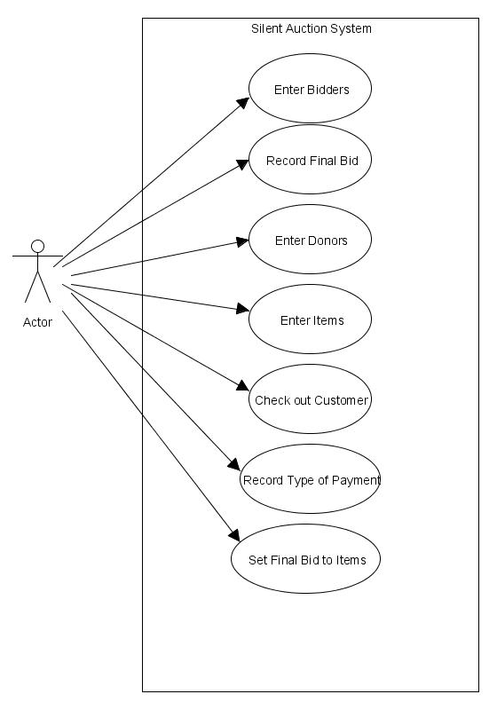

6.2 Sequence Diagrams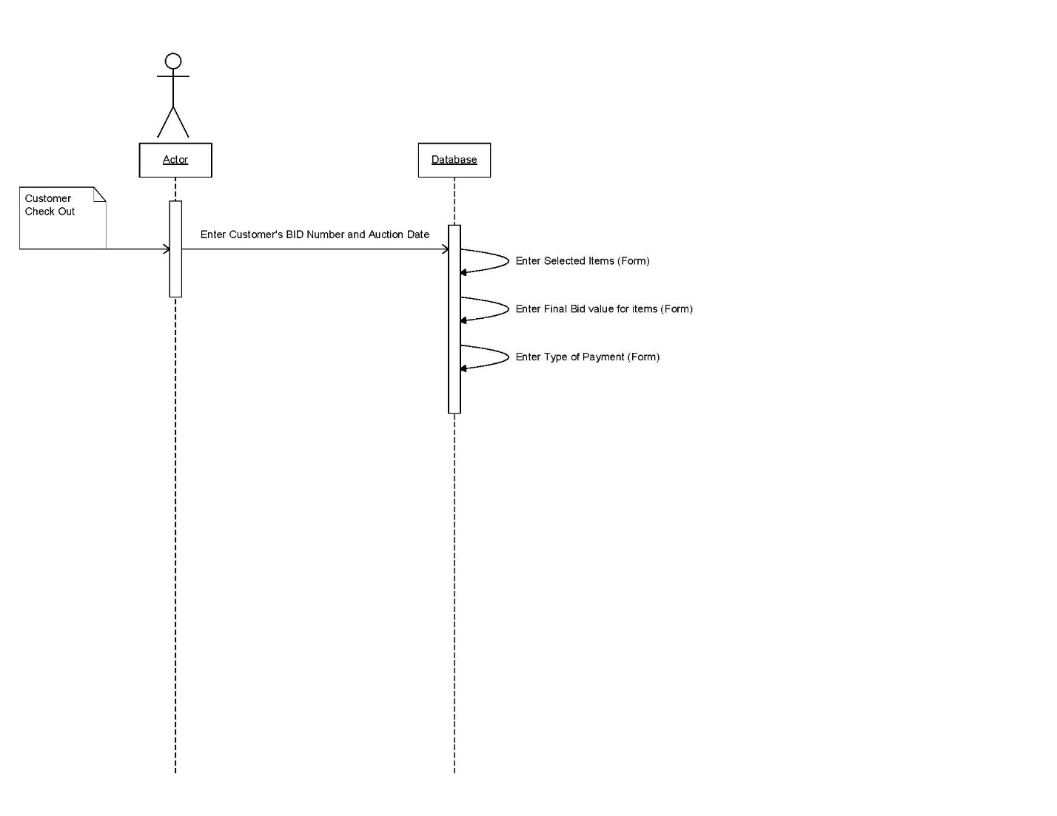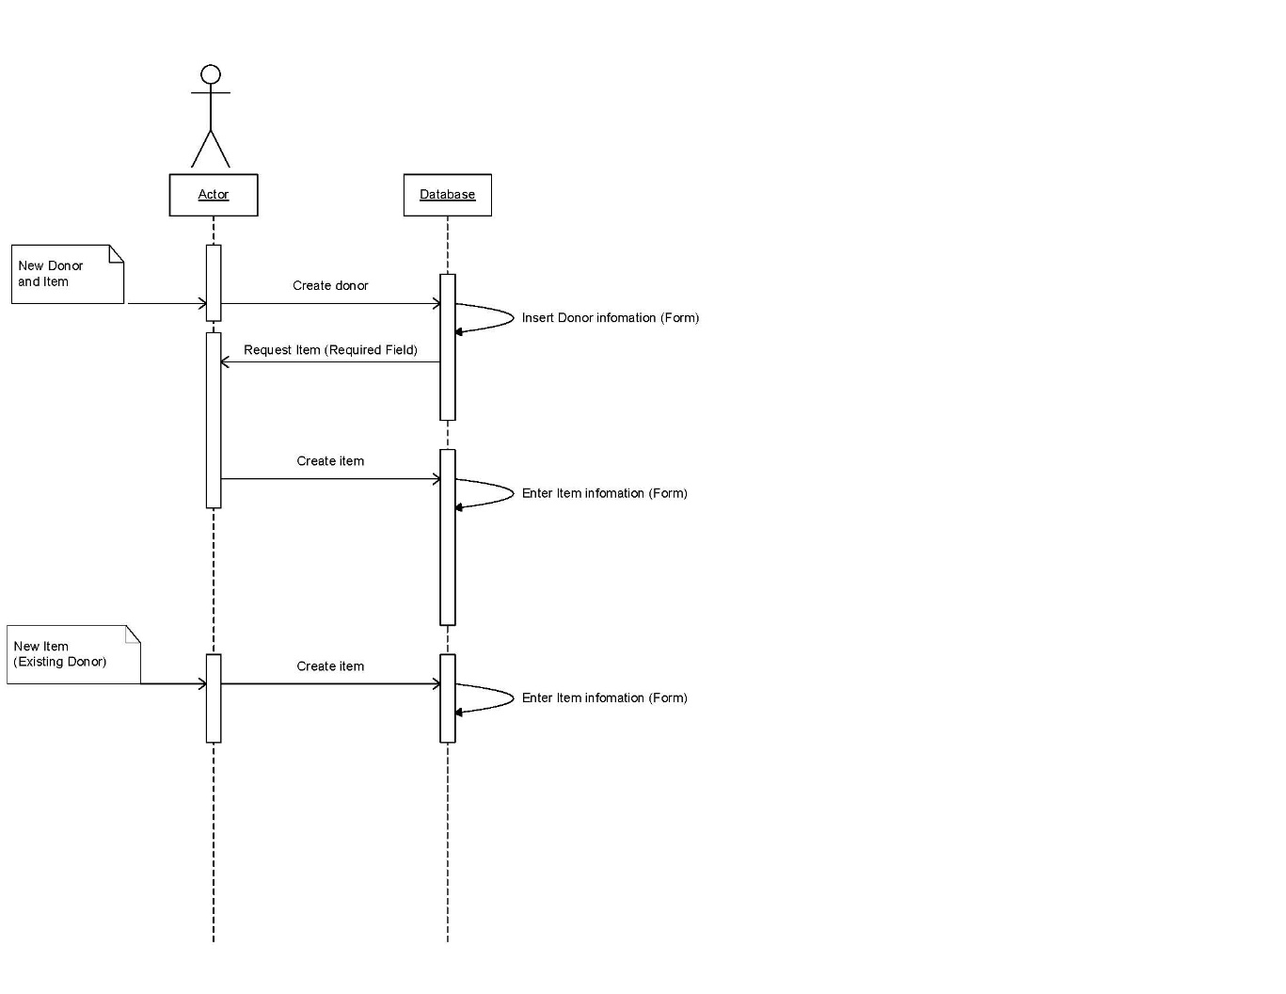

## 7. Appendices

7.1 Definitions, Acronyms, Abbreviations  
IDANRV- Intellectual Disabilities Agency of the New River Valley