**Let Us Think!**

Directions: Choose the letter that best answers the given question. Highlight the letter of the correct answer.

1. It is an academic paper expressing about a position about an issue
   1. Critique paper
   2. Position paper
   3. Reaction paper
   4. All of the above
2. Which of the following sections of a position paper needs ample time to collect information?
   1. Introduction C. Conclusion
   2. Body D. All of the above
3. Which sections of a position paper restate the main point and final comment?
   1. Introduction
   2. body
   3. conclusion
   4. All of the above
4. The following situations can be used to express a position, except:
   1. Social issues
   2. Intriguing issues
   3. Recurring issues
   4. Gossips
5. What is the ideal minimum number of paragraphs in a position paper?
   1. two paragraphs
   2. three paragraphs
   3. four paragraphs
   4. five paragraphs
6. How can you make your paper convincing?
   1. sources are cited properly
   2. support opinions with evidences
   3. record findings and post on any social media platform
   4. none of the above
7. How many sources shall you incorporate in your paper?
   1. one source
   2. two sources
   3. three or more sources
   4. no need of any source
8. The following are to be considered in writing a manifesto, except
   1. What issue should I want to address?
   2. What do I want others do to address the issue?
   3. What changes must I see?
   4. All of the above
9. Which of the following is employed in writing a manifesto?
   1. Be concise and use clear language
   2. Avoid using long and complicated words
   3. A and B
   4. Neither A nor B
10. Which of the following is true in dealing with manifestos?
    1. Elaborate on skills if doing manifesto for an election
    2. Your manifesto is not about you but about your opponent.
    3. Both A and B are correct
    4. Only B is correct

**Let Us Inspect!**

Directions: List at least 5 issues that you can identify that the society, your community is facing right now. Identify particular information that you would like to deal with in your paper.

|  |  |
| --- | --- |
| **ISSUES** | **WHAT I WANT TO FOCUS ON** |
| Example: Cyberbullying | * Effects among young people * What should the government do to address cybercrimes? |
| Gender issues and biases (gender discrimination) | * Effects among both genders * What does the community need to know to prevent and put a stop to gender discriminating and stereotyping? |
| Pollution | * Effects among community dwellers * What solutions do respective barangay communities need to have in order to lessen and eventually terminate pollution? |
| Poverty | * Effects on the marginalized sector * What should the government and citizens do to help combat poverty? |
| Climate change | * Effects on people within the community * What are the important things residents need to know to halt the possible succeeding effects of climate change? |
| Political corruption | * Effects among the citizens and taxpayers * What should the community need to know so that people will eventually choose competent and citizen-serving government leaders on the next opportunity they get to cast their votes. |

**Let Us Reflect!**

Directions: Read and Answer.

1. Why do you think it is important to familiarize the basic parts of an essay?

**It is important and essential to familiarize the basic parts of an essay since every part plays a vital role in the build-up of the essence of an essay. It serves as a binding technique that helps support in developing and maintaining an assertion that can further encourage the audience to ought to know more of what is in store of the essay. Moreover, connecting all of the sections of your essay will make it a lot easier to read and comprehend.**

1. Now that you have learned how to put basic items into its part, what do you think should you develop more to be able to write a position paper well in the future?

**Given that I have learned how to allocate the basic items of essay into their respective parts, I think that what I should develop more to be able to write a position paper well in the future is to acquire a skill with regards to paraphrasing since the gathered data and information from reliable sources that support my opinion need not to be directly copied, instead, these should be reiterated with the use of own words to avoid further problems such as plagiarism.**

**Let Us Achieve!**

Directions: From the issues you have listed in activity 3. Make a manifesto of your own. A sample is shown below. For your output, you can use a blank page so that you can be as creative as you like. You can send your output via email (teacher’s email).

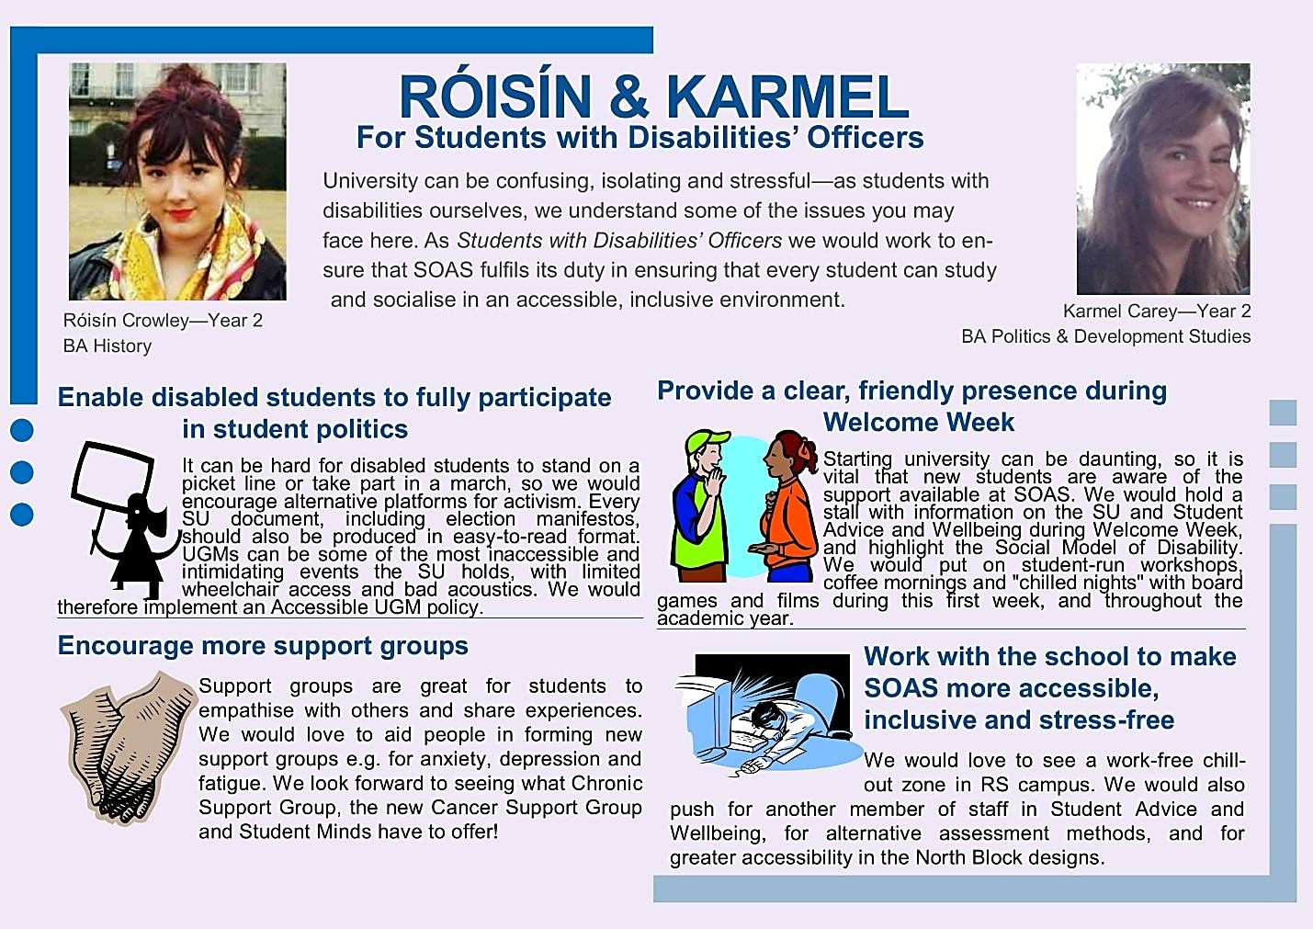Example: