**Let Us Think!**

Directions: Choose the letter that best answers the given question. Highlight the letter of the correct answer.

1. It is an academic paper expressing about a position about an issue
   1. Critique paper
   2. Position paper
   3. Reaction paper
   4. All of the above
2. Which of the following sections of a position paper needs ample time to collect information?
   1. Introduction C. Conclusion
   2. Body D. All of the above
3. Which sections of a position paper restate the main point and final comment?
   1. Introduction
   2. body
   3. conclusion
   4. All of the above
4. The following situations can be used to express a position, except:
   1. Social issues
   2. Intriguing issues
   3. Recurring issues
   4. Gossips
5. What is the ideal minimum number of paragraphs in a position paper?
   1. two paragraphs
   2. three paragraphs
   3. four paragraphs
   4. five paragraphs
6. How can you make your paper convincing?
   1. sources are cited properly
   2. support opinions with evidences
   3. record findings and post on any social media platform
   4. none of the above
7. How many sources shall you incorporate in your paper?
   1. one source
   2. two sources
   3. three or more sources
   4. no need of any source
8. The following are to be considered in writing a manifesto, except
   1. What issue should I want to address?
   2. What do I want others do to address the issue?
   3. What changes must I see?
   4. All of the above
9. Which of the following is employed in writing a manifesto?
   1. Be concise and use clear language
   2. Avoid using long and complicated words
   3. A and B
   4. Neither A nor B
10. Which of the following is true in dealing with manifestos?
    1. Elaborate on skills if doing manifesto for an election
    2. Your manifesto is not about you but about your opponent.
    3. Both A and B are correct
    4. Only B is correct

**Let Us Inspect!**

Directions: List at least 5 issues that you can identify that the society, your community is facing right now. Identify particular information that you would like to deal with in your paper.

|  |  |
| --- | --- |
| **ISSUES** | **WHAT I WANT TO FOCUS ON** |
| Example: Cyberbullying | * Effects among young people * What should the government do to address cybercrimes? |
|  |  |
|  |  |
|  |  |
|  |  |
|  |  |

**Let Us Reflect!**

Directions: Read and Answer.

1. Why do you think it is important to familiarize the basic parts of an essay?
2. Now that you have learned how to put basic items into its part, what do you think should you develop more to be able to write a position paper well in the future?

**Let Us Achieve!**

Directions: From the issues you have listed in activity 3. Make a manifesto of your own. A sample is shown below. For your output, you can use a blank page so that you can be as creative as you like. You can send your output via email (teacher’s email).

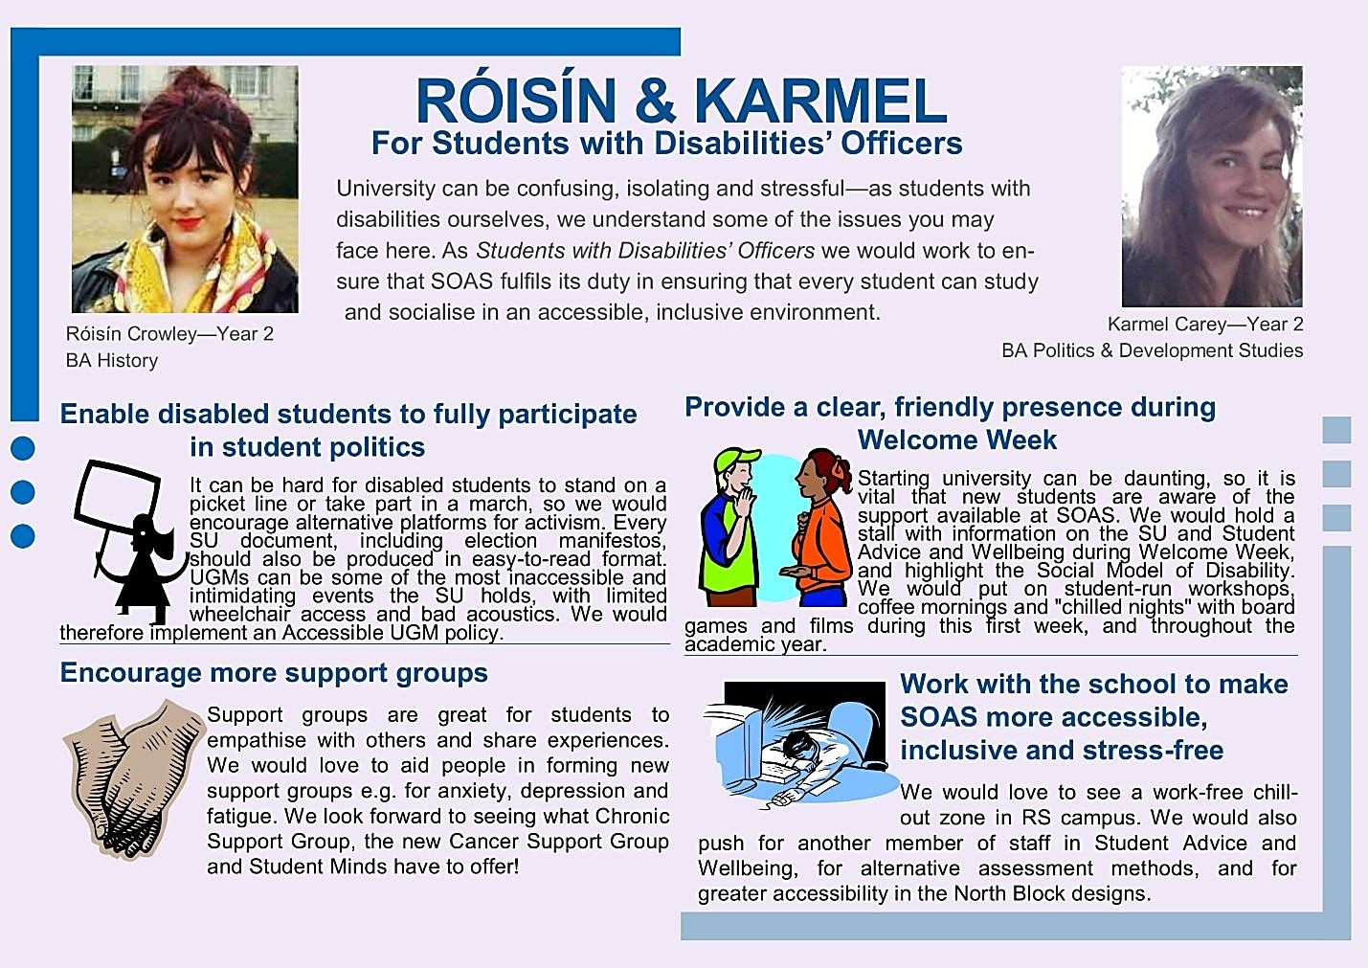Example: