# **Operational Concept Description (OCD)**

**The Study App**

**Justice League**

**Jeffrey Woo**

**Joan Sirma**

**Manisha Yalavarthy**

**Soneer Sainion**

**Vishal Ravuri**

**March 14, 2017**

# **Version History**

|  |  |  |  |  |
| --- | --- | --- | --- | --- |
| **Date** | **Author** | **Version** | **Changes** | **Rationale/Comments** |
| 3/14/17 | Manisha Yalavarthy | 1.0 | Initial Document | N/A |
|  |  |  |  |  |

# **Table of Contents**

**Operational Concept Description (OCD) i**

**Version History ii**

**Table of Contents iii**

**Table of Tables iv**

**Table of Figures v**

**1.** **Introduction 1**

**1.1** **Purpose of the OCD 1**

**1.2** **Status of the OCD 1**

**2.** **Shared Vision 2**

**2.1** **Benefits Chain 3**

**2.2** **System Capability Description 4**

**2.3** **System Boundary and Environment 4**

**3.** **System Transformation 6**

**3.1** **Information on Current System 6**

**3.2** **System Objectives, Constraints and Priorities 6**

**3.3** **Proposed New Operational Concept 8**

**3.4** **Organizational and Operational Implications 12**

# **Table of Tables**

*Table 1: The Program Model 2*

*Table 2: Level of Service Goals 7*

*Table 3: Relation to Current System 8*

# **Table of Figures**

*Figure 1: Benefits Chain Diagram of Volunteer Tracking System 3*

*Figure 2: Benefits Chain Diagram 4*

*Figure 3: System Boundary and Environment Diagram of Volunteer Tracking System 5*

*Figure 4: System Boundary and Environment Diagram 5*

*Figure 5: Element Relationship Diagram of Transportation Grant Fund system (NDI-intensive project) 9*

*Figure 6: Element Relationship Diagram of the Los Angeles Community Garden Inventory and Locator (Architected agile project) 9*

*Figure 7: Element Relationship Diagram 10*

*Figure 8: Business Workflow Diagram of Volunteer Tracking System 11*

*Figure 9: Business Workflows Diagram 12*

### **Introduction**

#### **Purpose of the OCD**

This document aims to describe the visions and goals of the stakeholders of The Study App. The aforementioned stakeholders of this project are, Justice League, as the team and project owner, Professor Moazeni, and students of San Jose State University, as users. Along with the vision and goals, this document will also discuss the scope, the advantages, and other various aspects of this project.

#### **Status of the OCD**

The status of the OCD is currently the initial version 1.0. The project has just commence and still in the developmental stage. The project is expected next to address the testing and reevaluation phase. During which, the OCD will undergo changes to accommodate the edited requirements of the project.

### **Shared Vision**

**Table 1: The Program Model**

|  |  |  |  |
| --- | --- | --- | --- |
| **Assumptions** Access to study material is available for public use. | | | |
| **Stakeholders** | **Initiatives** | **Value Propositions** | **Beneficiaries** |
| * Justice League * San Jose State University students * Professor Moazeni * Youtube lectures (provide some of study material to include in App) | * Create discussion board for students and teachers to communicate * Gather material on various courses and subjects   + subjects include Biology, Chemistry, Algebra, English, etc. | * Close gap between students and professors * Give students access to various course material and notes * Make learning and exploring new subjects an easier and more accessible task | * Students of San Jose State University * Professors of San Jose State University * Justice League * Professor Moazeni |

**Legend:**



#### **Benefits Chain**

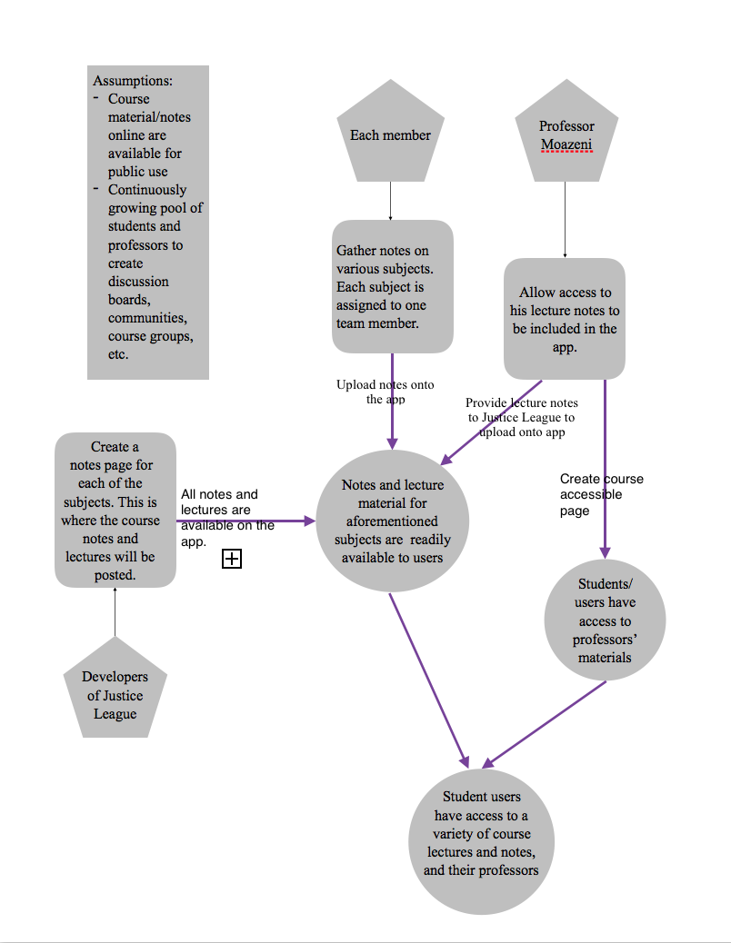

**Figure 1: Benefits Chain Diagram of Volunteer Tracking System**

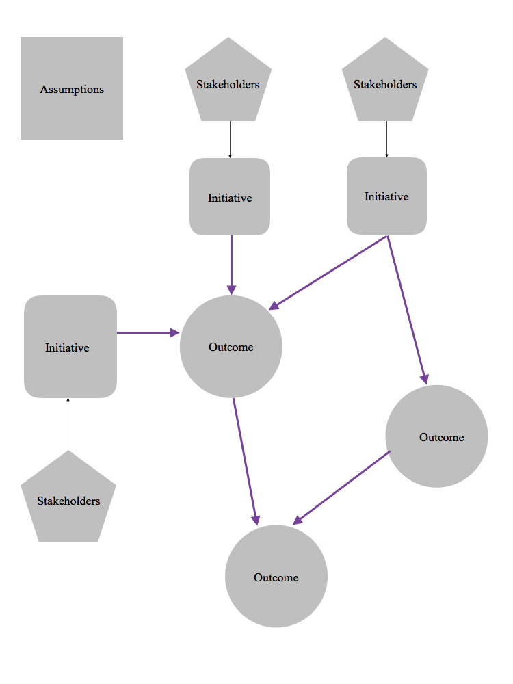

**Figure 2: Benefits Chain Diagram**

#### **System Capability Description**

* Android mobile phone study app
* Students and other people that want to learn, and have ready access to the subject’s material
* Learning a new subject and having access to experts in that subject takes a lot of time and resources
* If the user wants to learn a new subject and discuss the topics with a/their professor, they have an easy means to do so
* Khan Academy and Canvas
* This app offers a discussion forum where any professor that is an expert in a field is available to users/students.

#### **System Boundary and Environment**

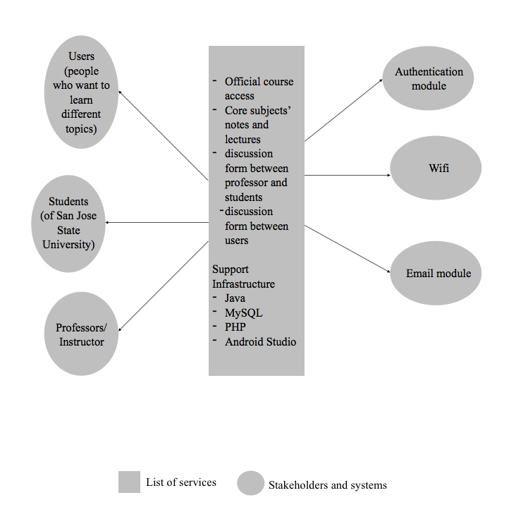

**Figure 3: System Boundary and Environment Diagram of Volunteer Tracking System**

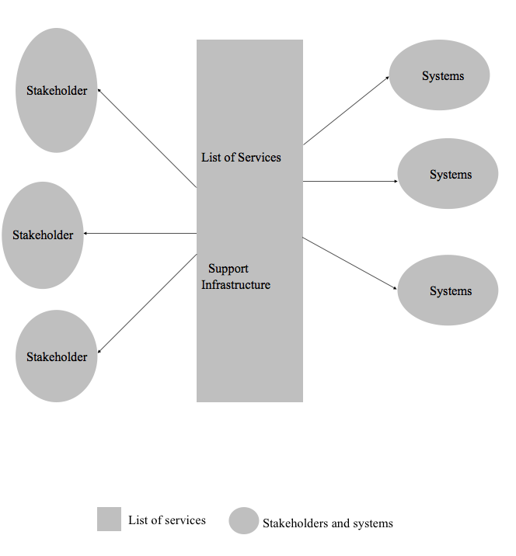

**Figure 4: System Boundary and Environment Diagram**

### **System Transformation**

#### **Information on Current System**

##### **Infrastructure**

The infrastructure that is currently being utilized is Android software. Wifi will be utilized, so any mobile device that supports wifi and Android OS should have access to The Study App.

##### **Artifacts**

Java

PHP

Android Studio

Youtube/Sources of academic material

##### **Current Business Workflow**

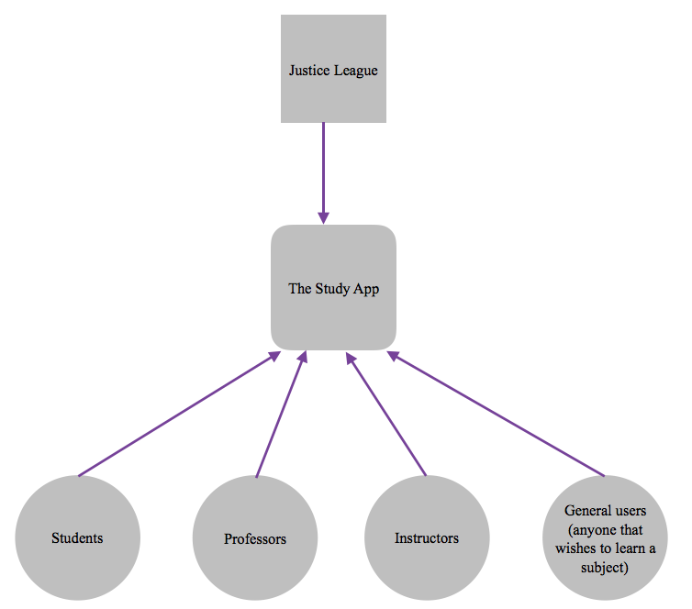

#### **System Objectives, Constraints and Priorities**

##### **Capability Goals**

|  |  |
| --- | --- |
| **Capability Goals** | **Priority Level** |
|  |  |
| Provide notes/lectures on various subjects | Must have |
| Provide discussion form between professors and users/students | Must have |
| provide discussion form between users | Would like to have |

##### **Level of Service Goals**

**Table 2: Level of Service Goals**

|  |  |  |
| --- | --- | --- |
| **Level of Service Goals** | **Priority Level** | **Referred WinWin Agreements** |
|  |  |  |
|  |  |  |
|  |  |  |
|  |  |  |

##### **Organizational Goals**

**OG-1:** Increase access for users to various study materials

**OG-2:** Offer students easier access to their instructors/professors as well as their course material

**OG-3:** Facilitate student-to-student discussions and interaction

##### **Constraints**

**CO-1:** Access to course modules

**CO-2:** No monetary budget: can’t pay for access to notes/lectures online

**CO-3:** Only offer a few courses’ notes/lectures

**CO-4:** Java is a development language

**CO-5:** Only available in Android

##### **Relation to Current System**

**Table 3: Relation to Current System**

|  |  |  |
| --- | --- | --- |
| **Capabilities** | **Current System** | **New System** |
| Roles and Responsibilities |  |  |
| User Interactions |  |  |
| Infrastructure |  |  |
| Stakeholder Essentials and Amenities |  |  |
| Future Capabilities |  |  |

#### **Proposed New Operational Concept**

##### **Element Relationship Diagram**

**Figure 5: Element Relationship Diagram of Transportation Grant Fund system   
(NDI-intensive project)**

**Figure 6: Element Relationship Diagram of   
the Los Angeles Community Garden Inventory and Locator (Architected agile project)**

**Figure 7: Element Relationship Diagram**

##### **Business Workflows**

First version. No tranformations yet.

**Figure 8: Business Workflow Diagram of Volunteer Tracking System**

**Figure 9: Business Workflows Diagram**

#### **Organizational and Operational Implications**

##### **Organizational Transformations**

First version. No tranformations yet.

##### **Operational Transformations**

First version. No tranformations yet.