# **Prototype Report**

**The Study App(Tentative)**

**Justice League**

**Jeffrey Woo**

**Joan Sirma**

**Manisha Yalavarthy**

**Vishal Ravuri**

**Soneer Sainion**

# **Version History**

|  |  |  |  |  |
| --- | --- | --- | --- | --- |
| **Date** | **Author** | **Version** | **Changes** | **Rationale/Comments** |
| 3/13/17 | Justice League | 0.1 | Documentation | Version 1 of prototype |
|  |  |  |  |  |

# 

# 

# 

# 

# 

# 

# 

# 

# 

# 

# 

# 

# **Table of Contents**

**Prototype Report i**

**Version History ii**

**Table of Contents iii**

**Table of Tables iv**

**Table of Figures v**

**1.** **Introduction 1**

**1.1** **Purpose of the prototype report 1**

**1.2** **Status of the prototype 1**

**2.** **Navigation Flow 2**

**3.** **Prototype 3**

# **Table of Tables**

*Table 1: Screenshot name-1 3*

*Table 2: Volunteer Clock Out Page 4*

# **Table of Figures**

*Figure 1: Navigation Flow of Volunteer Tracking System 2*

*Figure 2: Home Screen Screenshot* *9*

*Figure 3: New User Screenshot* *9*

*Figure 4: Class Home Screenshot 10*

*Figure 5: Study Tools page Screenshot 10*

*Figure 6:Study Tool page 2 Screenshot 10*

### **Introduction**

* The purpose of this prototype report is to document the different versions of prototypes that our application has gone through to this point.

**The Application Layout**

* The layout and flow of how we want our application to be like has been mapped out
* We are now beginning to implement these features onto the app, such as the home page login
* We are working on putting together the backend and figuring out how the username and passwords will be stored

### **Navigation Flow**

Currently our application is going its first prototype in which we have implemented a simple flow (using screenshots), and are yet to create a full Navigation flow. We want to create a simple to user interface that will not complicate the application. As we continue working on the application, our next step is to create a navigation flow like the one below:

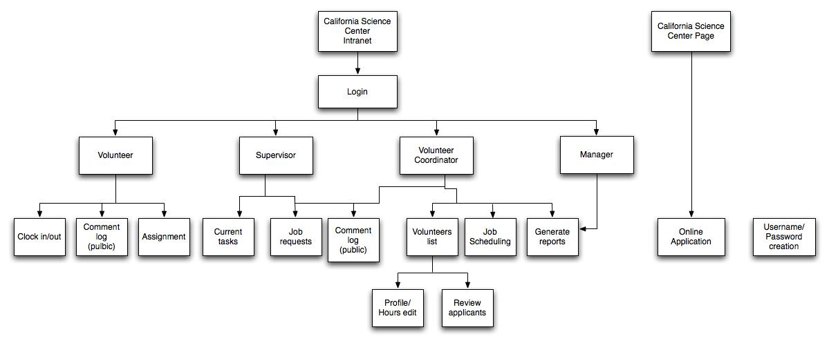

**Figure 1: Navigation Flow of Volunteer Tracking System**

### **Prototype**

Our application has different features and many different ways to navigate through them, and showing them. The way to best demonstrate it it is through a navigation flow as well as a few screenshots showcasing the flow of the application. The Screenshots below is a sample flow that a user might have when using the application. There are many different ways in which the application could be used and navigated through

The applications will follow the below format to detail the specific :

**Table 1: Screenshot name-1**

|  |  |
| --- | --- |
| Description | << Briefly describe what this screenshot is about. >> |
| Related Capability | << CR-# Capability name / Capability Goal >>  If CR# is not available, you can refer to Win Condition number. |
| Pre-condition | << Which screen shot leads to this screen shot? What condition will lead to this screenshot? >> |
| Post condition | << What will happen in the system after processing this screenshot? What’s next? >> |

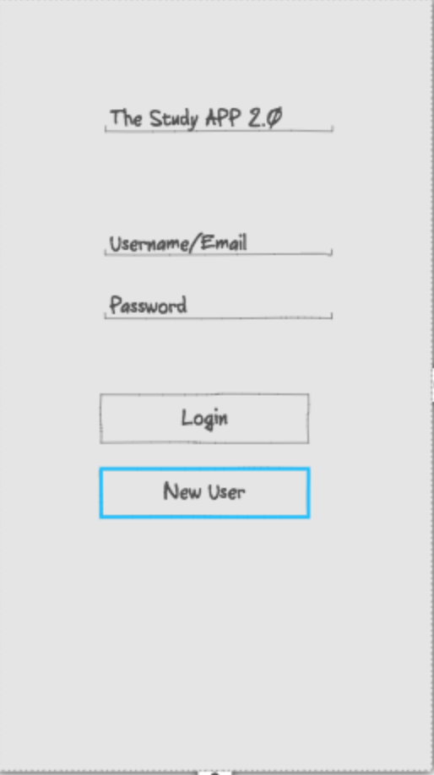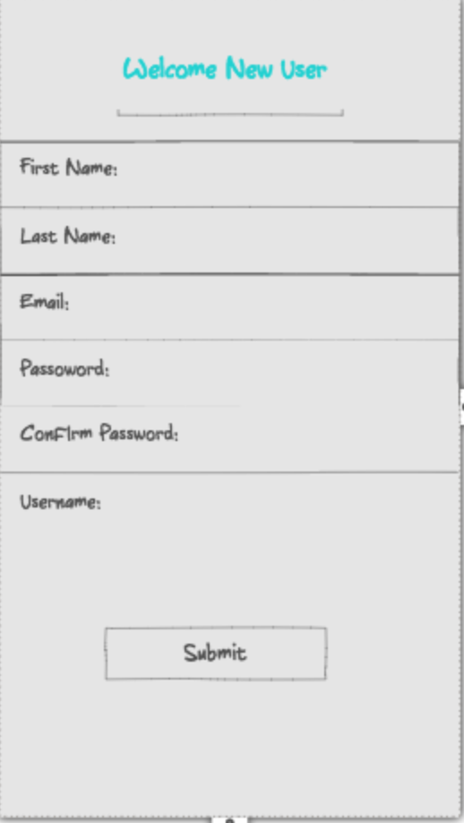

**Figure 2: Home Screen Figure 3: New User**

**Figure 2** is how the application will look like once it is launched, and ready to be used. If it is the first time that the user is using this application they will have to create a new account (**Figure 3**), otherwise the user can log into their account with and email or username and password. If the user forgot their password they will prompted with a message asking to reset once they attempt a failed password.

**Figure 3** is what the user will see when they are creating a new account. They will be asked to input in their first name, last name and email address as well as their password twice and to also create a username. Once they submit this information, an email will be sent to them to verify the account and then now they will be able to successfully login on the home screen (**Figure 2**)

Related Capability (Figure 1,2):

**Precondition:** The home screen will be the first page, which can transition to the new user if the user is new / has not created an account with the app yet

**Post Condition:** After the user decides to create the account then an email will be sent to them to verify the account and allow them to login

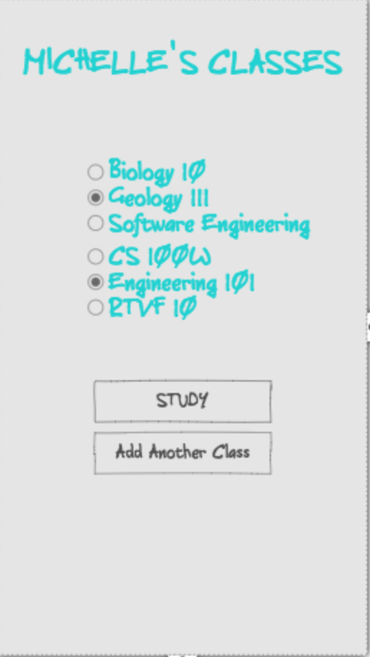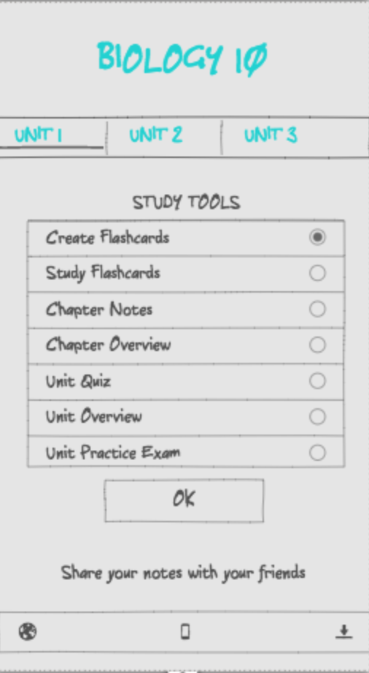

**Figure 4: Class Home Figure 5: Study Tools Page**

**Figure 4** Once the user has successfully logged into their account, they will be taken to their Class Home , which will show all the classes that the user has added. If the user has not added any classes, they have the option of doing so. There can be any number of classes added and can be archived for later semesters.

**Figure 5** The user selects a specific class and it taken to their study tools page, which has study tool options such as creating and studying flashcards to review quizzes. These questions will initially be created by the user for their own specific class and once they have done so, they are able to share it with other students whom can use it for their classes. The quizzes can be the student's own quiz or one that they have inherited from another user who made theirs public. Once the user has selected the study tool, then they are taken to a page which will show flashcards , unit notes or quiz like **Figure 6.**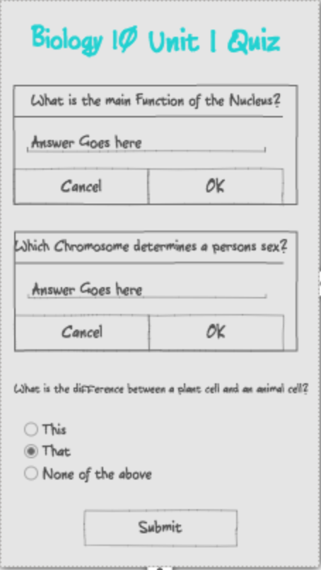

**Precondition:** The user will be able to select from a list of classes that they have already entered (or can create) and be able to “study” from those classes

**Post Condition:** The user will choose from an array of study tools, and in the case that the user selects a quiz - then they will be promoted with a page with questions based off the current unit that they had selected.

**Figure 6: Class Home**