1. output of the sortcompare on the same test cases for each sorting method.

2. Based on my output I would say the ratio is approximately 2.5 using the doublingRation technique. To solve k I used the formula (2n)^k / n^k = 2^k which is 2.5. So 2^k = 2.5 and to solve for k I did log(2.5)/log(2) which is approximately 1.5.

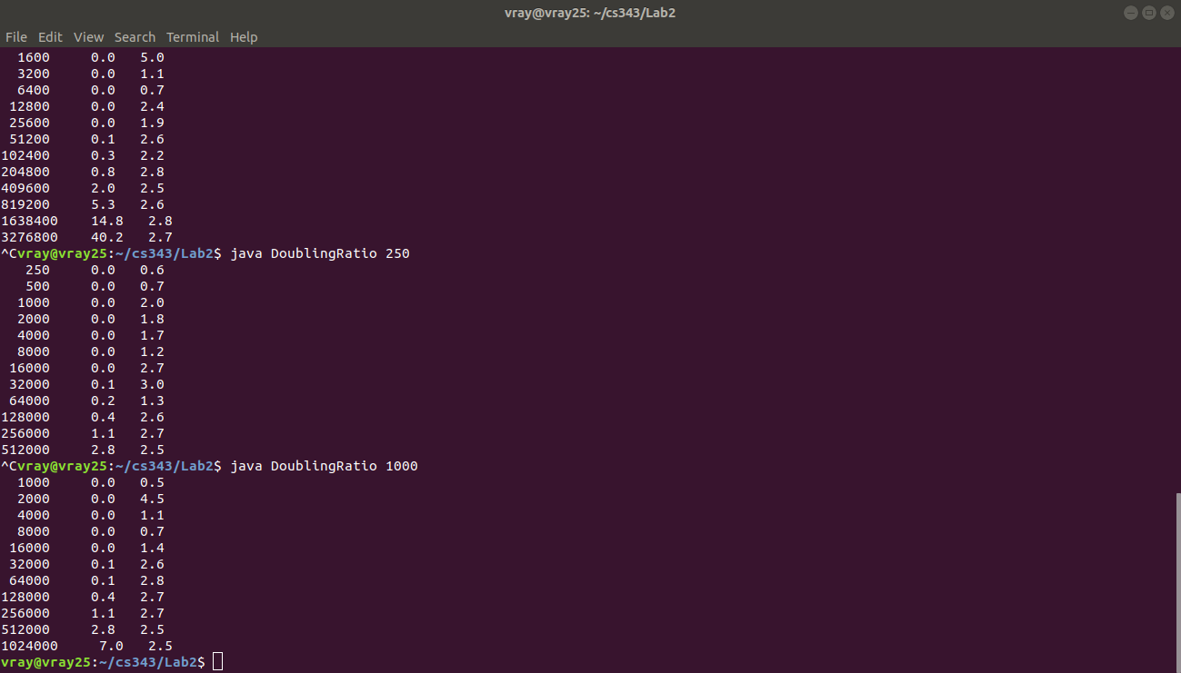

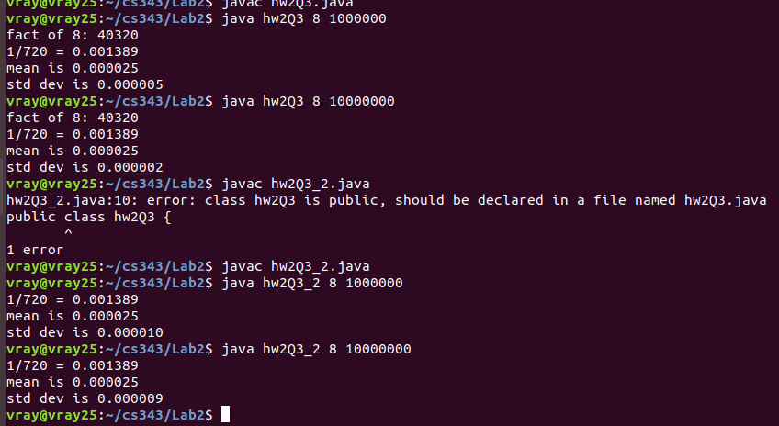
3.

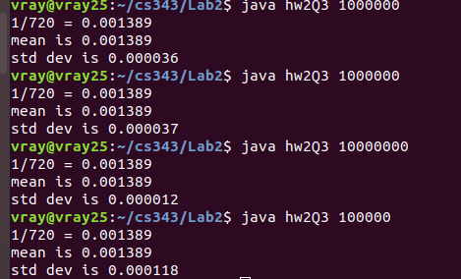

on a set of 9 data elements
