1. Based on my experiment the code seems to still run the same after the changes have been made.

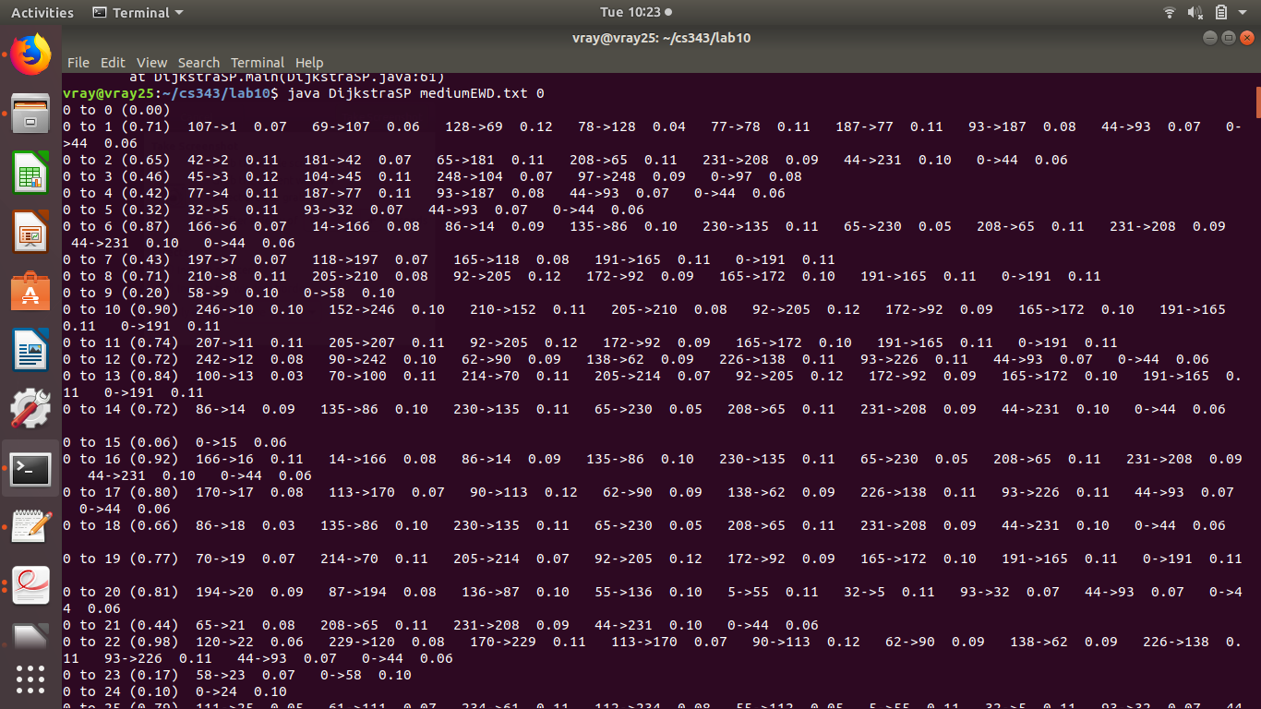
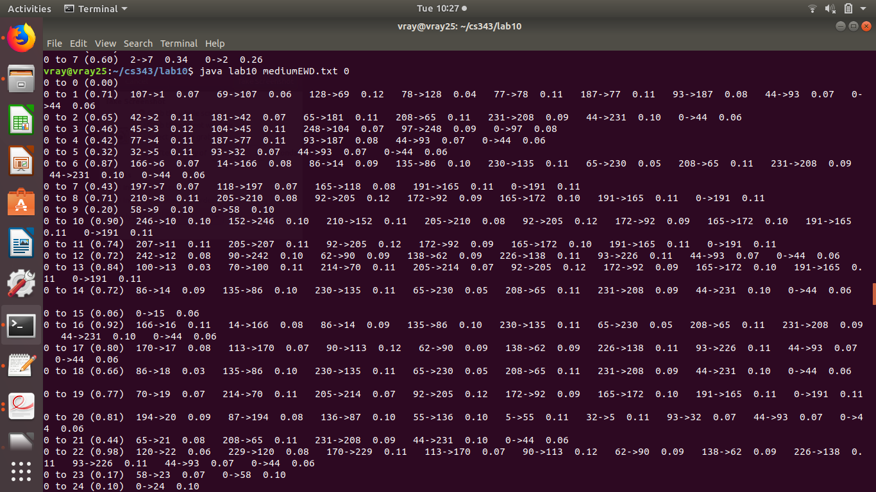

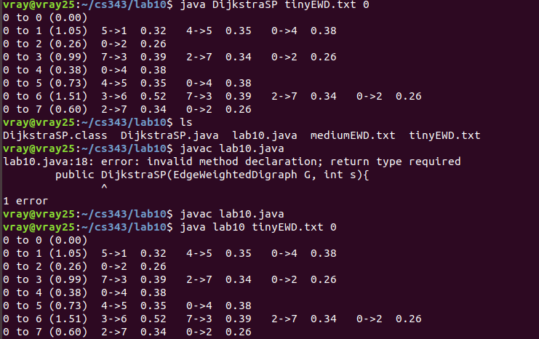

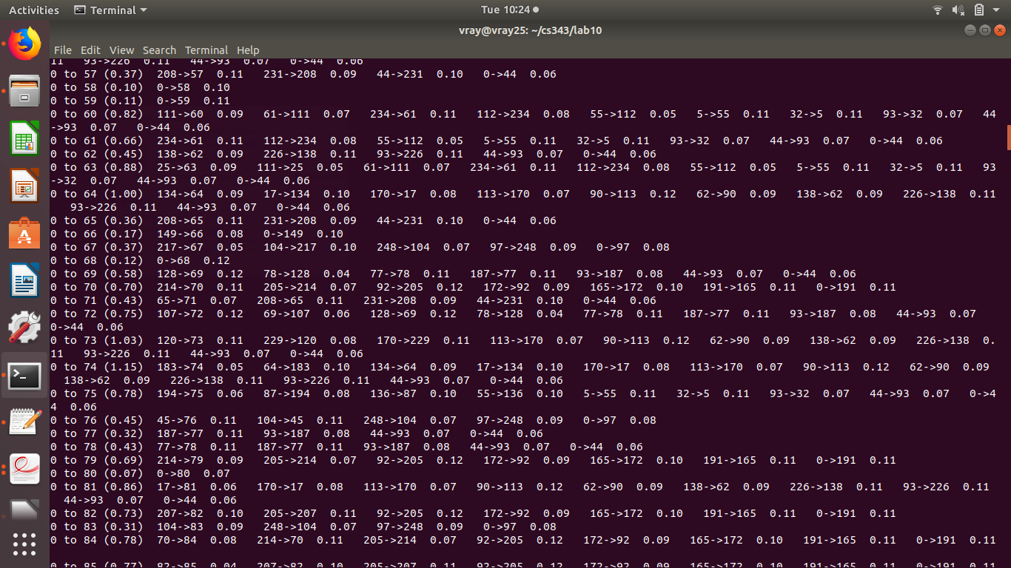

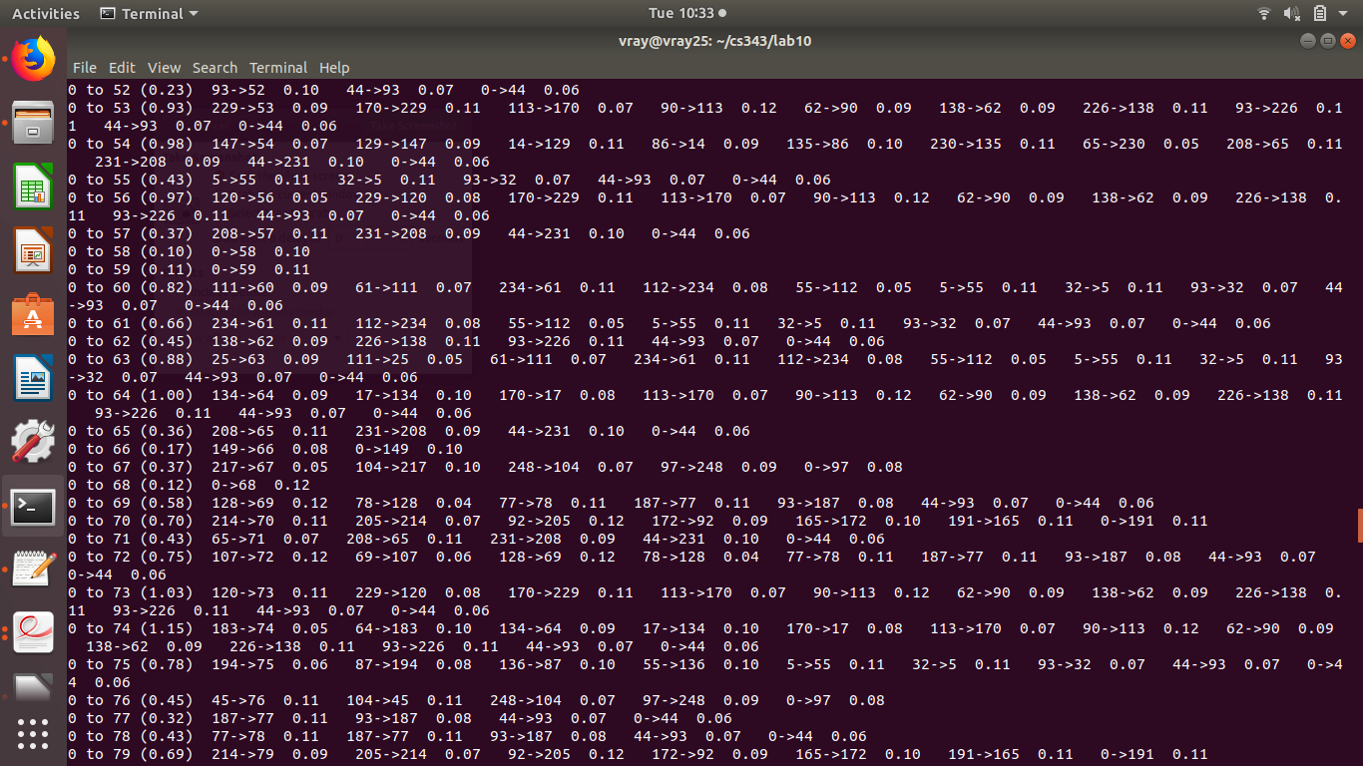

2. Based on my experiments it seems that after the modifications the program still runs as efficient there is a difference but it isn’t much. What I did was get the average of 100 times it computed the shortest paths on the same graph. At first the modifications seem to be more efficient but when I got to a bigger input file with more vertices's and edges the program without the modifications seems more efficient.

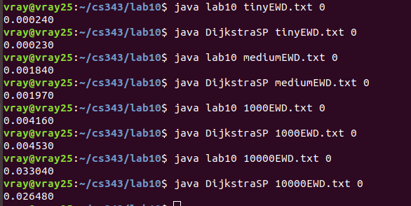

3. It isn’t necessary to have the marked array in DijkstraSP.java because the condition is that each non tree vertex is added with the lowest distTo[] value until all vertices’s are on the tree or until no non-tree vertex has a finite distTo[] value. So basically the not marked[w] is equivalent to a distTo[w] being infinite. So after I added the marked[] to the Dijkstra program I got some interesting results because with small inputs there isn’t much of a difference but when I increased to the 1000EWD.txt there was a bigger gap in the average so I expected it to increase more when I ran the 10000EWD.txt file but turns out the marked[] made the program more efficient by a small amount.

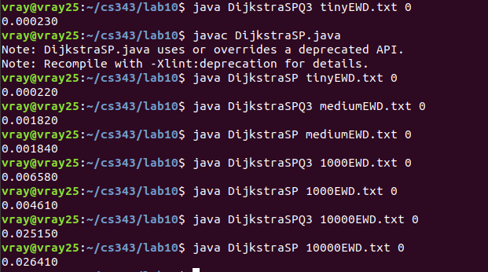

4. I was able to remove the feature of the primMST program having the marked array. I got the same result as the original code. I made a few changes first I added a parameter to PrimMST which is the vertex to be started from. Then I initialized distTo[s] to 0 and inserted the vertex s with value 0.
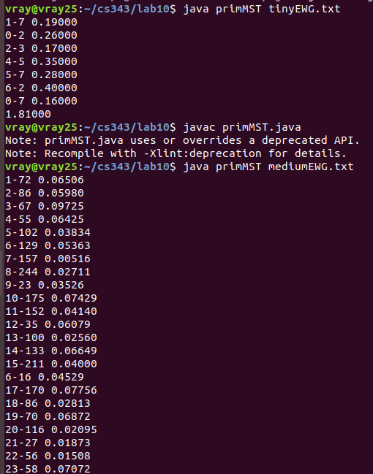

5. So first off Prims builds the minimum spanning tree of a graph starting from any vertex and Dijkstra builds a shortest path tree starting from a vertex given as an argument known as the source. The logic of prims uses a marked array to decide if it should continue with a vertex and add it to the path while Dijkstra determines if the distTo[w] is infinite if so then it continues to add the vertex to the tree. Prims adds next the vertex closest to the tree and Dijkstra adds next the vertex closest to the source. Vertices's are relaxed in Dijkstra based on their order of weight of their shortest path to the source. Prims adds next to the tree based on the minimum weight edge that connects the vertex to the tree. Edges become ineligible when they are added to the tree vertex and are already on the Priority queue.

