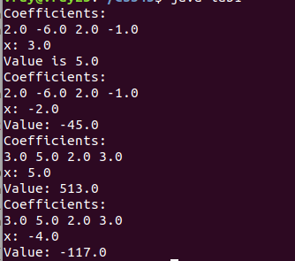
1.

2.
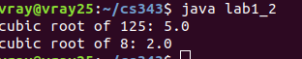

3.

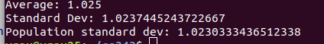

based on these results I would conclude that each permutation has almost equal chance of getting generated.

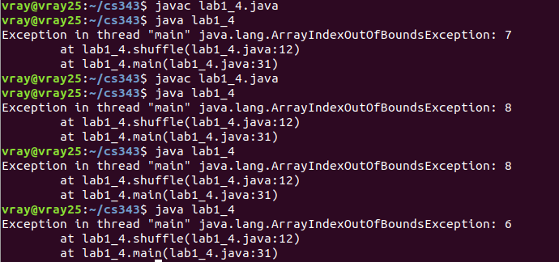
4. With the new modified code there is no unified permutation because I keep getting ArrayIndexOutOfBoundsException.

