2. after studying my results I found that QuickHoare is faster than Quick. I ran 1000000 test on random data sets for both methods and recorded the elapsed time using stopwatch. I got different percentages based on my test methods:

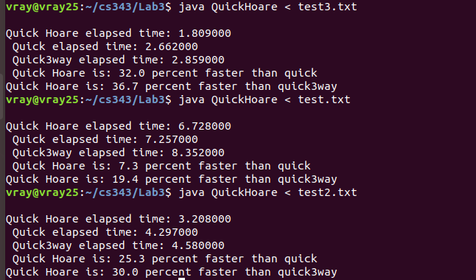

3. After running my studies I found QuickHoare is faster than Quick3way. I ran 1000000 test all with random data. The results are down also in the screen shot above.

4. The reason that boundary checks isn’t needed in the two inner loops for Hoare’s partitioning method is because once I and j intersect as I increases and j decreases the while true loop ends returning j.

