1.

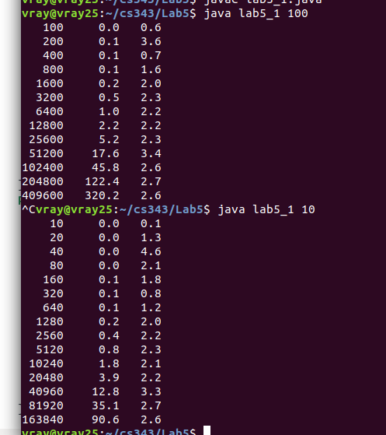
After my studies I conclude that select does run in linear time in finding the median of a random sequence.

2.

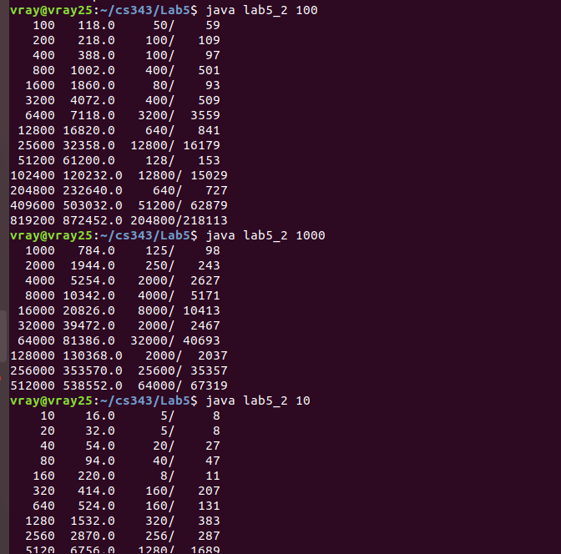
firs column is the number of elements in sequence, second is the number of comparisons after finding median. The last column is the ratio.

3.
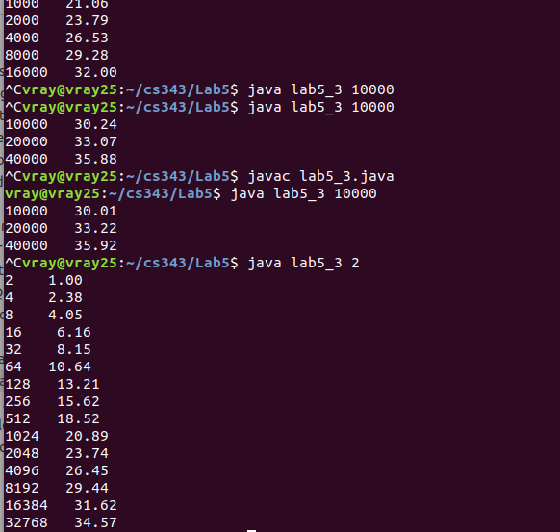

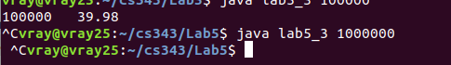

After my studies I found that the 2.99 lg N holds true in my experiment because the average never surpasses 3 lg N. I tried running it for N = 10^6 but my computer took to long on the computation.

