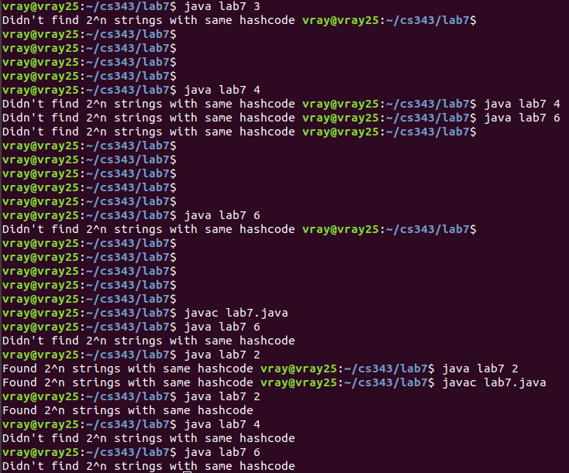

I was able to fine 2^n strings with the same hashcode but only when n was 2. It seems like anything other than that I got no luck.

Question 2: I felt like my code was correct but there seems to be a bug that I can’t find which has caused question 3 to also have a bug.

