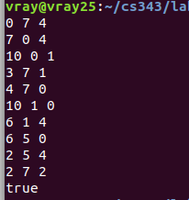
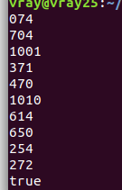

Based on my results it seems that both dfs and bfs find the same sequences which leaves 2 pint in the 4 pint container.

