Home Screen

1. Change the Text

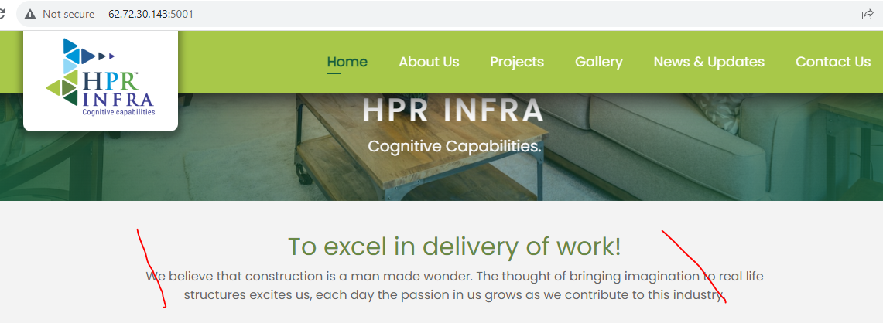

1. Change to **Ongoing Projects. Text also need to modified**

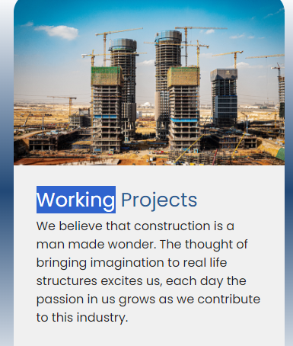

Need to Change below Text to Infra Related Text



Ongoing Projects

Text Need to Review

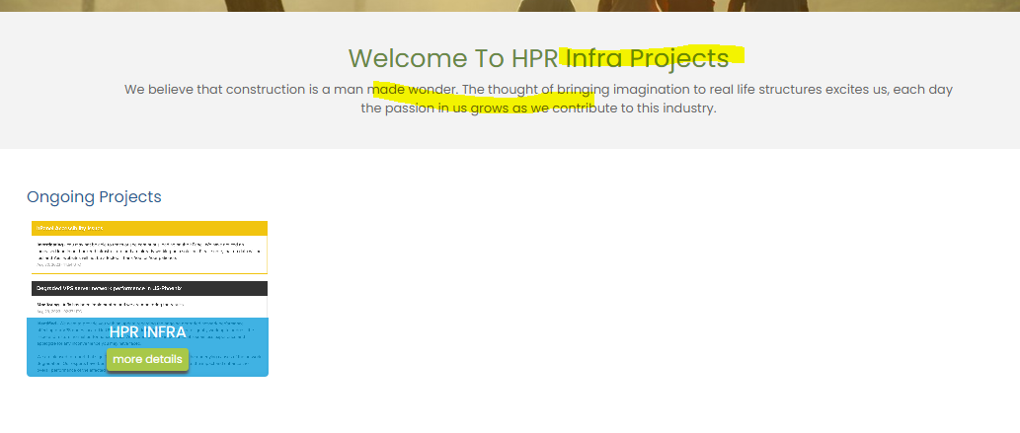

Seems Date is not implemented

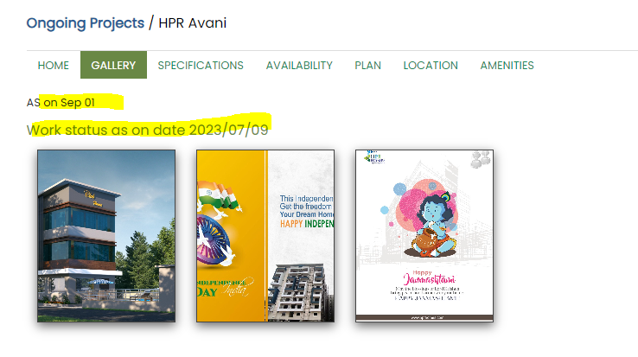

Saved one is not displaying

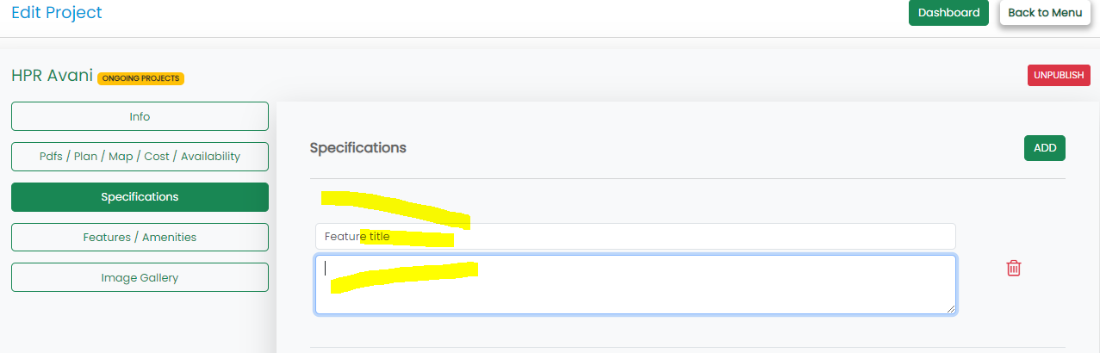

Spelling

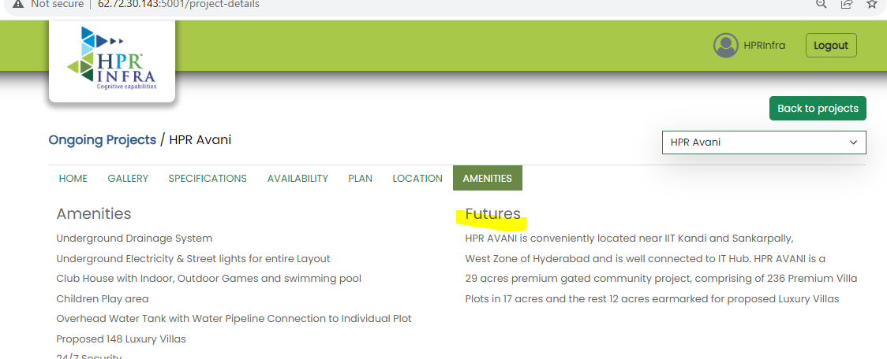

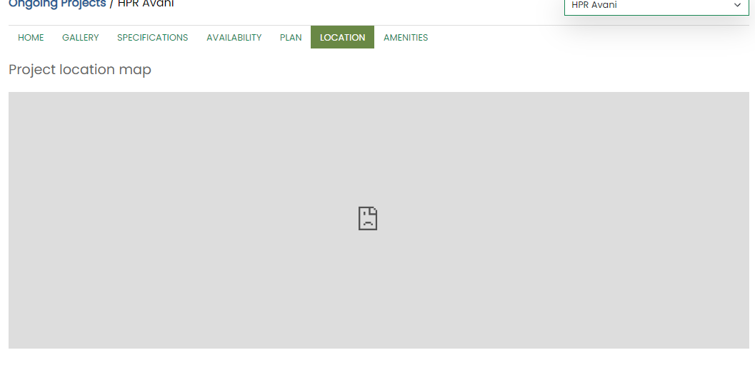

Imaage Navigation Not Available

ZoomIn and ZoomOut Required

