Project Documentation

**Project Title:** **Rhythmic Tunes:Your melodic Companion.**

# Introduction :

## Your Melodic Companion" is a collection of soothing and uplifting music designed to accompany you through life's moments. With a blend of harmonious melodies and infectious rhythms, Rhythmic Tunes aims to evoke emotions, spark creativity, and provide comfort. Whether you're relaxing, working, or exercising, these tunes are crafted to be your perfect companion.

## Project Title: Rhythmic Tunes:Your melodic Companion.

* + **Team ID :NM2025TMID33841**
  + **Team Leader:** Vignesh Raja D vrdvignesh@gmail.com

## Team Members:

* + 1. MOHAMED AJMAN M [mdajmanaf007@Gmail.Com](mailto:mdajmanaf007@Gmail.Com)
    2. ABDUL RAZAK S M [Abdulrazak7802@Gmail.Com](mailto:Abdulrazak7802@Gmail.Com)
    3. MOHAMMED RIYAS aer0511812@gmail.com

# Project Overview

* + **Purpose:** Your Melodic Companion" is to provide a harmonious and uplifting musical experience that enhances mood, fosters relaxation, and boosts focus, serving as a trusted companion for everyday life's moments.

## Features:

* + - Music Streaming
    - Personalized Playlists
    - Search Functionality
    - Music Analytics
    - Social Sharing

# Architecture

* + **Frontend:** React.js with Bootstrap and Material UI
  + **Backend:** Node.js and Express.js managing server logic and API endpoints
  + **Database:** MongoDB stores user data, project information, applications, and chat messages

# Setup Instructions

* Node.js and npm: Node.js is a powerful JavaScript runtime environment that allows you to run JavaScript code on the local environment. It provides a scalable and efficient platform for building network applications.
  + Install Node.js and npm on your development machine, as they are required to run JavaScript on the server-side.
  + Download: <https://nodejs.org/en/download/>
  + Installation instructions: <https://nodejs.org/en/download/package-manager/>
* React.js: React.js is a popular JavaScript library for building user interfaces. It enables developers to create interactive and reusable UI components, making it easier to build dynamic and responsive web applications.

Install React.js, a JavaScript library for building user interfaces.

* Create a new React app:

npx create-react-app my-react-app

Replace my-react-app with your preferred project name.

* Navigate to the project directory:

**cd my-react-app**

* Running the React App:

With the React app created, you can now start the development server and see your React application in action.

* Start the development server:

**npm start**

This command launches the development server, and you can access your React app at http://localhost:3000 in your web browser.

* HTML, CSS, and JavaScript: Basic knowledge of HTML for creating the structure of your app, CSS for styling, and JavaScript for client-side interactivity is essential.
* Version Control: Use Git for version control, enabling collaboration and tracking changes throughout the development process. Platforms like GitHub or Bitbucket can host your repository.
  + Git: Download and installation instructions can be found at: <https://git-scm.com/downloads>
* Development Environment: Choose a code editor or Integrated Development Environment (IDE) that suits your preferences, such as Visual Studio Code, Sublime Text, or WebStorm.
  + Visual Studio Code: Download from <https://code.visualstudio.com/download>
  + Sublime Text: Download from <https://www.sublimetext.com/download>
  + WebStorm: Download from [https://www.jetbrains.com/webstorm/download](https://www.sublimetext.com/download)

Follow below steps:

* Install Dependencies:
  + Navigate into the cloned repository directory and install libraries:

**cd tunes**

**npm install**

* Start the Development Server:
  + To start the development server, execute the following command:

**npm start**

* Access the App: Open your web browser and navigate to http://localhost:3000.
* You should see the rythamic tunes app's homepage, indicating that the installation and setup were successful.

You have successfully installed and set up the application on your local machine. You can now proceed with further customization, development, and testing as needed.

# Folder Structure

SB-Works/

|-- client/ # React frontend

| components/ L pages/

| server/ # Node.js backend

| routes/

| models/

| controllers/

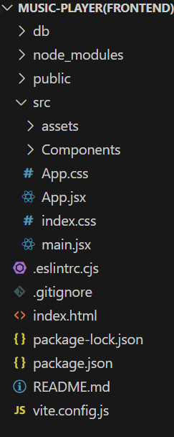

# Running the Application

* **Install Dependencies:**

Navigate into the cloned repository directory and install libraries:

* + - * + cd store
        + npm install
* **Start the Development Server**:

To start the development server, execute the following command:

* + - * + npm start

# API Documentation

## User:

* + - /api/user/register
    - /api/user/login

**Projects:**

/api/projects/create

/api/projects:id

Applications:/api/apply

# Authentication

* + Username and Password
  + Social Media Login
  + Email Verification
  + Two-Factor Authentication (2FA)

# User Interface

* + Intuitive Music Library
  + Personalized Recommendations
  + Mood-Based Playlists
  + Seamless Search

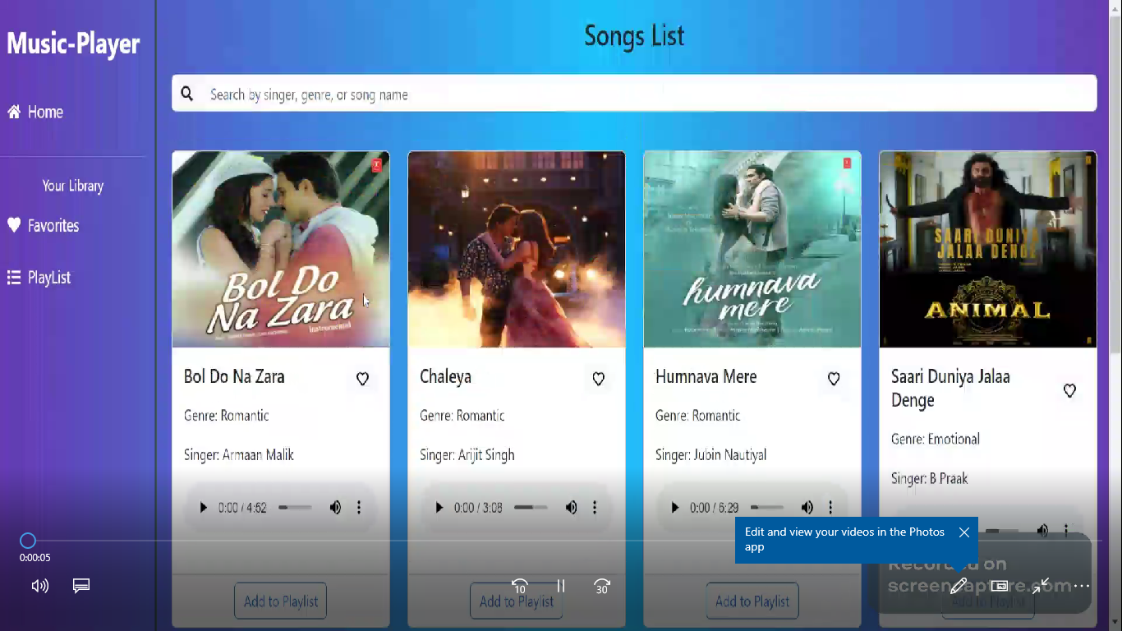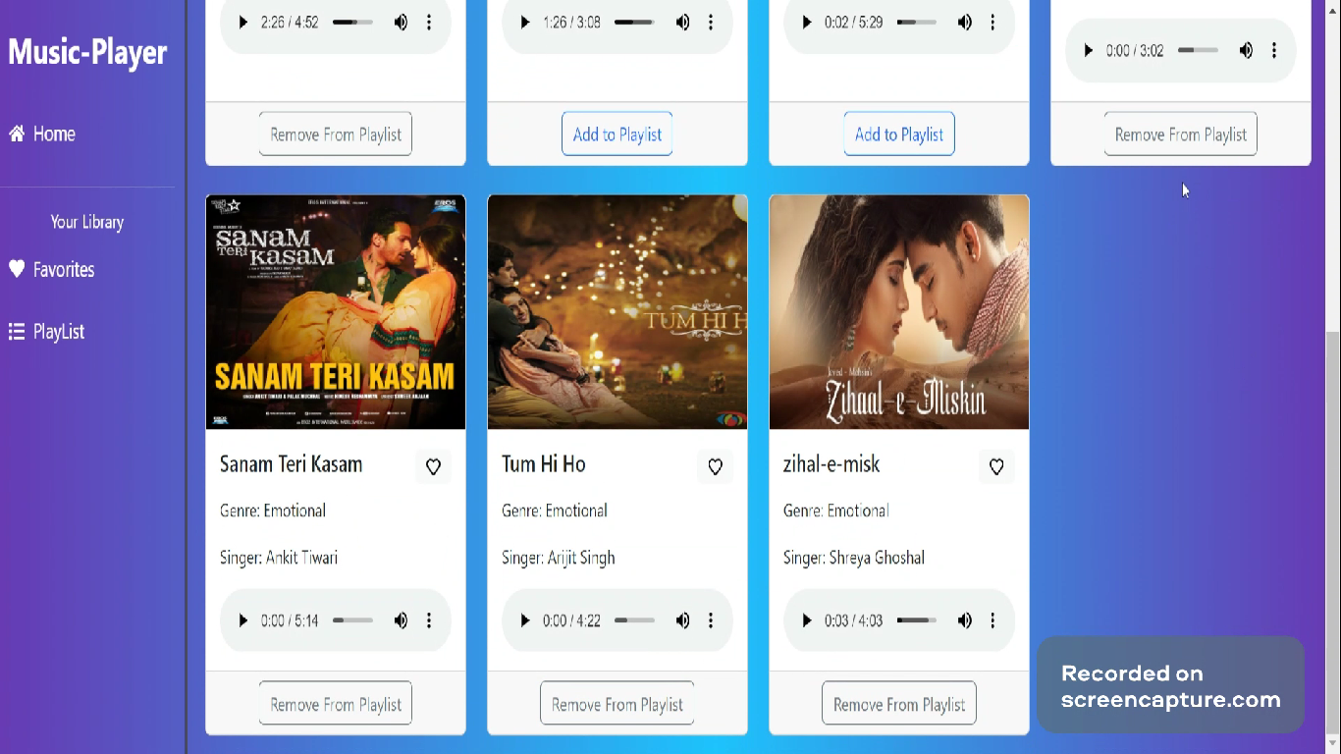

# Testing

* + Evaluating musical compositions or applications.
  + Ensuring rhythm accuracy and melodic coherence.
  + Testing harmony and chord progressions.

1. **Known Issues**

1.Rhythm Inconsistencies: Issues with maintaining consistent rhythm patterns.

2.Melodic Discord: Problems with melody sounding unpleasant or disjointed.

3.Harmony Issues: Challenges with chord progressions or harmonies sounding off.

4. Tempo Problems: Issues with maintaining consistent tempo or pace.

1. **Future Enhancements**

1.New Rhythm Patterns: Adding more diverse and complex rhythm patterns.

2.Advanced Melody Generation: Improving melody creation algorithms for more varied and interesting melodies.

3. Enhanced Harmony Options: Expanding harmony and chord progression options for greater musical depth.

4. User Customization: Allowing users to personalize rhythm, melody, and harmony settings.

5. Advanced Analytics: Gain deeper insights into inventory trends and performance.

6. Customizable Reports: Create custom reports with relevant metrics and KPIs.

7. Integration with E-commerce: Streamline online sales and inventory management.