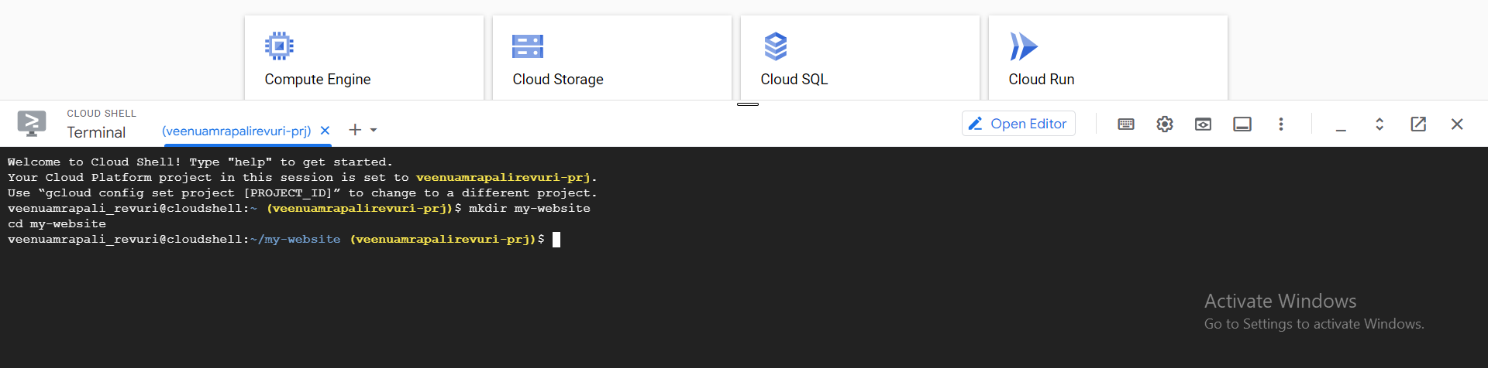

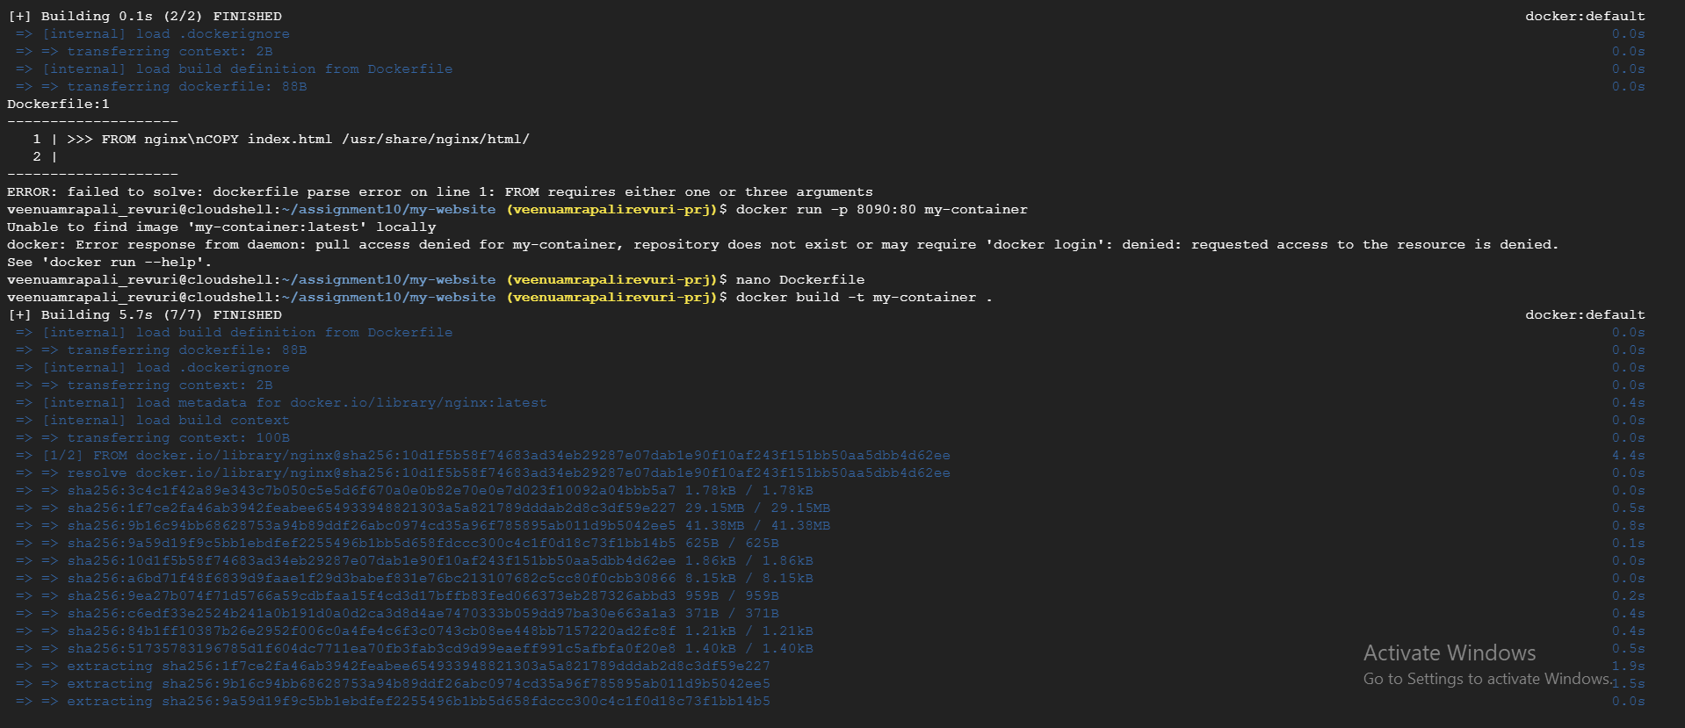

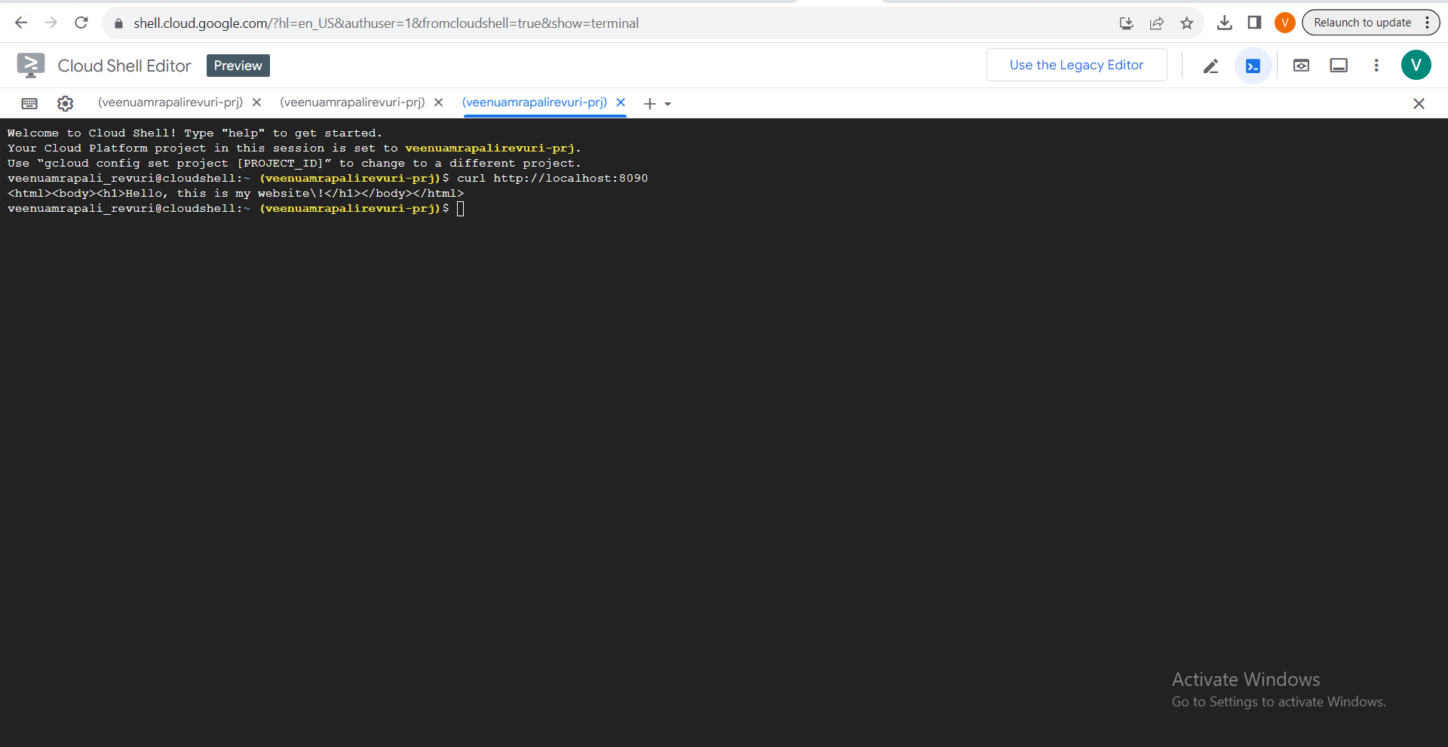

git remote add origin https://github.com/vrevuri/<fgh>.git

git branch -M main

git push -u origin main

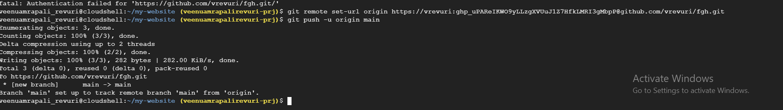

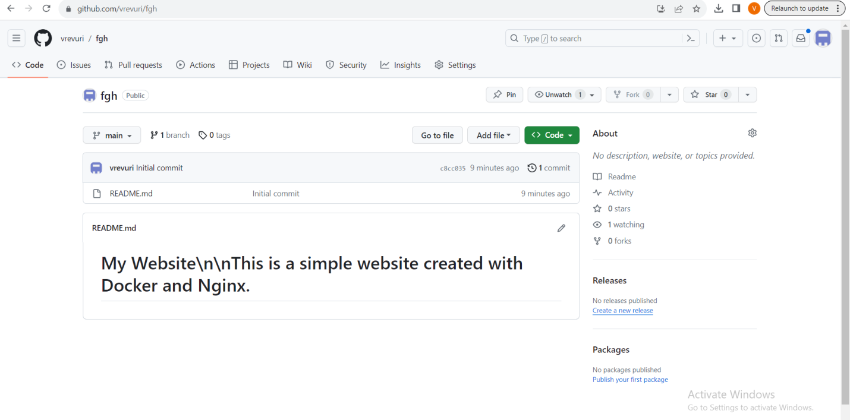

<https://github.com/vrevuri/fgh>