U.S. Semiconductor Trade and Manufacturing Trends, January–August 2025 vs. January–August 2026
Victoria Reyna
DS 4023 Final Project
October 14, 2026

Abstract
Semiconductors are essential inputs for products ranging from cars to data centers, and recent shortages showed how quickly supply disruptions can spread through U.S. manufacturing (U.S. Department of Commerce, 2022). Expanding domestic manufacturing capacity and supply-chain resilience have become national priorities (Semiconductor Industry Association, 2025). This project examines U.S. trade in semiconductor devices (HS 8541) and integrated circuits (HS 8542) using monthly country-level U.S. Census Bureau trade data, and compares those trade patterns with the Federal Reserve industrial production index for semiconductor and other electronic-component manufacturing (NAICS 3344). To compare the same months in each year, the main analysis compares January through August 2025 with January through August 2026. Integrated-circuit imports rose 39.10 percent while integrated-circuit exports rose 6.00 percent, and the combined trade balance shifted from a USD 2.70B surplus to a USD 1.27B deficit. Over the same months, the average production index rose 11.31 percent. Taiwan was the largest integrated-circuit import partner and China the largest integrated-circuit export partner in August 2026.

Literature Review
Published research describes semiconductors as a globally distributed industry rather than a product made entirely in one country. Barbe, Kim, and Riker (2018) explain that high-value wafer fabrication, testing, assembly, packaging, and downstream manufacturing can take place in different locations. Because of this division of work, a single chip may cross borders several times before it reaches a final product. Their study also found that China and Vietnam became more important U.S. semiconductor trade partners between 2006 and 2016. This research suggests that U.S. trade data should be examined by partner country, not only as one national total, because the countries involved reveal where different stages of production happen.
A second theme in the literature is concentration. The Organisation for Economic Co-operation and Development (OECD, 2023) reports that semiconductor value chains contain concentrated bottlenecks, especially in specialized machinery and advanced production inputs. When a small number of locations supply a critical input, a disruption in one place can affect many downstream industries. Jones, Krulikowski, Lotze, and Schreiber (2023) apply this concern directly to the United States, finding substantial U.S. exposure to Taiwan-made logic chips through both direct imports and indirect imports embedded in other goods. Together, these studies suggest that if U.S. imports are heavily concentrated among a few partners, the country may be more exposed to supply shocks.
A third theme is the real-world effect of supply disruptions. The U.S. Department of Commerce (2022) reported that chip buyers' median inventory fell from about 40 days in 2019 to fewer than five days in 2021. With so little inventory, even a short interruption in imports could slow U.S. manufacturing. This finding shows why monthly trade data matters: month-to-month movements in imports can signal changes in how dependent U.S. producers are on outside suppliers.
Across these studies, three common themes appear. First, semiconductor production is spread across many countries, so trade flows reflect different stages of the value chain (Barbe et al., 2018). Second, supply is concentrated in a few locations and inputs, which creates risk when one partner is disrupted (Jones et al., 2023; OECD, 2023). Third, low inventories mean those disruptions can reach U.S. manufacturers quickly (U.S. Department of Commerce, 2022). These themes shape the questions in this project: which partners matter most, how concentrated U.S. imports are, and how trade is changing over time.
Finally, recent industry research focuses on domestic capacity. The Semiconductor Industry Association (2025) describes building U.S. manufacturing capacity and strengthening supply-chain resilience as central issues for the U.S. industry. This raises a practical question that the trade data can help answer: when domestic production grows, does the United States import less, or does trade keep growing alongside it? Based on this literature, possible outcomes for this project include (1) imports concentrated among a few Asian partners such as Taiwan, (2) partners such as China and Vietnam appearing prominently, consistent with a distributed value chain, and (3) domestic production growing at the same time as imports, rather than replacing them. This project tests these expectations using recent monthly data.

Research Question
How did U.S. imports and exports of semiconductor devices and integrated circuits change from January–August 2025 to January–August 2026, which countries were the leading trade partners, and how did these trade patterns compare with U.S. semiconductor and electronic-component manufacturing production?

Tools and Analysis Methods
The trade data came from the U.S. Census Bureau International Trade API, which reports monthly U.S. import and export values by partner country and Harmonized System (HS) product code (U.S. Census Bureau, 2026). I collected values for HS 8541 (semiconductor devices) and HS 8542 (integrated circuits) from January 2025 through August 2026 and saved them as us_semiconductor_trade_2025_2026.csv. The production data came from FRED series IPG3344S, the Federal Reserve industrial production index for semiconductor and other electronic-component manufacturing, where 2017 equals 100 (Board of Governors of the Federal Reserve System, 2026). It was saved as us_semiconductor_production_index.csv.
I used Python in a Jupyter Notebook with pandas DataFrames to load, clean, validate, and summarize the data. The trade file began with 10,980 records. Census files include rows for regional and group totals (such as Asia, the European Union, and CAFTA-DR) and a row for the total of all countries. Keeping these would count the same trade more than once. I kept only rows whose country code had four digits and did not begin with zero, which identifies individual countries, and removed zero-value rows. This left 7,061 country-level records. To validate the cleaning, I added up the cleaned country rows for each month, product, and trade flow and compared them with the Census official total row. The largest difference was USD 0, confirming that no trade was double-counted or lost.
I then grouped the data by month, trade flow, and product category, and calculated monthly totals, averages, minimums, maximums, and percent changes. To make a like-for-like comparison, I compared January–August 2025 with January–August 2026, so that eight months are compared with the same eight months. I also counted surplus and deficit months, ranked partner countries for August 2026, and indexed imports, exports, and production to January 2025 = 100 to compare their growth on one scale. I created charts with matplotlib and seaborn and built an interactive dashboard with Plotly Express and Streamlit. A limitation is that HS 8541 and HS 8542 do not cover every semiconductor-related good, while the production index covers the broader NAICS 3344 industry rather than only chip fabrication.

Results (Images, Analysis and Interpretation)
Figure 1 compares January–August trade in each year. Integrated circuits made up most of the trade value. Integrated-circuit imports increased from USD 26.30B to USD 36.58B (39.10 percent), while integrated-circuit exports increased only from USD 35.04B to USD 37.14B (6.00 percent). For semiconductor devices, exports increased from USD 3.99B to USD 7.32B (83.24 percent), while imports decreased 8.80 percent from USD 10.03B to USD 9.15B. Across both categories, the trade balance shifted from a USD 2.70B surplus in January–August 2025 to a USD 1.27B deficit in January–August 2026. Across all 20 months there were 11 surplus months and 9 deficit months, and August 2026 had the largest deficit, at USD 1.21B (USD 6.81B in imports and USD 5.60B in exports).
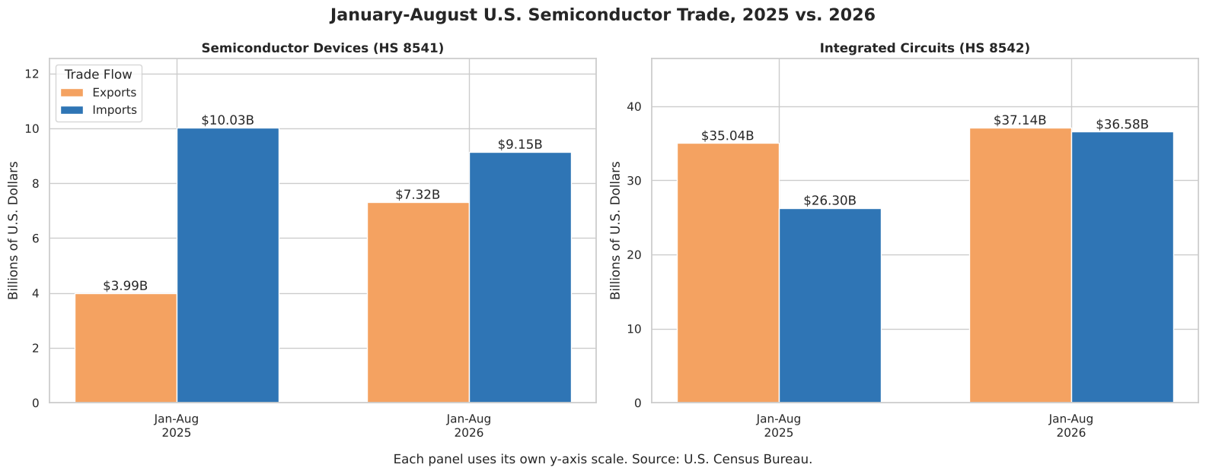
Figure 1. January–August U.S. trade in semiconductor devices (HS 8541) and integrated circuits (HS 8542), 2025 vs. 2026, in billions of U.S. dollars. Each panel uses its own y-axis scale. Source: U.S. Census Bureau (2026).
Figure 2 provides a longer view of domestic production. The index reached 190.1 in August 2026, about 90 percent above its 2017 average. Within the study period, the average index rose from 163.44 in January–August 2025 to 181.92 in January–August 2026, an 11.31 percent increase. This index measures broad manufacturing activity, not a count of chips produced.
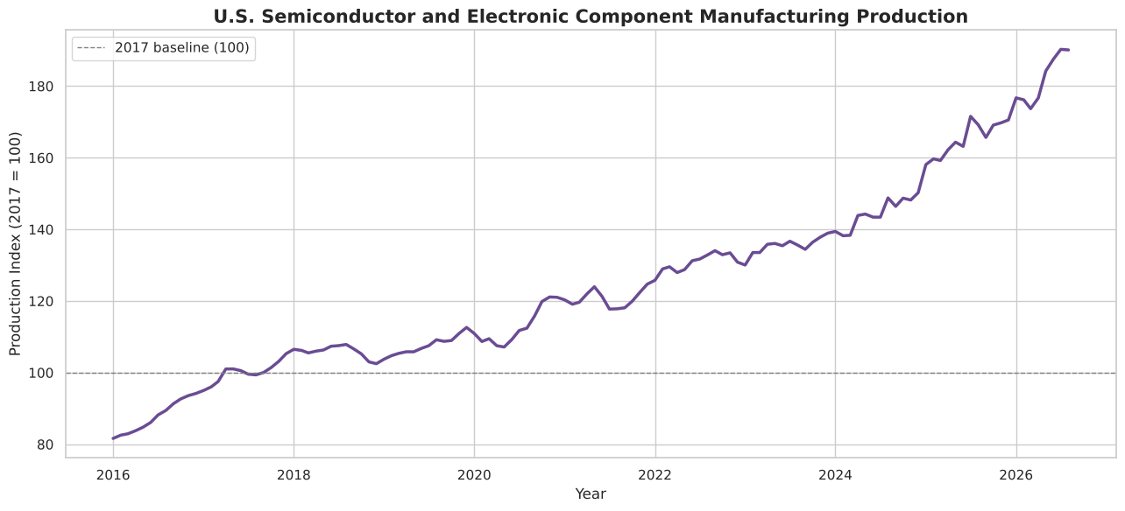
Figure 2. U.S. semiconductor and electronic-component manufacturing production index, 2016 through August 2026 (2017 = 100). Source: Board of Governors of the Federal Reserve System (2026), FRED series IPG3344S.
Figure 3 places trade and production on the same scale by setting each series to 100 in January 2025. By August 2026, combined imports had reached about 155, production about 120, and exports about 102. Imports grew faster and more unevenly than production, while exports ended close to where they started. The chart shows patterns only; it does not prove that production caused the change in trade.
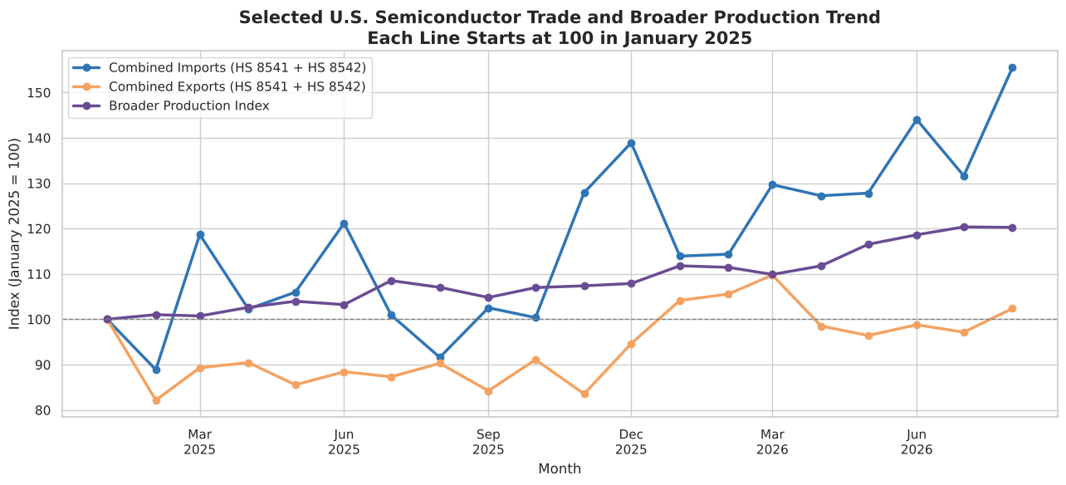
Figure 3. Combined U.S. imports and exports (HS 8541 + HS 8542) and the production index, each indexed to January 2025 = 100. Sources: U.S. Census Bureau (2026); Board of Governors of the Federal Reserve System (2026).
Figure 4 shows the leading integrated-circuit import partners in August 2026. Taiwan was the largest partner at about USD 1.85B, roughly one-third of integrated-circuit imports that month, followed by Ireland (about USD 650M), South Korea, and Israel (about USD 600M each). The top four partners together supplied about two-thirds of integrated-circuit imports. On the export side, China was the largest reported buyer of U.S. integrated circuits at about USD 1.21B, followed by Mexico (USD 0.93B) and Malaysia (USD 0.59B).
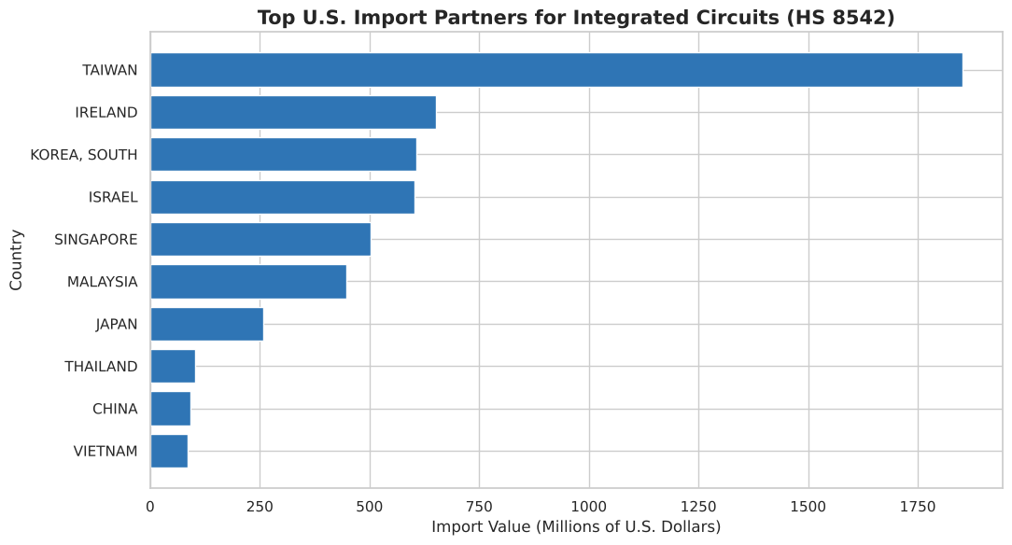
Figure 4. Top 10 U.S. import partners for integrated circuits (HS 8542), August 2026, in millions of U.S. dollars. Source: U.S. Census Bureau (2026).
Figure 5 shows the product mix of imports across all 20 months. Integrated circuits averaged USD 3.94B in imports per month, about 77 percent of the combined average, while semiconductor devices averaged USD 1.19B, about 23 percent. This is why the partner analysis focuses on integrated circuits.
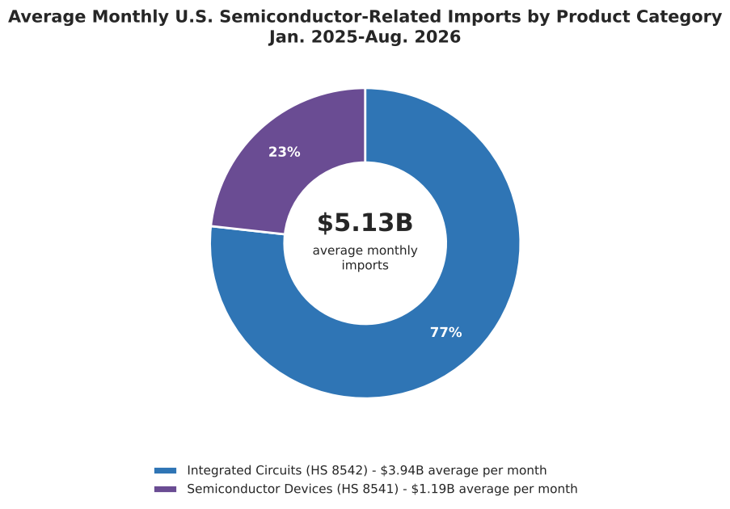
Figure 5. Average monthly U.S. imports by product category, January 2025 through August 2026. Integrated circuits made up about 77 percent of the combined average. Source: U.S. Census Bureau (2026).
These results support and extend the reviewed literature. Taiwan's position as the largest integrated-circuit import partner, at about one-third of integrated-circuit imports, is consistent with Jones et al. (2023), who documented substantial U.S. exposure to Taiwan-made chips. The appearance of China, Malaysia, Vietnam, and Mexico among the leading partners fits the distributed value chain described by Barbe, Kim, and Riker (2018), including their finding that China and Vietnam had become more important partners. The concentration of supply, with four partners providing about two-thirds of integrated-circuit imports, echoes the OECD (2023) finding of concentrated bottlenecks and, given the low inventories reported by the U.S. Department of Commerce (2022), suggests continued exposure to disruptions. Finally, the 11.31 percent rise in production alongside a shift from surplus to deficit extends the Semiconductor Industry Association (2025) discussion of domestic capacity: in this period, domestic production grew while imports grew even faster, rather than production replacing imports.

Summary and Conclusion
This project asked how U.S. trade in semiconductor devices and integrated circuits changed between January–August 2025 and January–August 2026, which countries led that trade, and how trade compared with domestic production. The data shows three main findings. First, integrated circuits dominate the trade, making up about 77 percent of average monthly imports in the two categories studied. Second, integrated-circuit imports grew much faster than exports (39.10 percent vs. 6.00 percent), so the combined trade balance shifted from a USD 2.70B surplus to a USD 1.27B deficit, with August 2026 recording the largest monthly deficit in the 20-month period. Third, domestic production also grew, with the average index rising 11.31 percent, but imports grew faster than production when both were indexed to January 2025.
Together, these results suggest that growth in U.S. semiconductor manufacturing during this period happened alongside greater reliance on imports, especially integrated circuits from a concentrated group of partners led by Taiwan, rather than in place of it. This is consistent with research describing a globally distributed and concentrated semiconductor supply chain (Barbe et al., 2018; Jones et al., 2023; OECD, 2023).
The study has several limitations. It covers only two HS codes, so it does not capture every semiconductor-related product, such as manufacturing equipment or chips contained inside finished electronics. The production index measures the broader NAICS 3344 industry, not chip output alone. The study period is 20 months, so the results describe recent patterns rather than long-term trends, and the comparisons show association rather than cause. Some partner values also showed unusual month-to-month changes that would need further checking. Future work could add more HS codes, extend the time period, or examine trade by U.S. state or port.

References
Barbe, A., Kim, D., & Riker, D. (2018). Trade and labor in the U.S. semiconductor industry. Journal of International Commerce and Economics, United States International Trade Commission. https://www.usitc.gov/publications/332/journals/barbe_kim_and_riker_-_trade_and_labor_in_the_us_semiconductor_industry_.pdf
Board of Governors of the Federal Reserve System. (2026). Industrial production: Manufacturing: Durable goods: Semiconductor and other electronic component (NAICS = 3344) [IPG3344S]. FRED, Federal Reserve Bank of St. Louis. https://fred.stlouisfed.org/series/IPG3344S
Jones, L., Krulikowski, S., Lotze, N., & Schreiber, S. (2023). U.S. exposure to the Taiwanese semiconductor industry (Economics Working Paper 2023-11-A). United States International Trade Commission. https://www.usitc.gov/publications/332/working_papers/us_exposure_to_the_taiwanese_semiconductor_industry_11-21-2023_508.pdf
Organisation for Economic Co-operation and Development. (2023). Vulnerabilities in the semiconductor supply chain. OECD Science, Technology and Industry Working Papers. https://www.oecd.org/en/publications/vulnerabilities-in-the-semiconductor-supply-chain_6bed616f-en.html
Semiconductor Industry Association. (2025). 2025 state of the U.S. semiconductor industry. https://www.semiconductors.org/2025-state-of-the-u-s-semiconductor-industry/
U.S. Census Bureau. (2026). International trade monthly datasets [Data set]. https://www.census.gov/data/developers/data-sets/international-trade.html
U.S. Department of Commerce. (2022). Results from semiconductor supply chain request for information. https://www.commerce.gov/news/blog/2022/01/results-semiconductor-supply-chain-request-information

