Memo

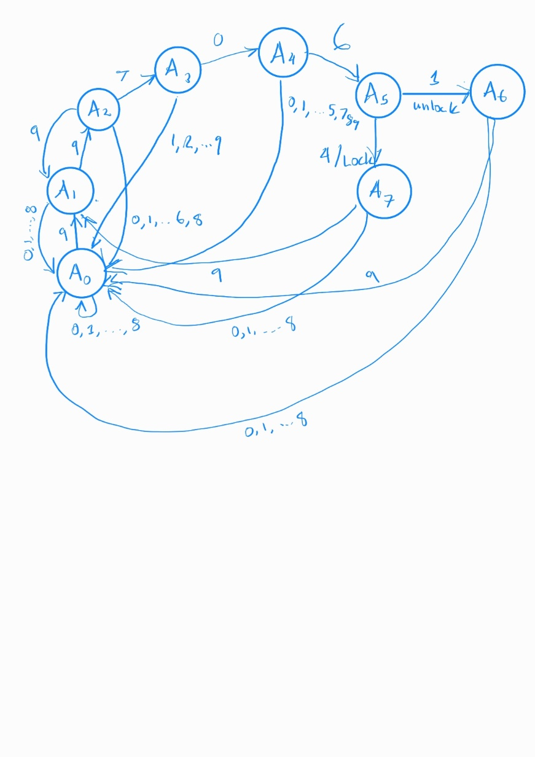I make a simple security system that utilizes a finite state machine. I wrote the programs using JAVA in Eclipse IDE. For part 2 of the assignment, we ran the executable 10 times and collected the results, here are my findings, the average amount of tries to unlock the system was 1451624, the minimum was 23558 and the max it was 4140362. I believe that my implementation for a finite state machine is some what accurate for the first part of the assignment but I am not confident with the implementation of the second part of the assignment. I also found it difficult to create a Java app using gradle despite the demo you provided professor. I get eventually got it working but I am still not sure why we needed to use it, I am looking forward to learn more about it in my own time.