USER & PERMISSION MANAGEMENT
. User & Permission Management
Create users: user1, user2, user3
Create group: developers
Add users to the group
Create a shared directory /project
Configure permissions so only group members can access it

PAGE 1 — RHEL
Topic: Red Hat Enterprise Linux (RHEL)
What I did: This page identifies the operating system environment used for the user and permission management tasks.
PAGE 1 — RHEL — Original screenshot

PAGE 2 — CREATE USERS
Topic: Create user1, user2, and user3
What I did: The commands create the three required user accounts: user1, user2, and user3. These accounts are used for the permission and access tests later.
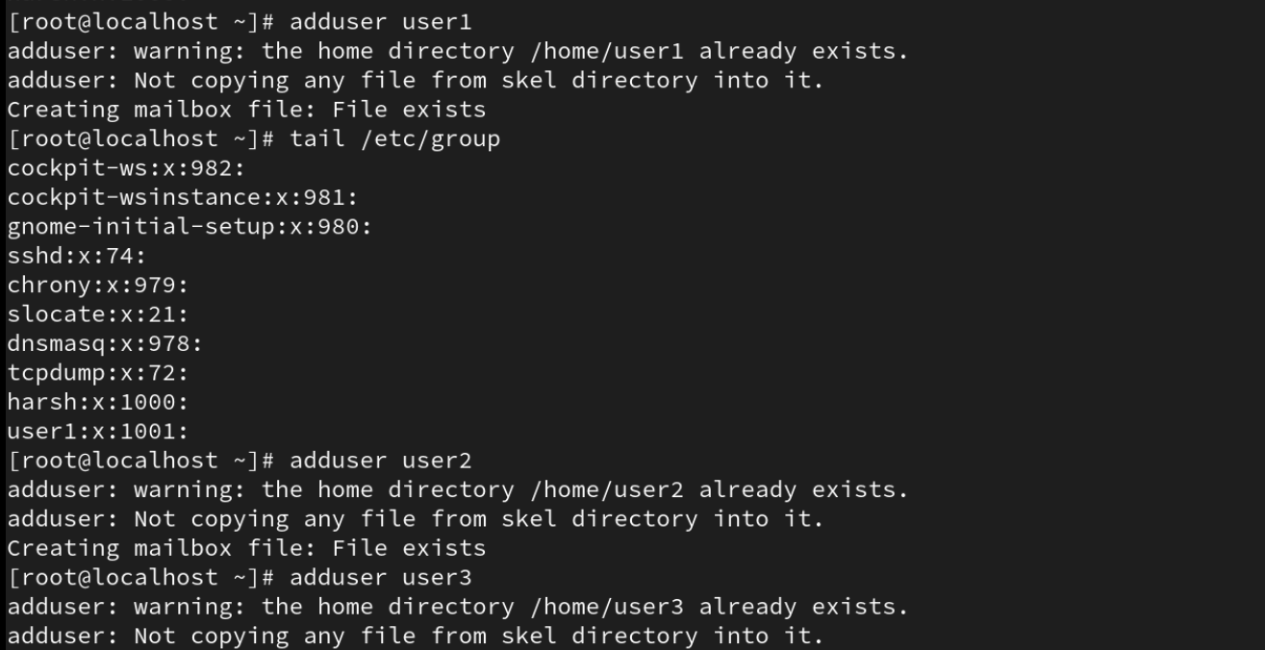
PAGE 2 — CREATE USERS — Original screenshot

PAGE 3 — CREATE GROUP & ADD USERS
Topic: Create the developer group and add users
What I did: The group is created and the users are added to it. Group membership is then used to control access to the shared /project directory.
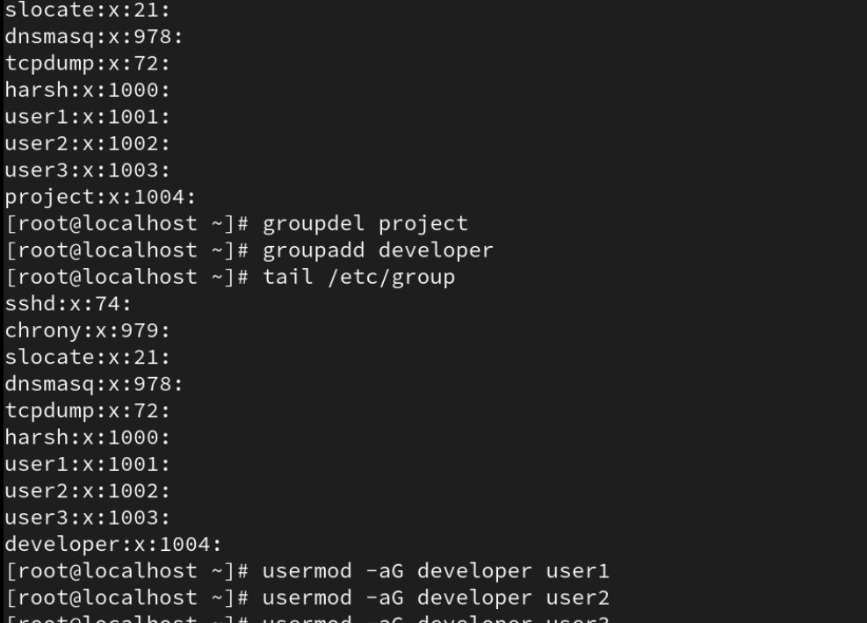
PAGE 3 — CREATE GROUP & ADD USERS — Original screenshot

PAGE 4 — CREATE /project & SET PERMISSIONS
Topic: Create the shared /project directory
What I did: The /project directory is created, its group ownership is changed to developer, and chmod 770 is applied so the owner and group have access while other users do not.
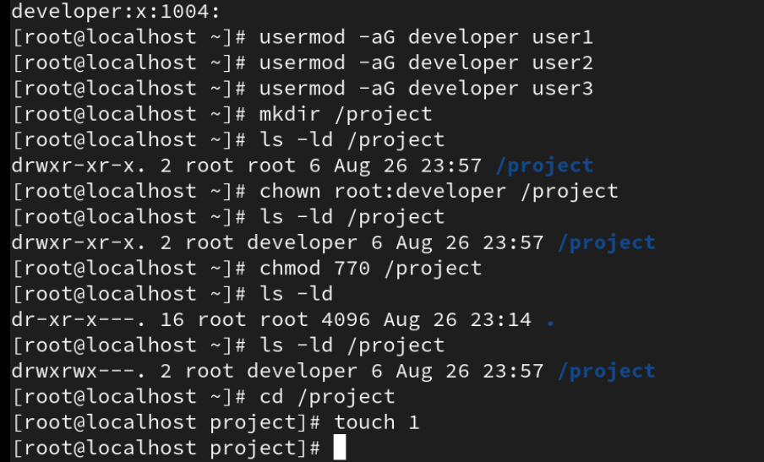
PAGE 4 — CREATE /project & SET PERMISSIONS — Original screenshot

PAGE 5 — VERIFY GROUP / USER CONFIGURATION
Topic: Verify users and group configuration
What I did: The passwd and group information is checked to verify the created users and the developer group configuration.
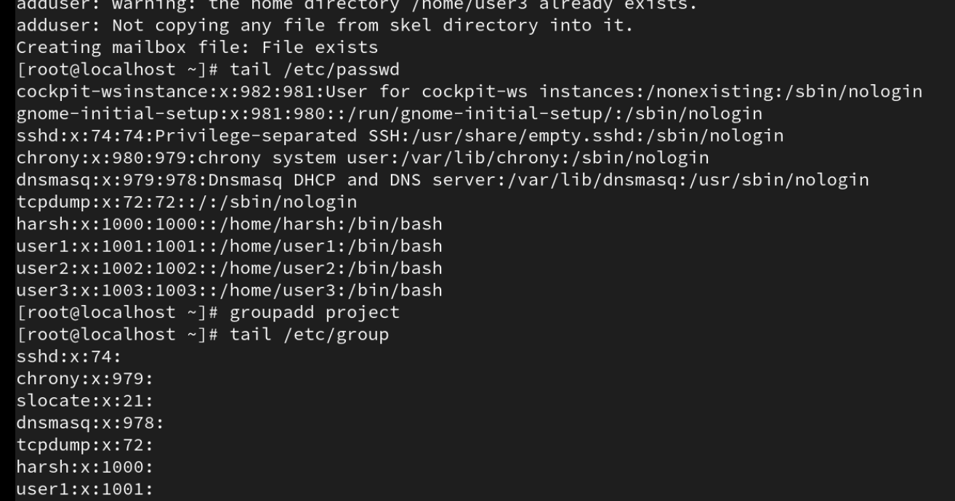
PAGE 5 — VERIFY GROUP / USER CONFIGURATION — Original screenshot

PAGE 6 — VERIFY USER CREATION
Topic: Verify the user accounts
What I did: The terminal output is reviewed to confirm the user accounts and their home-directory/login information.
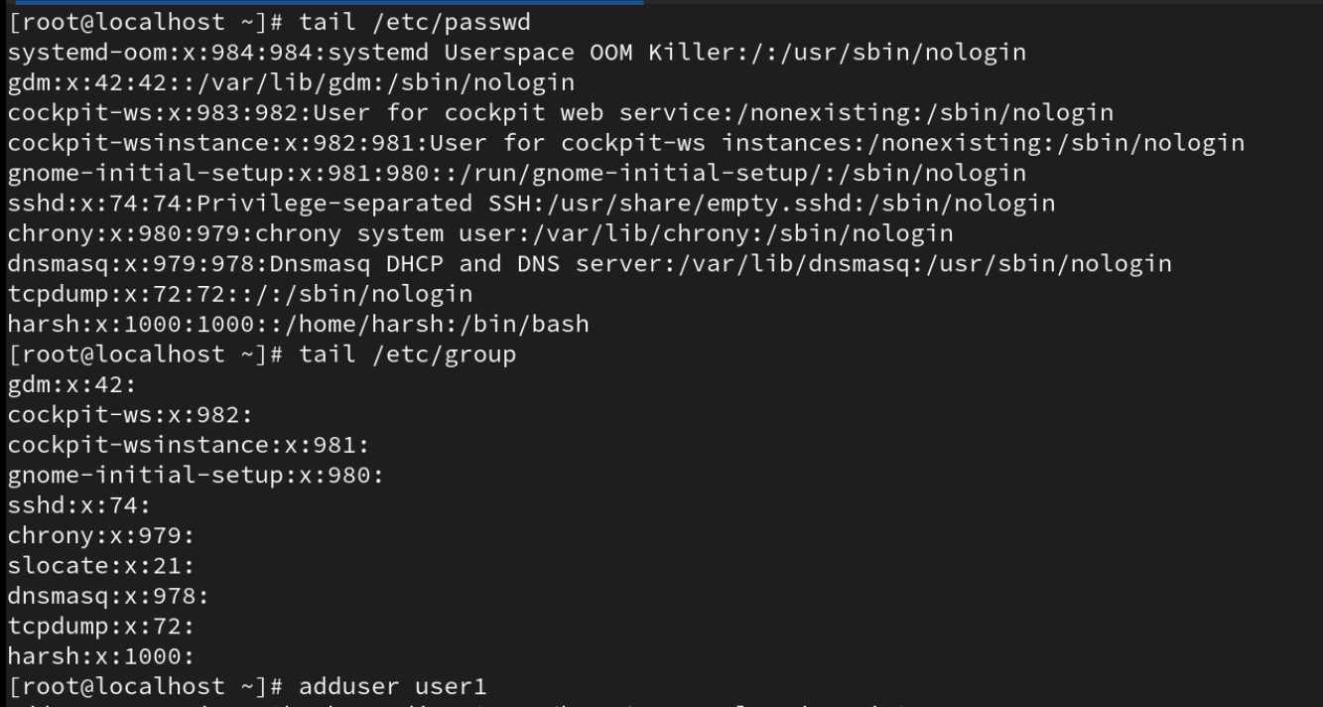
PAGE 6 — VERIFY USER CREATION — Original screenshot

PAGE 7 — TEST ACCESS
Topic: Test allowed and denied access to /project
What I did: user1 can enter /project successfully, while another user receives 'Permission denied'. This confirms that the directory permissions are restricting access as intended.
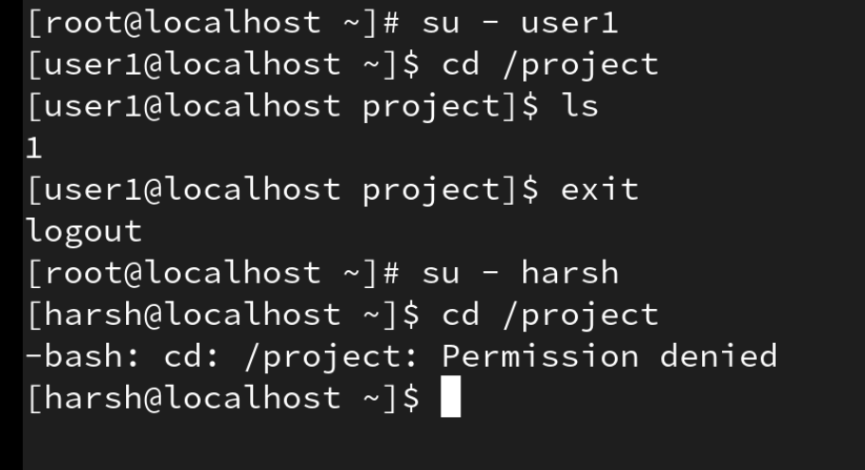
PAGE 7 — TEST ACCESS — Original screenshot

