PAGE 1 – DHCP – Enable Automatic IP Addressing
Topic: DHCP – Enable Automatic IP Addressing
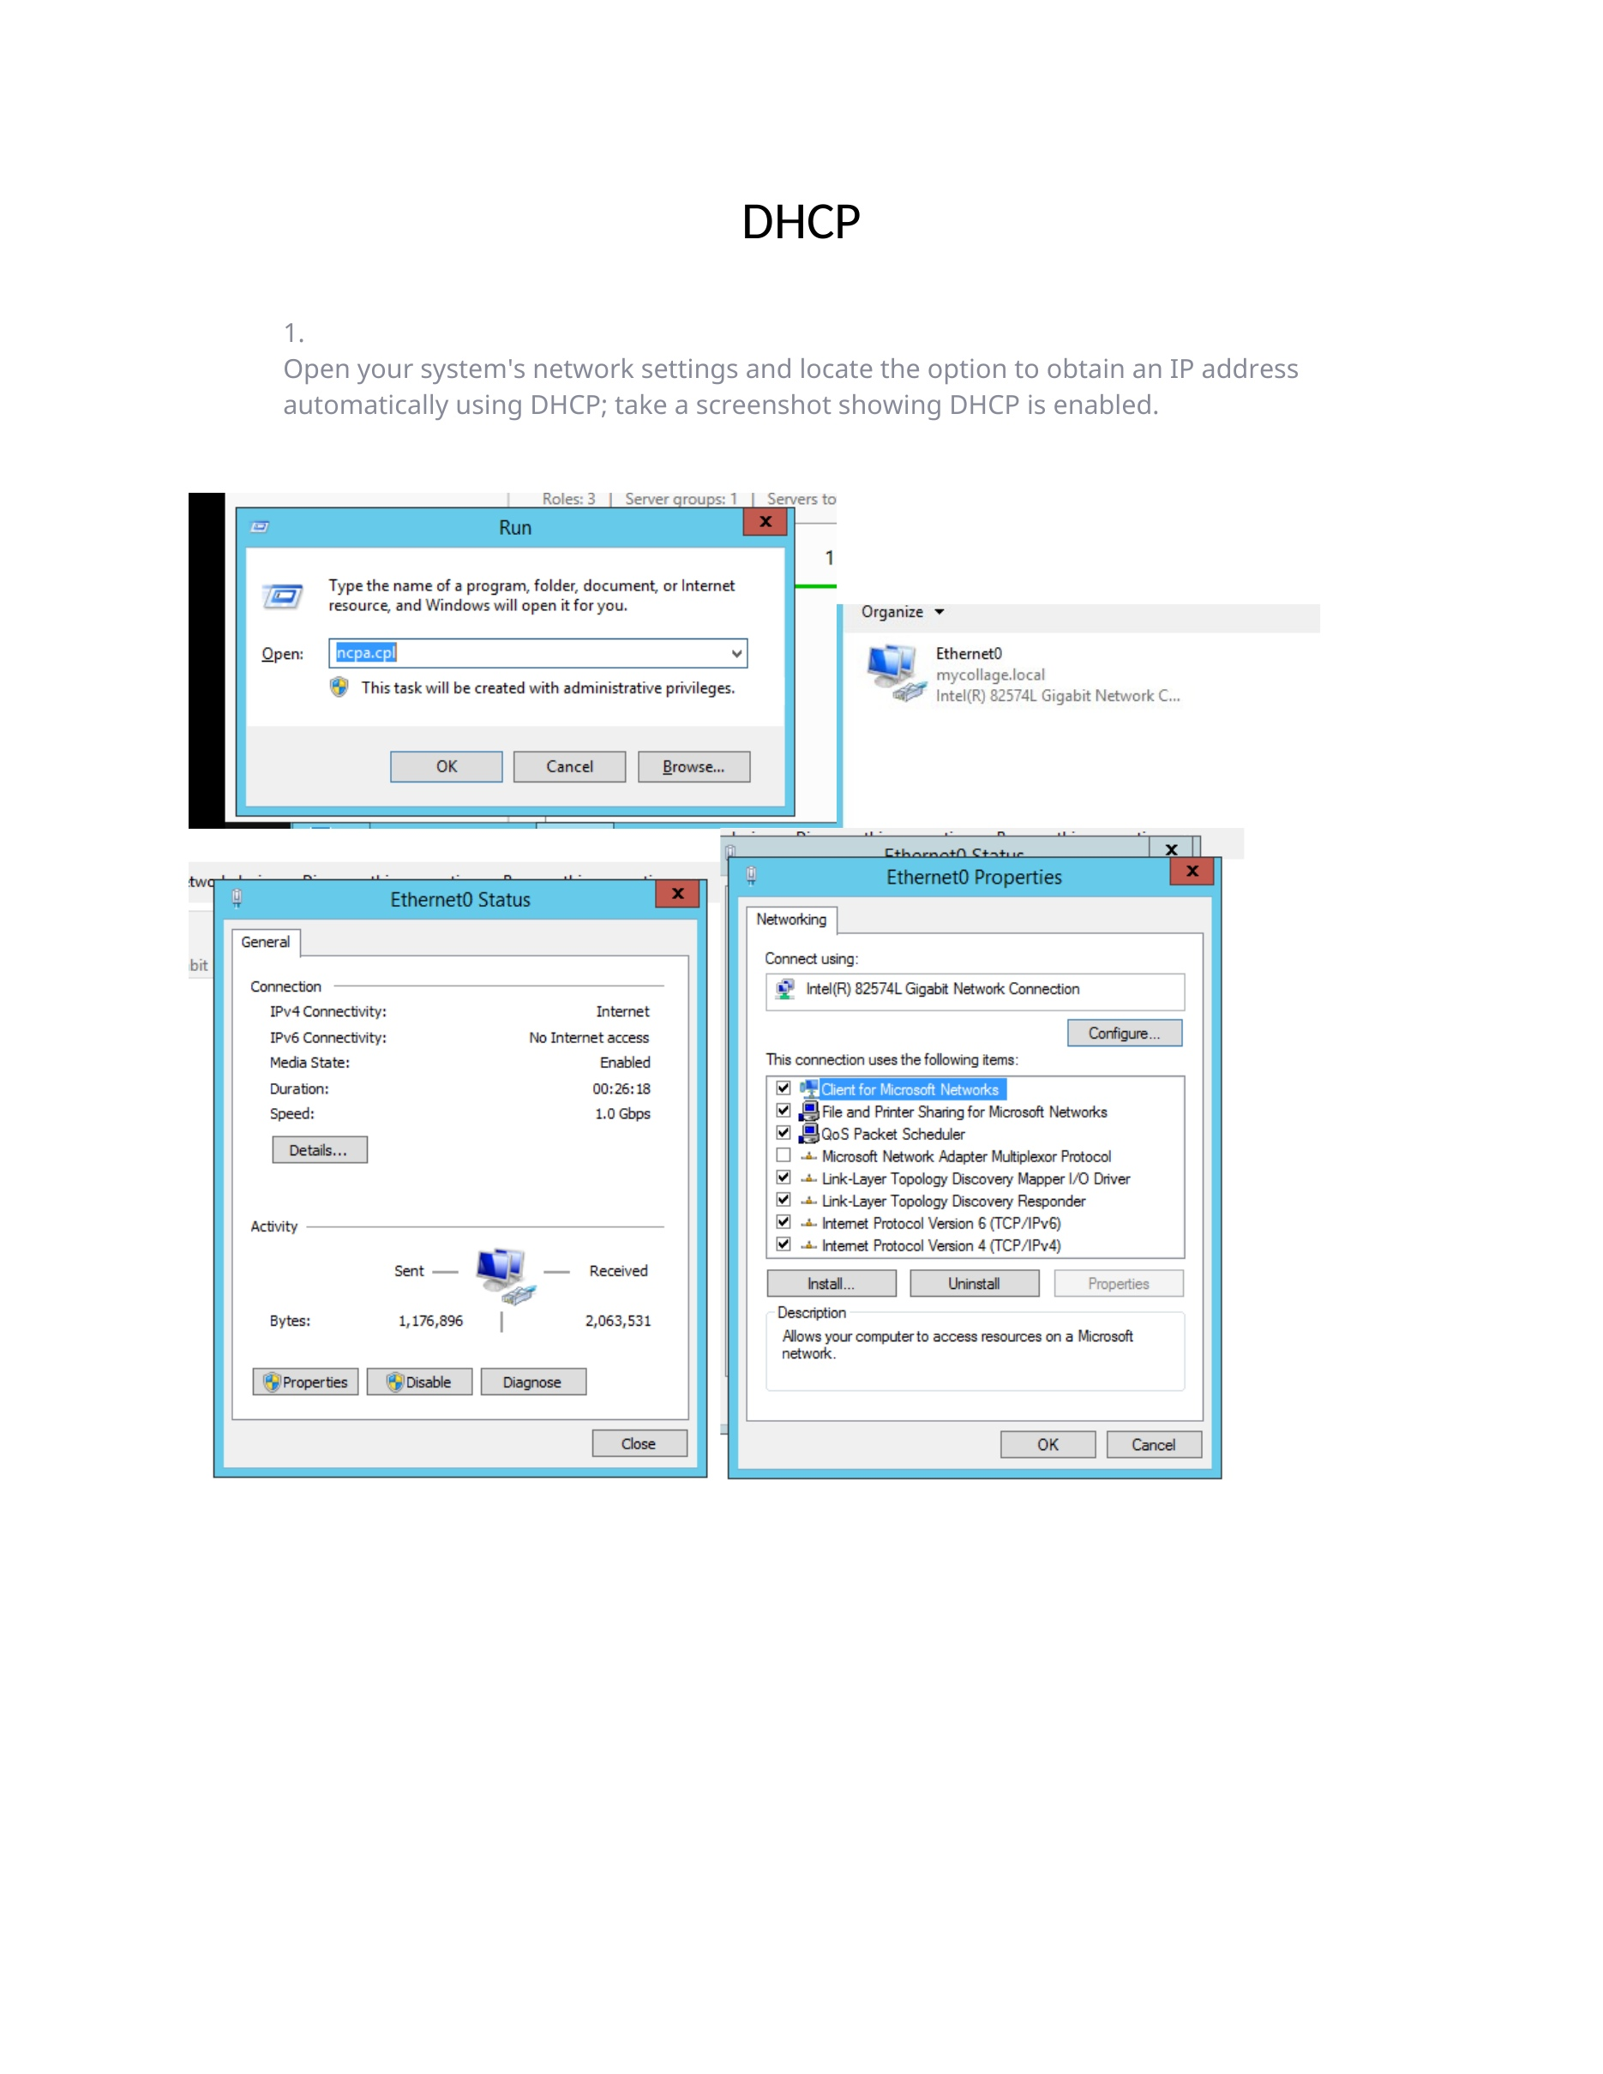
What I did: I opened the network settings and enabled the option to obtain the IP address automatically.
Explanation: The screenshot shows the system configured to receive its network settings through DHCP.

PAGE 2 – DHCP – Verify Network Configuration
Topic: DHCP – Verify Network Configuration
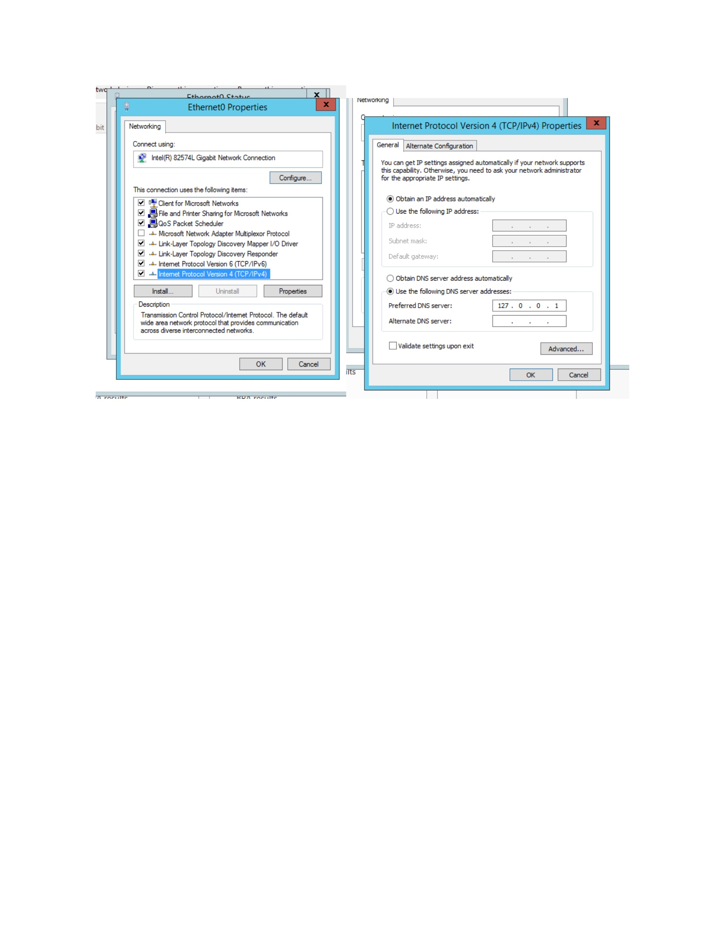
What I did: I reviewed the network configuration screens to verify that automatic addressing was selected.
Explanation: The displayed settings confirm that the client is prepared to obtain its IP configuration from DHCP.

PAGE 3 – DHCP Server – Build the Simulated Network
Topic: DHCP Server – Build the Simulated Network
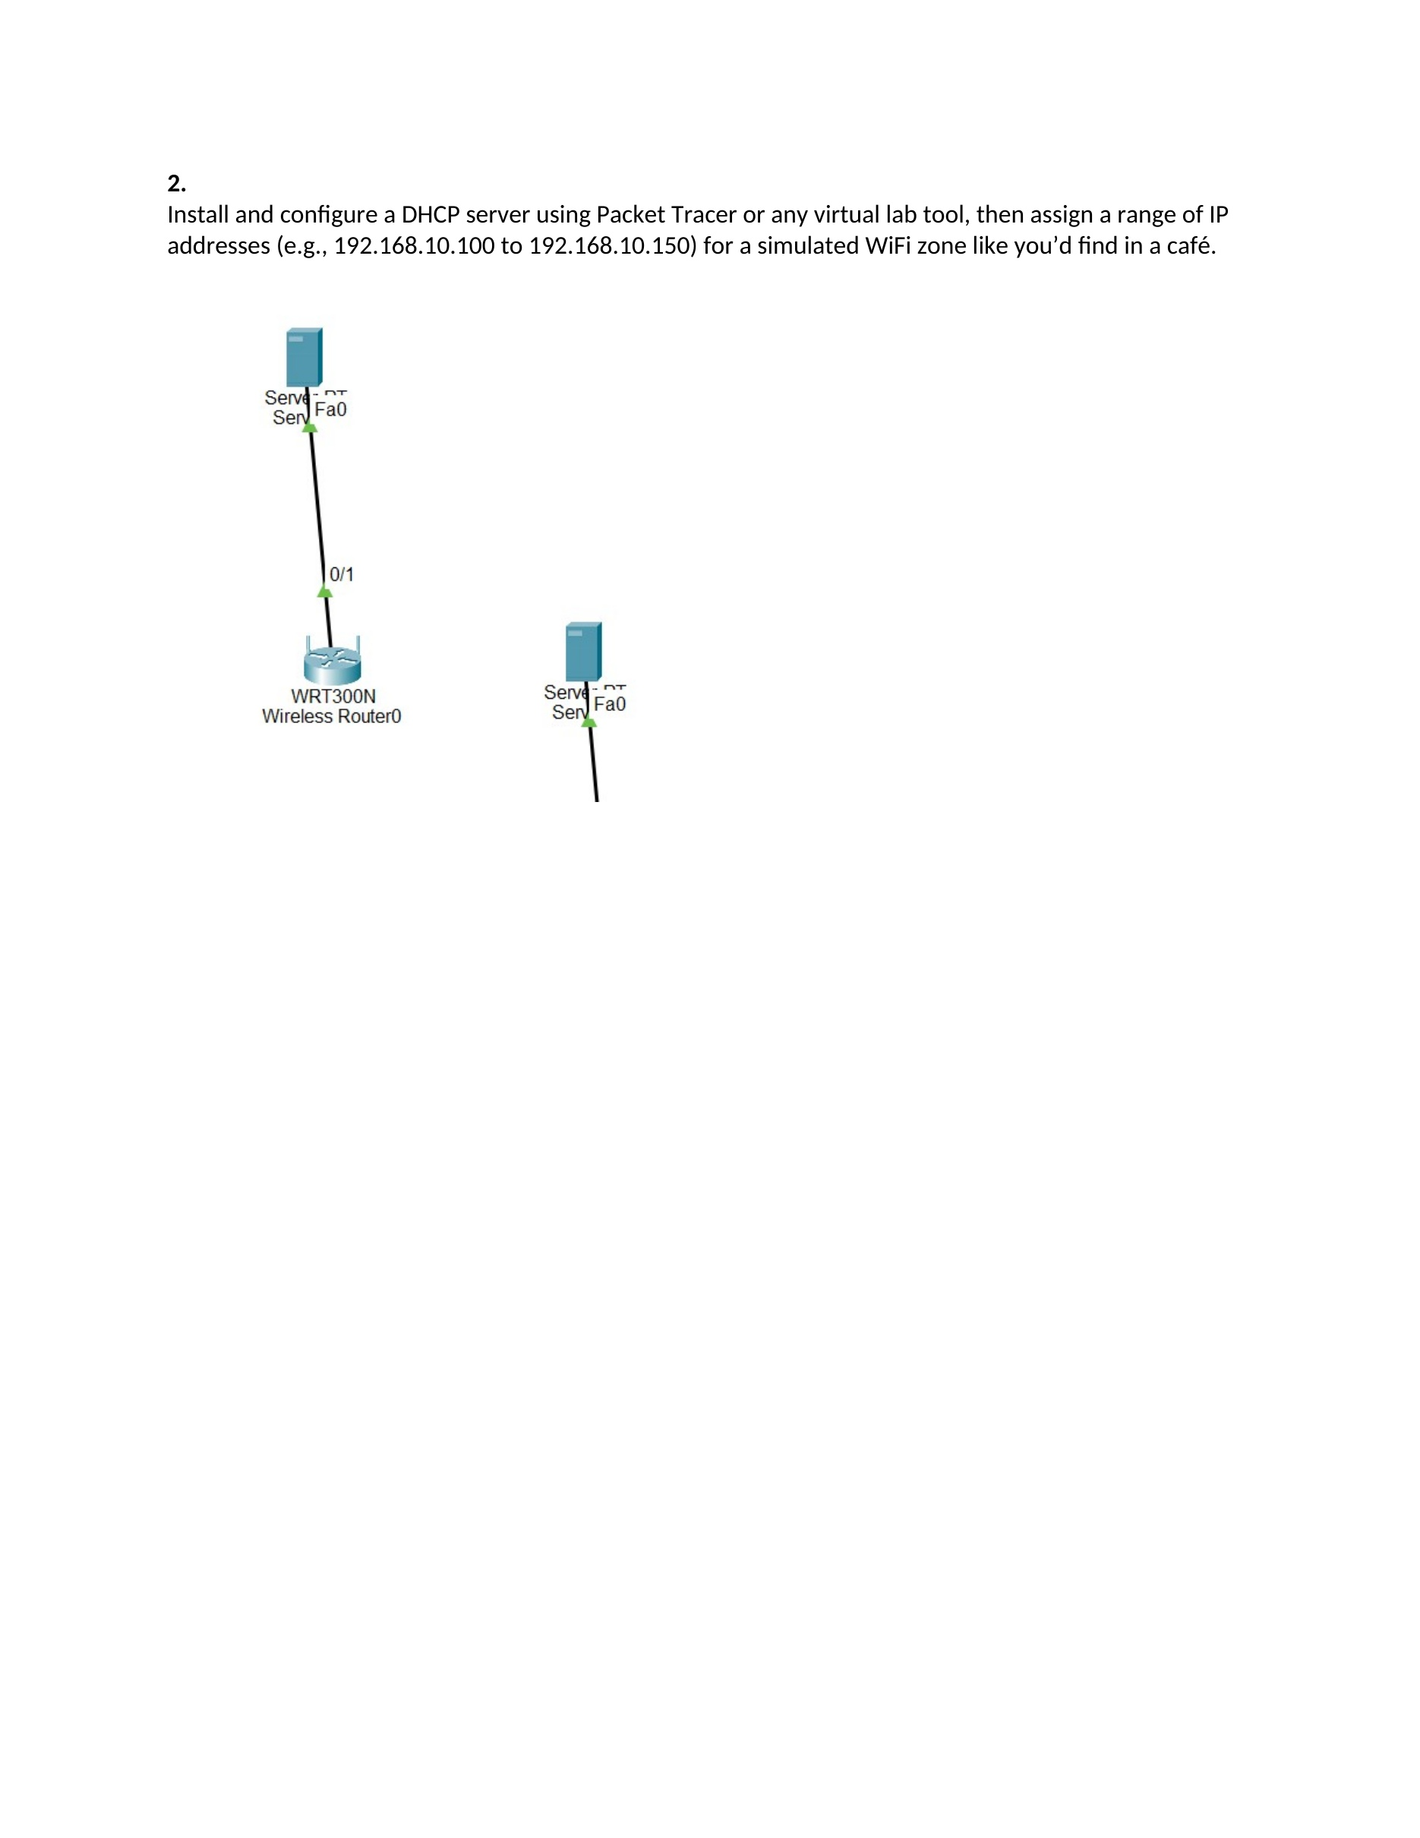
What I did: I created the simulated network topology and placed the required networking devices in the Packet Tracer workspace.
Explanation: The topology provides the network structure used for the DHCP configuration.

PAGE 4 – DHCP Server – Configure the Server
Topic: DHCP Server – Configure the Server
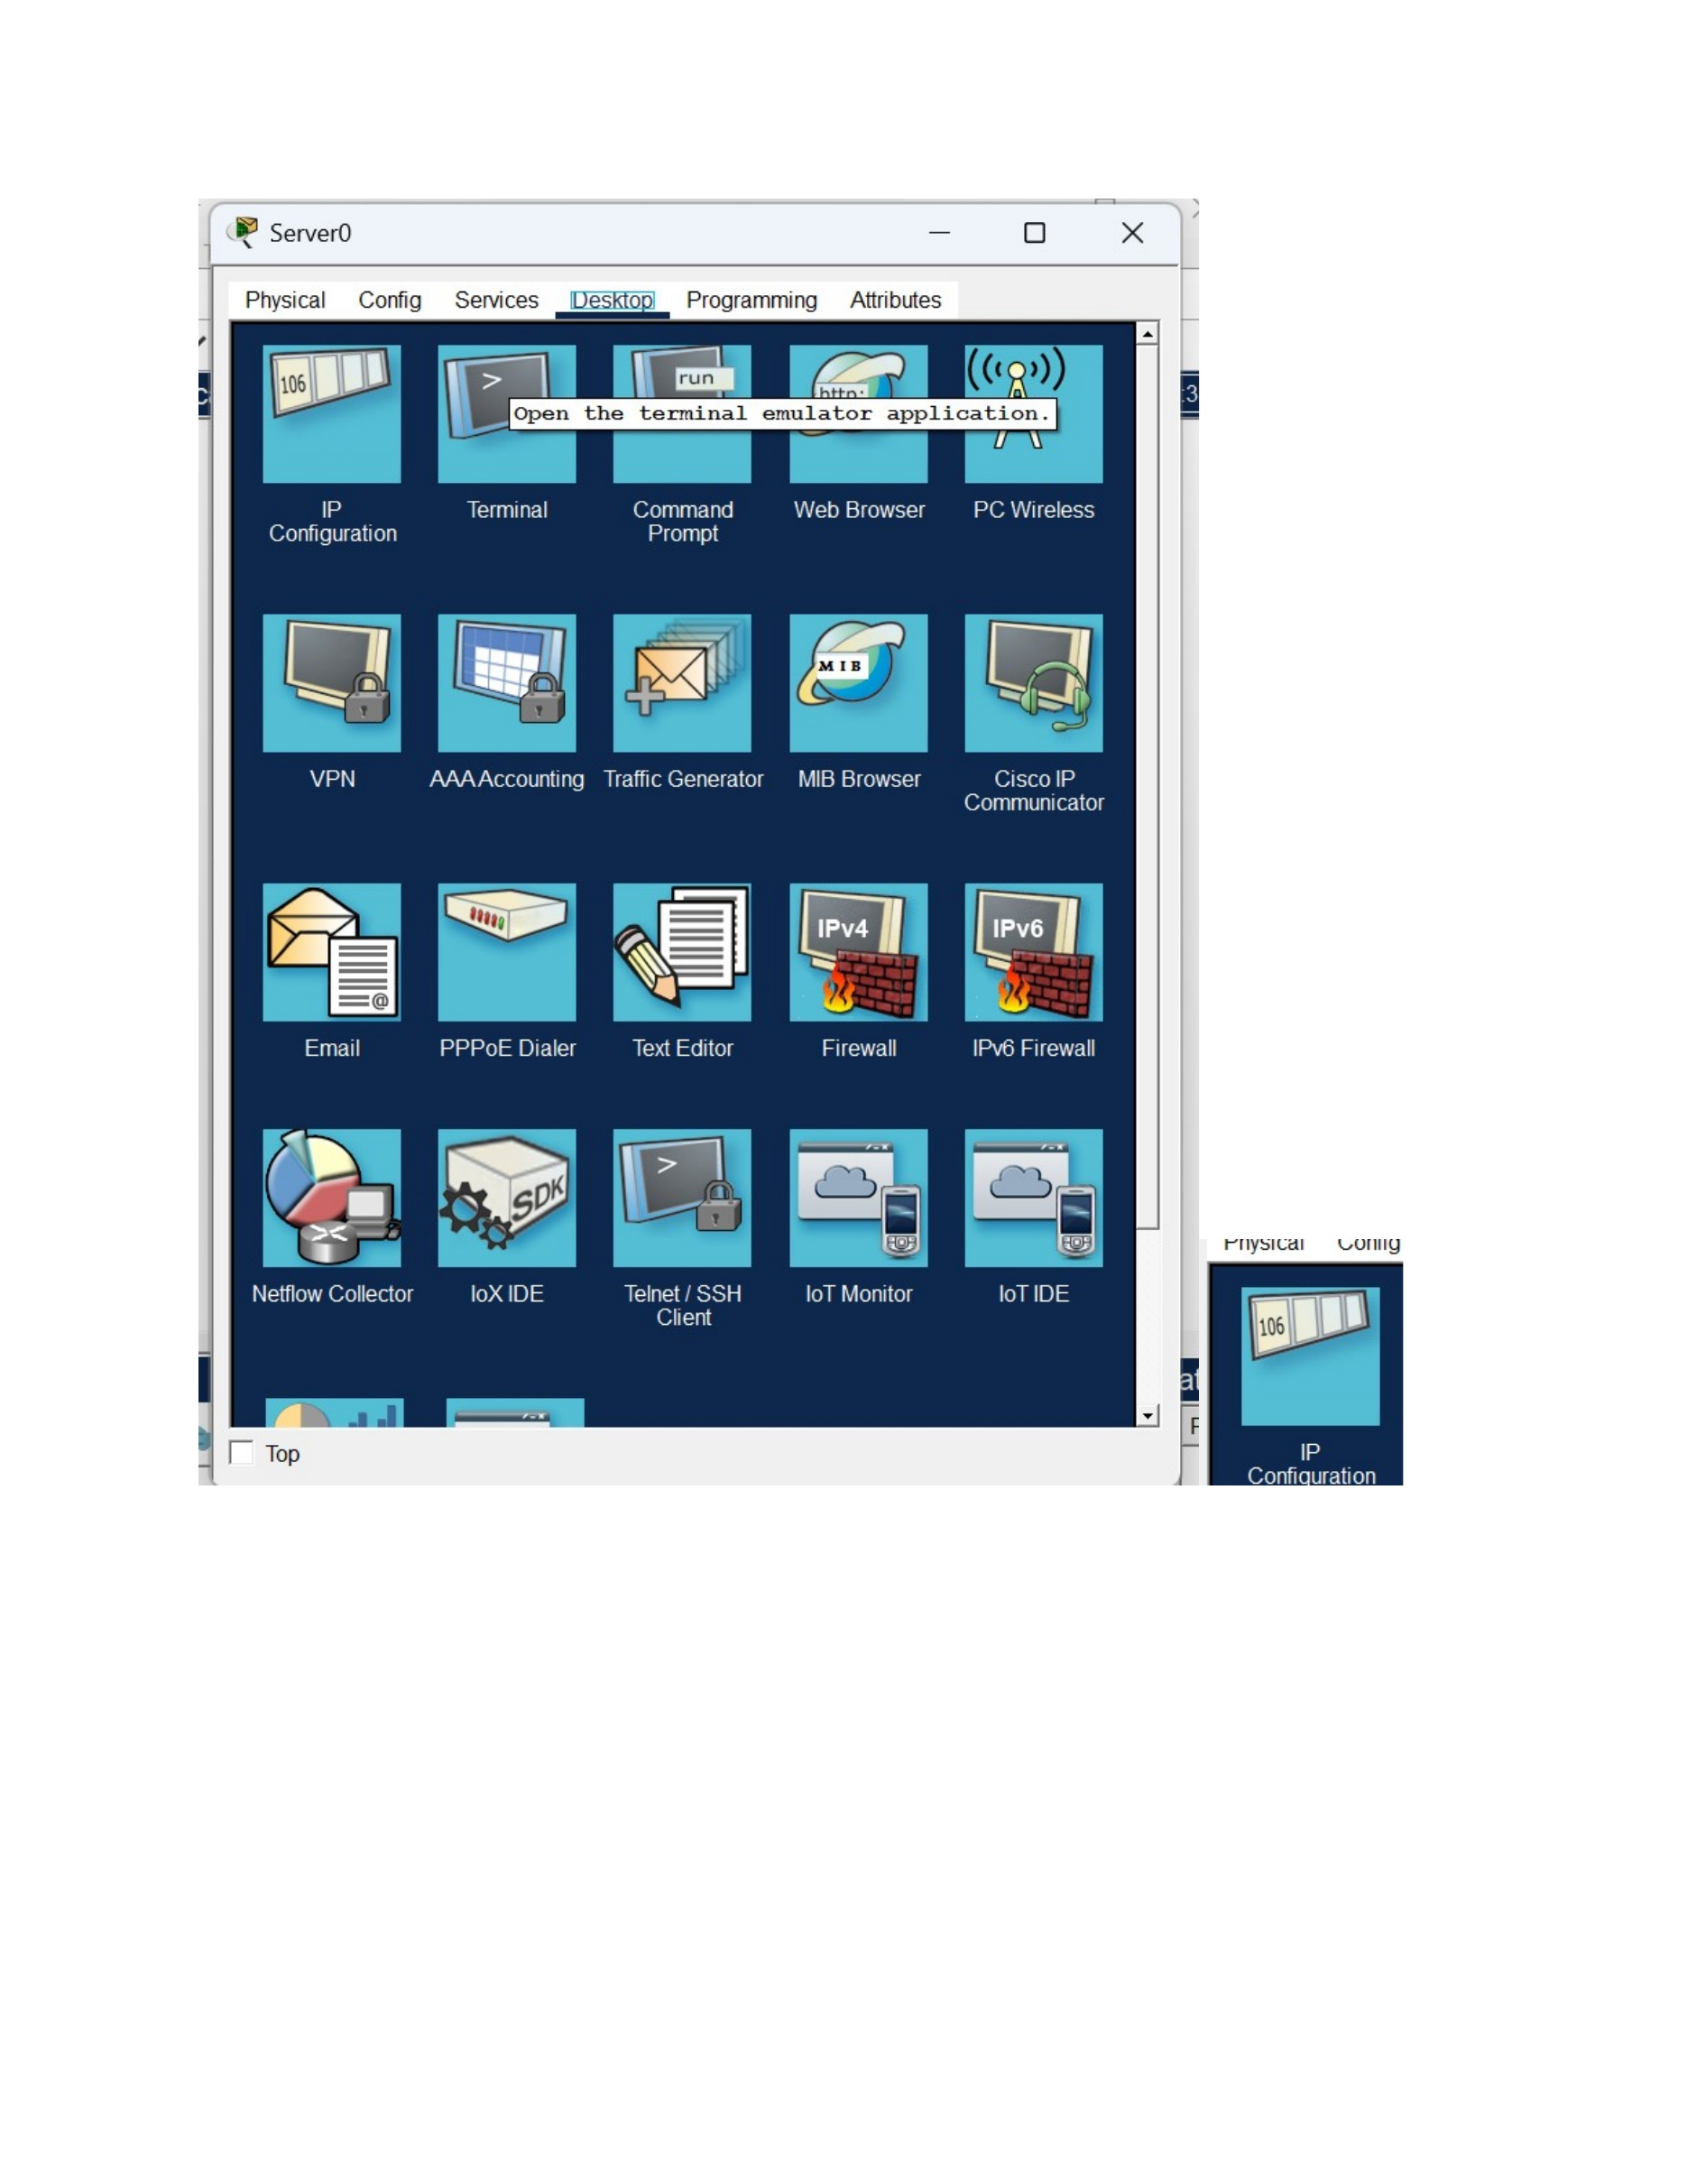
What I did: I opened the server configuration and entered the required network addressing information.
Explanation: The server settings shown here prepare the device to provide IP configuration to clients.

PAGE 5 – DHCP Server – Configure the Network Interface
Topic: DHCP Server – Configure the Network Interface
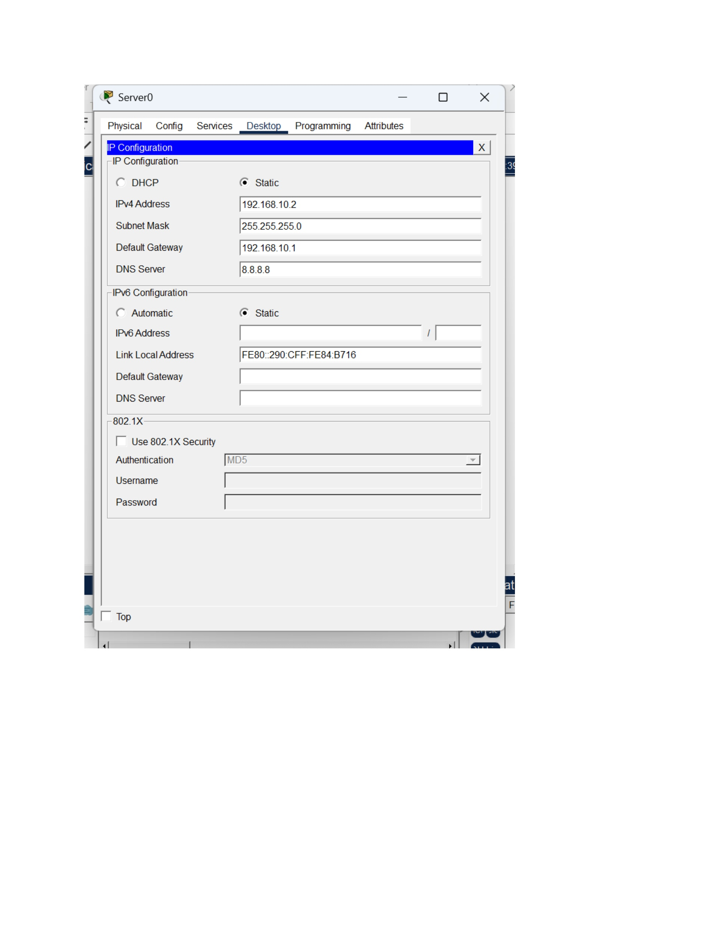
What I did: I configured the server interface with the required IP address and network parameters.
Explanation: The interface configuration gives the DHCP server its fixed address on the simulated network.

PAGE 6 – DHCP Server – Open DHCP Service
Topic: DHCP Server – Open DHCP Service
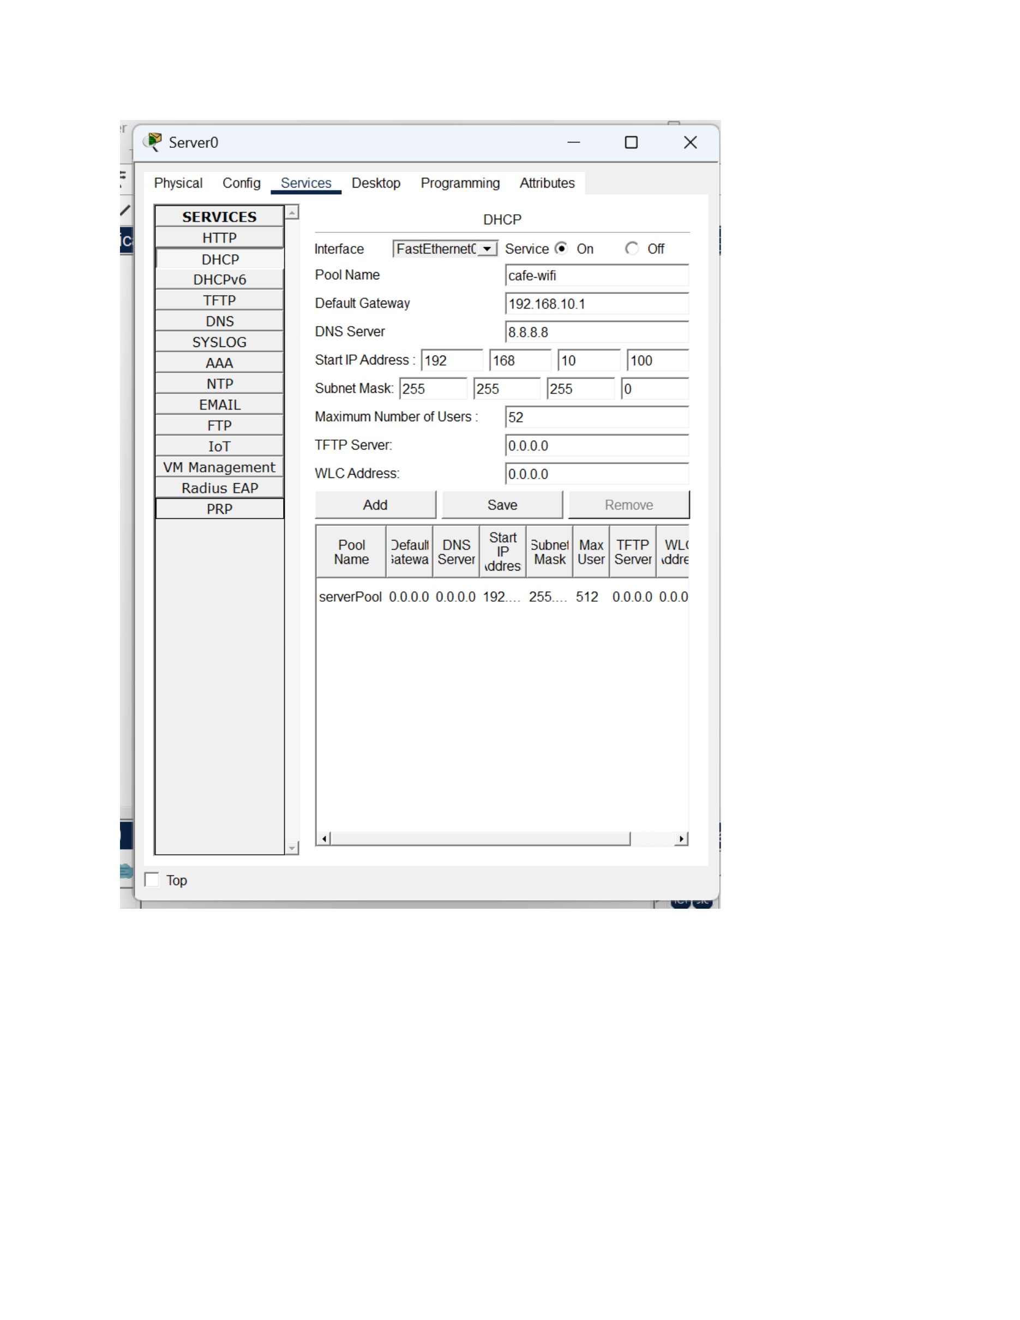
What I did: I opened the DHCP service configuration on the server.
Explanation: This screen is where the DHCP pool and client addressing parameters are configured.

PAGE 7 – DHCP Server – Enter the DHCP Pool Settings
Topic: DHCP Server – Enter the DHCP Pool Settings
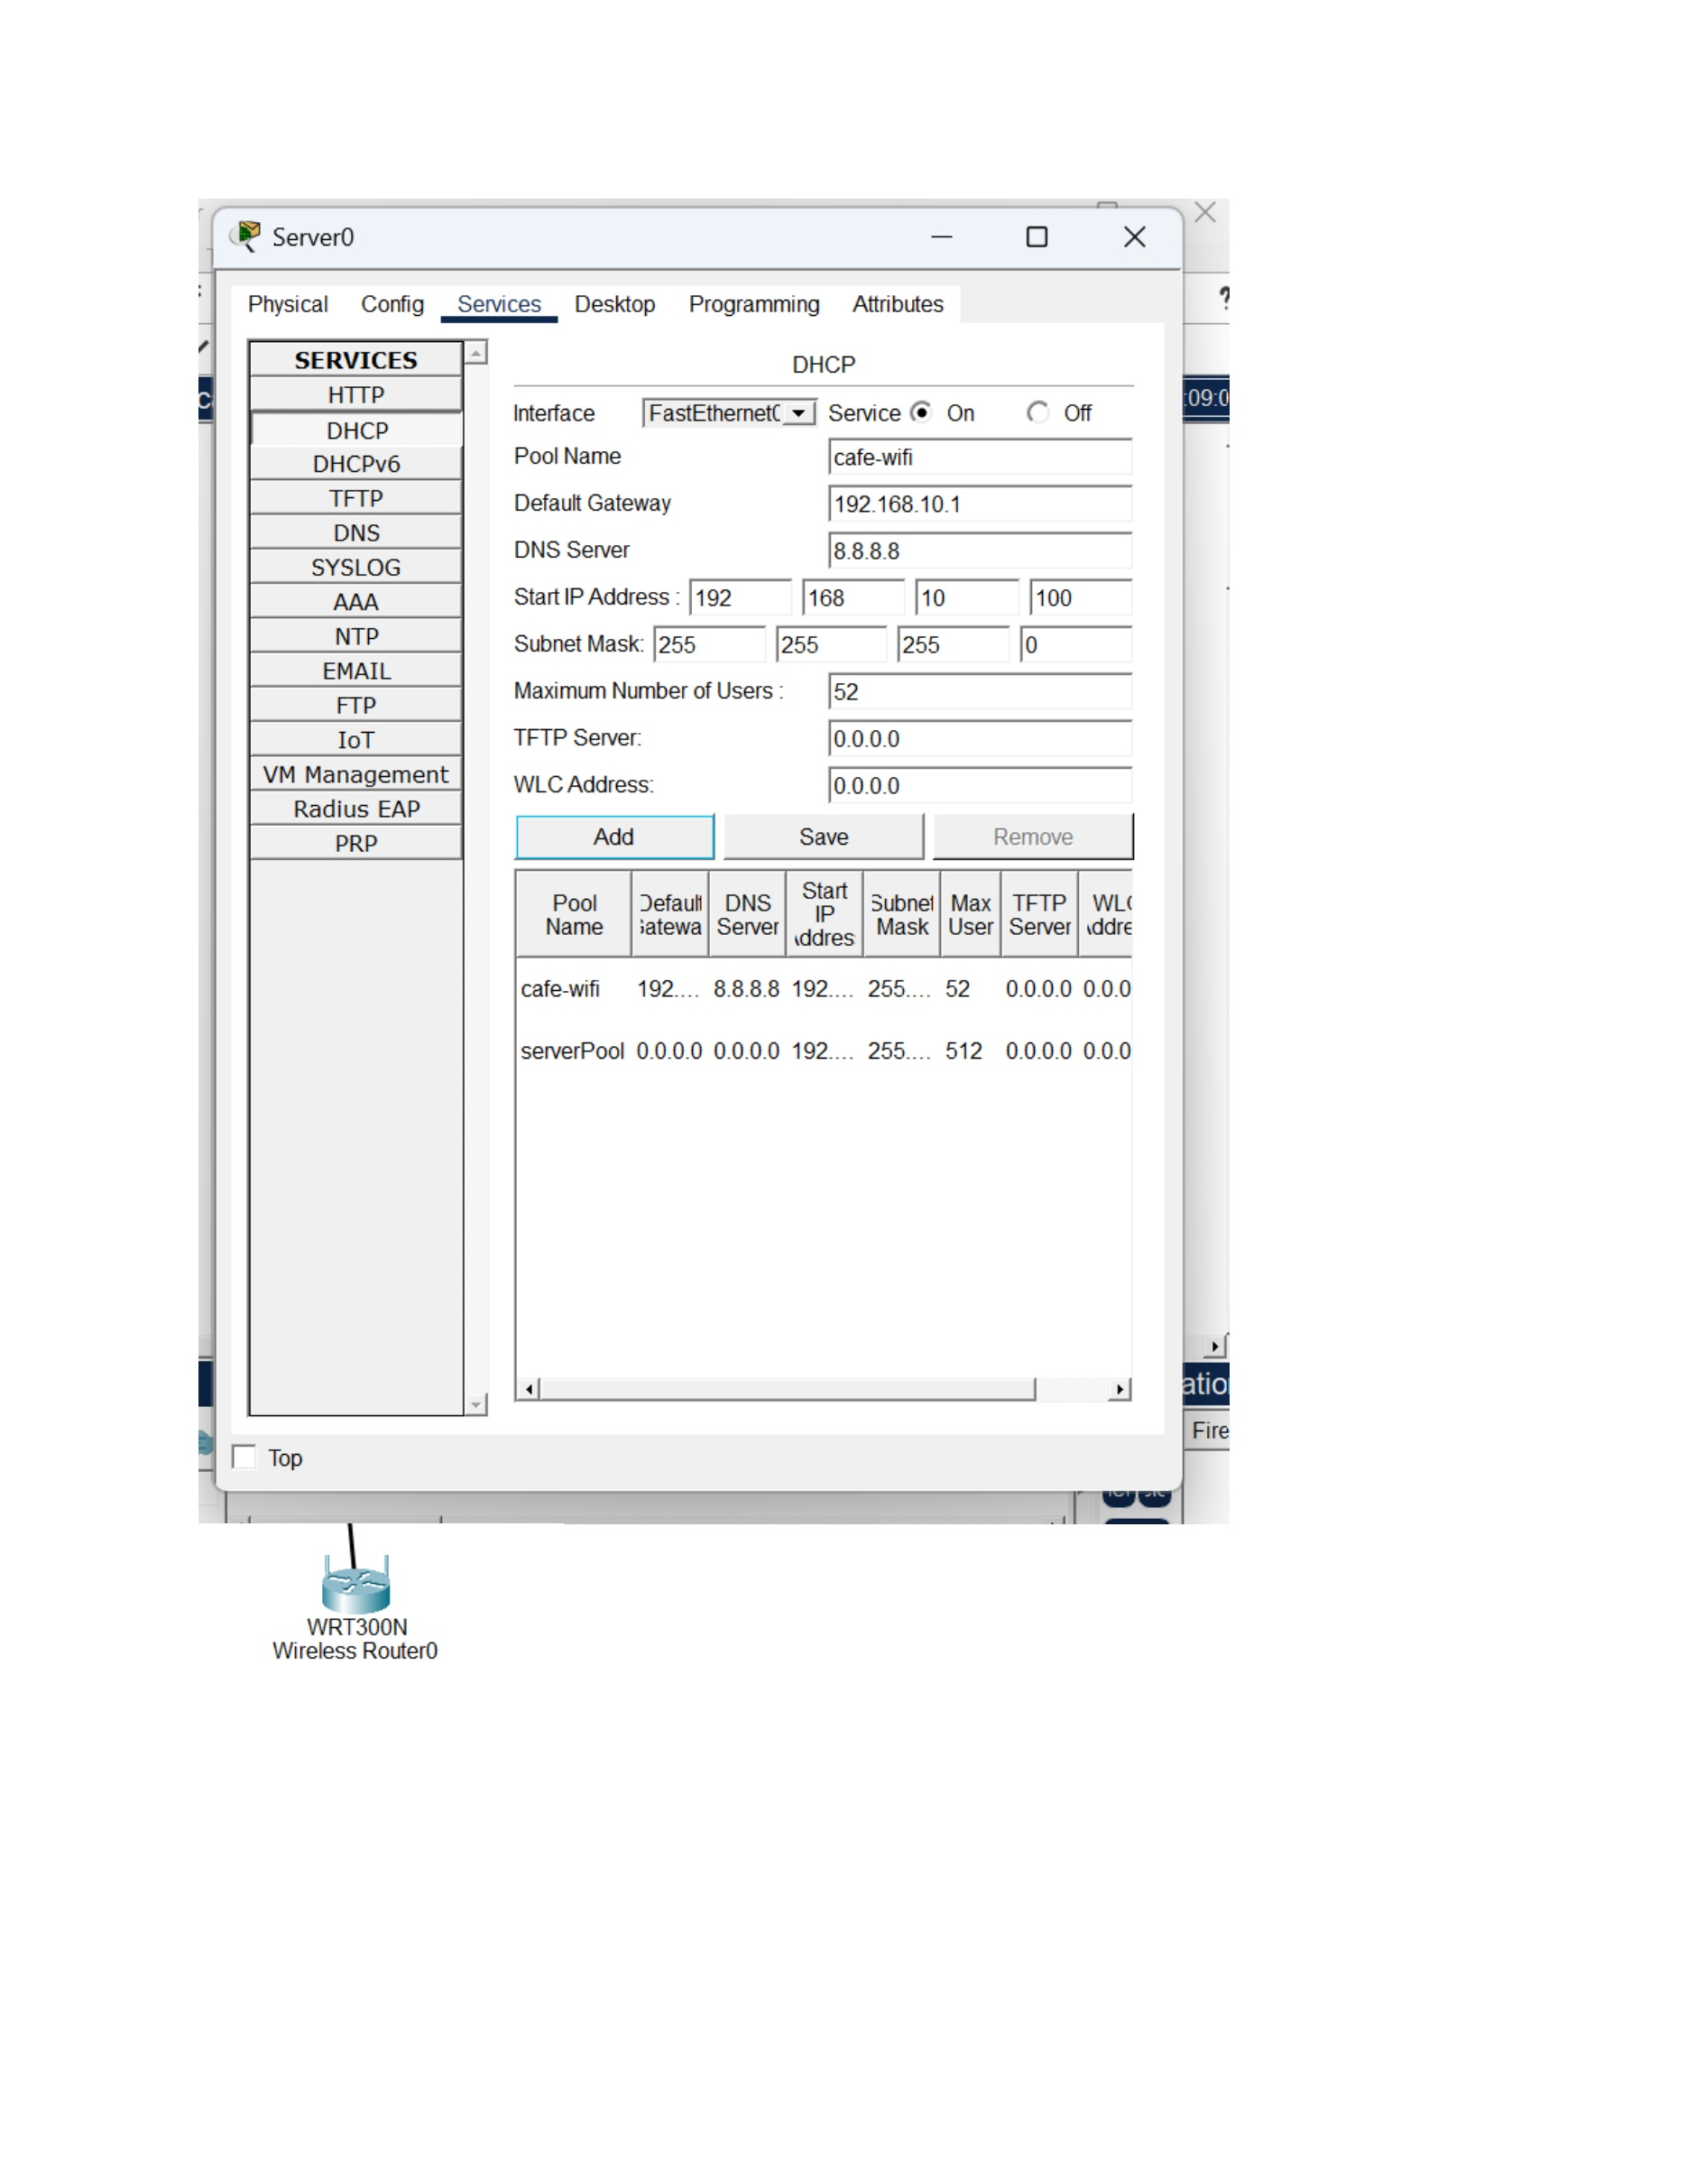
What I did: I entered the DHCP pool information, including the starting address and the network parameters.
Explanation: The configured pool defines the addresses that can be leased to devices on the simulated network.

PAGE 8 – DHCP Server – Set the DHCP Range
Topic: DHCP Server – Set the DHCP Range
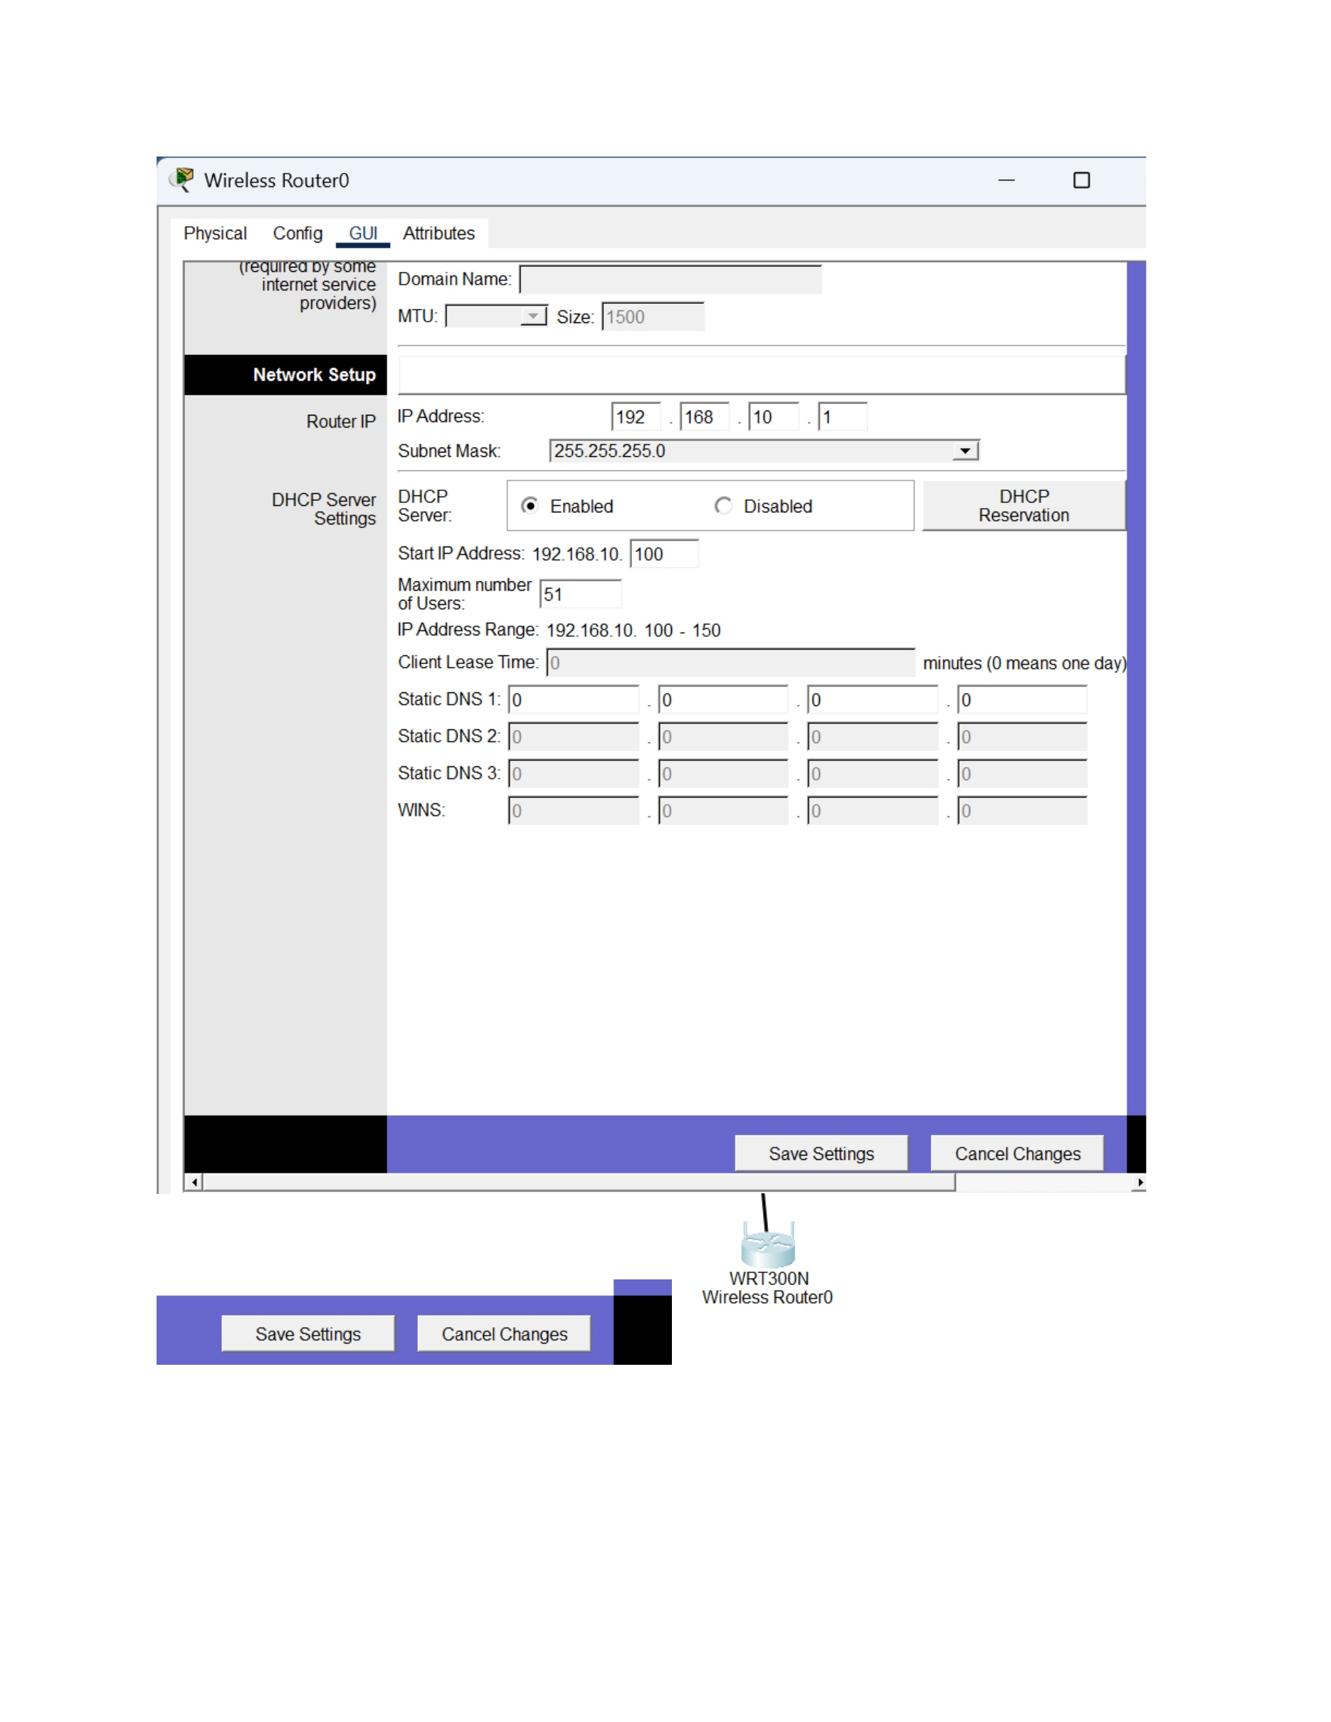
What I did: I configured the DHCP address range for the simulated WiFi network.
Explanation: The pool settings specify the range of IP addresses available for automatic assignment.

PAGE 9 – DHCP Client – Request an IP Address
Topic: DHCP Client – Request an IP Address
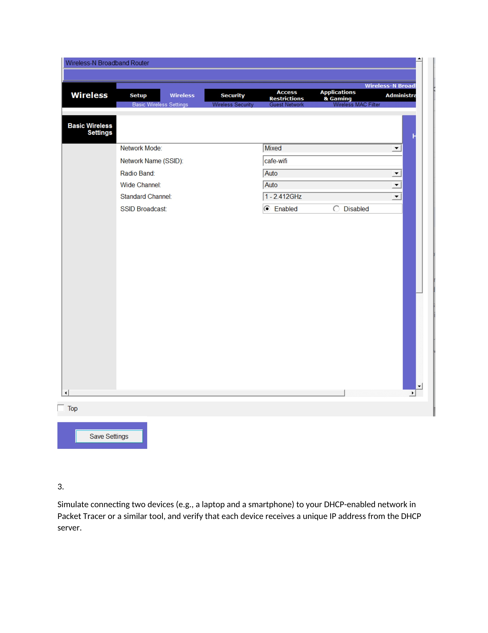
What I did: I opened the client device network settings and selected DHCP to request an address automatically.
Explanation: The client is configured to obtain its IP configuration from the DHCP server.

PAGE 10 – DHCP Client – Verify the Assigned Address
Topic: DHCP Client – Verify the Assigned Address
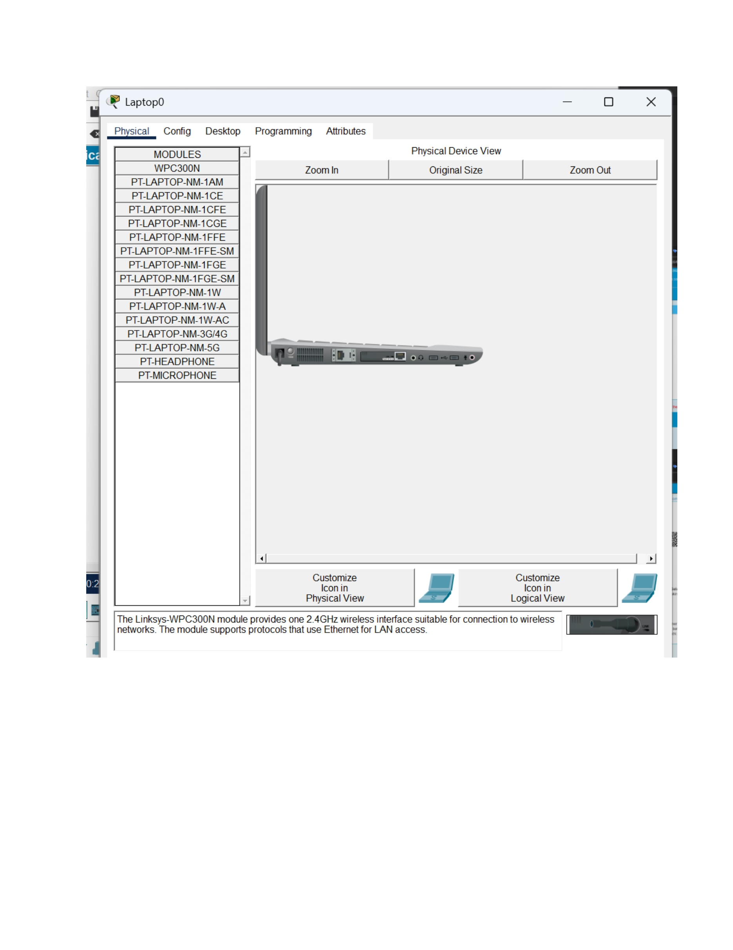
What I did: I checked the client network information after enabling DHCP.
Explanation: The displayed configuration shows the address information received by the client.

PAGE 11 – DHCP Client – Check the Second Device
Topic: DHCP Client – Check the Second Device
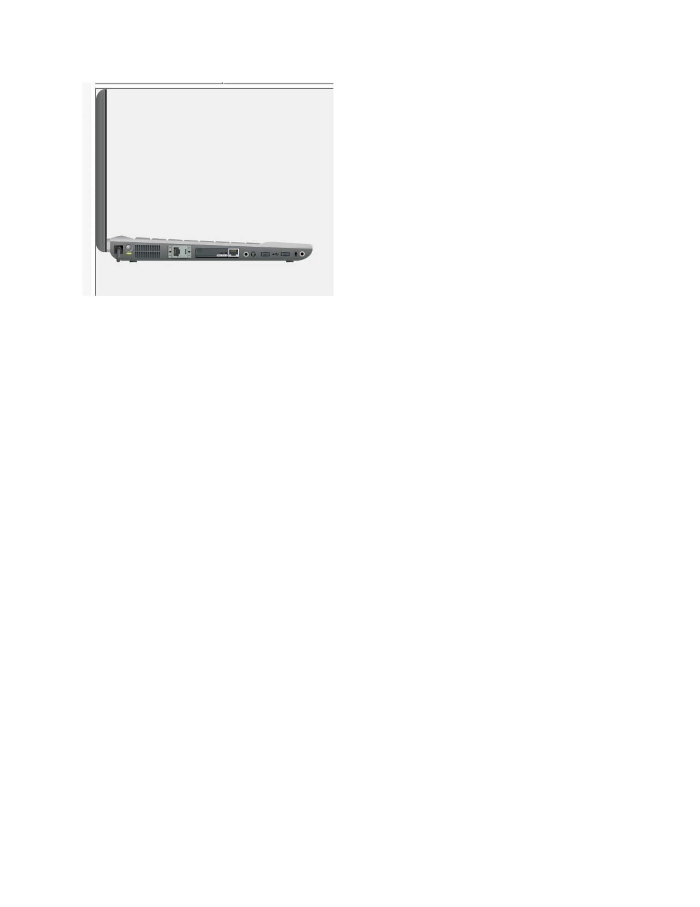
What I did: I opened the second simulated device and reviewed its network configuration.
Explanation: This step checks the second client that is connected to the DHCP-enabled network.

PAGE 12 – DHCP Client – Verify the Second Lease
Topic: DHCP Client – Verify the Second Lease
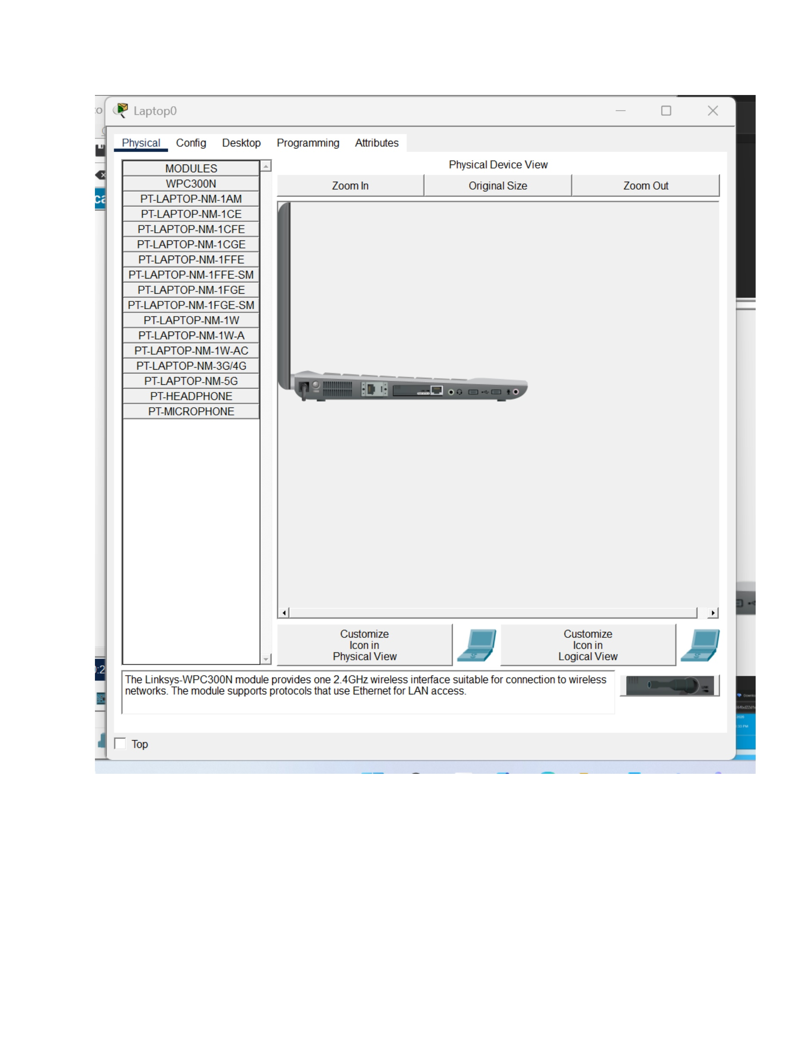
What I did: I checked the second device's assigned network information.
Explanation: The screenshot shows the address received by the second client from the DHCP service.

PAGE 13 – DHCP Network – Review Connected Devices
Topic: DHCP Network – Review Connected Devices
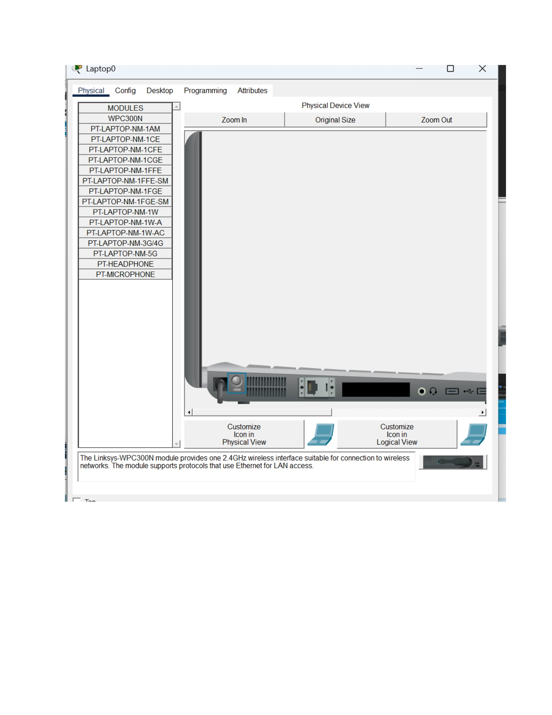
What I did: I reviewed the simulated devices and their network connections in the Packet Tracer workspace.
Explanation: The topology shows the clients connected to the DHCP-enabled network.

PAGE 14 – DHCP – Verify Client Addressing
Topic: DHCP – Verify Client Addressing
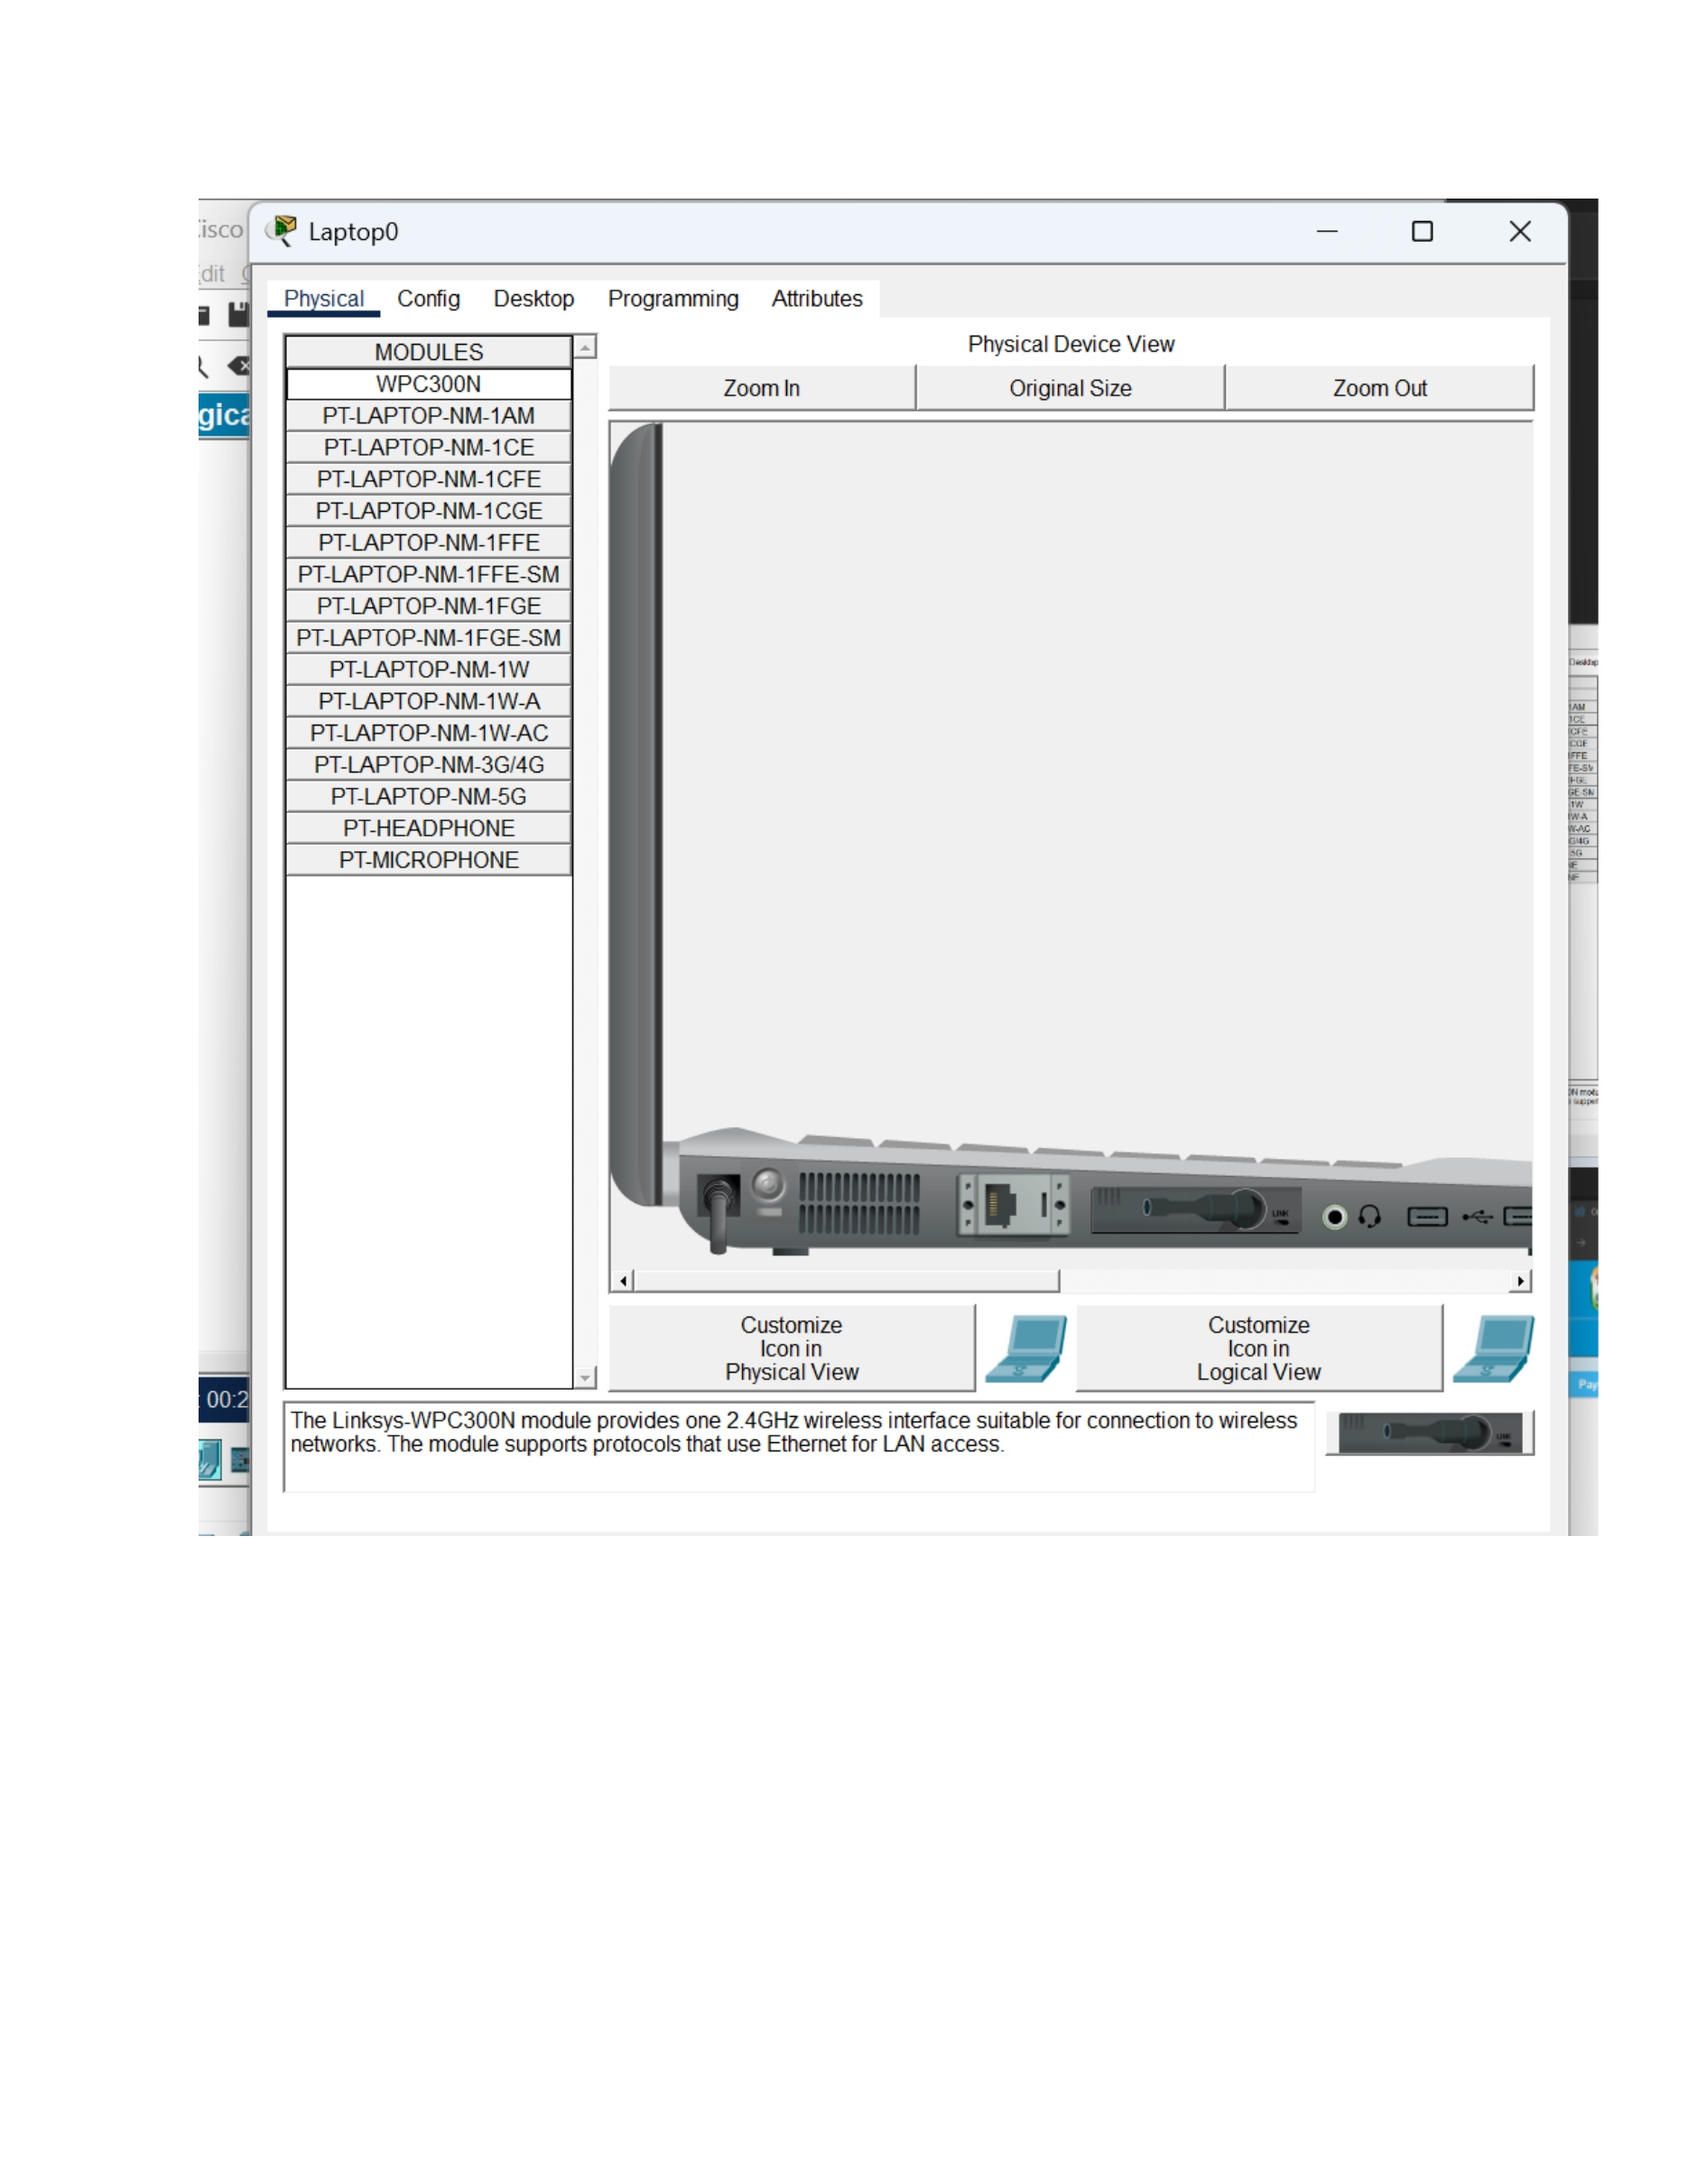
What I did: I checked the device configuration again to verify the DHCP-assigned addressing.
Explanation: The network settings provide the final verification of automatic IP assignment.

PAGE 15 – DHCP – Confirm Network Operation
Topic: DHCP – Confirm Network Operation
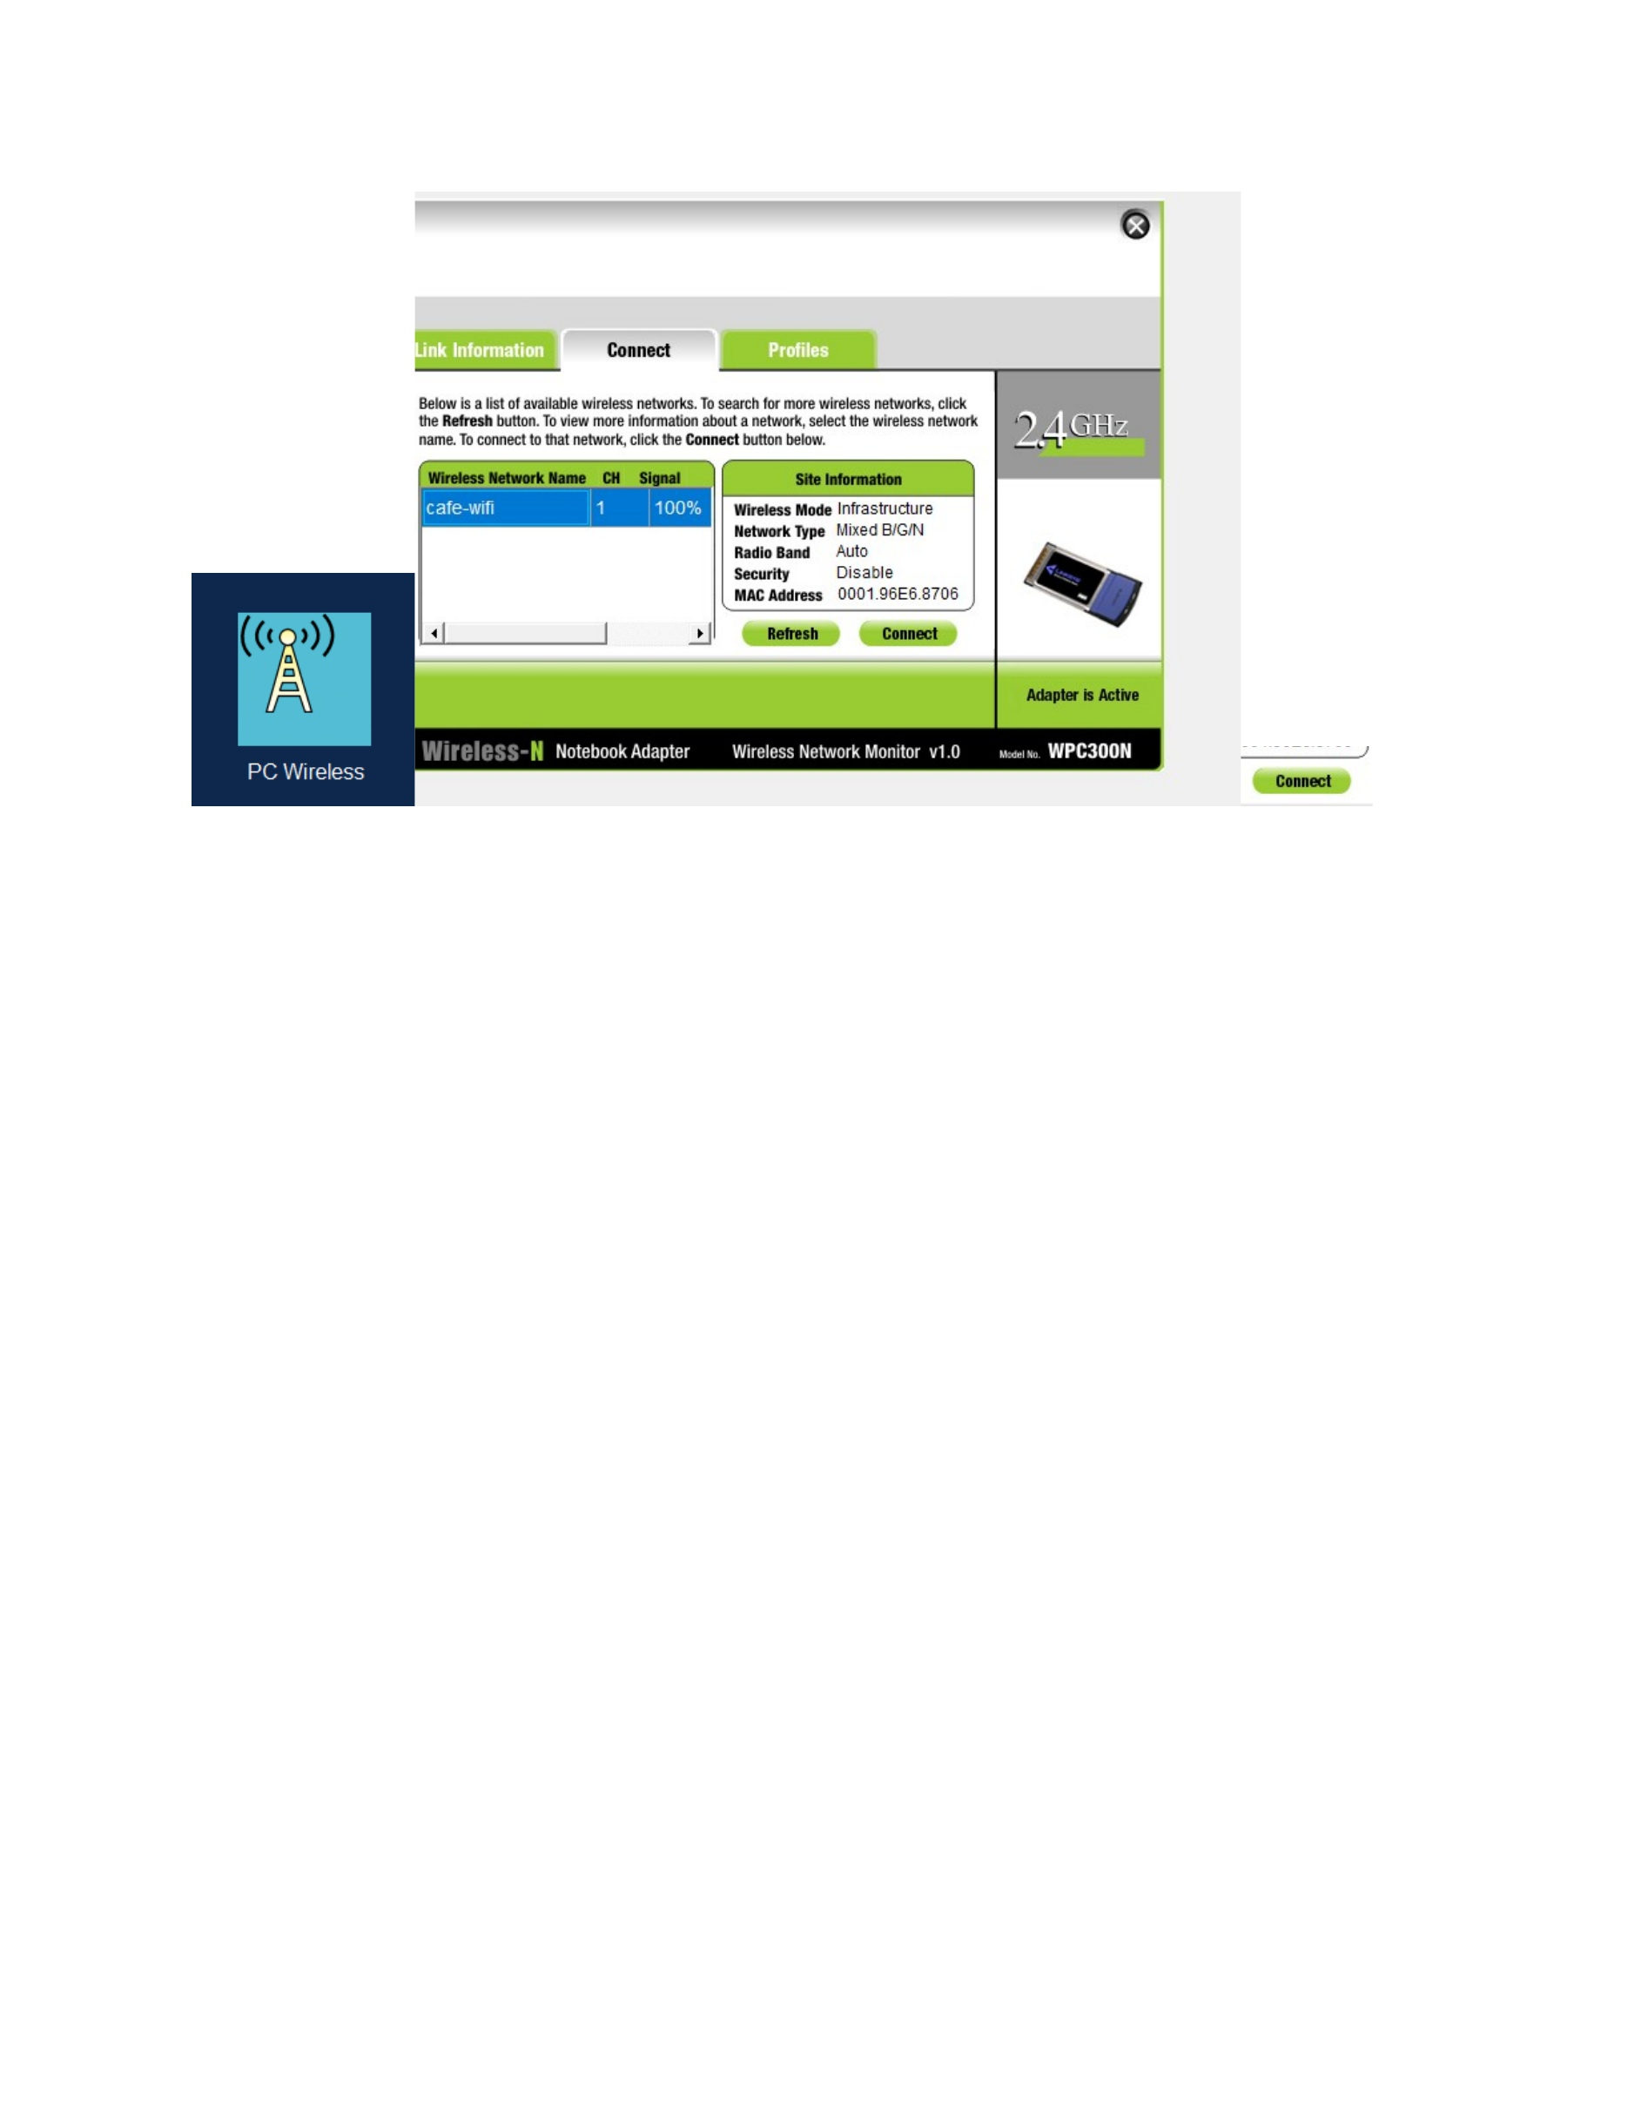
What I did: I reviewed the completed simulated network and the client/server configuration.
Explanation: The screenshot shows the DHCP setup after the clients have been configured.

PAGE 16 – DHCP Reservation – Open Server Settings
Topic: DHCP Reservation – Open Server Settings
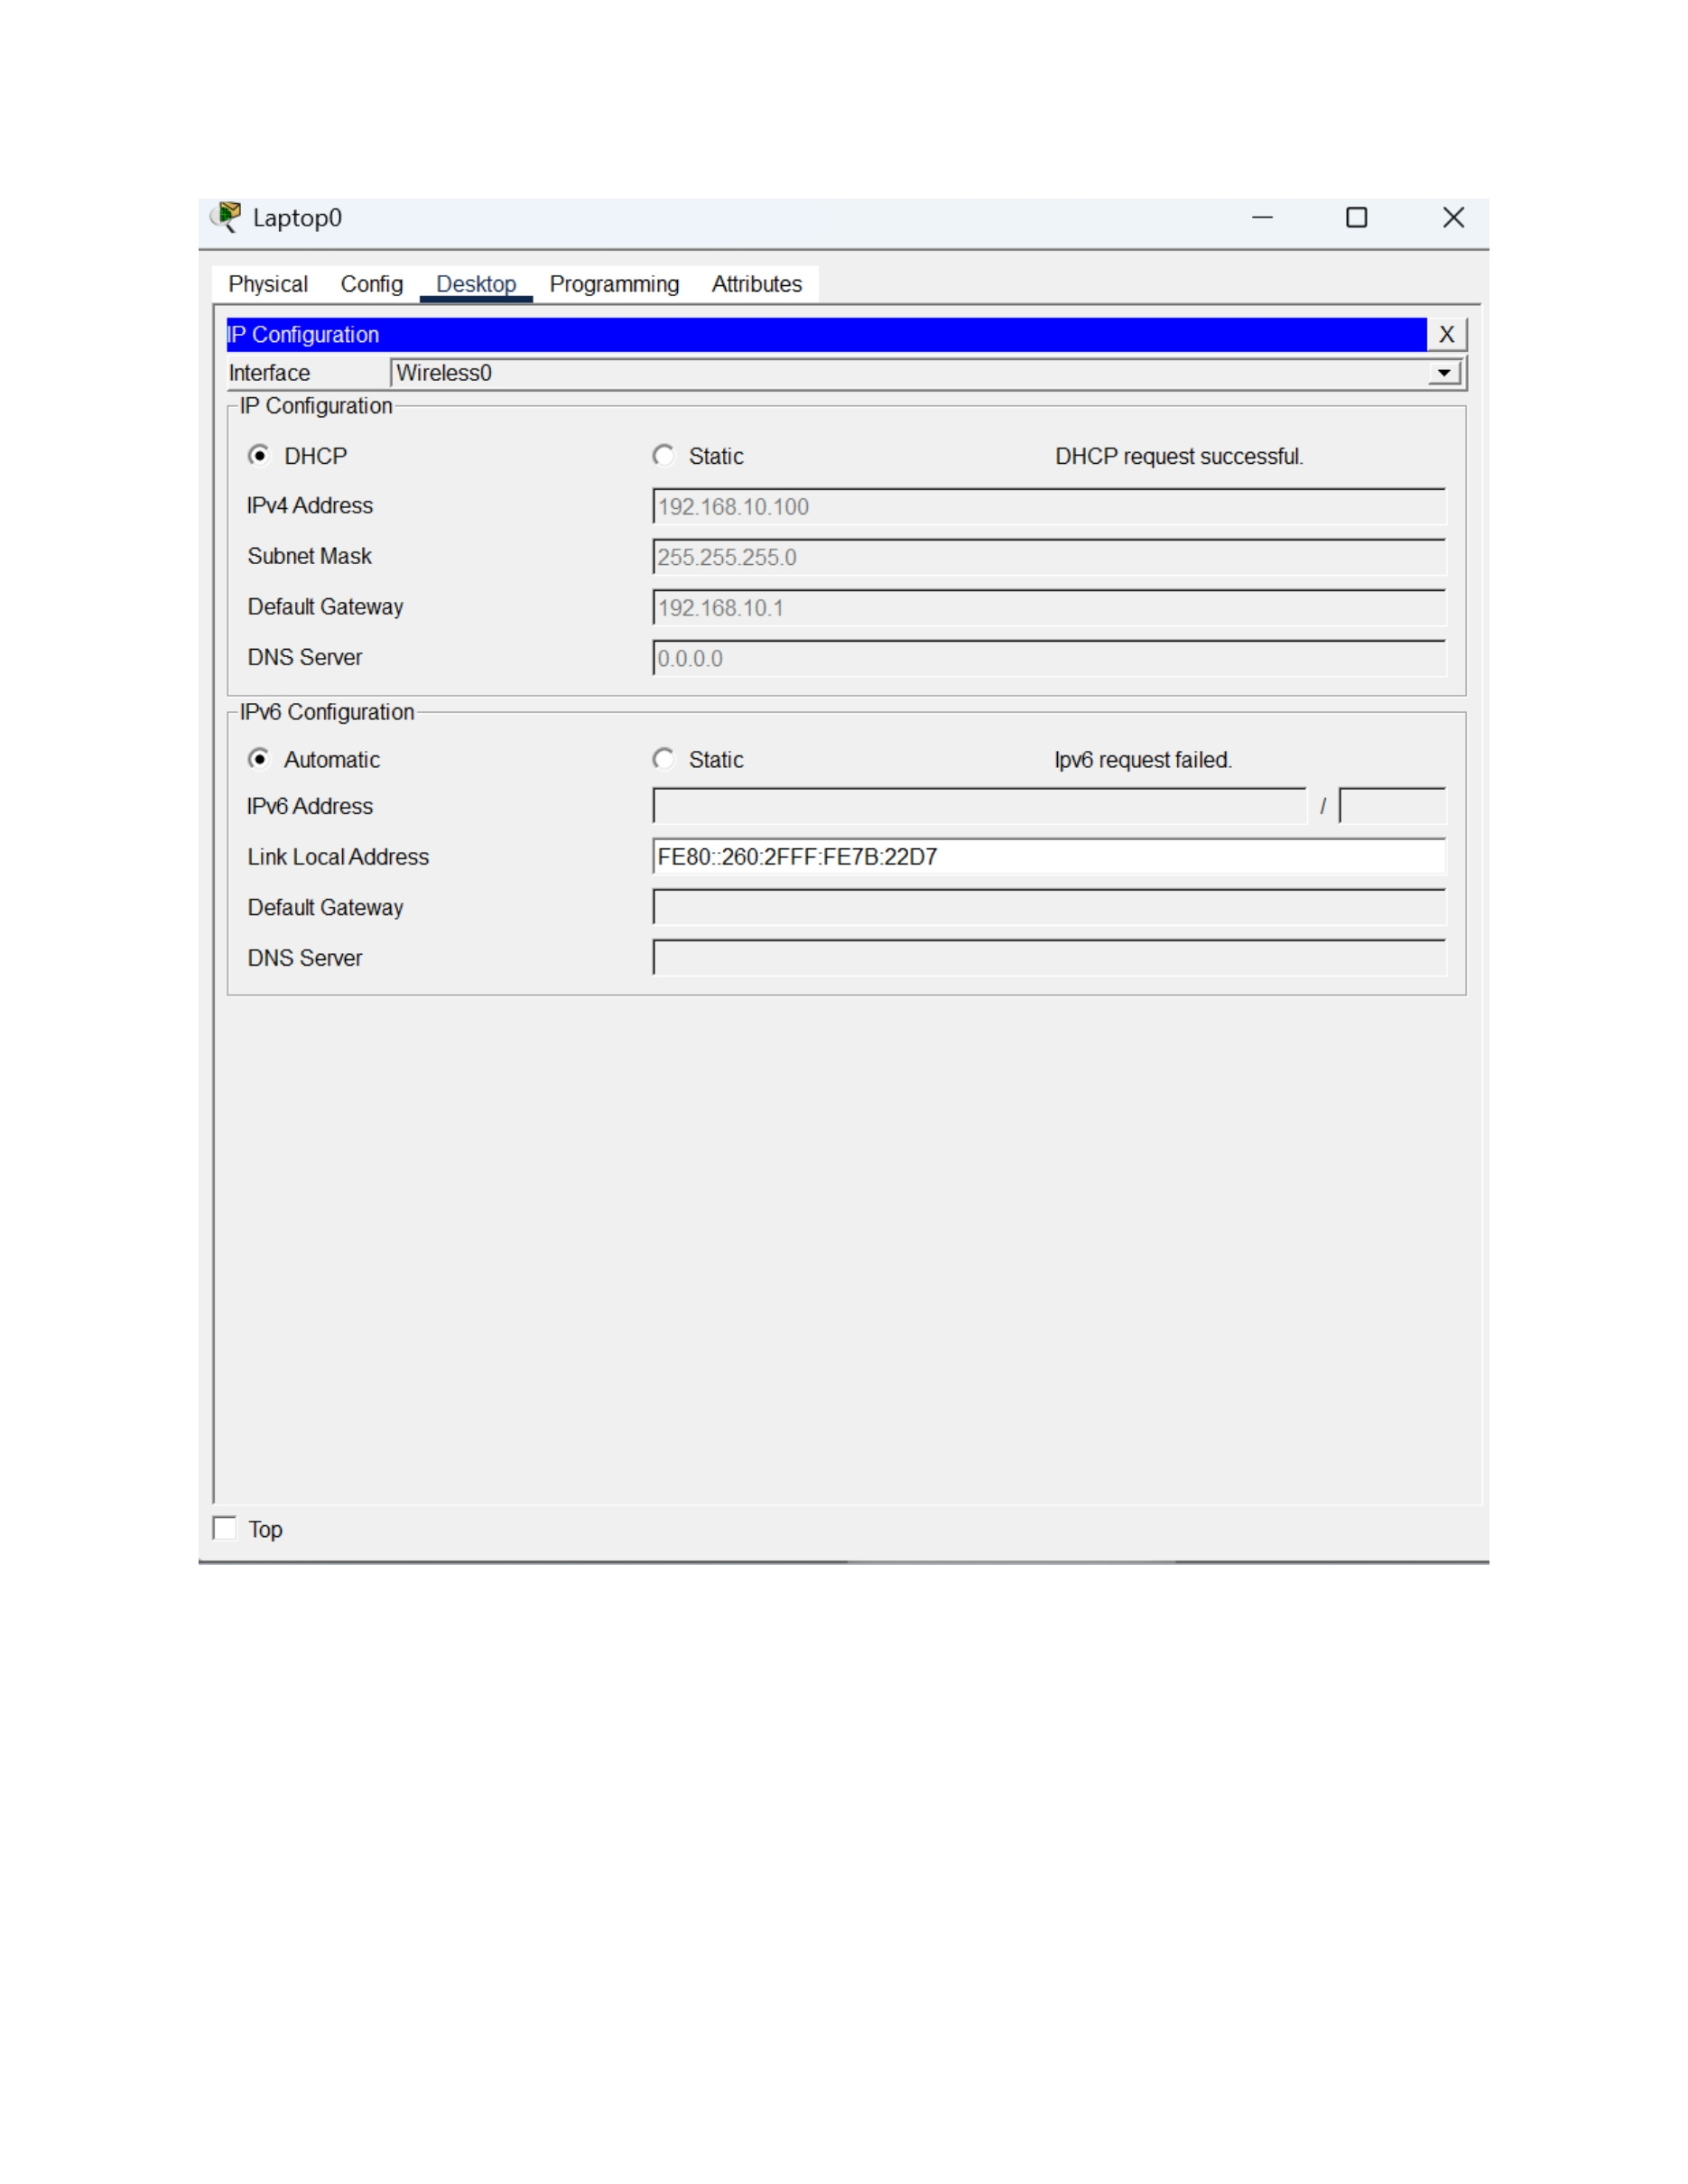
What I did: I opened the DHCP server configuration to modify the address-assignment settings.
Explanation: The server configuration is being prepared for a DHCP reservation.

PAGE 17 – DHCP Reservation – Identify the Device
Topic: DHCP Reservation – Identify the Device
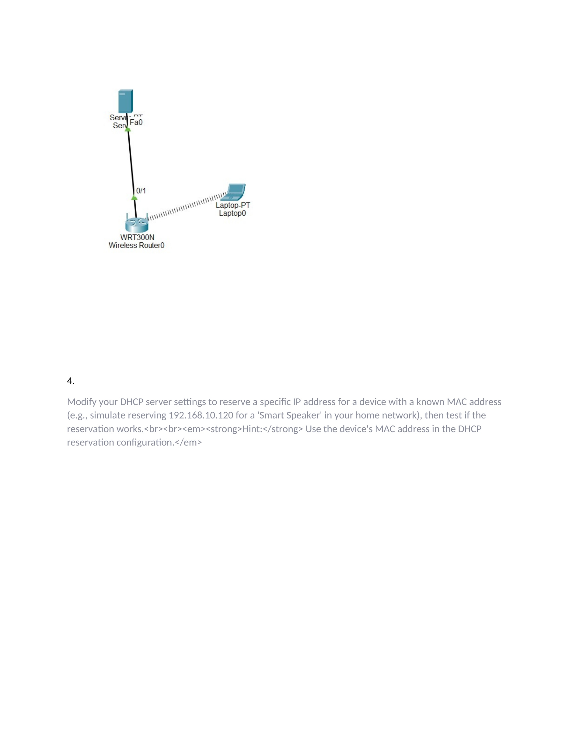
What I did: I reviewed the connected device information needed to identify the device for the reservation.
Explanation: The device information provides the values required to associate a reserved IP with a specific client.

PAGE 18 – DHCP Reservation – Configure the Reservation
Topic: DHCP Reservation – Configure the Reservation
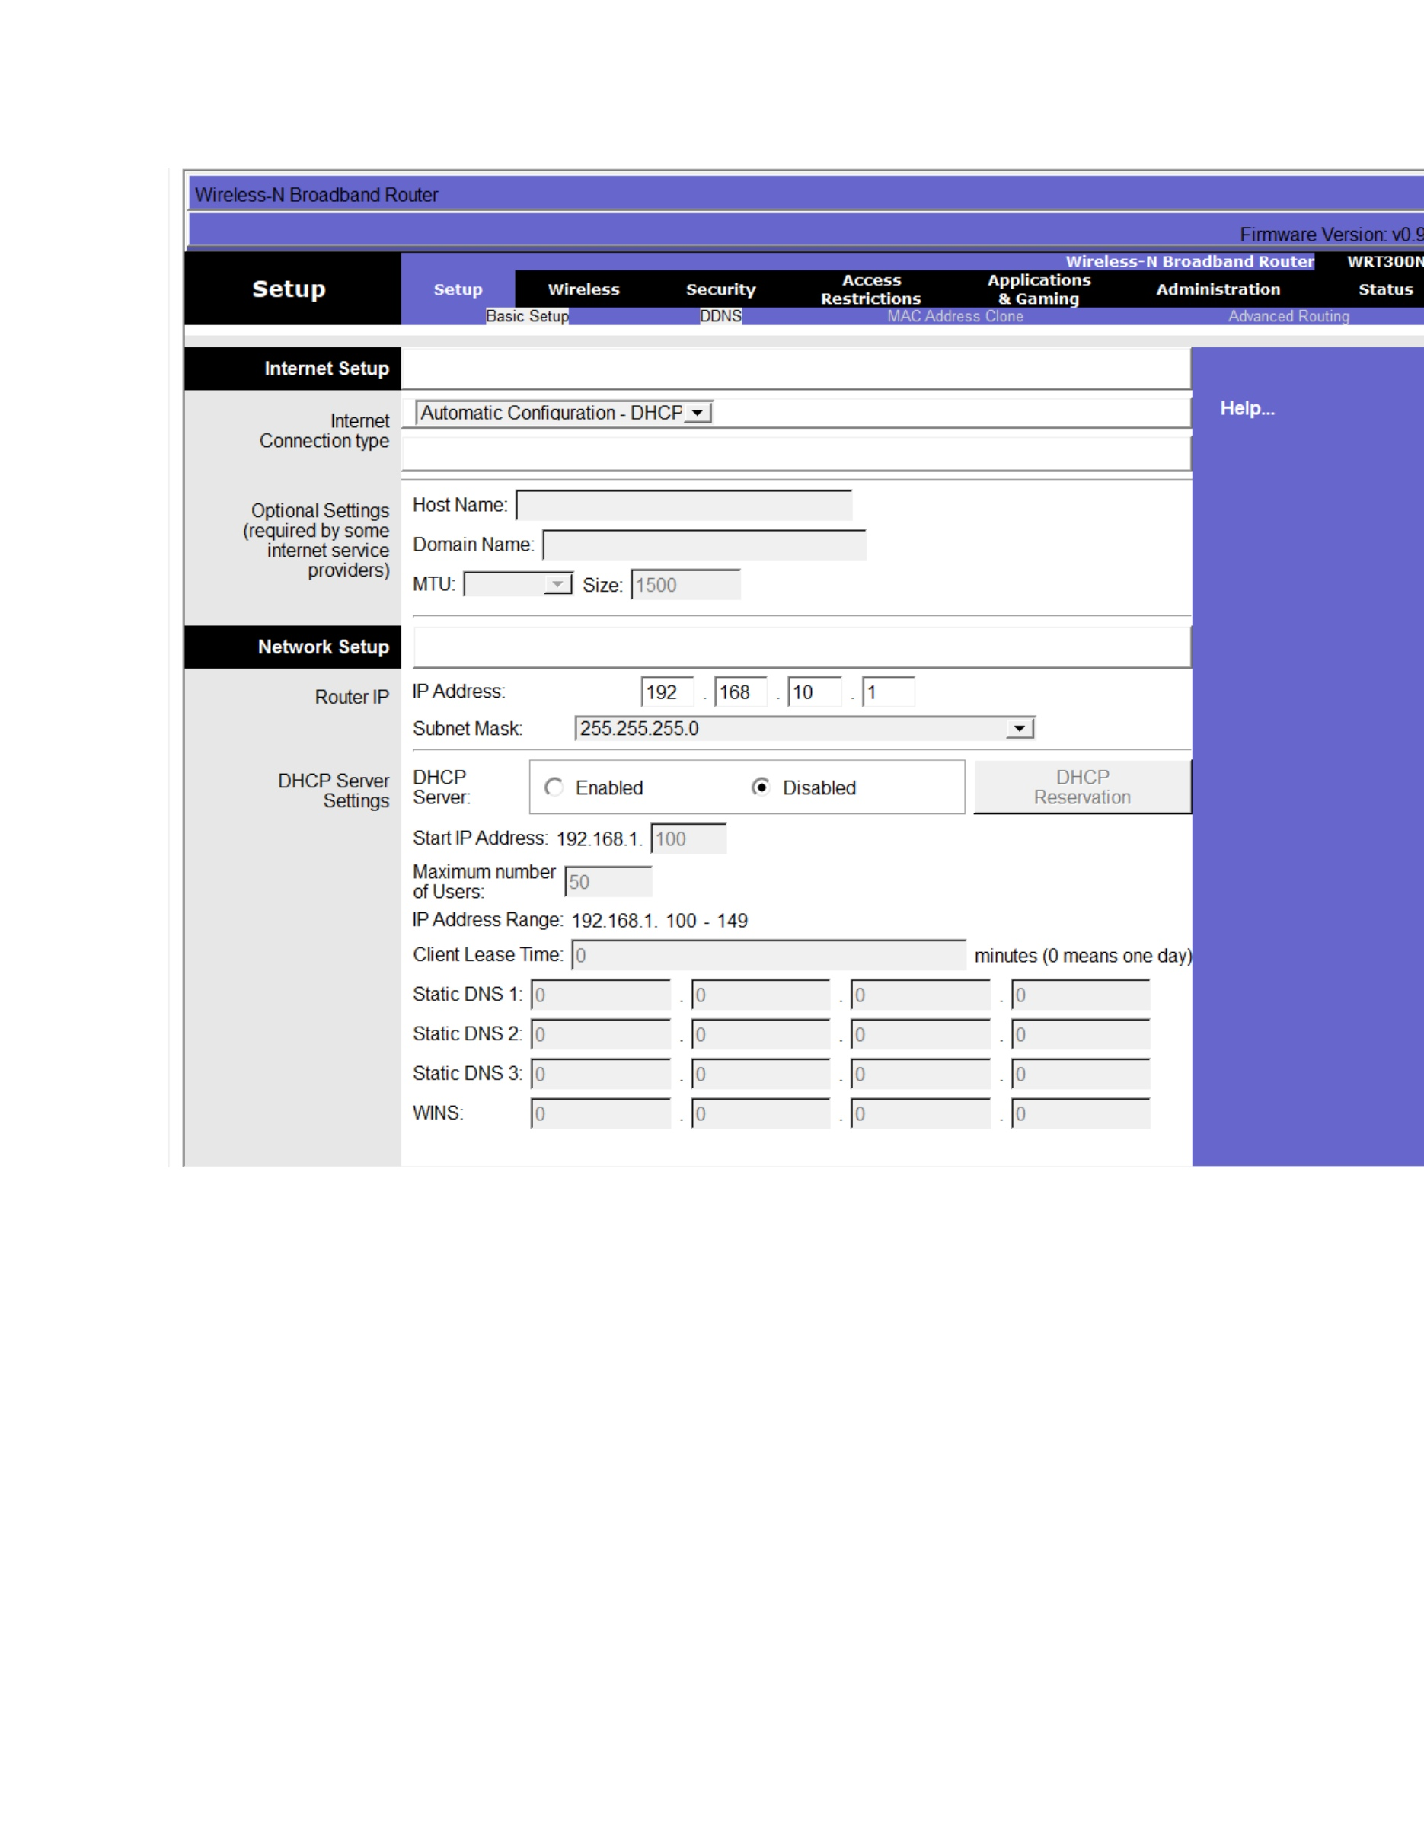
What I did: I entered the reservation information using the device's identifying network details.
Explanation: The DHCP configuration associates a specific address with the selected client.

PAGE 19 – DHCP Reservation – Enter the Reserved IP
Topic: DHCP Reservation – Enter the Reserved IP
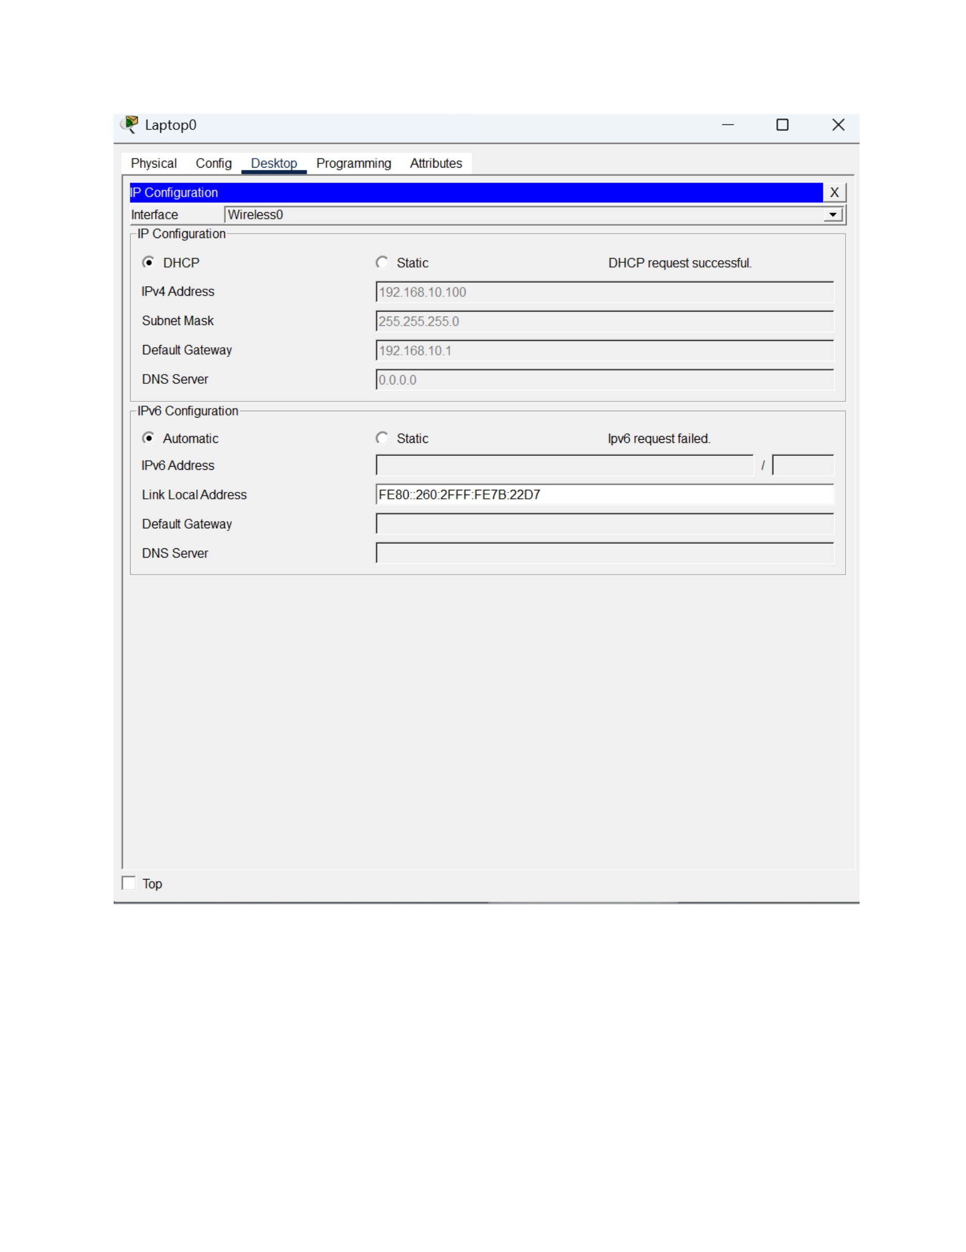
What I did: I entered the specific IP address to be reserved for the selected device.
Explanation: The reservation ensures that the selected device can receive the designated address.

PAGE 20 – DHCP Reservation – Verify the Reservation Settings
Topic: DHCP Reservation – Verify the Reservation Settings
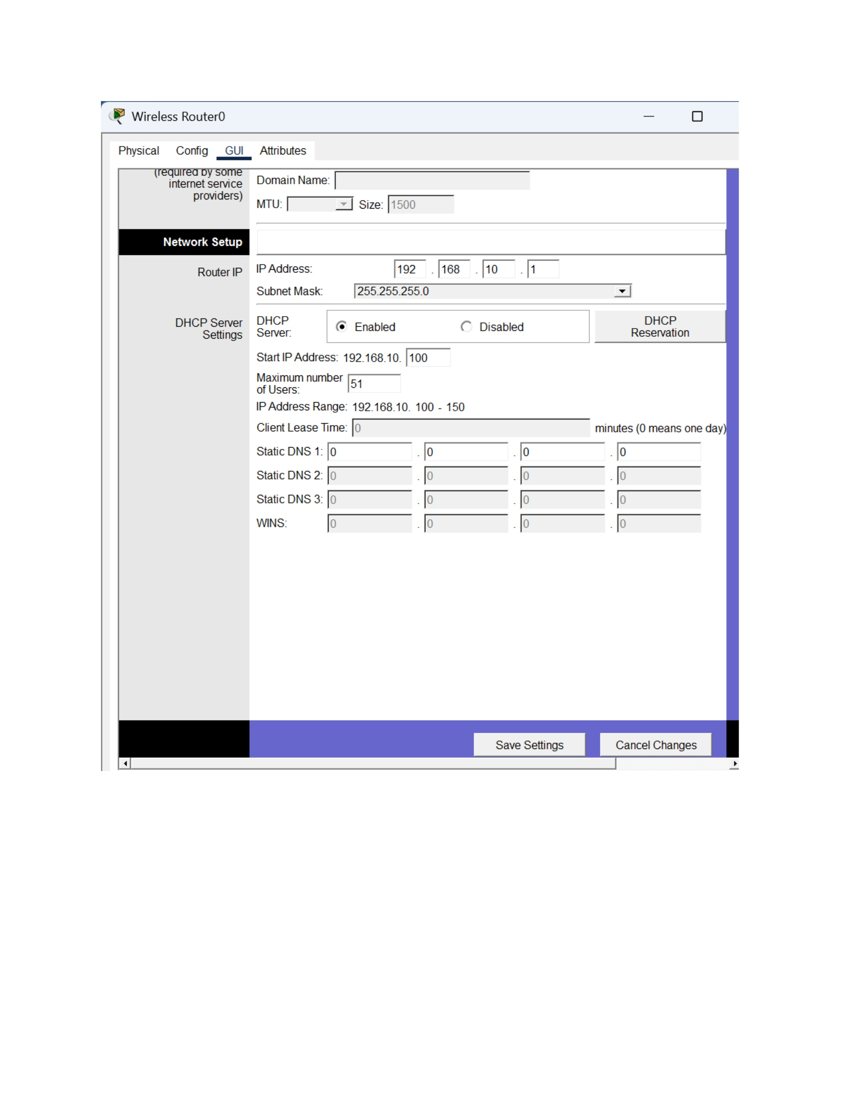
What I did: I reviewed the DHCP reservation configuration before applying the change.
Explanation: The settings show the reserved address and the client information used for the reservation.

PAGE 21 – DHCP Reservation – Save the Configuration
Topic: DHCP Reservation – Save the Configuration
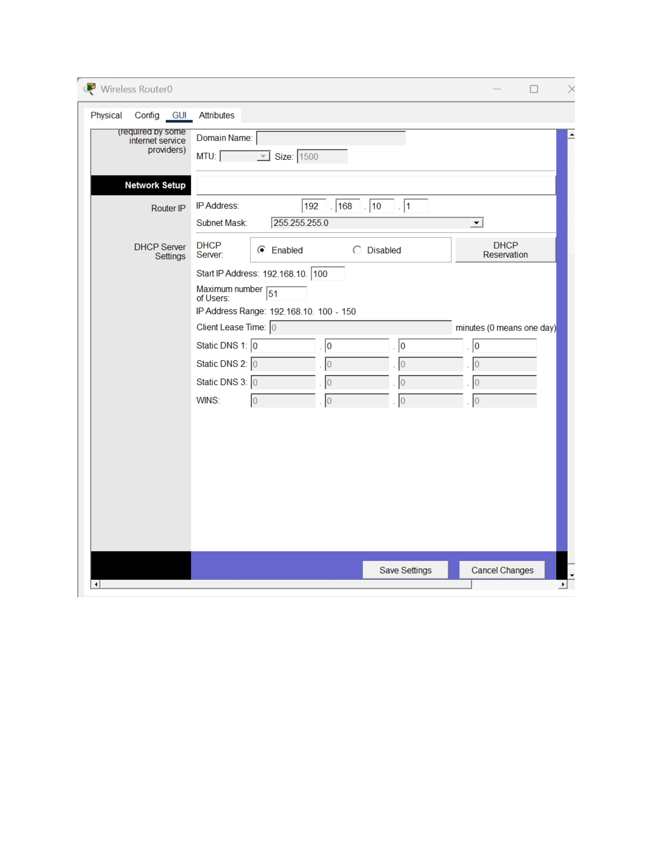
What I did: I applied the DHCP reservation settings on the server.
Explanation: The updated configuration saves the reserved address for the selected device.

PAGE 22 – DHCP Reservation – Review Device Configuration
Topic: DHCP Reservation – Review Device Configuration
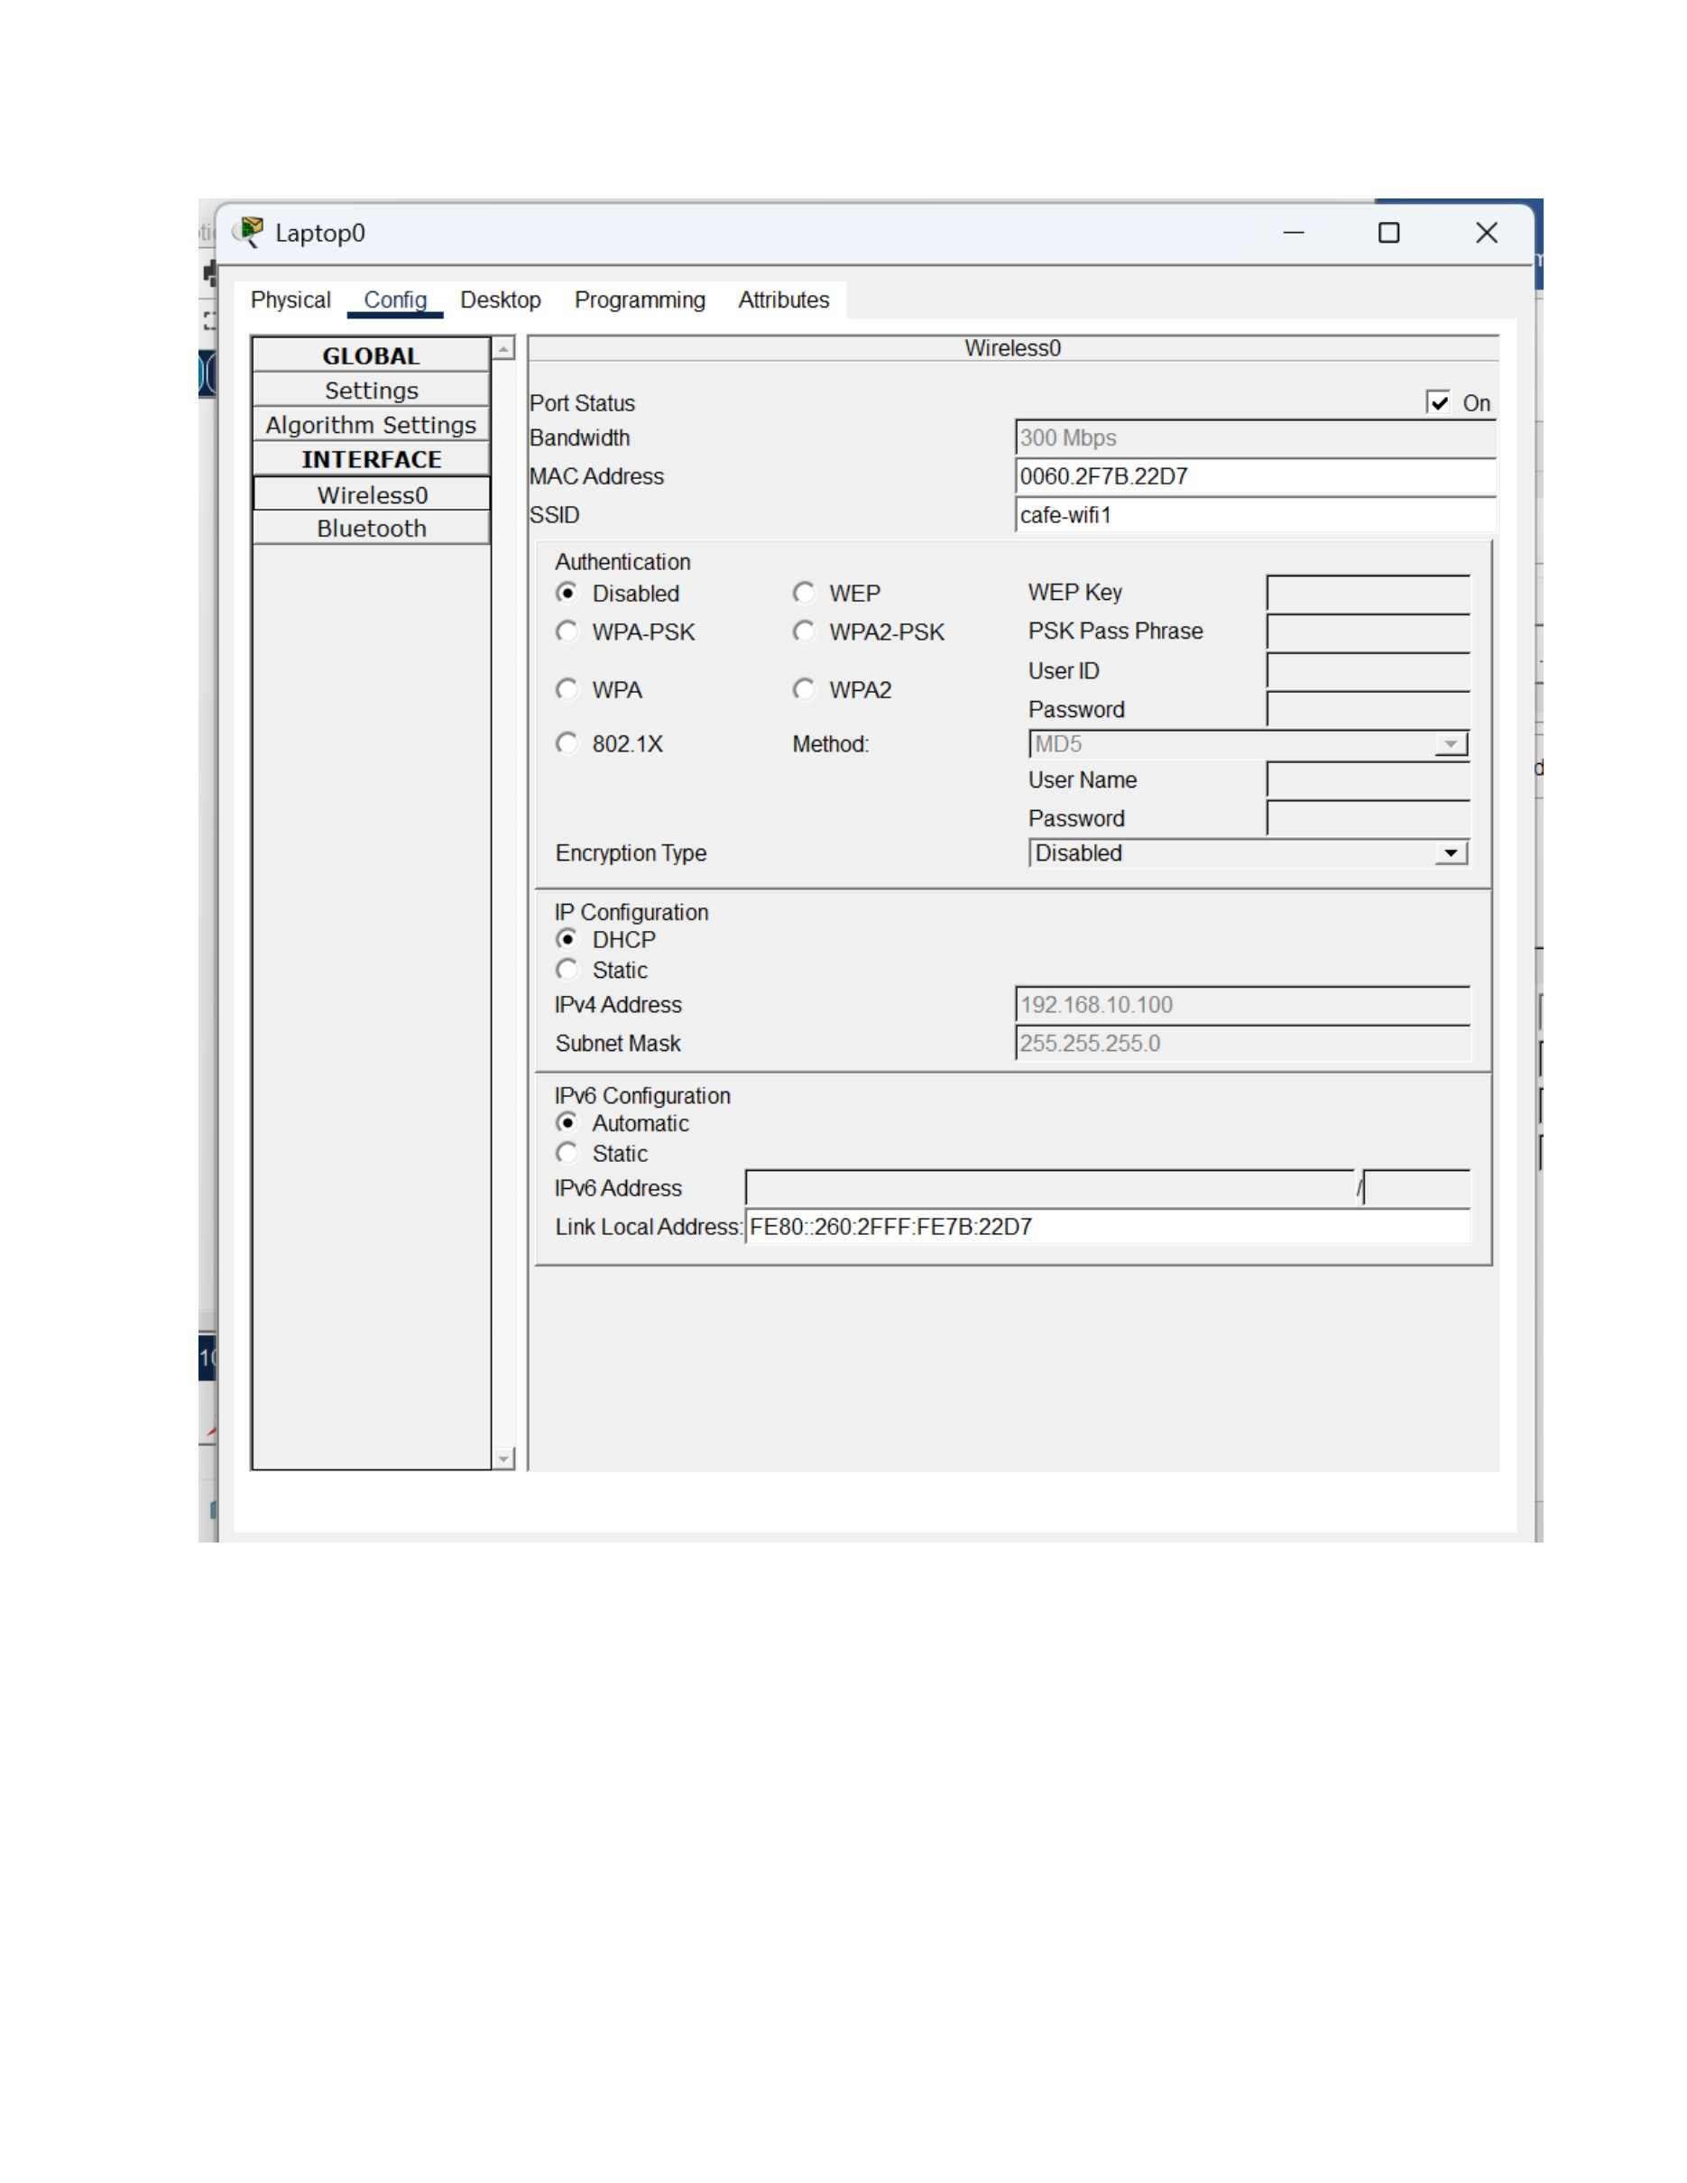
What I did: I opened the device configuration to check the network information after the reservation was configured.
Explanation: The client settings are used to verify the result of the DHCP reservation.

PAGE 23 – DHCP Reservation – Check the Assigned Address
Topic: DHCP Reservation – Check the Assigned Address
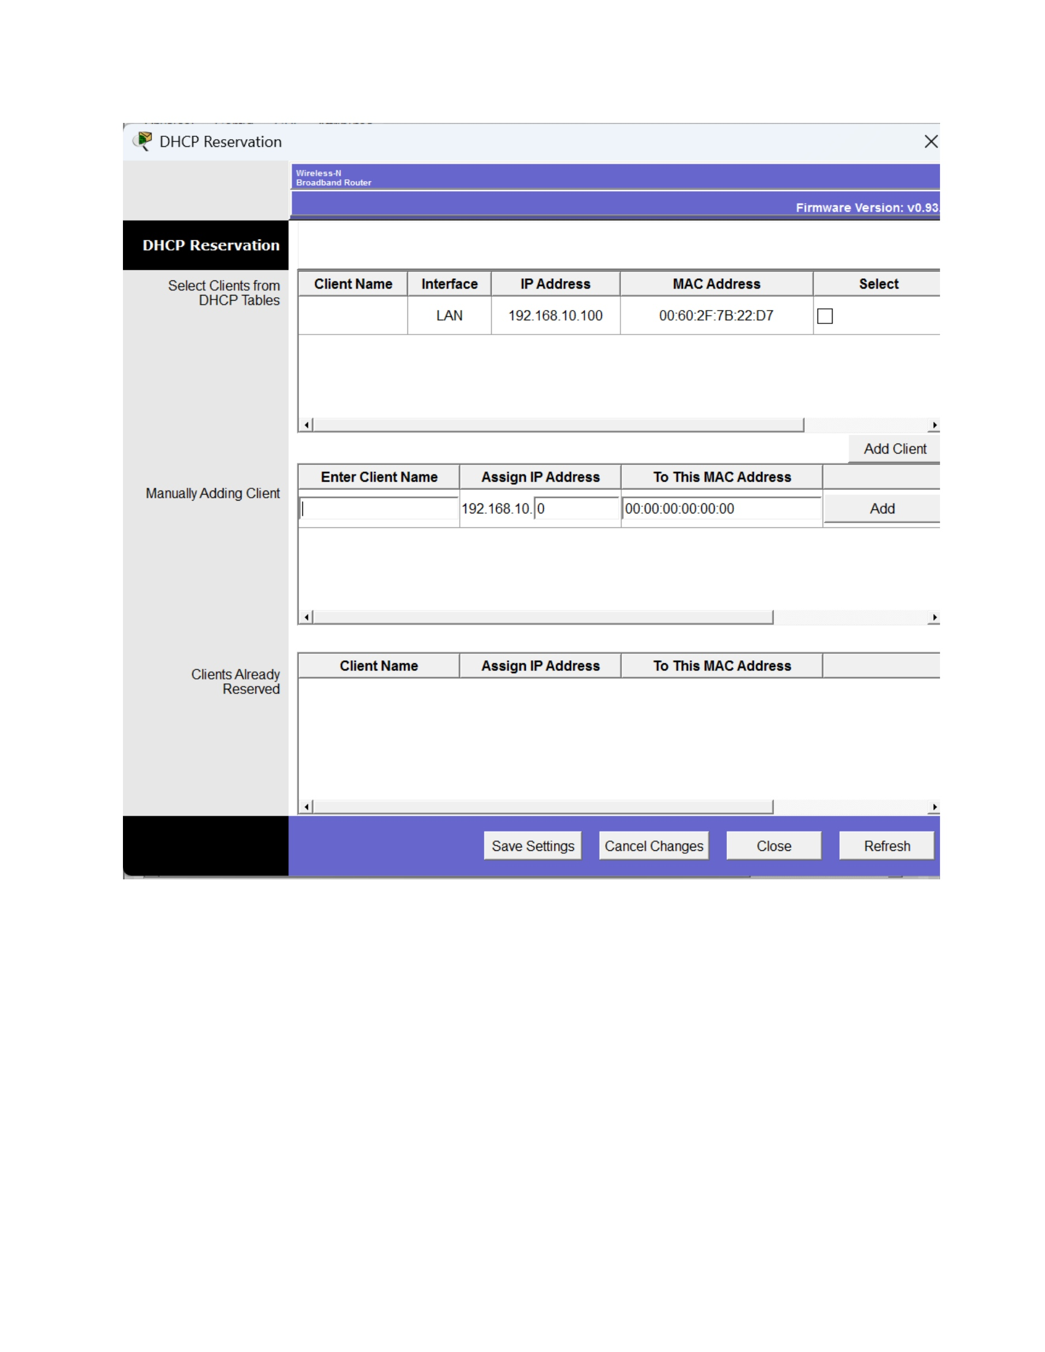
What I did: I checked the client's IP configuration to verify the reserved address.
Explanation: The displayed network information is used to confirm whether the reservation worked.

PAGE 24 – DHCP Reservation – Final Server Check
Topic: DHCP Reservation – Final Server Check
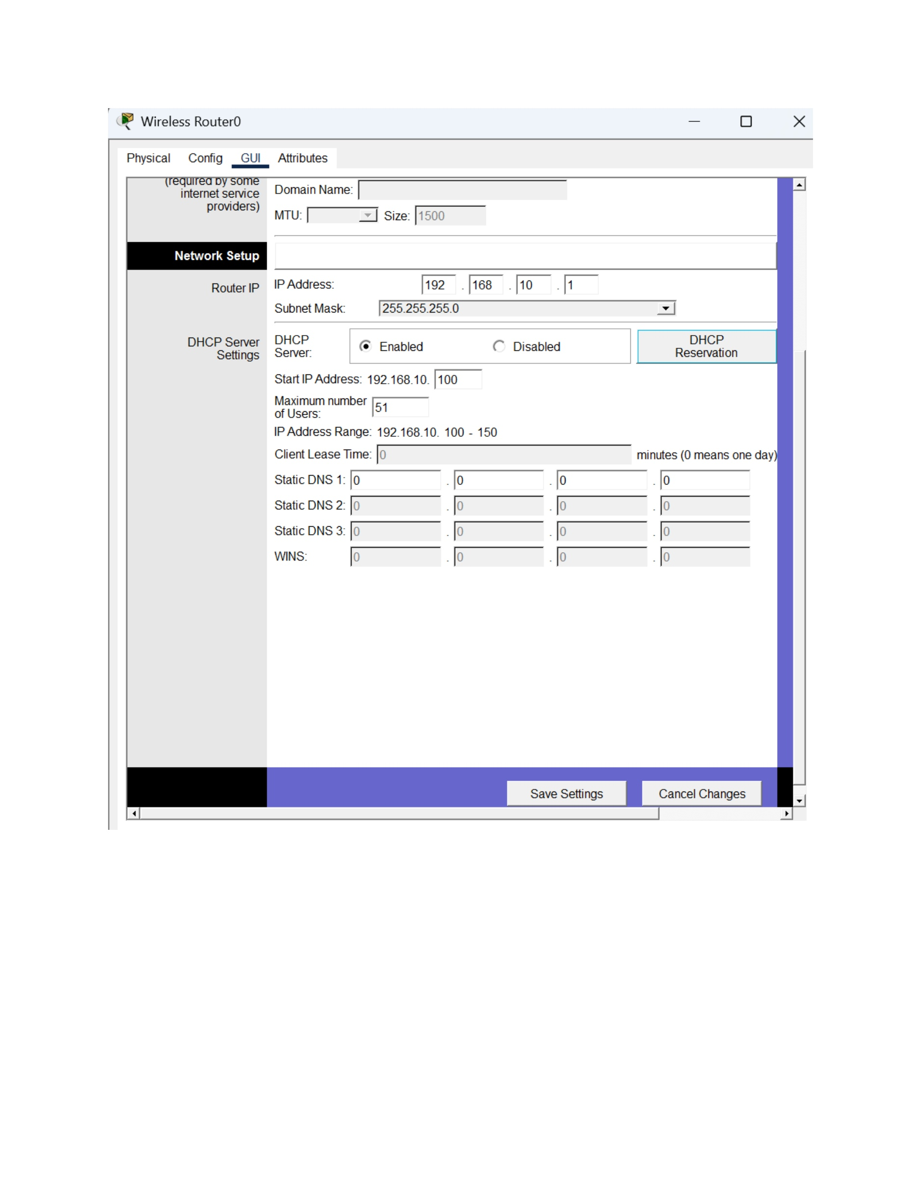
What I did: I reviewed the DHCP server settings and the configured reservation.
Explanation: The final server view confirms the reservation configuration is present.

PAGE 25 – DHCP – Final Verification
Topic: DHCP – Final Verification
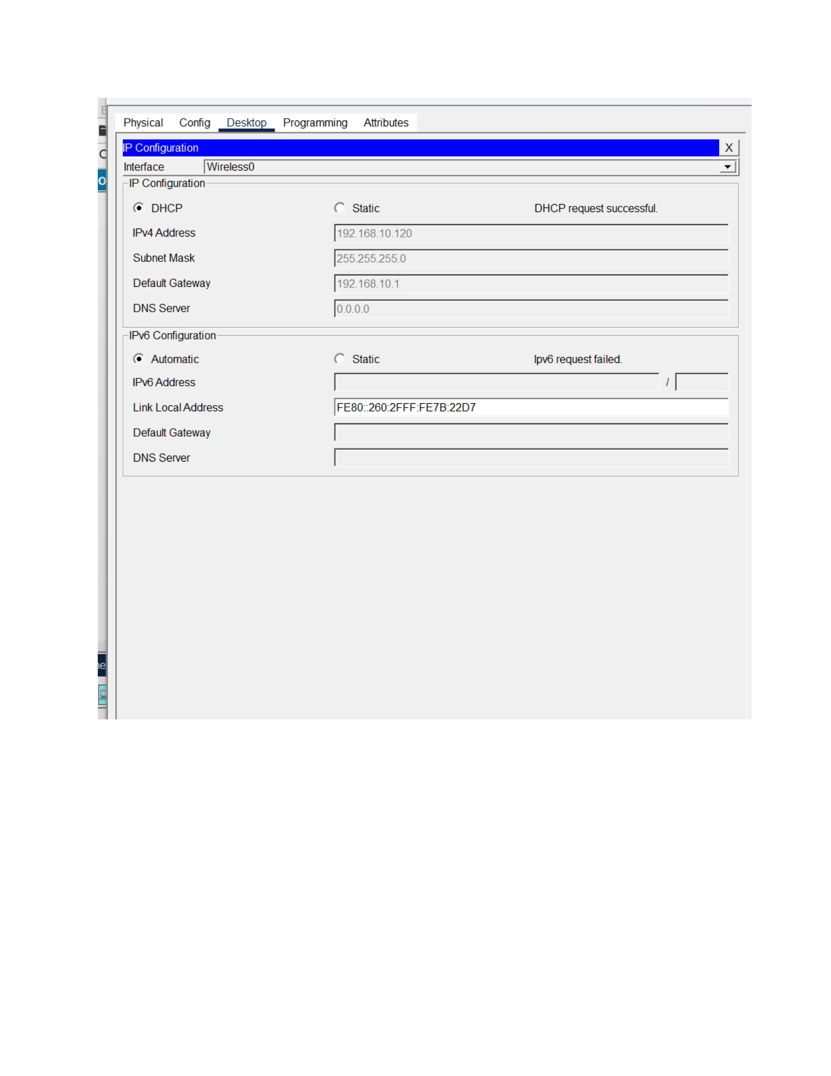
What I did: I reviewed the completed DHCP configuration and the resulting network settings.
Explanation: This final screenshot shows the configured DHCP environment after the required changes.

