LVM MANAGEMENT
RHEL — Step-by-Step Screenshot Guide
Add Disk → PV → VG → LV → XFS → /etc/fstab → Remove LVM
LVM Management
Add a new virtual disk
Create a Physical Volume (PV)
Create a Volume Group (VG)
Create a Logical Volume (LV)
Format it with XFS
Mount it permanently using /etc/fstab
Remove All

PAGE 1 — LVM MANAGEMENT
Topic: RHEL Environment
What I did: I opened the Red Hat Enterprise Linux (RHEL) environment where the LVM storage work is being performed.
Explanation: This is the starting RHEL environment for the storage-management procedure.
Original screenshot — Page 1

PAGE 2 — LVM MANAGEMENT
Topic: Virtual Machine Settings
What I did: I opened Edit virtual machine settings to manage the virtual machine hardware.
Explanation: The hardware settings are used to add and configure the new virtual disk.

Original screenshot — Page 2

PAGE 3 — LVM MANAGEMENT
Topic: Review Hardware Options
What I did: I reviewed the existing hardware configuration of the virtual machine.
Explanation: This confirms the current hardware before adding the new storage device.
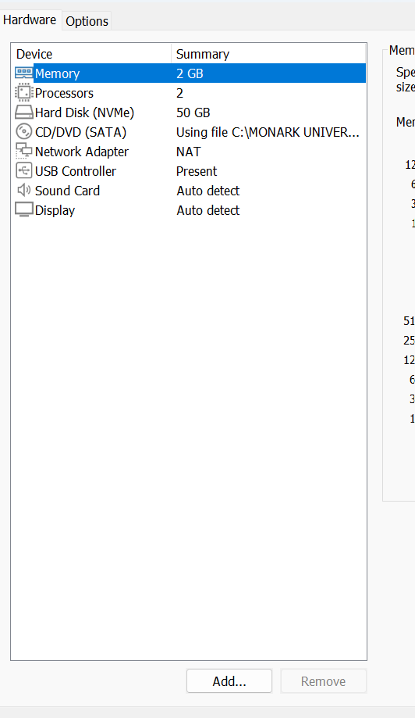
Original screenshot — Page 3

PAGE 4 — LVM MANAGEMENT
Topic: Add a Hard Disk
What I did: I selected Add a hard disk from the Add Hardware window.
Explanation: This starts the process of attaching a new virtual disk to the RHEL virtual machine.
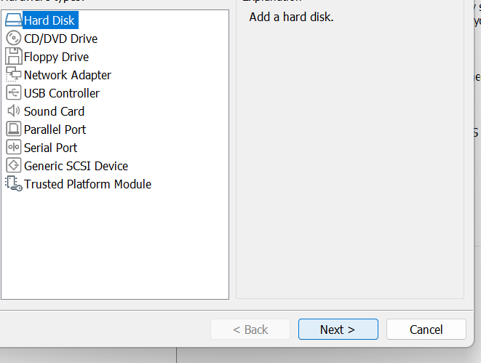
Original screenshot — Page 4

PAGE 5 — LVM MANAGEMENT
Topic: Select Disk Type
What I did: I selected NVMe as the virtual disk type.
Explanation: NVMe is selected for the new virtual disk that will be used for the storage setup.
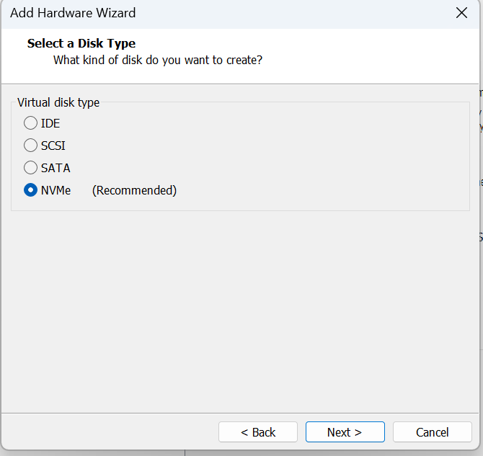
Original screenshot — Page 5

PAGE 6 — LVM MANAGEMENT
Topic: Create a New Virtual Disk
What I did: I selected Create a new virtual disk in the Add Hardware Wizard.
Explanation: This creates a new virtual disk instead of using an existing disk file.
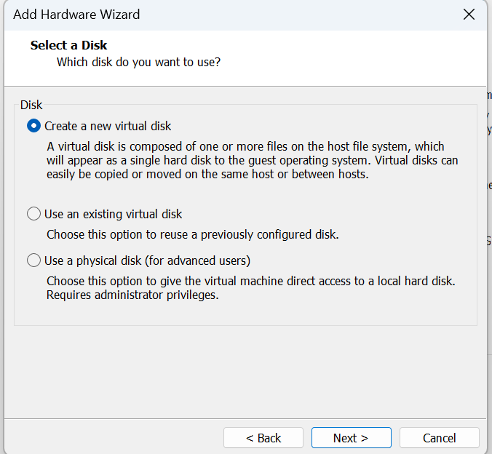
Original screenshot — Page 6

PAGE 7 — LVM MANAGEMENT
Topic: Specify Disk Capacity
What I did: I set the maximum disk size for the new virtual disk.
Explanation: The disk capacity is defined here before the virtual disk file is created.
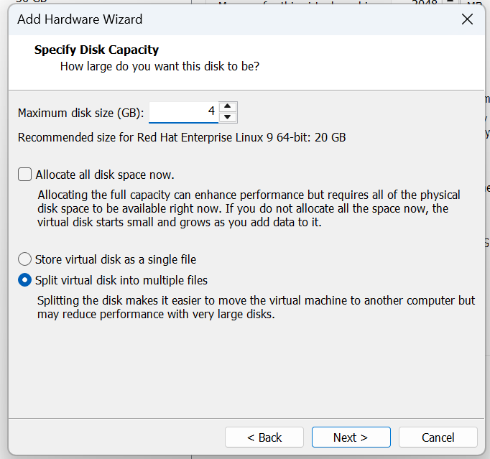
Original screenshot — Page 7

PAGE 8 — LVM MANAGEMENT
Topic: Specify Disk File
What I did: I specified the location and file name for the new virtual disk.
Explanation: This tells VMware where the new virtual disk file will be stored.
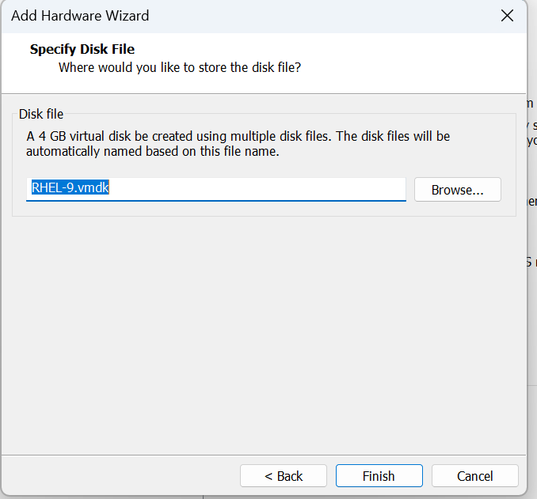
Original screenshot — Page 8

PAGE 9 — LVM MANAGEMENT
Topic: Power On the Virtual Machine
What I did: I selected Power on this virtual machine.
Explanation: The RHEL virtual machine is started so the newly configured storage can be detected.

Original screenshot — Page 9

PAGE 10 — LVM MANAGEMENT
Topic: RHEL Login
What I did: I entered the root account at the RHEL login screen.
Explanation: The root account is used to perform the administrative LVM and disk-management commands.
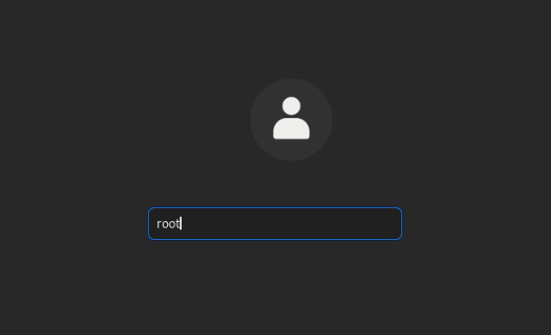
Original screenshot — Page 10

PAGE 11 — LVM MANAGEMENT
Topic: RHEL Desktop
What I did: I reached the RHEL desktop after logging in.
Explanation: The system is now ready for the storage configuration commands.
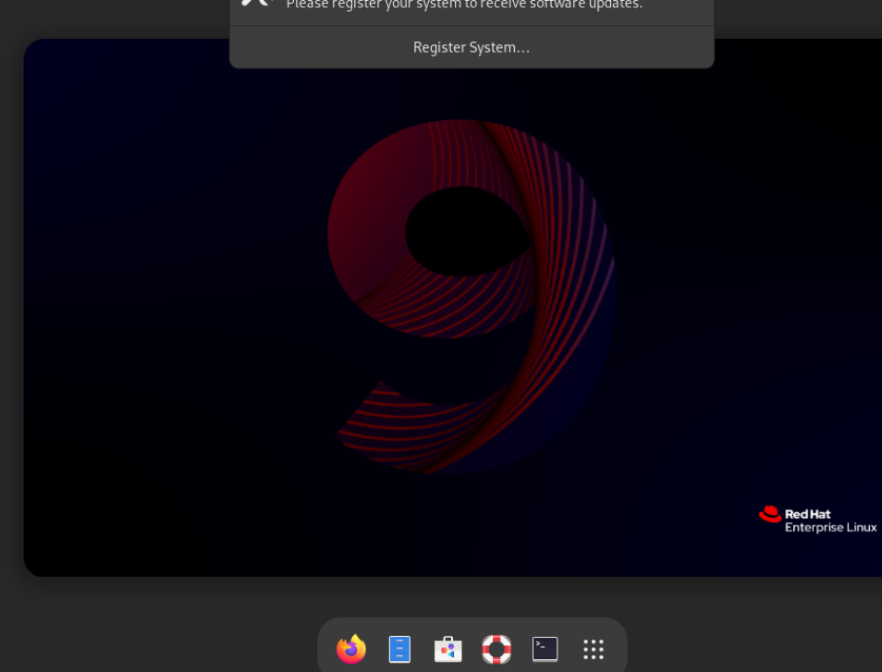
Original screenshot — Page 11

PAGE 12 — LVM MANAGEMENT
Topic: Check the Disk Layout
What I did: I ran lsblk to view the disks, partitions, and current mount points.
Explanation: The command is used to identify the available disk before creating the LVM storage structure.
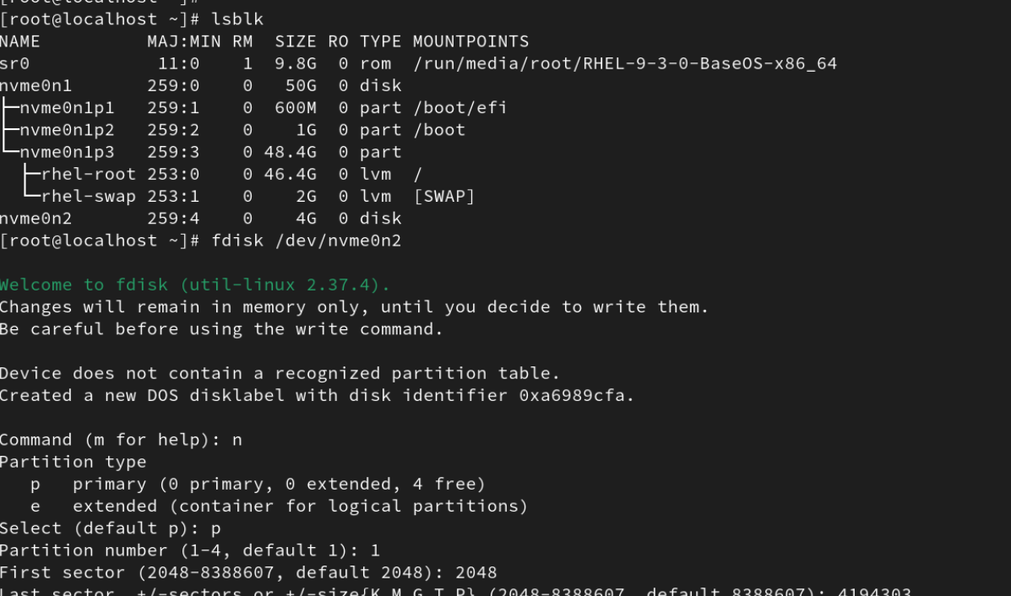
Original screenshot — Page 12

PAGE 13 — LVM MANAGEMENT
Topic: Create a New Partition
What I did: I used fdisk to create a new Linux partition of approximately 2 GiB on the new disk.
Explanation: The new partition provides the storage that will be used for the LVM configuration.
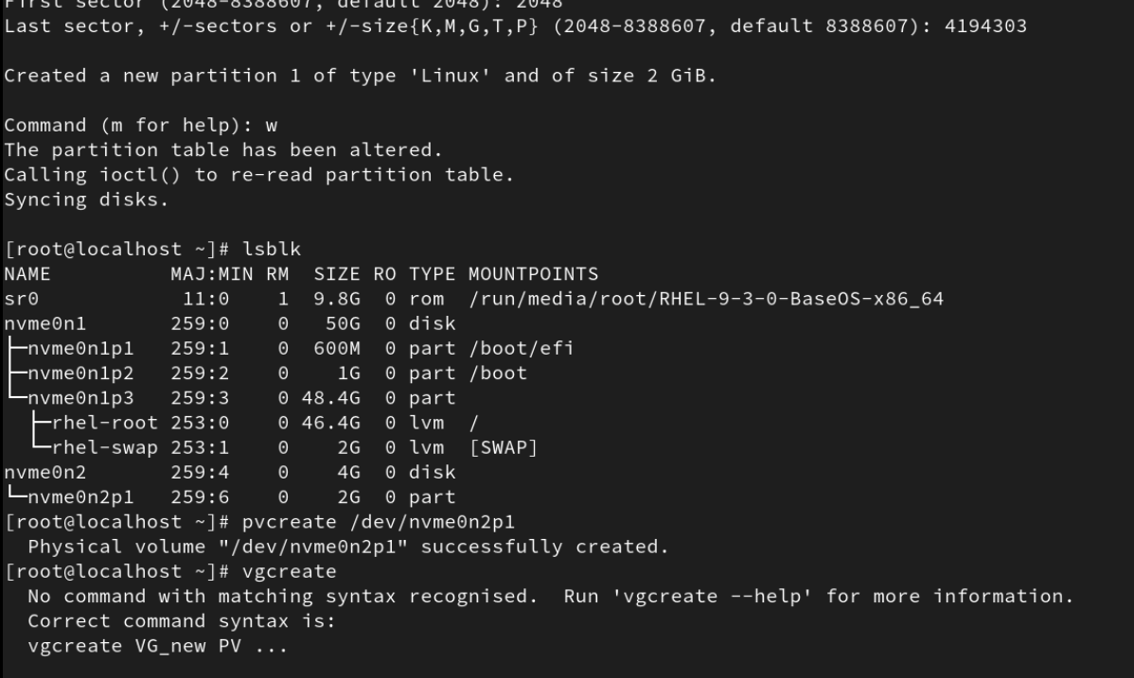
Original screenshot — Page 13

PAGE 14 — LVM MANAGEMENT
Topic: Write the Partition Table
What I did: I wrote the fdisk changes to the disk and then checked the layout with lsblk.
Explanation: The partition-table changes are saved and the new partition is verified in the disk list.
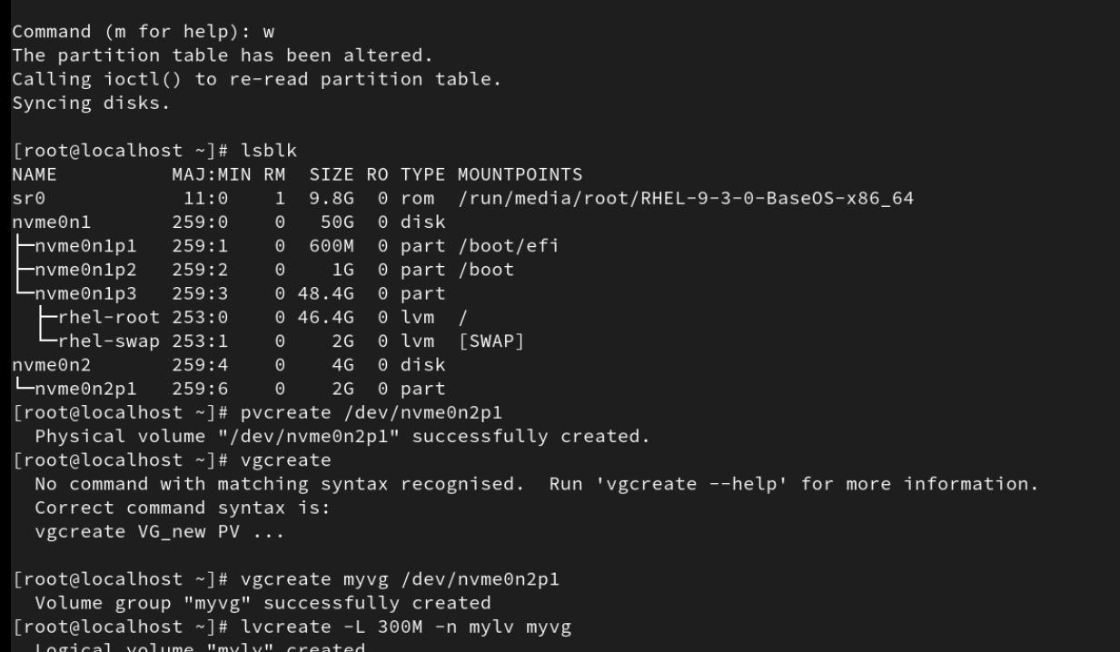
Original screenshot — Page 14

PAGE 15 — LVM MANAGEMENT
Topic: Try to Mount the Logical Volume
What I did: I tried to mount /dev/myvg/mylv on /project.
Explanation: The mount failed because the logical volume did not yet have a usable filesystem.
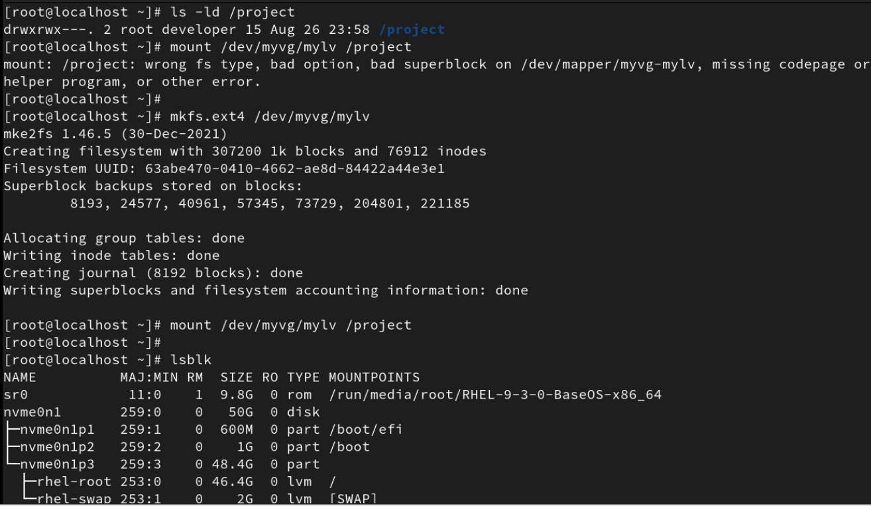
Original screenshot — Page 15

PAGE 16 — LVM MANAGEMENT
Topic: Mount the Logical Volume
What I did: I mounted /dev/myvg/mylv on /project and checked the result with lsblk.
Explanation: The logical volume is now mounted on /project and the storage layout confirms the mount.
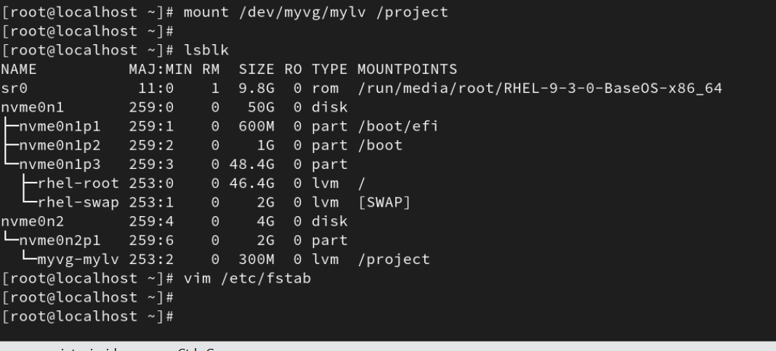
Original screenshot — Page 16

PAGE 17 — LVM MANAGEMENT
Topic: Open /etc/fstab
What I did: I opened /etc/fstab in the text editor.
Explanation: The file is opened so the /project mount can be configured to persist across reboots.
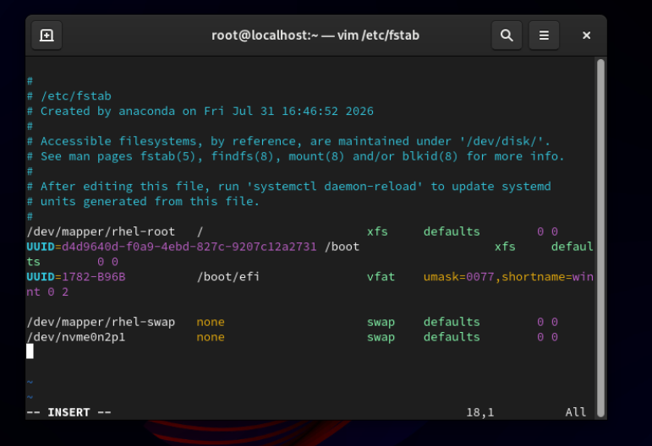
Original screenshot — Page 17

PAGE 18 — LVM MANAGEMENT
Topic: Edit /etc/fstab
What I did: I added the logical-volume mount information to /etc/fstab.
Explanation: This configuration makes the /project filesystem available automatically when the system starts.
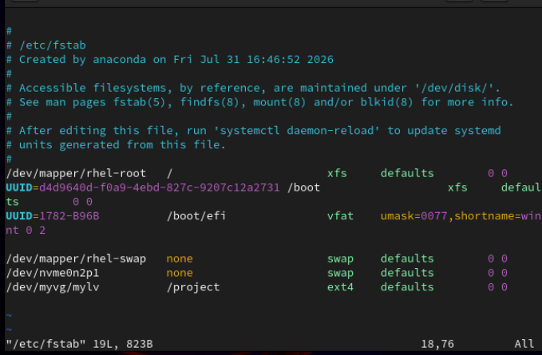
Original screenshot — Page 18

PAGE 19 — LVM MANAGEMENT
Topic: Verify the Permanent Mount
What I did: I mounted the logical volume and checked the result with lsblk.
Explanation: The verification confirms that the logical volume is mounted at /project.
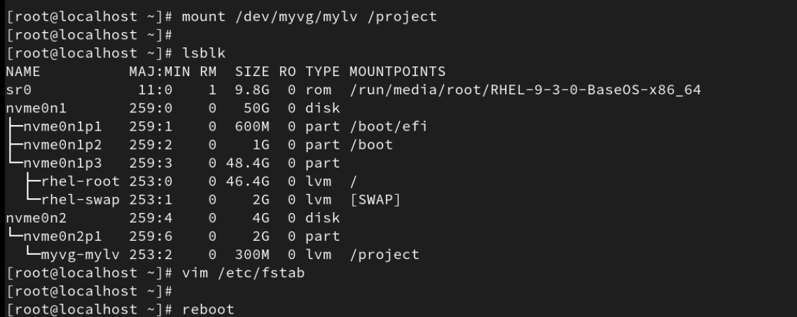
Original screenshot — Page 19

PAGE 20 — LVM MANAGEMENT
Topic: System Transition
What I did: I waited for the system to finish the current operation before continuing.
Explanation: This screen shows the transition between the storage-management operations.

Original screenshot — Page 20

PAGE 21 — LVM MANAGEMENT
Topic: Check the Final Disk Layout
What I did: I ran lsblk again to review the current disks, partitions, and logical volume.
Explanation: The command verifies the storage structure before removing the LVM configuration.
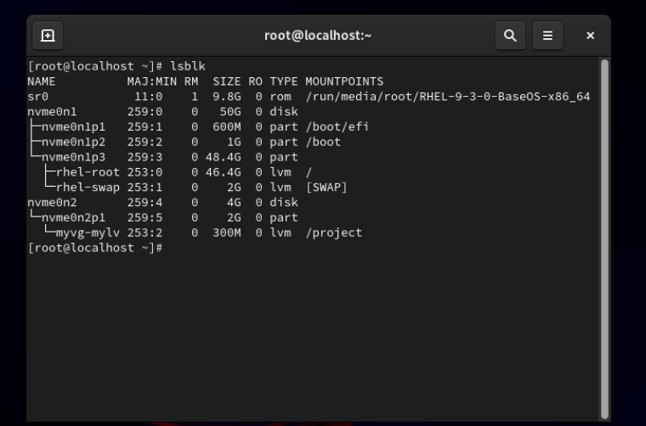
Original screenshot — Page 21

PAGE 22 — LVM MANAGEMENT
Topic: Remove the Logical Volume
What I did: I removed /dev/myvg/mylv and confirmed the removal.
Explanation: The logical volume is deleted as the first step of removing the LVM storage configuration.
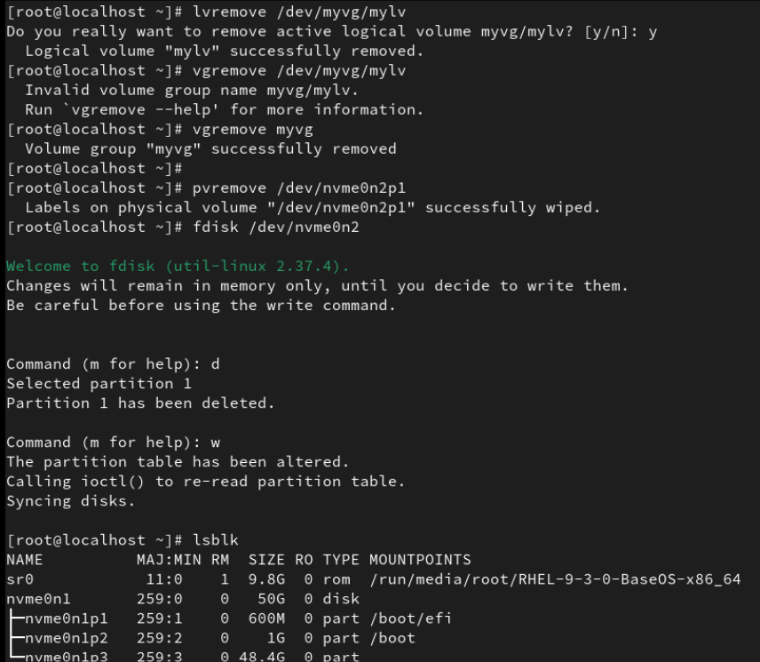
Original screenshot — Page 22

PAGE 23 — LVM MANAGEMENT
Topic: Verify Storage After Removal
What I did: I ran lsblk to check the storage devices after removing the logical volume.
Explanation: The output is used to verify the remaining disk and partition structure.
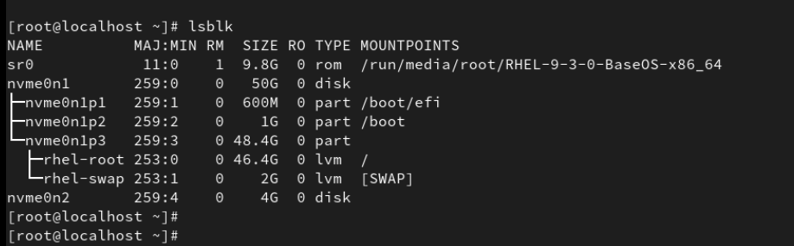
Original screenshot — Page 23

PAGE 24 — LVM MANAGEMENT
Topic: Review Virtual Machine Hardware
What I did: I opened the virtual machine hardware settings and reviewed the storage devices.
Explanation: The hardware configuration is checked before removing the virtual disk.
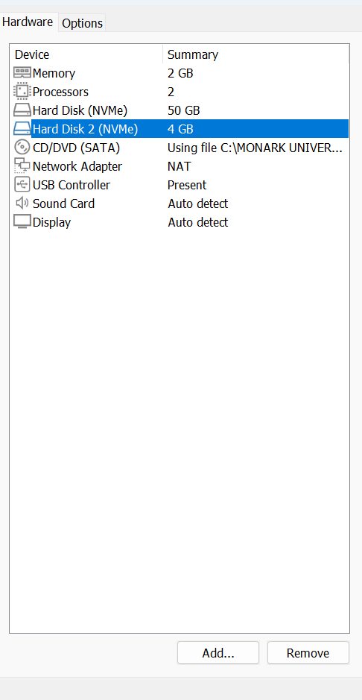
Original screenshot — Page 24

PAGE 25 — LVM MANAGEMENT
Topic: Remove the Virtual Disk
What I did: I selected Remove for the virtual disk in the hardware settings.
Explanation: This removes the virtual disk from the virtual machine after the LVM storage has been removed.
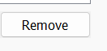
Original screenshot — Page 25

